Producer Consumer Problem
Excercise 4 24/09/2019

code

#include<stdio.h>
int mutex=1,full=0,empty,n;
int wait(int s){
if(s > 0){
s--;
return s;
}
else{
return -1;
}
}
int signal(int s){
s++;
return s;
}
void producer(){
int status = wait(empty);
mutex=wait(mutex);
if(status==-1)
printf("\nBuffer full:......\n");
else{
empty=status;
full=signal(full);
printf("\nProducer produces item %d\n",full);
}
mutex=signal(mutex);
}
void consumer(){
mutex=wait(mutex);
int status= wait(full);
mutex=wait(mutex);
if(status==-1)
printf("\nBuffer empty:.......\n");
else{
full=status;
printf("\nConsumer consumes %d\n",full+1);
empty=signal(empty);
}
mutex=signal(mutex);
}
void main(){
int choice,flag=0;
printf("Enter the size of buffer: ");
scanf("%d",&n);
empty=n;
while(1){
printf("1.Produce 2.consume 3.Exit: ");
scanf("%d",&choice);
switch(choice){
case 1:producer();
break;
case 2:consumer();
break;
case 3:flag=1;
break;
default:flag=1;
break;
}
if(flag==1)
break;
}
}

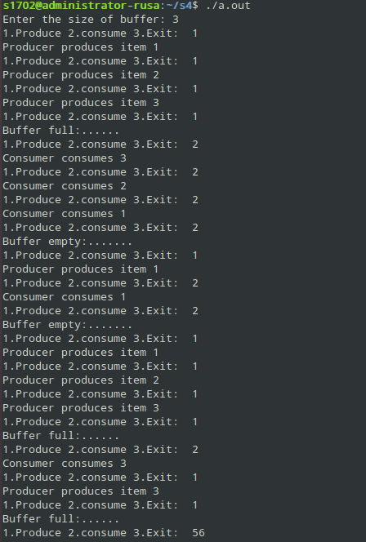
Output

