Experiment 2
Page Replacement
FIFO

#include<stdio.h>
#include<stdlib.h>
#include<string.h>
void main(){
int n,i,num,nreq,pos=0,pagefault=0,j;
printf("Enter the number of page frames: ");
scanf("%d",&n);
printf("Enter the total number of pages: ");
scanf("%d",&num);
int *page=(int *)malloc(n*sizeof(int));
int *present=(int *)malloc(num*sizeof(int)); //to make searching faster
memset(present, 0, num*sizeof(int));
printf("Enter the number of request: ");
scanf("%d",&nreq);
int *req =(int *)malloc(nreq*sizeof(int));
printf("Enter the request: ");
for(i=0;i<nreq;++i)
scanf("%d",&req[i]);
for(i=0;i<nreq;++i){
if(present[req[i]]==1){ //if page already present
printf("%d Already present\n",req[i]);
printf("------------------------Current page :");
if(pos < n){
for(j=0;j< pos;++j)
printf("%d ",page[j]);
}
else{
for(j=0;j< n;++j)
printf("%d ",page[j]);
}
printf("\n");
continue;
}
else if(pos < n){ //if page is absent but free page frame available
printf("%d added\n",req[i]);
present[req[i]]=1;
page[pos]=req[i];
pos++;
pagefault++;
printf("------------------------Current page :");
for(j=0;j< pos;++j)
printf("%d ",page[j]);
printf("\n");
}
else{ //page absent and no free page frame
printf("%d removed and %d added\n",page[0],req[i]);
present[page[0]]=0;
for(j=0;j<n-1;++j){
page[j]=page[j+1];
}
page[n-1]=req[i];
present[req[i]]=1;
pagefault++;
printf("------------------------Current page :");
for(j=0;j< n;++j)
printf("%d ",page[j]);
printf("\n");
}
}
printf("Total number of page fault is %d\n",pagefault);
}

OUTPUT

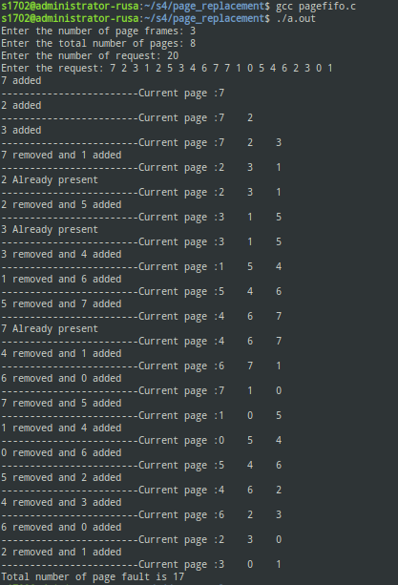

LRU

#include<stdio.h>
#include<stdlib.h>
#include<string.h>
void main(){
int n,i,num,nreq,pos=0,pagefault=0,k,j;
printf("Enter the number of page frames: ");
scanf("%d",&n);
printf("Enter the total number of pages: ");
scanf("%d",&num);
int *page=(int *)malloc(n*sizeof(int));
int *present=(int *)malloc(num*sizeof(int)); //to make searching faster
memset(present, -1, num*sizeof(int));
printf("Enter the number of request: ");
scanf("%d",&nreq);
int *req =(int *)malloc(nreq*sizeof(int));
printf("Enter the reuest: ");
for(i=0;i<nreq;++i)
scanf("%d",&req[i]);
for(i=0;i<nreq;++i){
if(present[req[i]]>=0){ //if page already present
printf("%d Already present\n",req[i]);
for(j=present[req[i]];j<pos-1;++j){
page[j]=page[j+1];
present[page[j]]--;
}
page[pos-1]=req[i];
present[req[i]]=pos-1;
printf("-------------------------current page ");
for(k=0;k<pos;++k){
printf("%d ",page[k]);
}
printf("\n");
/*
printf("------current pos ");
for(k=0;k<num;++k){
printf("%d ",present[k]);
}
printf("\n");
*/

}
else if(pos < n){ //if page is absent but free page frame available
printf("%d added\n",req[i]);
present[req[i]]=pos;
page[pos]=req[i];
pos++;
pagefault++;
printf("-------------------------current page ");
for(k=0;k < pos;++k){
printf("%d ",page[k]);
}
printf("\n");
/*
printf("------current pos ");
for(k=0;k<num;++k){
printf("%d ",present[k]);
}
printf("\n");
*/
}
else{ //page absent and no free page frame
printf("%d removed and %d added\n",page[0],req[i]);
present[page[0]]--;
for(j=0;j<n-1;++j){
page[j]=page[j+1];
present[page[j]]--;
}
page[n-1]=req[i];
present[req[i]]=n-1;
pagefault++;
printf("-------------------------current page :");
for(k=0;k<n;++k){
printf("%d ",page[k]);
}
printf("\n");
/*
printf("------current pos ");
for(k=0;k<num;++k){
printf("%d ",present[k]);
}
printf("\n");
*/
}
}
printf("Total number of page fault is %d\n",pagefault);
}

OUTPUT
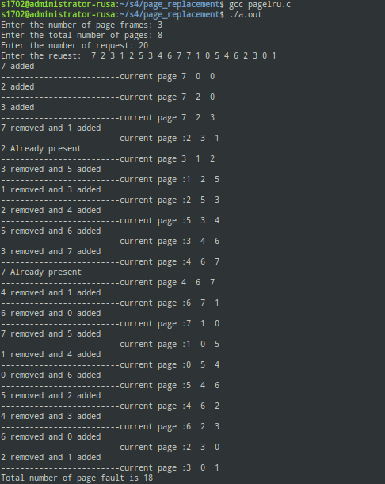

LFU

#include<stdio.h>
#include<stdlib.h>
#include<string.h>
void main(){
int n,i,num,nreq,pos=0,pagefault=0,k,j;
printf("Enter the number of page frames: ");
scanf("%d",&n);
printf("Enter the total number of pages: ");
scanf("%d",&num);
int *page=(int *)malloc(n*sizeof(int));
int *present=(int *)malloc(num*sizeof(int)); //to make searching faster
int *count=(int *)malloc(num*sizeof(int));
memset(present,-1, num*sizeof(int));
memset(count,0, num*sizeof(int));
printf("Enter the number of request: ");
scanf("%d",&nreq);
int *req =(int *)malloc(nreq*sizeof(int));
printf("Enter the reuest: ");
for(i=0;i<nreq;++i)
scanf("%d",&req[i]);
for(i=0;i<nreq;++i){
if(present[req[i]]>=0){ //if page already present
printf("%d Already present\n",req[i]);
count[req[i]]++;
for(j=present[req[i]];j<pos-1;++j){
if(count[req[i]]<count[page[j+1]])
break;
page[j]=page[j+1];
present[page[j]]--;
}
page[j]=req[i];
present[req[i]]=j;
printf("-------------------------current page :");
for(k=0;k < pos;++k){
printf("%d ",page[k]);
}
printf("\n");
/*
printf("------current pos ");
for(k=0;k<num;++k){
printf("%d ",present[k]);
}
printf("\n");
*/

}
else if(pos < n){ //if page is absent but free page frame available
printf("%d added\n",req[i]);
present[req[i]]=pos;
page[pos]=req[i];
pos++;
pagefault++;
count[req[i]]++;
printf("-------------------------current page :");
for(k=0; k< pos;++k){
printf("%d ",page[k]);
}
printf("\n");
/*
printf("------current pos ");
for(k=0;k<num;++k){
printf("%d ",present[k]);
}
printf("\n");
*/
}
else{ //page absent and no free page frame
printf("%d removed and %d added\n",page[0],req[i]);
present[page[0]]--;
count[req[i]]++;
for(j=0;j<n-1;++j){
if(count[req[i]]<count[page[j+1]])
break;
page[j]=page[j+1];
present[page[j]]--;
}
page[j]=req[i];
present[req[i]]=j;
pagefault++;
printf("-------------------------current page :");
for(k=0;k<n;++k){
printf("%d ",page[k]);
}
printf("\n");
/*
printf("------current pos ");
for(k=0;k<num;++k){
printf("%d ",present[k]);
}
printf("\n");
*/
}
}

OUTPUT

