HTML & CSS TABLE OF CONTENT

- Introduction.
- Basic Understanding.
- Commonly Used Tags.
- Elements, Attributes, Headings, Formatting, Quotations, Comments & Paragraphs.
- CSS.
- Link.
- Images.
- Lists.
- Tables.
- Blocks.
- Classes & ID.
- Iframe.
- HTML Forms, Form elements, input types (text, number, radio, checkbox, dropdown,range,textarea,date,time,week,reset,url,email,month,password,file,tel).

HTML Layout:
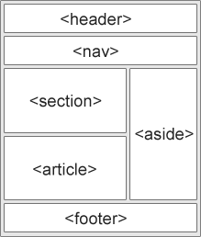
NOTE: target can also be a attribute of Form, and size attribute in dropdown tell how many option can be visible.

