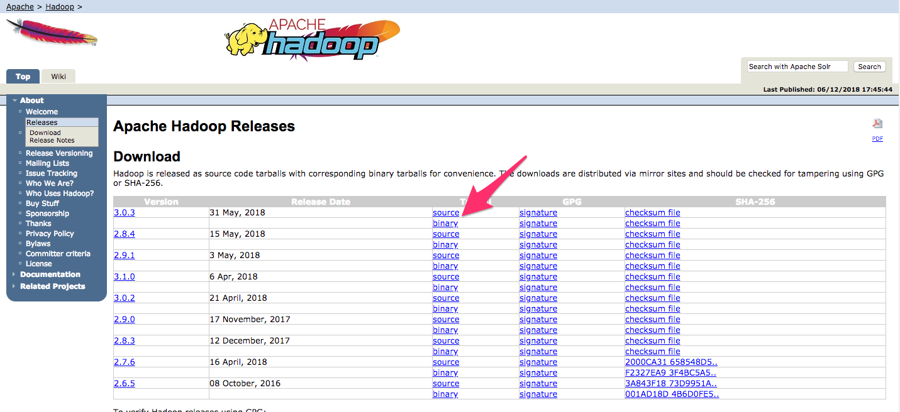



$ wget <http://www-us.apache.org/dist/hadoop/common/hadoop-3.0.3/hadoop-3.0.3.tar.gz>

Then run the verification:

$ shasum -a 256 hadoop-3.0.3.tar.gz

Output

db96e2c0d0d5352d8984892dfac4e27c0e682d98a497b7e04ee97c3e2019277a hadoop-3.0.3.tar.gz

Compare this value with the SHA-256 value in the .mds file:

$ cat hadoop-3.0.3.tar.gz.mds

~/hadoop-3.0.3.tar.gz.mds

...

/build/source/target/artifacts/hadoop-3.0.3.tar.gz:

SHA256 = DB96E2C0 D0D5352D 8984892D FAC4E27C 0E682D98 A497B7E0 4EE97C3E 2019277A

To begin, open hadoop-env.sh:

$ sudo nano /usr/local/hadoop/etc/hadoop/hadoop-env.sh

Then, choose one of the following options:

### Option 1: Set a Static Value

/usr/local/hadoop/etc/hadoop/hadoop-env.sh

. . .

#export JAVA_HOME=${JAVA_HOME}

export JAVA_HOME=/usr/lib/jvm/java-11-openjdk-amd64/

. . .

Option 2: Use Readlink to Set the Value Dynamically

/usr/local/hadoop/etc/hadoop/hadoop-env.sh

. . .

#export JAVA_HOME=${JAVA_HOME}

export JAVA_HOME=$(readlink -f /usr/bin/java | sed "s:bin/java::")

Now we should be able to run Hadoop:

$ /usr/local/hadoop/bin/hadoop

Output

Usage: hadoop [OPTIONS] SUBCOMMAND [SUBCOMMAND OPTIONS]

or hadoop [OPTIONS] CLASSNAME [CLASSNAME OPTIONS]

where CLASSNAME is a user-provided Java class

OPTIONS is none or any of:

--config dir Hadoop config directory

--debug turn on shell script debug mode

--help usage information

buildpaths attempt to add class files from build tree

hostnames list[,of,host,names] hosts to use in slave mode

hosts filename list of hosts to use in slave mode

loglevel level set the log4j level for this command

workers turn on worker mode