To use HDFS commands, start the Hadoop services using the following command:

sbin/start-all.sh

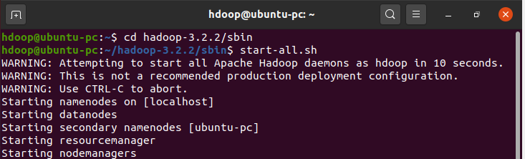

To check if Hadoop is up and running:

Jps

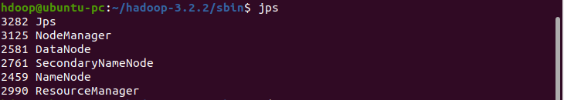

mkdir:

To create a directory, similar to Unix ls command.



cp:

Copy files from one directory to another within HDFS, similar to Unix cp command.



rm:

Remove a file from HDFS, similar to Unix rm command. This command does not delete directories. For

recursive delete, use command -rm -r.



**Put:**

Transfer and store a data file from local systems to the Hadoop file system using the put command.



**Get:**

Gets the file from HDFS to the local file system using **get** command.



You can shut down the HDFS by using the following command.

