1. At the most we need to start the cluster using the start-all.sh script further check all daemons are running using the jsp command

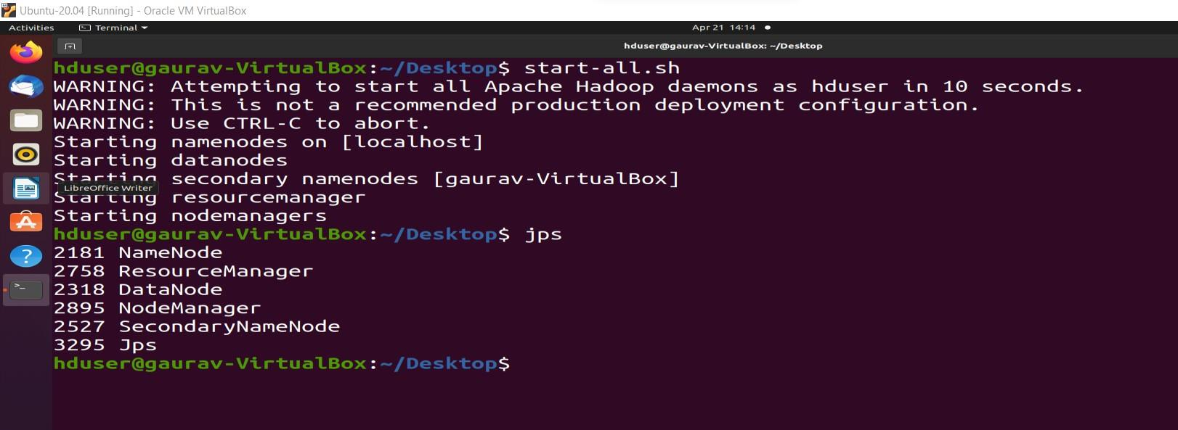

2. Once we have the cluster running we also need to download the tar.gz file which we will be using to install the hive in our system. To install the hive we will be just extracting the data in the file tar -xzfs <tar file name>

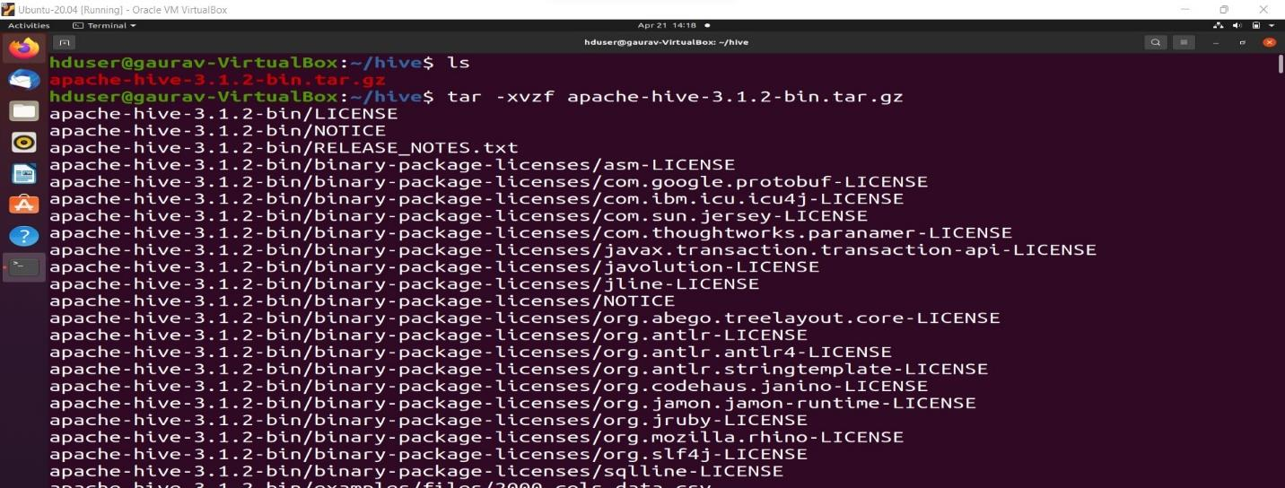

3. Now folder will be visible for Apache-hive in which we have the bin where the executable for the hive is present which will be using to get the hive shell

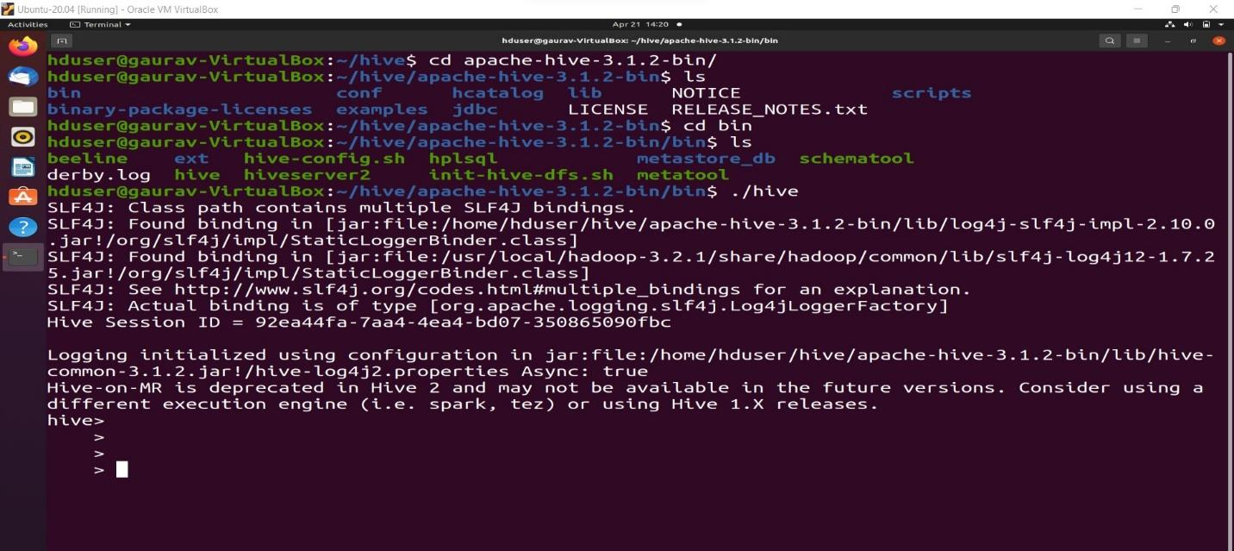

4. Once we get the hive shell ready we will be using the HQL command first we will be creating our database using the use command which will switch us to the new database and if not existed it will create and then switch.

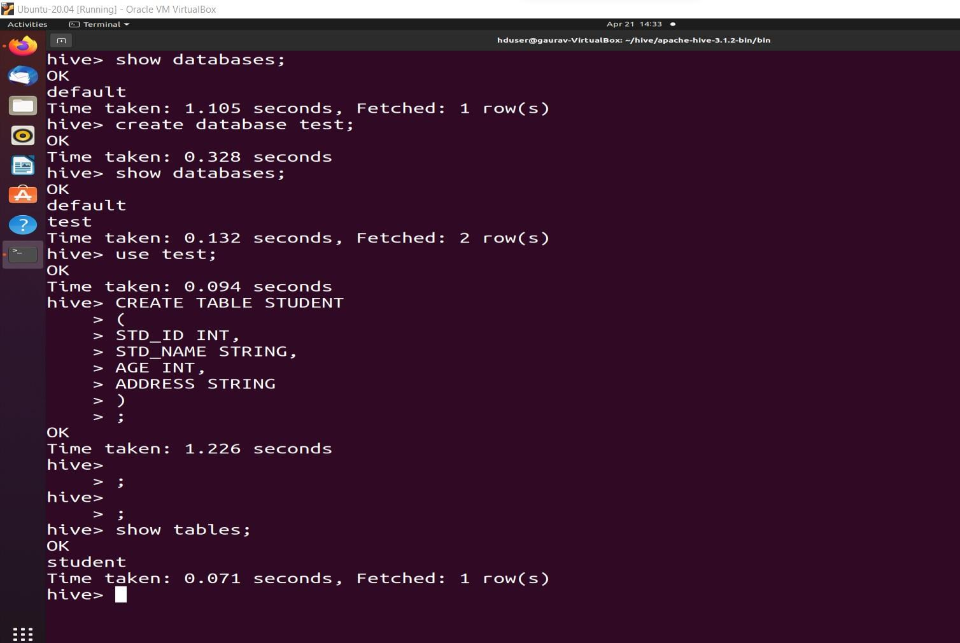

5. We can ask to show the tables using the $show tables command further we can also create the

table using the $create table <table_name> (<column_name> <type of value>, …) query.

6. We can now insert necessary values in the table using the insert values command.

