Motion Detection System Task 2

Selected Working Environment
Environment: Tinkercad (Arduino UNO Simulation)

Sensor Used
Sensor: PIR (Passive Infrared) Motion Sensor
Purpose: Home Security / Motion Detection System

How the PIR Sensor Works
The PIR sensor detects motion by sensing changes in infrared radiation (heat) emitted by humans or animals. When motion is detected, the sensor outputs HIGH (1). When no motion is detected, it outputs LOW (0).

Program Explanation
• The Arduino reads input from the PIR sensor connected to digital pin 2.
• The sensor value is displayed in the Serial Monitor.
• If motion is detected (HIGH), the LED connected to pin 13 turns ON and an alert message is shown.
• If no motion is detected (LOW), the LED turns OFF.

Arduino Program
// Motion Detection System using PIR Sensor
int pirPin = 2;
int ledPin = 13;
int motionValue;
void setup() {
pinMode(pirPin, INPUT);
pinMode(ledPin, OUTPUT);
Serial.begin(9600);
Serial.println("=== Motion Detection System Started ===");
delay(3000);
}
void loop() {
motionValue = digitalRead(pirPin);
Serial.print("Sensor Value: ");
Serial.println(motionValue);
if (motionValue == HIGH) {
digitalWrite(ledPin, HIGH);
Serial.println("ALERT: Motion Detected!");
} else {
digitalWrite(ledPin, LOW);
Serial.println("No Motion Detected");
}
delay(1000);
}
Circuit Diagram
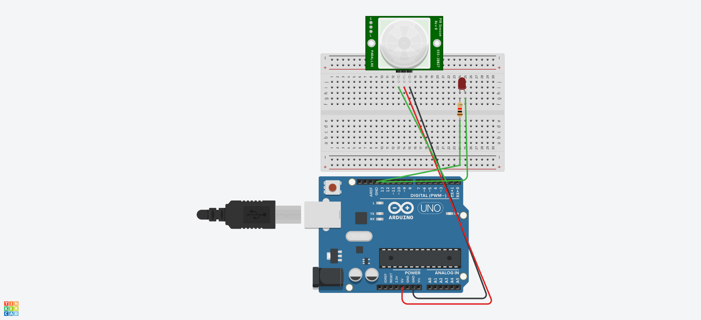

Conclusion
This project demonstrates sensor interfacing with Arduino. The system reads input from a motion sensor, displays output on the Serial Monitor, and controls an LED based on the detected motion. Such systems are widely used in security and automation applications.

