Angular
What is Angular?
It’s JavaScript framework for building single page web application

Building blocks of angular application
- Modules
- Components
- Templates
- Metadata
- Data Binding
- Directives
- Service
- Dependency Injection

What is Angular CLI?
It’s command line interface to develop and maintain project from command prompt. For example generating component/service etc

How to create Angular project?
By using command: ng new project_name

What is Modules?
Defination: In module we can group components, directives, pipes & services
Example: In case you’re developing website, the header, footer, left section, right section become part of module
Practical: To create module ng generate module_name
It’s decorated with @NgModule & it has different parts like:
declarations: the components associated with this module are added here
imports: If we create any module that module is added here
providers: services, class, pipes are added here

Why we need Module?
If we don’t create module if we decare all component inside one module apk get too heavy so instead of that we can create modules
For example: if we have shopping cart apk we can declare all component related cart inside one module homepage all components inside one module etc

What is Decorators?
Decorators are simply function that return function
For example @Component executes component function
The name of decorator start with @ following by brackets and args since it’s function
Decorators are invoke at runtime
@NgModule() to define module
@Component() to define component
@Injectable () to define service
@input&@output()to define properties that send & received data from dom
@HostListner() this take event name as arg when that event get fired on the host element it calls associated function
For example:
@HostListner(‘click’,[‘$event’]) //click is event here
Display(){
Alert(“Hi..”); //anywhere click in browser it’ll show Hi..
}

What is Selector?
selector is used to load the component
for e.g if im having component app-student I can load this component using <app-student></app-student>

What is Template and templateUrl?
1)Template means we can give inline html to component in ts file itself
2)TemplateUrl means we give path of html file where html is define
Below is the e.g
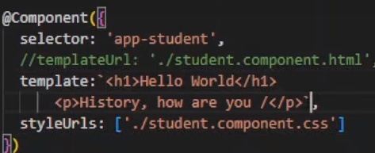

Note- if we define both TemplateUrl will have first priority

What is styles and styleUrls?
1)styles means we can give inline css to component in ts file itself
2)styleUrls means we give path of css file where css is define

Below is the e.g
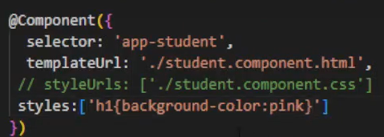
We can give path of multiple css file in styleUrls

What is style.css file?
style.css is the global css file where we can define global css which will be apply for all the components
note- if global css is define but if we define inline css then inline css will be apply

What is preserveWhitespaces?
If we write code like this:
Then It shows output like this:
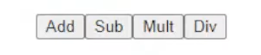
So to give space in between this buttons we use preserveWhitespace in ts file.
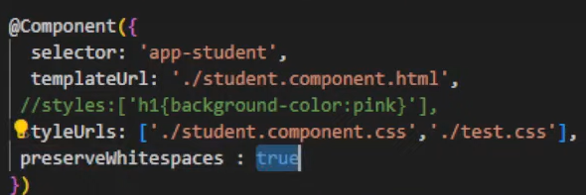

What is viewProvider?
It’s metadata like selector,templateUrl by which we define class in component to use class at component level
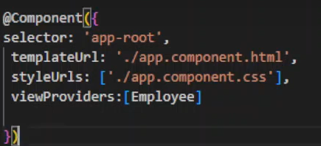
Note- whichever class we want to use at component level that class name should be mention in viewProividers and object should be created of that class.
What is Encapsulation in Angular?
Parent: in which we keep selector of other (child) component
Child: the (child) component of which we take selector and put in other (parent) component.
In below example app component is parent and student component is child
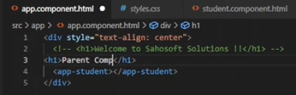
Question Is why encapsulation is there in Angular?
By default parent css is not applicable to child so to make it applicable encapsulation is used like below
For this we need to add encapsulation:ViewEncapsulation.ShadowDom in ts file like below
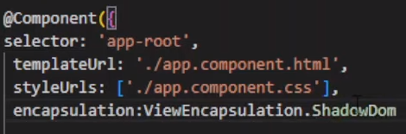
Note- child css will not be applicable on parent

What is Parent to child communication with property?
Input property is used within one component (child component) to received value from another component (parent component).
This is one way communication from parent to child.

Example/flow is given below:
1)in parent component we’re taking one input field of type text which will take input and store in Pcomponent
So to pass this parent component data which is store In Pcomponent we are putting property binding inside child component selector and storing the value in Pdata
(#Pcomponent is template reference variable to store data)
(keyup Is event which trigger when we release key after pressing)
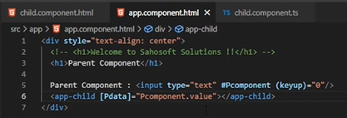
2)next we need to add input in child component ts to receive data from parent like below
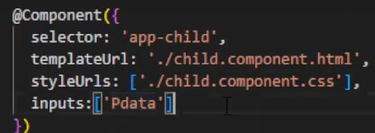
3)now in child component html we can display this value like below
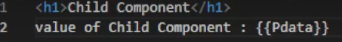

What is Child to Parent communication with property?
Output property is used within one component (child component) to send value to another component (parent component).
This is one way communication from child to parent.

Example/flow is given below:
1)in child component we’re taking one input field of type text which will take input and store in Ccomponent
Keyup event will call onchange method and pass the entered value as parameter
2) after getting value we created one custom event called childevent using EventEmitter and that value is emit inside childevent and after that that childevent value is send to parent using output as given below
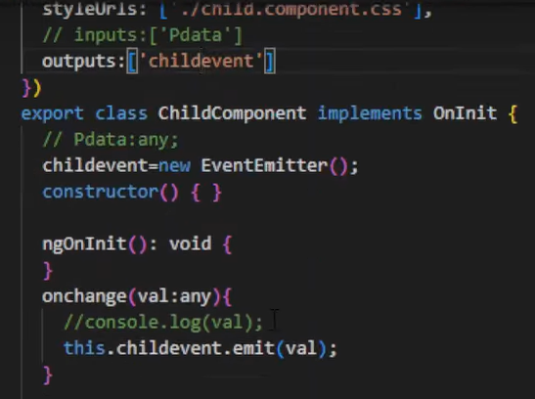
3)then in parent, we define $event in order to extract that childevent value
in getdata method like below
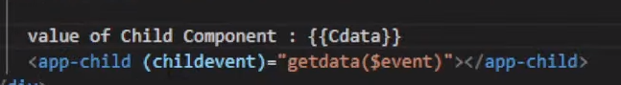
To get value we define that getdata method in parent ts like below
And print as {{Cdata}} in html as above
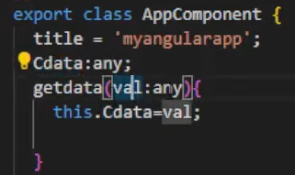

What is Directive in Angular?
we can run any loop like ngIf, ngFor, ngSwitch directly on html using directives
There are 3 Types of Directive:
1)Component Directive
2)Structural Directive (*ngIf, *ngFor, *ngSwitch)
3)Attribute Directive

ngIf directive can add or remove host element in DOM layout at runtime.
It conditionally shows the inline template
Practical example is given below:

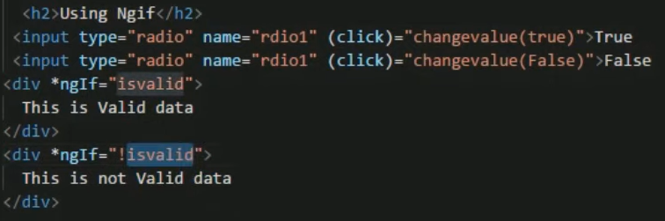

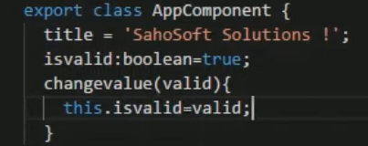

Output:
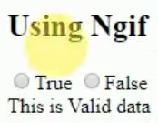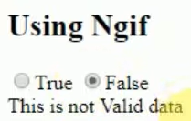
Similarly, we can use then and else directive also like below
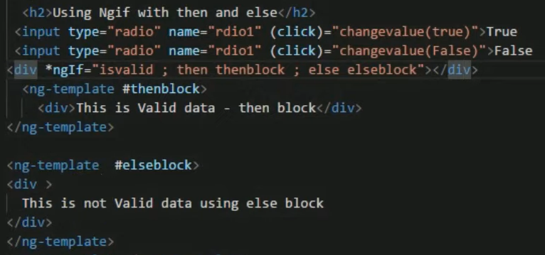

ngSwitch directive:
ngSwitch don’t have ‘*’ but ngSwitchCase & ngSwitchDefault have ‘*’
below is example:
ts file
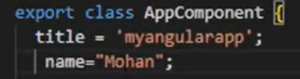
Html file
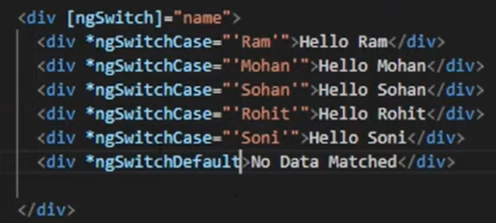

ngFor Directive:
ngFor is use for looping over a collection of items & rendering them dynamically
The Syntax is *ngFor = “let <value> of <collection>”
Below is example
ts file
here we have declare Students array of type any and store some records in it
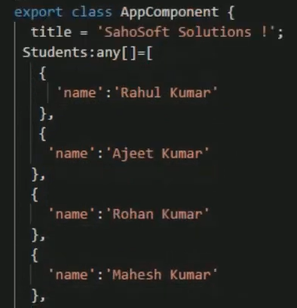
Html file
Here student is the variable where one by one value of array will be store
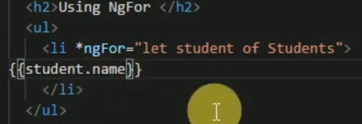
Output
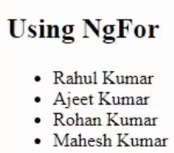

We can also see index of array using syntax:
let i = index (it will take i as 0, 1, 2…)

TrackBy with ngFor directive
trackBy function is used to improve the performance and enhance the rendering behaviour of the loop items.
How to use the track by?
1) Define trackBy function In ts that takes two args: the index and the item in the collection.
The function should return unique identifier for the item.
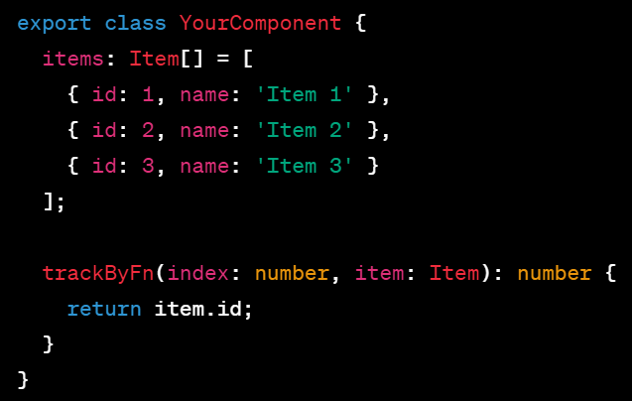

2) Use trackBy function in ngFor directive
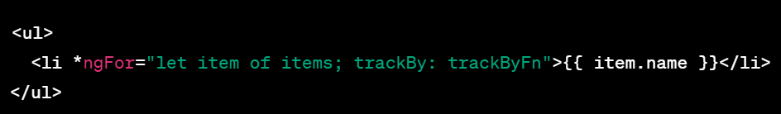

Grouping with ngFor directive
It’s used to group items based on certain criteria.
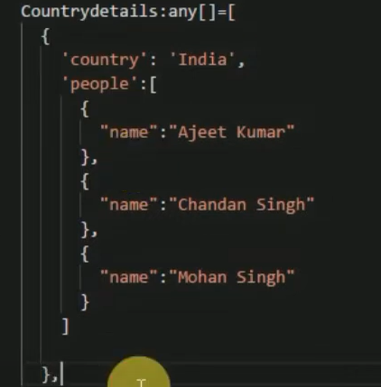
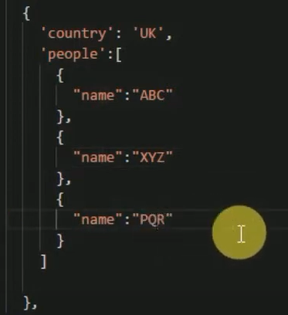
Output
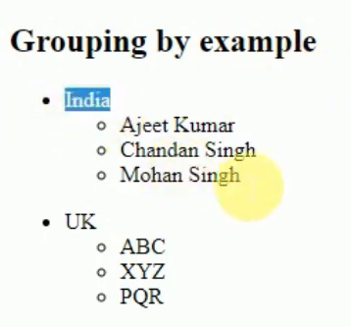
ngStyle directive
ngStyle directive allows you to dynamically apply inline styles to html elements based on the values or properties in component
below is example:
ts file
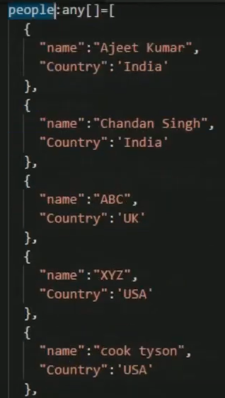
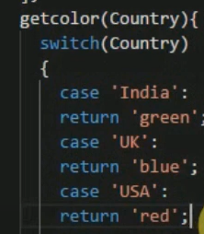
Html file
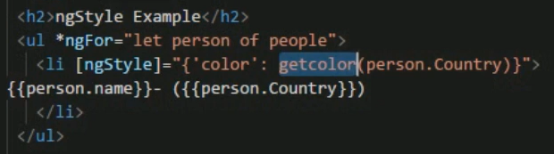

Output
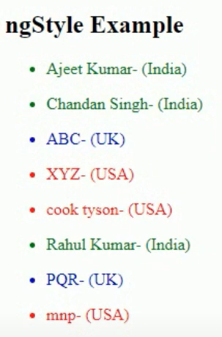

ngClass directive
ngClass directive allows us to dynamically apply css classes to html elements based on values or properties in component

how to use?
Define style classes in css or In ts using styles
Then write some logic in ts and use it in html as given below

ts file
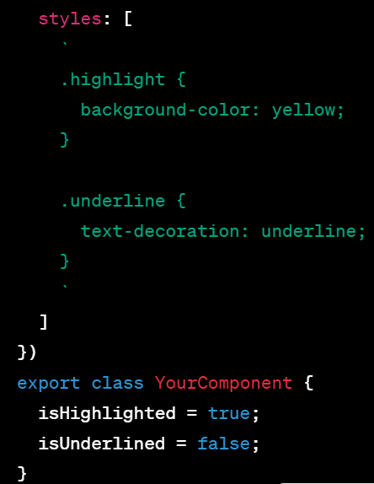

Html file
What is Data binding in Angular?
Data binding means to bind the html with component.
Types of data binding?
-Interpolation
-Property binding
-Event binding
-Two-way binding

What is Interpolation binding?
It’s one way data binding
Whatever value we store In component we can show in html using {{ }}
Below is example
Component file
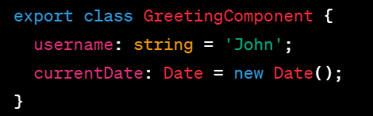
html file
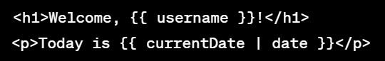

What is Property binding?
It’s one way data binding
Whatever value we store In component we can show in html
Syntax: [property]=’expression’
Here, property can be span property, style property or button property and expression is component property

Below is example,
Component file
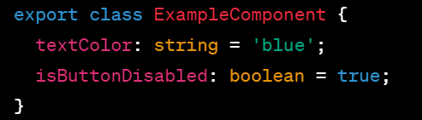
HTML file
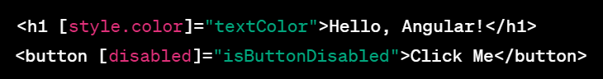
here, style.color Is h1 proprty & disabled is button property

What is Event binding?
It’s one way binding
When user interact with apk in the form of keyboard, a mouse click, or a mouseover, it generates an event. These event needs to be handle to perform some kind of action. This is where event binding comes into picture
Syntax: <button (click) = “onClick()”> Click me</button>
Here,
onClick() is method which declare in component which will call when click event occurs.

Below is example,
Component file
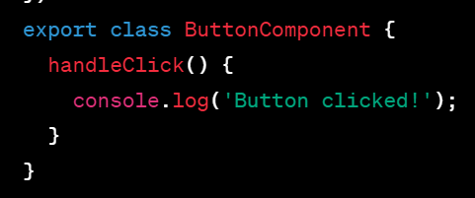

HTML file

What is two-way binding?
It’s combination of event binding and property binding
If we change value in html it’ll update in component and vice versa
We need to use [(ngModel)] directive & need to import FormsModule to use two-way binding.
Syntax: <input [(ngModel)=’data’]
Below is example,
Component file
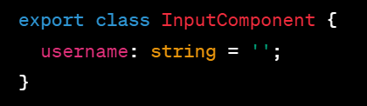
HTML file
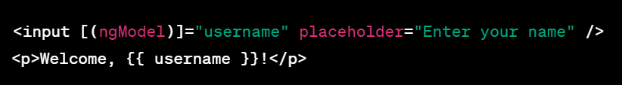
Here, whatever data we enter in input field will store in username variable

What are Pipes in angular?
Angular pipes can be used to transform data to desired output
Pipes take input and transform data to different output
It’s denoted as ‘|’
For example, pipe can take “Learn Angular” as input and transform to “LEARN ANGULAR” in capital or you can give input as “100” which you want to display (transform) as “100.00$” on UI.

Syntax: {{‘Test’ | uppercase}}
Here, Test is input data & uppercase is filter
Syntaxes are written inside HTML

Below is example,
Component file
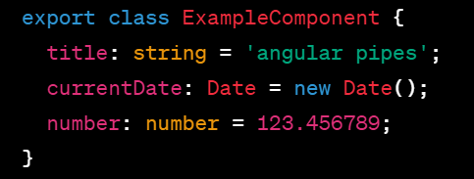
HTML file
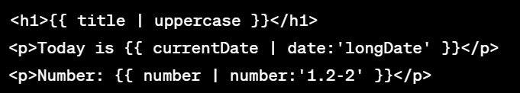
Output
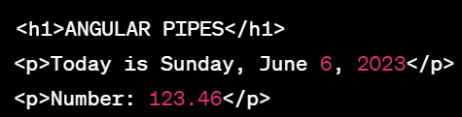

we can pass any number of parameter to pipe using ‘:’
like,
Data | pipename : parameter1 : parameter2 : …n
Above is example <p> of html
We can use multiple pipes for same data
For example,
Data | pipe1 | pipe2 | pipe3 | …….pipe n

Below is example,
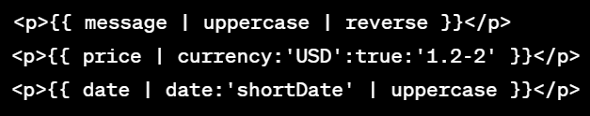

String pipes
Uppercase Converts the string type data to uppercase in UI
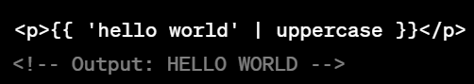
Lowercase Converts the string type data to lowercase in UI

Titlecase Converts the string type data in which first alphabet will capital
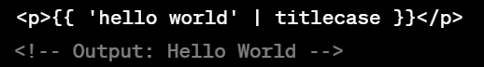

Slice <starting index>: it slices input from index till end of string

Slice: <starting index>:<end index> it slices input from start index to end index
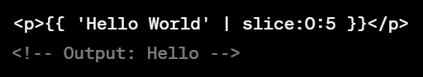

Date pipes
Date current date
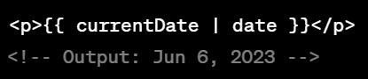
shortDate it converts date to short date
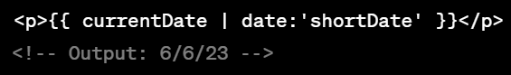
longDate it provide full month name, day and year
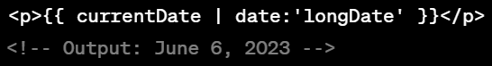

Percent pipes
Percent the pipe multiplies number by 100 and append % symbol
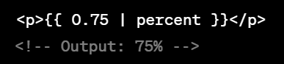

Percent with custom format the pipe multiplies number by 100 and append % symbol, also displays output with custom format
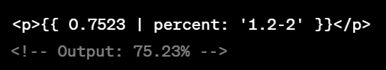

Here,
1 minimum number of digit before decimal
2 minimum number of digit after decimal
2 maximum number of digit after decimal
- separates the minimum and maximum number of decimal places

Decimal pipes
In decimal we need to add number instead of percentage else everything same
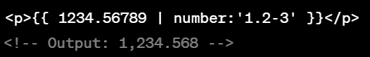

Currency pipes
It’s used to format a number as a currency value
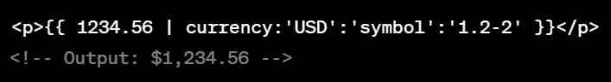
Here,
USD is currency code
Symbol means currency symbol here its USD so it’ll be dollar sign ‘$’
Instead of symbol we can use code as well so it will display code instead of symbol, like below
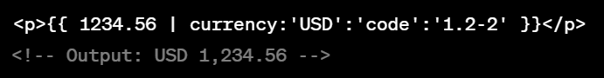

Json pipe
Json pipe converts a value Into JSON string
Syntax: expression | json
Example: {{countries | json}}

Component file
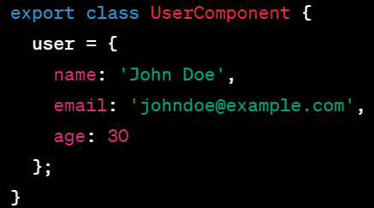

HTML file

Output
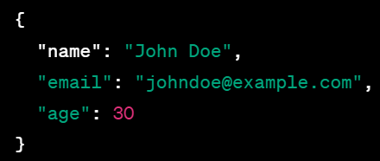

Custom pipe
We can create custom pipe to implement our own data transformation and formatting logic.
To create pipe you need to define class which implements PipeTransform interface and provides a transform method.
The transform method performs desired data transformation and return transformed result

Component file
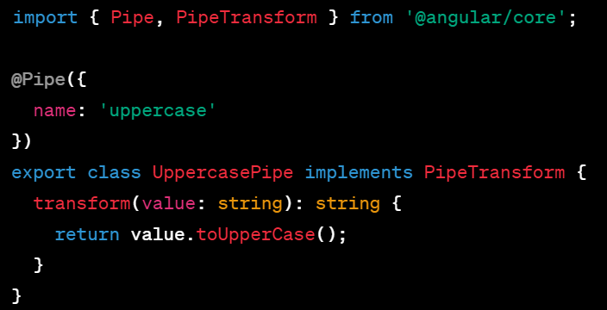

HTML file
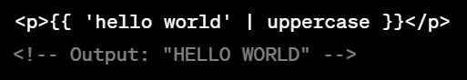

What is Routing in angular?
Router Is mechanism by which we navigate from one page to another in a single page application.

Steps to implement routing:
1)install necessary dependencies using: npm install @angular/router then import RouterModule and Routes from @angular/router in app module.

2)Define routes: in your routing module define array of route using Routes type.
Each route configuration consist of path and component optionally data or children (nested routes)
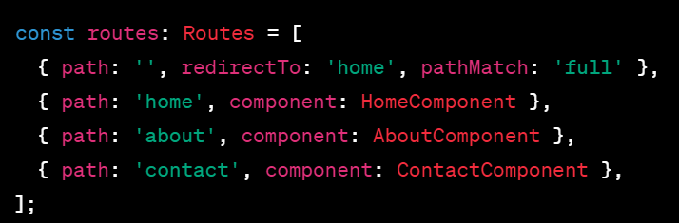
3)configure the router: add the RouterModule.forRoot() method to the imports array of app module
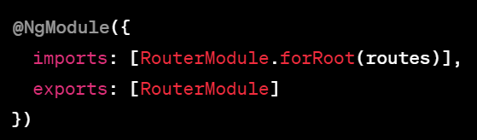
4)setup <router-outlet></router-outlet> in html

routerLink
used to create links and navigate between different routes in your angular application it’s commonly used in anchor tags <a>

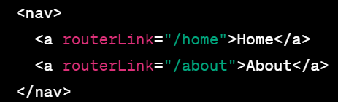
Here, By clicking Home it’ll redirect to home

redirectTo
if you want redirect a route to another route you can achieve using redirectTo
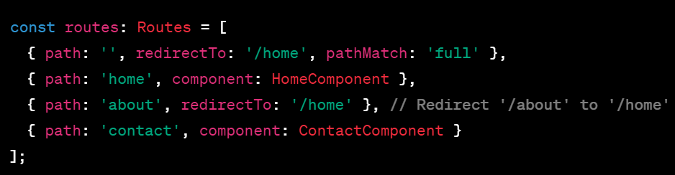
Here,
about route redirecting to home route which calling HomeComponent

Wildcard Route
It’s used to handle unknown or invalid routes and provide default component
It should be added at last.
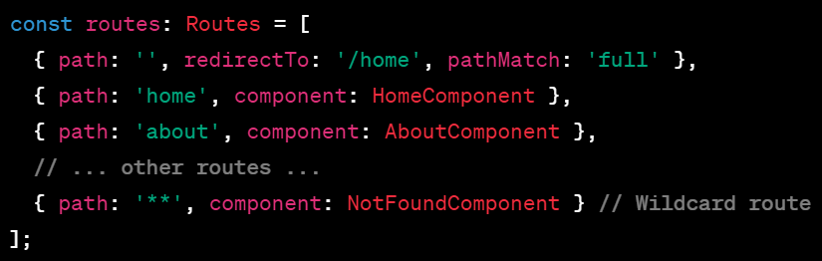

Bootstrap in angular
Steps to use bootstrap:
- Install bootstrap
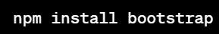
- In angular.json go to styles array and add path to bootstrap css file
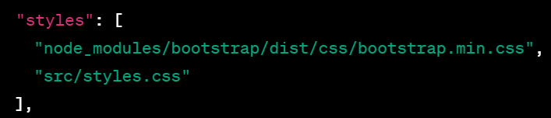
- In your angular components, you can now Start using bootstrap css class
Below is example,
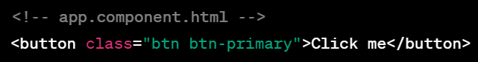

What is Service in angular?
Services allow us to share common functionality across the application
Create single reusable service and inject it into the component that need it
Services usually contain backend data

Steps to use service:
- Create service using

- Import the injectable member in service file:

- Add the injectable decorator: @Injectable
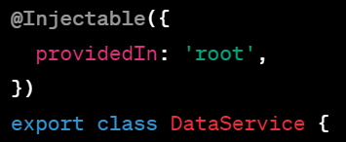

- Export the service class

- Import the Service to your component:

- Add service inside component provider
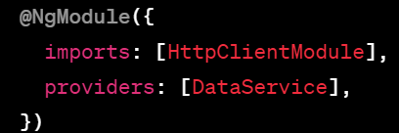

- Inject it:
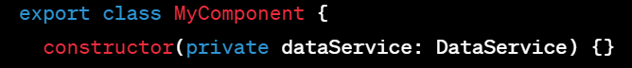

- Now we can access the service methods and properties by using dataService object
For example,
ngOnInit(){
this.title = this.dataService.someMethod();
}

Note: when you create service through command line step 2,3,4,6 will be auto perform

(part 54 )

