Digital Signals Analysis and ApplicationS
Assignment-1

Name: Abhishek Nalla
Roll No: 20161115

Q1)

A)
The aim of this problem is to resize a given image according to the given scale factor which is a positive integer. This is done using Interpolation. Nearest Neighbor Interpolation and Bilinear Interpolation are used to solve this problem.
Solution
A) Nearest Neighbor Interpolation
In this method, we assign the value of the nearest pixel to the pixel in the output visualization. This is the fastest interpolation method but the resulting image may contain jagged edges.
B) Bilinear Interpolation
In this method, we take the weighted mean of the nearest four pixels and use it to calculate the value of output pixel.
As the above image shows, for each pixel value J(r', c') the weighted mean corresponding to I(r, c), I(r, c+1) , I(r+1, c) and I(r+1, c+1) are calculated. The weighted mean is calculated first by taking the values corresponding to I(r, c), I(r+1, c) ; I(r, c+1), I(r+1, c+1) and calculating the weighted mean by using the vertical distances from required pixel. Let those values be x and y. Now the weighted mean of x and y is calculated by using the horizontal distances of x and y from required pixel and filled into it.

The 2 different resampling methods vary on how the cell values of an output raster are determined after a geometric operation is done.
Nearest Neighbor Interpolation:
It is best used for categorical data. The values that go into the grid stay exactly the same. The value of the output cell is determined by the nearest cell center on the input grid . It preserves original values in the unaltered scene.
Disadvantages:
Nearest Neighbor when used on continuous data, produces blocky results. Noticeable position errors, especially along linear features where the realignment of pixels is obvious.
Bilinear Interpolation:
It should be used for continuous data like elevation. Unlike Nearest-neighbor, it only uses the values of nearest four pixels.
Disadvantages:
The output value could be different than the nearest input, but is always within the same range of values as the input. Since the values can change, bilinear is not recommended for categorical data. It takes more time and is more complex than nearest neighbor.
Bicubic Interpolation can be used for interpolation as it uses more values for computation of the output pixel. MATLAB uses this approach, along with other image optimization methods, when image is resized using imresize() method. Hence, it can be used.

RESIZED: X2 by Nearest Neighbour Interpolation
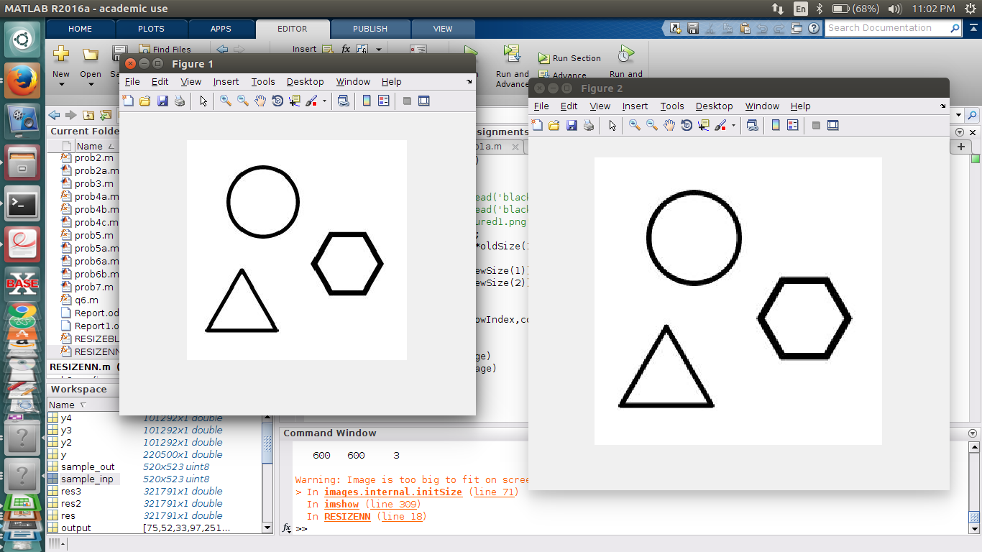
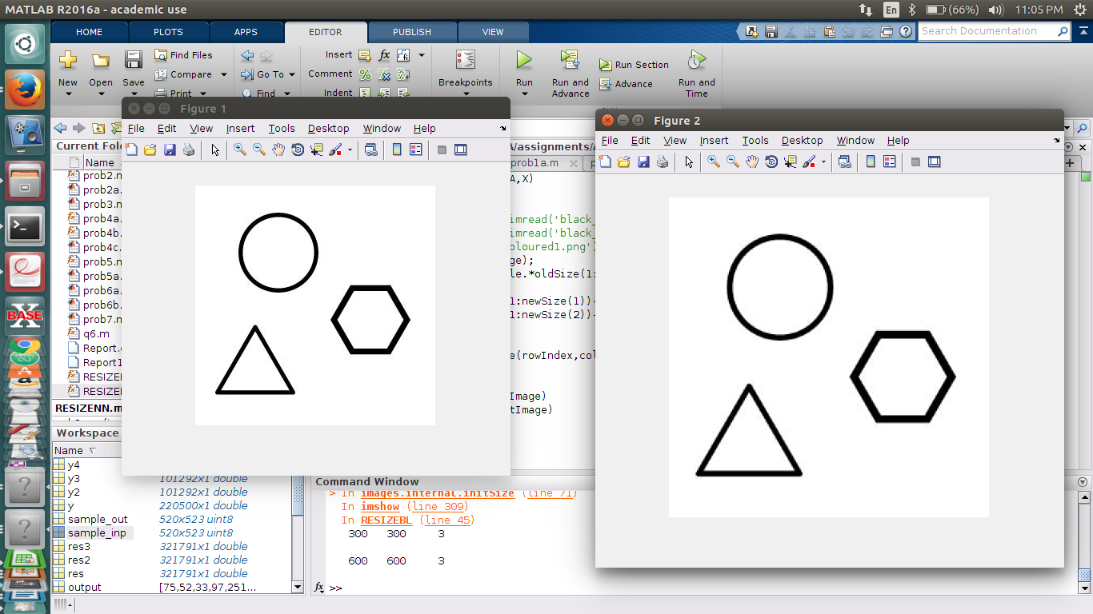
RESIZED: X2 by Bilinear Interpolation

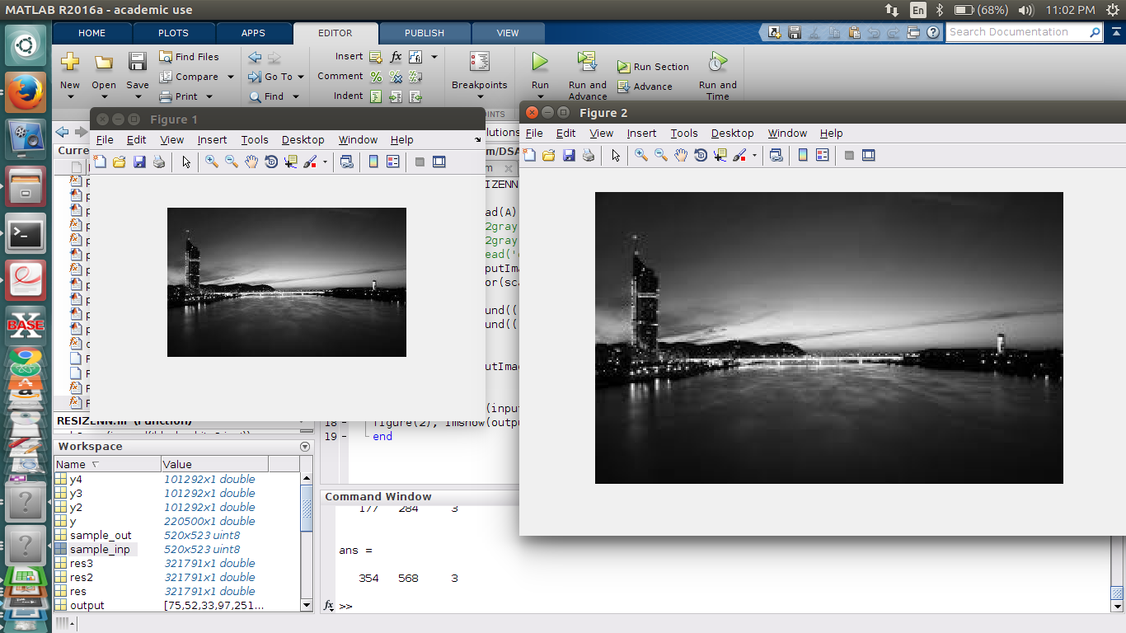

Black and White Image

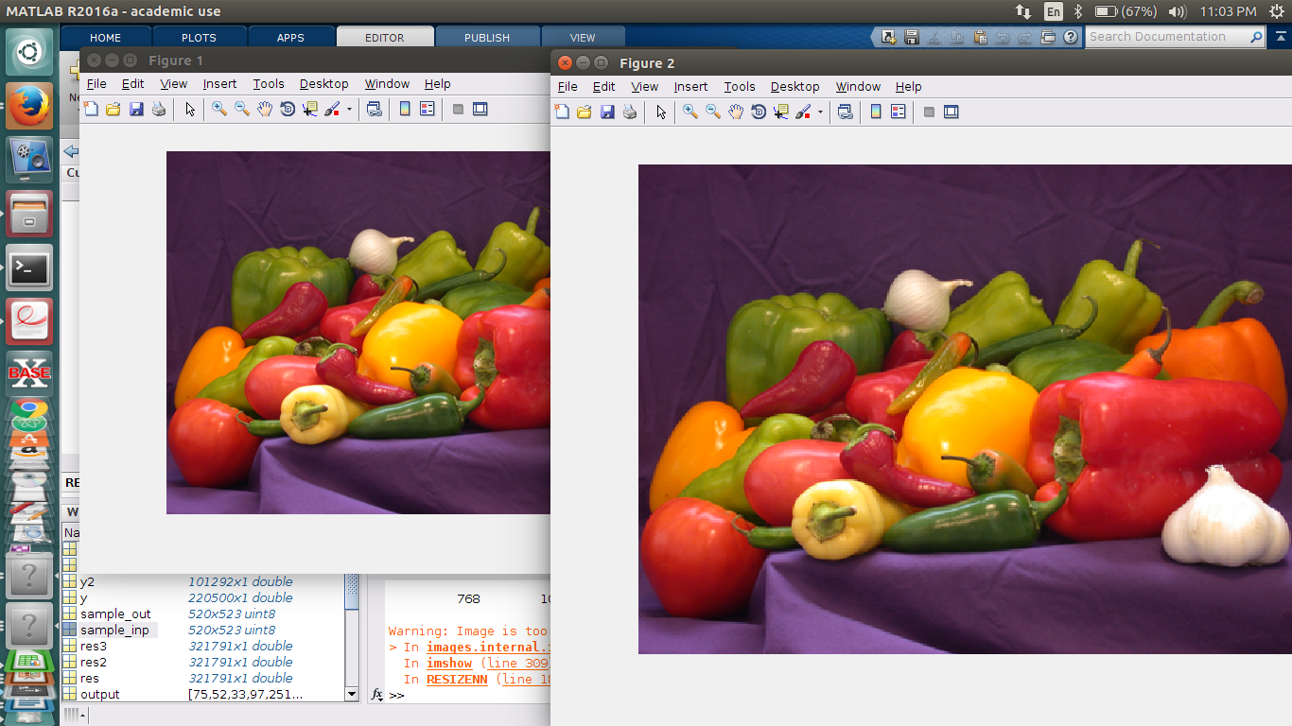

Coloured Image

Bilinear interpolation is better than nearest neighbour. In nearest neighbour we just put the values of nearest values but using bilinear interpolation is precise and values are predicted using accurate formulas.By using gaussian formula for finding points we can do better resize.

Q2)

A) M = [ -1 -2 -1; 0 0 0; 1 2 1]
“EDGE” is the place where there is a change in
the instensity of the image.

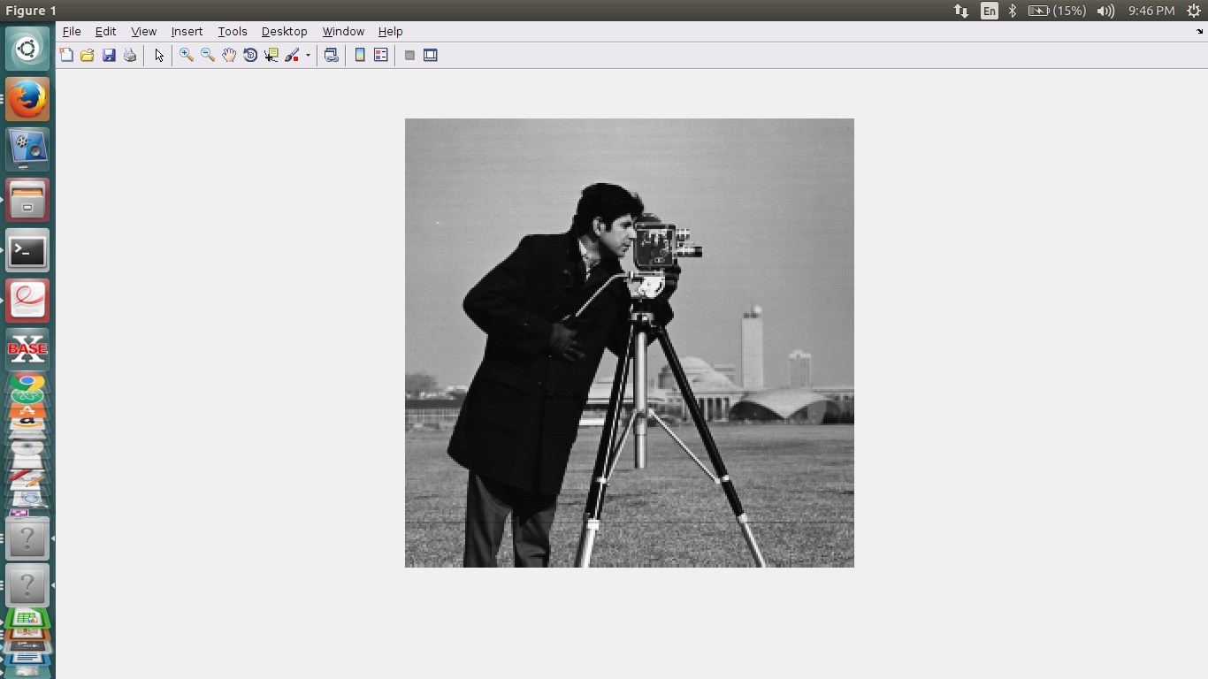
Fig: Cameraman.tif image

a) The given filter detects the HORIZONTAL edges in the image. As the sum of elements in the filter sums to zero, where there is a Uniform density,the value at that pixel becomes zero(Black). When there is non-uniform intensity,value at that pixel becomes 255(White).

After convolution with “M”, the resultant image is:

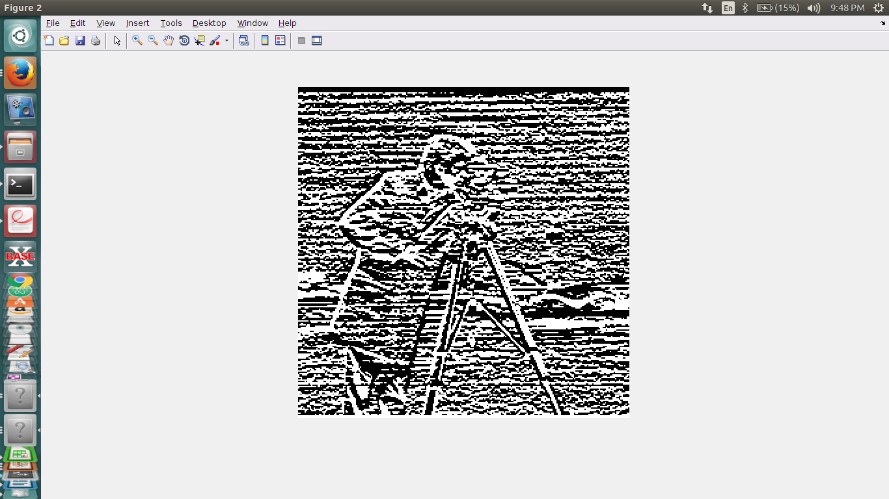
Fig: Cameraman.tif after filtering with M.

b) Next
M^{T} = [-1 0 1; -2 0 2; -1 0 -1];
This filter detects the VERTICAL edges in the image. Else it is same as the above filter.
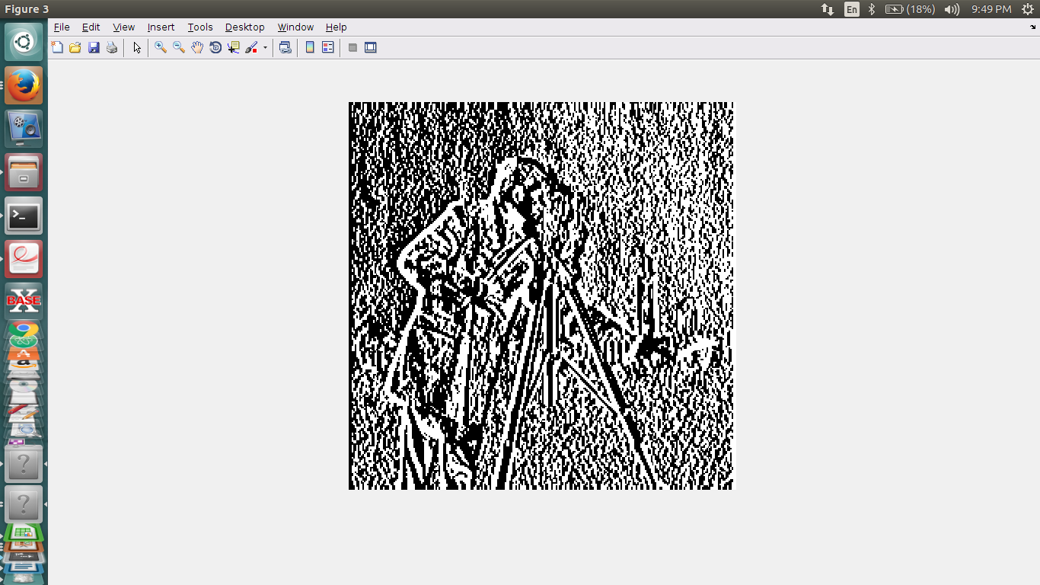
Fig:Cameraman.tif after filtering with M^{T}

The difference is thus that on taking transpose and then convoluting, we are considering perpendicular edges.

Q3)

A) Given,
Input-size = W x H x channels
Filter-size = F x F x channels
Step-size = S
Zero-Padding = Z
No.of Filters = N
a)
After Zero padding the size of the input
becomes
(W + 2*Z) x (H + 2*Z) x channels

let k1,k2 be +ve positve numbers

k1*S + F = W + 2*Z
k1 = floor((W + 2*Z-F)/S)
Similarly
k2*S + F = H + 2*Z
k2 = floor((H+2*Z-F)/S)

Therefore, after apppying one filter the dimensions become
(k1+1) x (k2+1) x channels

For width
W’ = floor((W + 2*Z)/S – F/S + 1)
W’ = floor((W + 2*Z)/S + 1 - (F/S))
let
A = 1 - (F/S)
W’ = floor((W + 2*Z)/S) + A

Now for the 2nd filter
W’’ = floor(W’/S) + A
W’’ = ((W + 2*Z)/S + A)/S + A
W’’ = (W + 2*Z)/S² + A/S + A
Similary then After the n^{th} filter applied
W^{n} = (W + 2*Z)/S^{n} + A/S^{n-1} + A/S^{n-2} + ..... + A

which is a GP sequence

W^{n} = (W + 2*Z)/S^{n} + (A/S^{n-1})*((S^{n} - 1)/(S – 1))

W^{n} = floor((W + 2*Z)/S^{n} + (A/S^{n-1})*((S^{n –} 1)/ (S - 1)))

where A = 1 – (F/S)

Similarly for the Height also

H^{n} = floor((H + 2*Z)/S^{n} + (A/S^{n-1})*((S^{n –} 1)/(S - 1)))

where A = 1 - (F/S)

The no.of channels remain same throught the process

Therefore, the final output dimensions are

W^{n} x H^{n} x channels

b)
Multiplications:

inp-size (W+2*Z)x(H+2*Z)xchannels {After padding}
“
“ ==> {W’*H’*(F*F)*channels} mulplications
“
“

After 1st Filter W’ x H’ x channels
“
“ ==> {W”*H”*(F*F)*channels} multiplications
“

After 2nd Filter W” x H” x channels
“
“
“ ==> {W^{n} *H^{n*}(F*F)*channels} multiplications
“
“

After n^{th} Filter W^{n} x H^{n} x channels

==> Total No.of multiplications are

= (W’*H’ + W”*H” + ... + W^{n}*H^{n})*(F*F)*channels

Similarly,
Total No.of Additions are

= (W’*H’ + W”*H” + ... + W^{n}*H^{n})*(F*F-1)*channels

Q4)

A)

(a) Reading a wav file and recording our own voice.
(b) Subsampling to certain frequencies.
(c) Simulating it in different environments.

The first part, which is to first sample our own audio file was implemented using the MATLAB’ s audio recorder object.
Next we used the getaudiodata with which we can get the get the signal as a matrix with dimension one.
Now for the subsampling part, let us say we need to subsample it to 8kHz. Now the input was of 44.1 KHz frequency. So we need to take 8000 data points from the array of 44100 data points which were already obtained in part ‘a’. Implementation was done by sampling out data points at equal intervals starting from index one. The interval would be Input Freq divided by the Output freq. For the third part, we just convolute the external wav files which are read by audio read function with the initial sampled matrix. Also, the frequencies were made same by resampling.

Q5)

A)
In complete sense,the filter should detect horizontal edges in the image.

For that we can use

M = [1 2 1; 0 0 0; -1 -2 -1]

It is similar to the ‘Sobel Edge detecting filter’.
If we apply this to “sample_inp.png”:



sample_inp.png

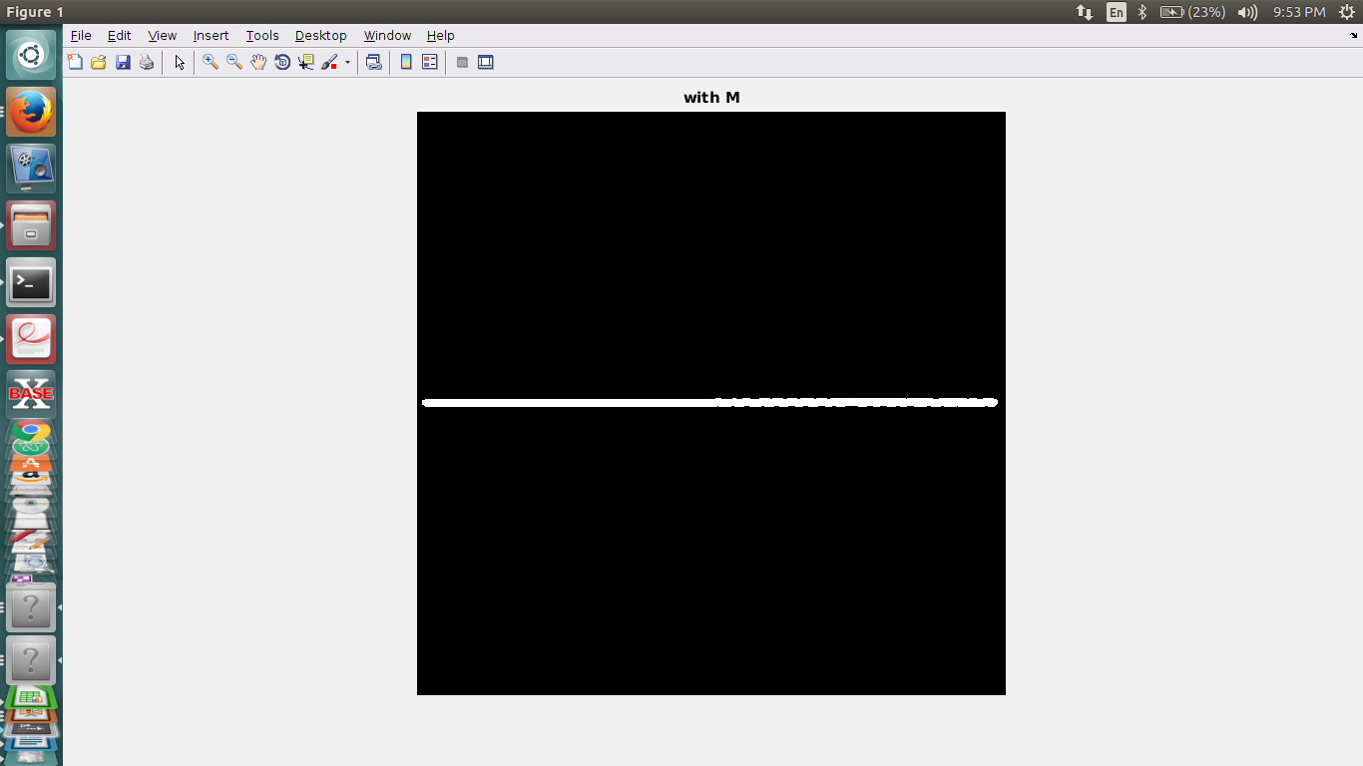
Output obtained on convolution with M

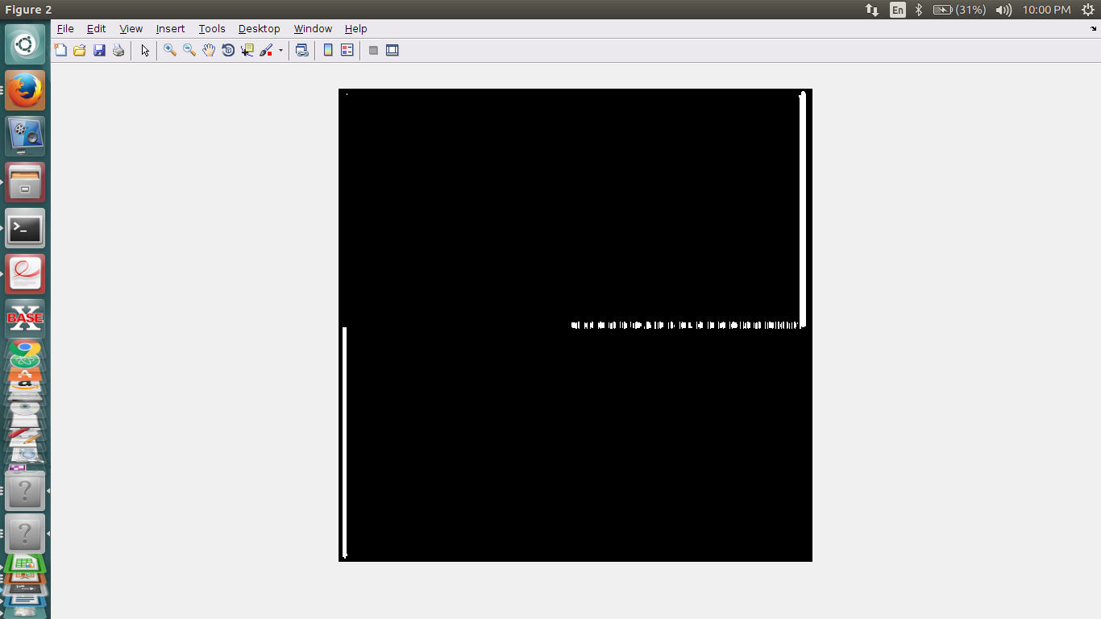
Output obtained on convolution with M^{T}

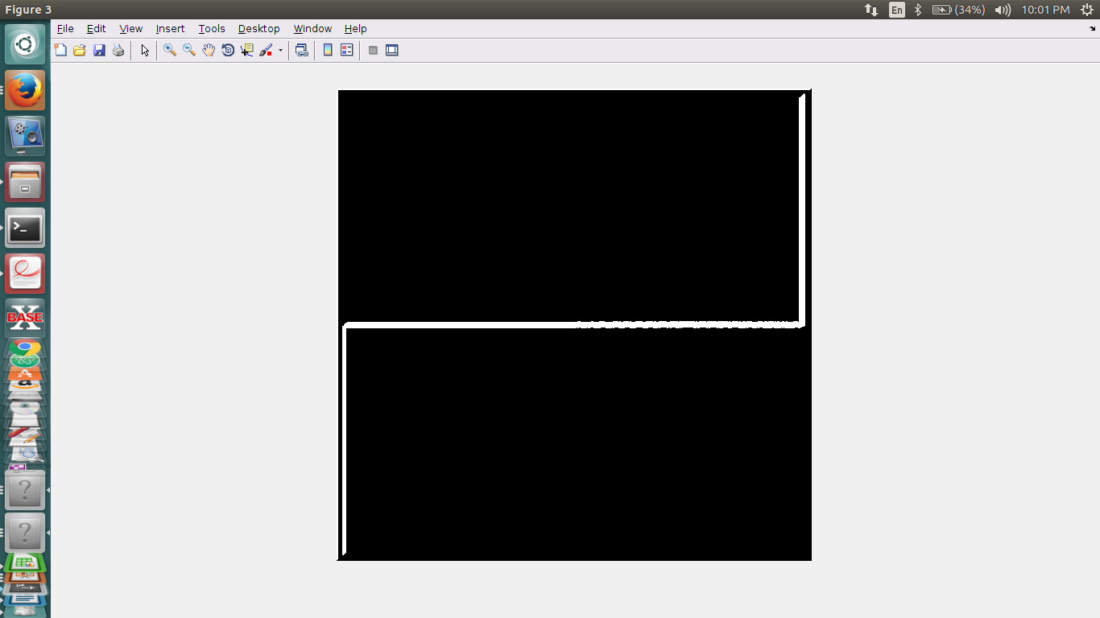

Sum of the images obtained(M and M^{T})

M detects edges in edges in Horizontal direction,
so, if we apply the same filter on “blur.jpg”, the results are:

On convoluting with M On convoluting with M^{T}
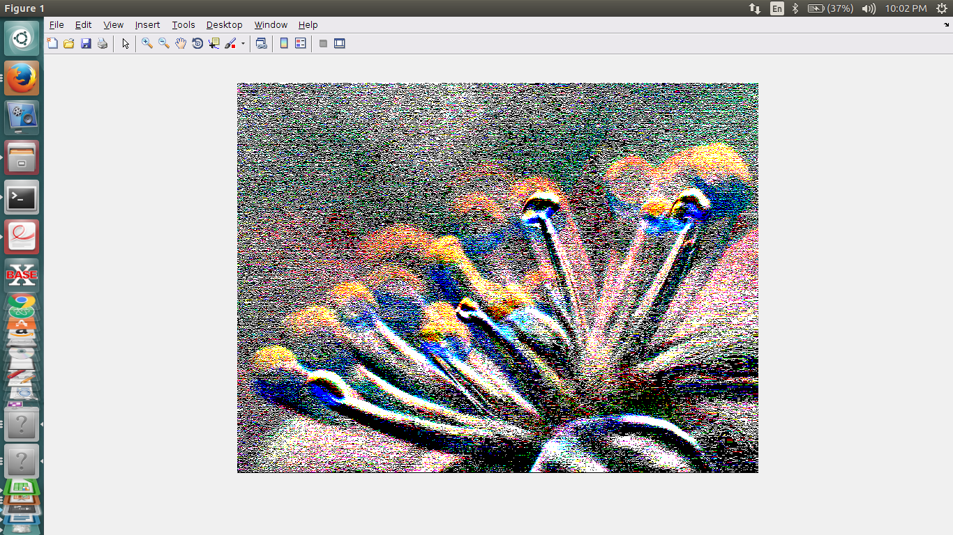
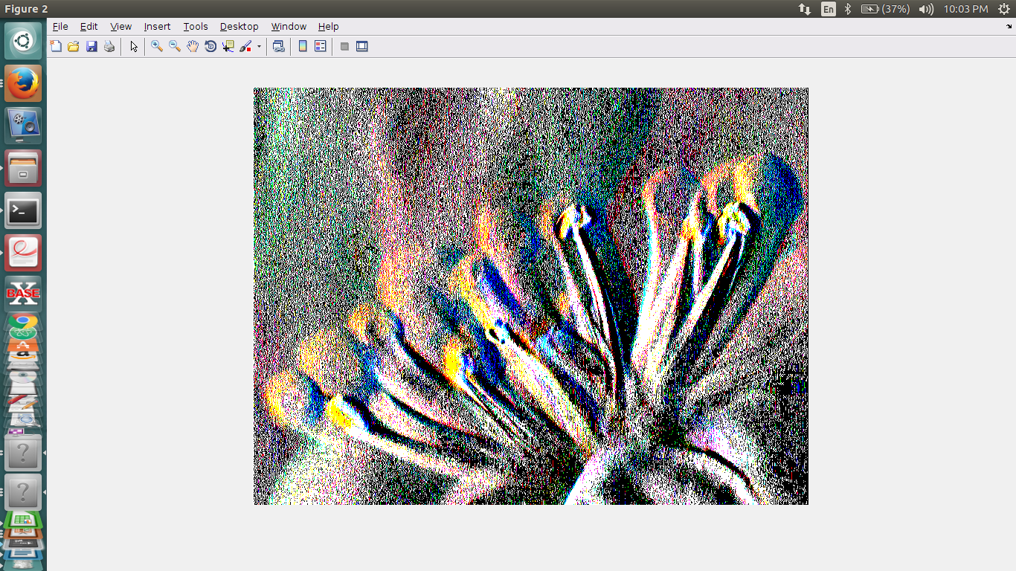

==> Left side image is convolved with horizontal filter
==> Right side image is convolved with vertical filter
If we add the both the results of convolution:
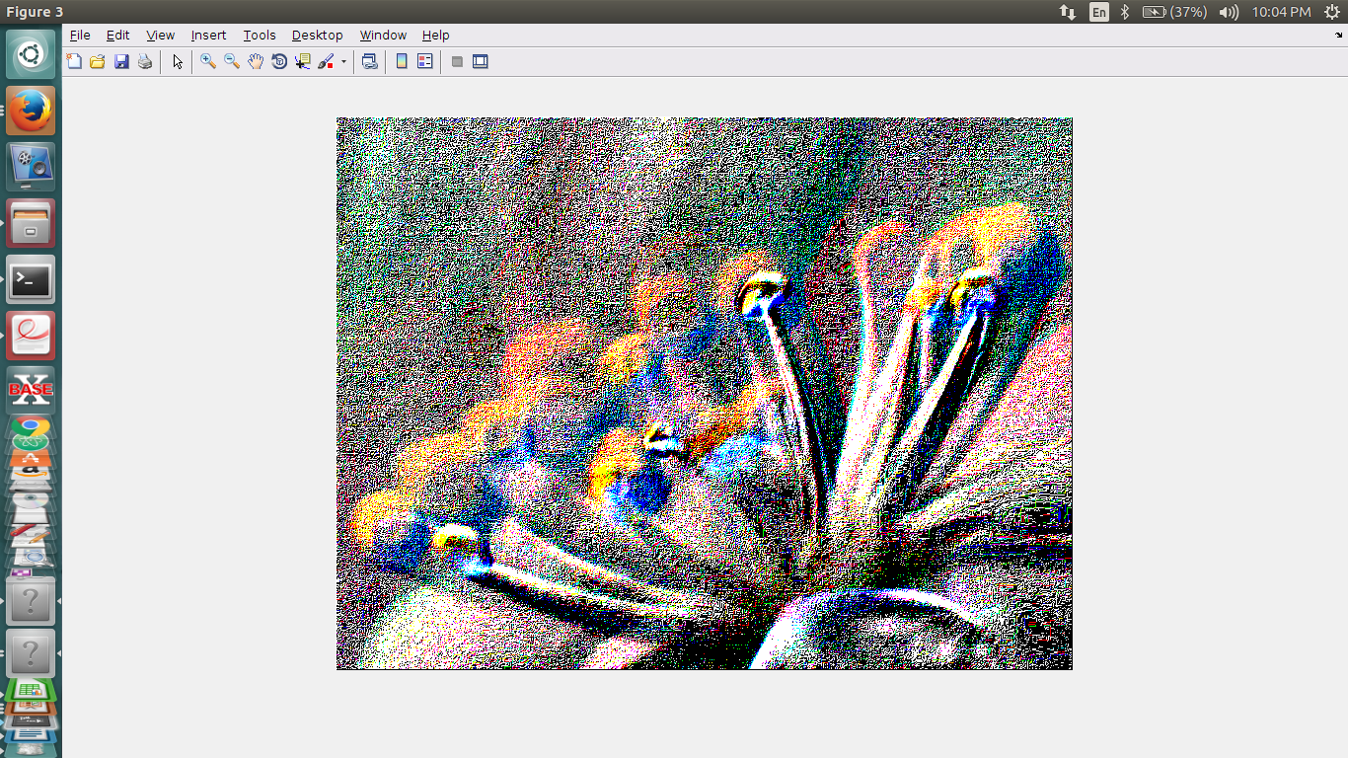
Fig: Addition of both images

By adding the both covoluted images we get grid like structure for both vertical and horizontal edge detection.

Q6)

A)
To find the required face in the big image just iterate through the image in size of face and check the matrix that resemble mostly with the face.
This is done as boolean check of corresponding elements of matrices and counting maximum resemblence of matrix.
And finding the coordinate of face required and then drawing a rectangle around the face using function rectangle

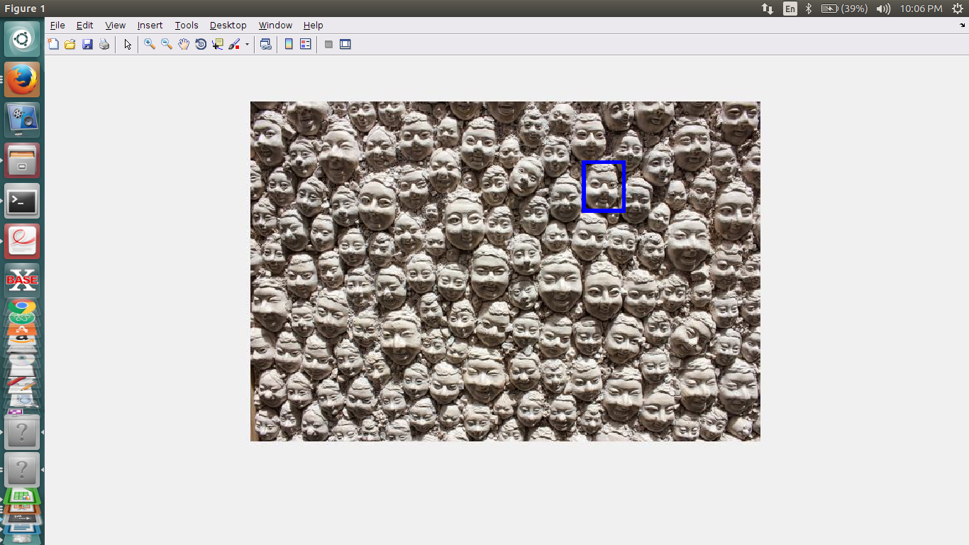
Fig: Face Detection

Q7)

A)
Given, Input
A = [12,20,3,10,22,19,23,16,0,21,23,16,18]
Output
B = [75,52,33,97,251,211,63,65]

It is said that the filter is Causal.
So, it uses only uses the prevoius values for future values. Also the there is no zero padding to the input.

size of A(input) = 13
size of B(ouput) = 08

the size of filter
= sizeof(A) – sizeof(B) + 1;

From the above equations we get the size of filter as ‘6’.

let F = [a,b,c,d,e,f]

=> by using that we get 8 equations for 6 variables:

a*12+b*20+c*3+d*10+22*e+f*19 = 75
a*20+b*3+c*10+d*22+e*19+f*23 = 52
a*3 +b*10+c*22+d*19+e*23+f*16 = 33
a*10+b*22+c*19+d*23+e*16+f*0 = 97
a*22+b*19+c*23+d*16+e*0+f*21 = 251
a*23+b*16+c*0+d*21+e*23+f*16 = 63

{ we have to reverse the order of the
values obtained in the above output }

We can get the output by using matrix multiplacation
On solving it we get the filter to be:

[1,-3,-3,4,4,5]

