OS ASSIGNMENT - 5
REPORT ON PRIORITY BASED SCHEDULING

- The scheduling can be demonstrated by the pictures attached in the folder.

- Implemented the cps syscall which shows the name,pid,state,priority of the process
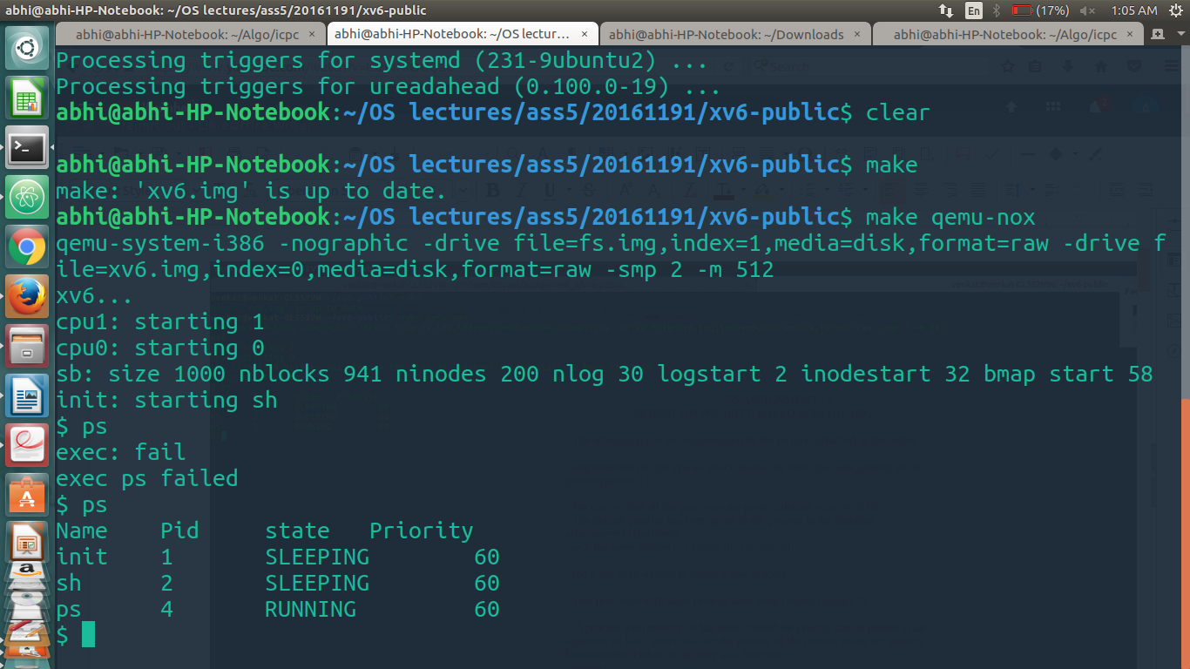

- We can see that all the processes are given a default priority of 60.
- The default priority has been given to the process in the function allocprocess().
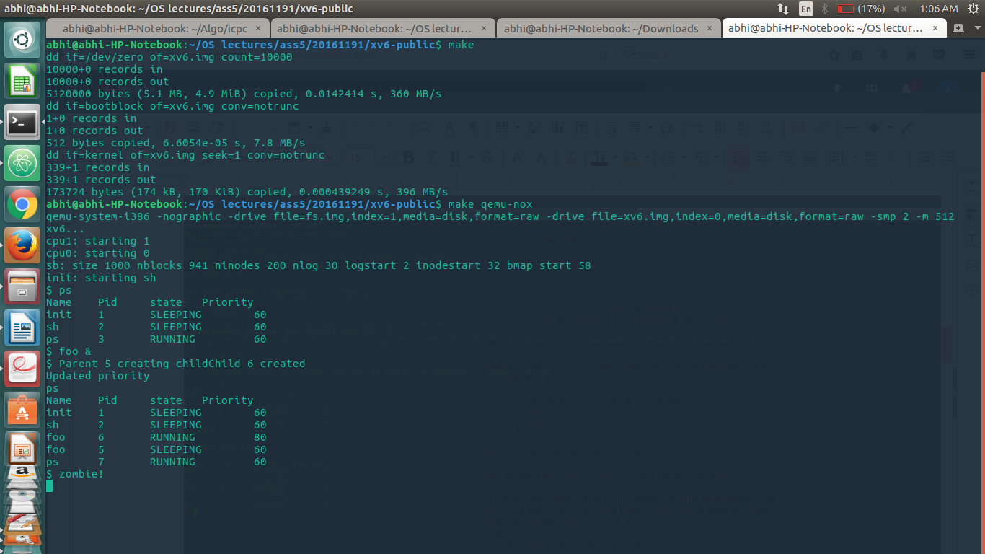
- ps.c has been written to execute the cps syscall.

- foo.c has been written to create a new process

- Two processes with same priority have been created.
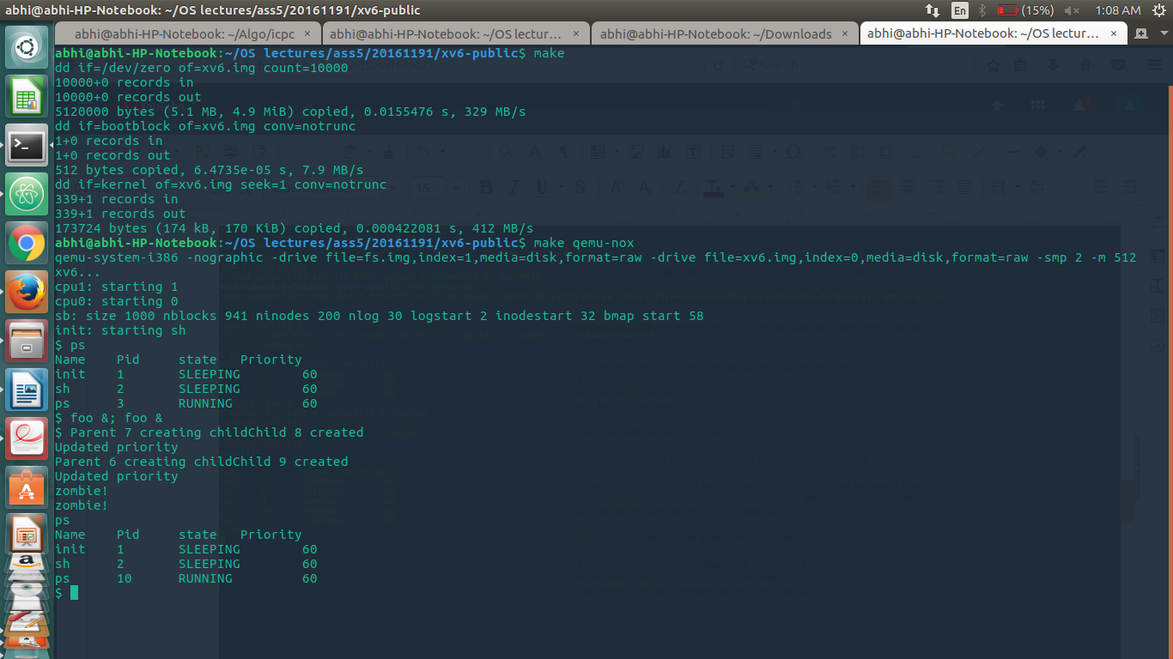

- A process with priority 70 has been created the priority can be passed as an argument to foo.c which will set the priority of the process using set_priority function which takes the priority as a function.
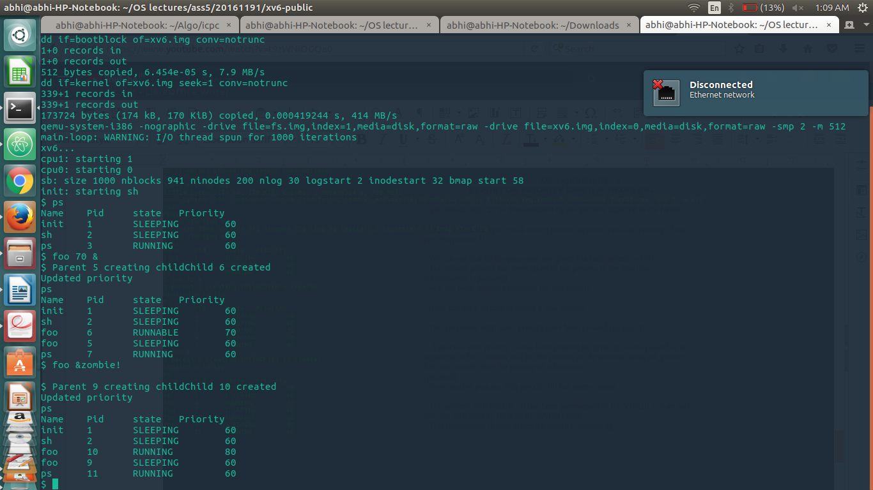
- Now another process with priority 60 has been created.

- The process with priority 70 has been preemepted to RUNNABLE state and process with priority 60 is in RUNNING state.
- This observation demonstrates the priority scheduling.

COMPARISON BETWEEN ROUND-ROBIN AND PRIORITY SCHEDULING

- In round-robin all processes are scheduled in a circular manner.
- Whereas in priority scheduling a process is preemped if a higher process with higher priority comes and rescheduling is done.
- In priority scheduling starvation takes place ie., lower priorities are not allocated CPU until all the processes with higher priority are added.

