Self-Supervised and Conformally Calibrated State-of-Health Estimation From Arbitrary Partial Charging Sessions: A Cell- and Dataset-Separated Benchmark
[Author Name], [Author Name], and [Author Name]
[Department], [Institution], [City], [Country] (e-mail: [address])
Abstract—Electric-vehicle battery management systems rarely observe a complete charge–discharge cycle, but they observe many partial charging sessions that start and stop at arbitrary states of charge. This paper asks how accurately, and with what calibrated uncertainty, the state of health (SOH) can be estimated from a single such session when evaluation is separated by cell and by dataset. We construct 81,073 arbitrary partial sessions from 361 cells of six public datasets (CALCE, Sandia, HUST, MATR, NASA and Oxford; LFP, NMC, NCA, LCO and LCO/NCO). Sessions are represented only by quantities a battery management system can measure, terminal voltage and the charge accumulated since plug-in, so the cell capacity cannot leak into the input. We compare ridge regression and gradient-boosted trees on handcrafted session features with a dual-view convolutional encoder trained from scratch and after self-supervised masked-curve pre-training, and we calibrate 90 % prediction intervals with split conformalized quantile regression (CQR). On unseen cells (three seeds), gradient-boosted trees achieved the lowest error, 4.89 ± 0.19 % SOH RMSE (R² = 0.79), while the convolutional encoders reached 5.81–5.89 %; self-supervised pre-training changed RMSE by −0.21 to +0.24 percentage points across seeds and label budgets, which is within seed variability. CQR delivered 0.895 marginal coverage at the 90 % level, but coverage ranged from 0.81 to 0.91 across datasets. When an entire dataset was held out, no model generalized ($R^2\le0.03$ in all 27 model–dataset–seed runs) and coverage fell to as low as 0.20. All trained models, split manifests and calibration artifacts are released with checks that reproduce every reported test prediction from the saved weights. These results indicate that arbitrary partial sessions support coarse SOH estimates with honest, but wide, intervals, and that marginal conformal guarantees do not transfer across datasets without recalibration.
Index Terms—Conformal prediction, electric vehicles, lithium-ion battery, partial charging, self-supervised learning, state of health, uncertainty quantification.

I. Introduction
The traction battery is the most expensive and least observable component of an electric vehicle (EV). Its state of health (SOH), the currently deliverable discharge capacity divided by the rated capacity, determines driving range, resale value and warranty decisions. A capacity test measures SOH directly, but it requires a full, controlled cycle that a vehicle in daily use rarely performs. What a battery management system (BMS) does observe frequently is a partial charging session: the driver plugs in at an arbitrary state of charge (SOC), unplugs at another, and the BMS records the terminal voltage and the charge accumulated in between.
Partial data carry degradation information. Chinomona et al. [1] estimated capacity from fixed partial voltage windows of four NASA cells and found that a partial-charge window (3.8–4.1 V) gave a larger error (RMSE 0.13054 Ah) than a partial-discharge window (4.0–3.1 V, RMSE 0.06448 Ah). Wang et al. [7] derived an indirect health indicator from the constant-current charging stage, and Tian et al. [13] reconstructed charging curves from 30 points collected within 10 min. Three issues that matter for field use remain under-tested in this line of work: sessions that start and stop at arbitrary points; generalization to unseen cells and unseen datasets, since five of the seven audited studies in Section II evaluate on the same four NASA cells; and uncertainty estimates whose coverage is measured on held-out cells rather than assumed.
This paper addresses the following question. How accurately, and with what calibrated uncertainty, can SOH be estimated from one partial charging session of arbitrary start and length under cell- and dataset-separated evaluation, and does self-supervised pre-training on unlabelled sessions help? The contributions are:
- A leakage-controlled benchmark of 81,073 arbitrary partial sessions from 361 cells of six public datasets and five chemistries, in which inputs are restricted to BMS-observable quantities and every evaluation is separated by cell, with a leave-one-dataset-out protocol.
- A controlled comparison of handcrafted-feature models, raw-curve gradient boosting, and a dual-view convolutional encoder with and without self-supervised masked-curve pre-training, under full and 10 % label budgets. The comparison shows that, in this setting, gradient-boosted trees outperform the learned encoders and that pre-training yields no measurable gain.
- A measurement of split conformalized quantile regression (CQR) [17] for SOH intervals, showing near-nominal marginal coverage on unseen cells of seen datasets, large per-cell and per-dataset variation, and failure of both accuracy and coverage under dataset shift.
Closely related self-supervised approaches have recently been proposed [19]–[21], including treating partial charging as natural masking [20]; we therefore evaluate self-supervision as a design choice rather than claim it as new. Physics-constrained long-horizon forecasting [18] and downstream services are outside the evaluated scope. The work is part of the battery-health module of SmartEV, an EV charging and route-planning platform (Fig. 1), but all results reported here are offline evaluations. The evaluated pipeline is summarized in Fig. 2.

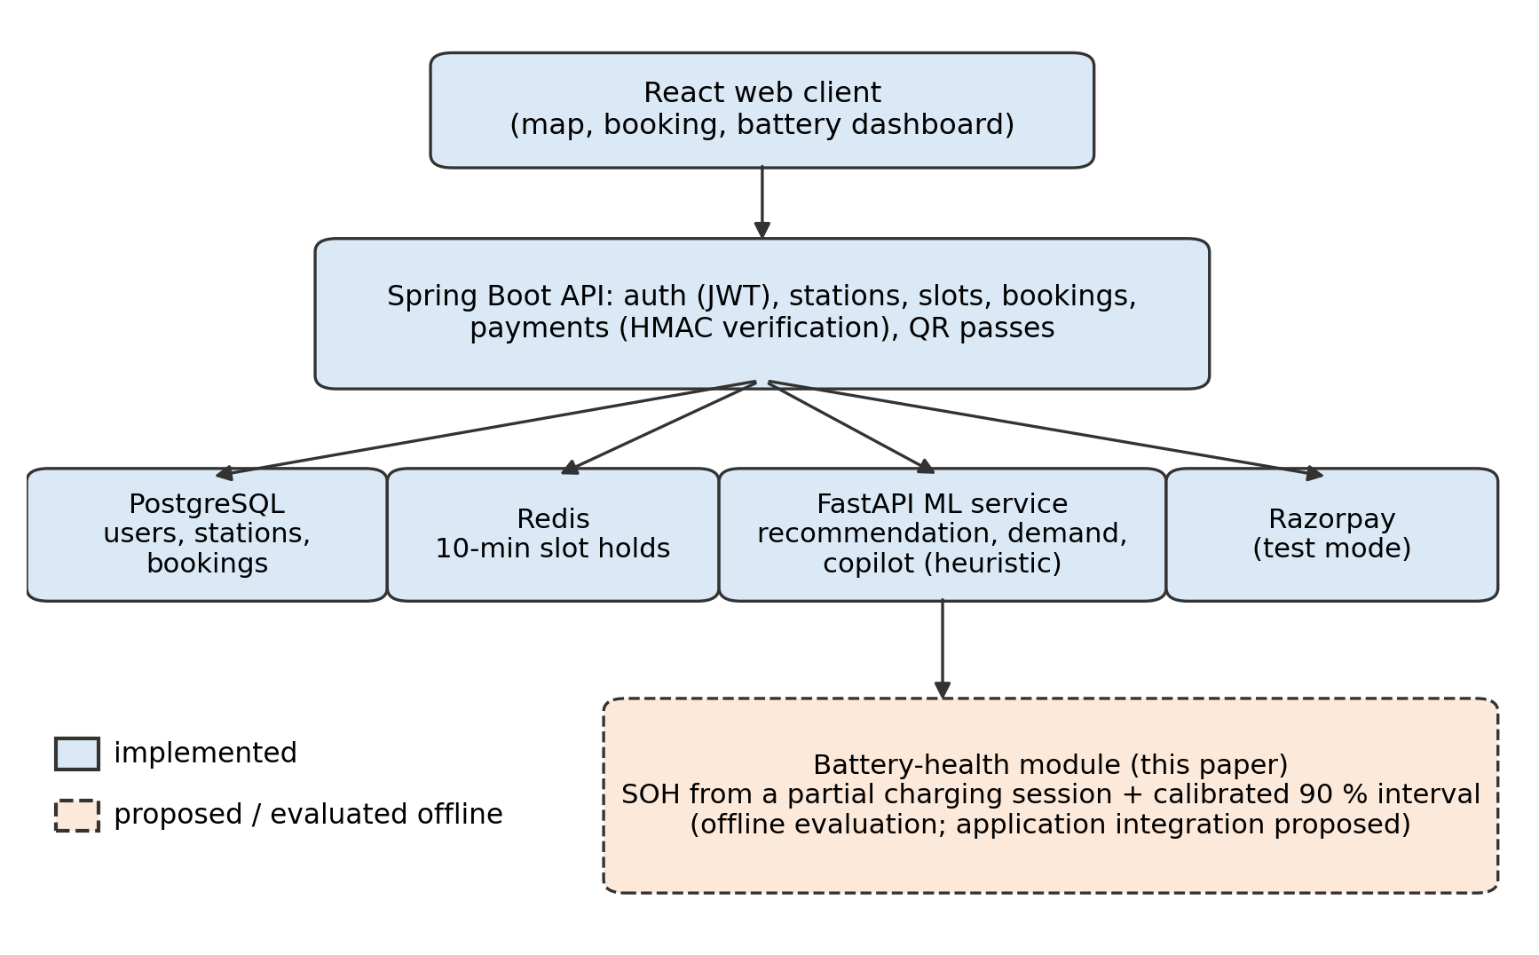
Fig. 1. SmartEV system architecture. Solid boxes are implemented components; the dashed box is the battery-health module evaluated offline in this paper and proposed for integration.

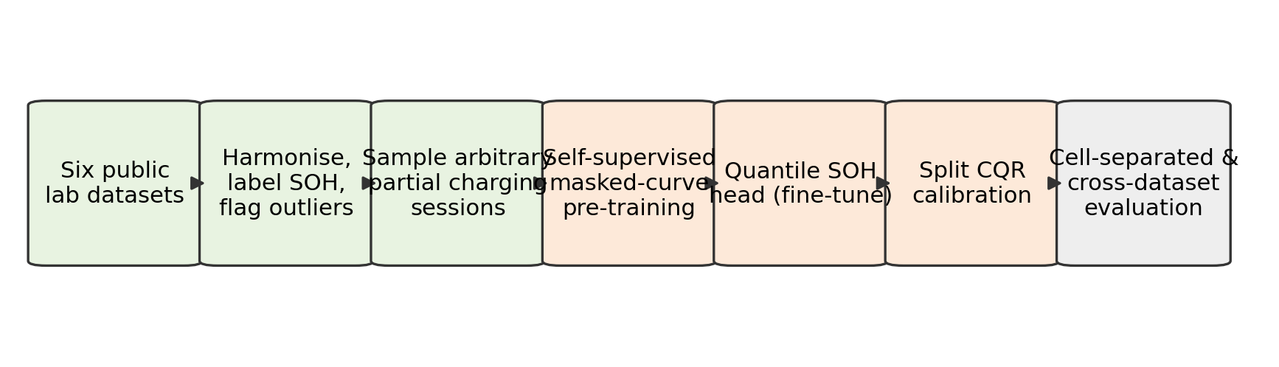
Fig. 2. Research framework evaluated in this paper: data harmonization, arbitrary partial-session construction, self-supervised masked-curve pre-training, quantile SOH head, split CQR calibration, and cell- and dataset-separated evaluation (conceptual diagram).

II. Related Work
Table I summarizes the studies whose bibliographic data and key results were verified for this paper. Metrics are quoted as reported; because targets (capacity in Ah, SOH, normalized health indicators, RUL in cycles), datasets and protocols differ, they are not comparable with each other or with our results.
TABLE I
VERIFIED LITERATURE COMPARISON (METRICS AS REPORTED BY THE AUTHORS)

Ref. | Dataset (cells) | Target | Method | Reported result | Limitation for this study
[1] | NASA B5, B6, B7, B18 | Capacity, RUL | Feature selection + LSTM | Partial charge 3.8–4.1 V: RMSE 0.13054 Ah | Fixed windows tuned on one cell; no intervals
[2] | MIT-Stanford (124), Tongji (57) | Early RUL | Lebesgue sampling + parallel-state LSTM | APE 3.59 % / 6.71 % at cycle 100 | Needs a run-to-failure library; no intervals
[3] | NASA (6), CALCE CS2 | Capacity, RUL | LSTM + GPR | Capacity RMSE 0.0032 | Full capacity series; Gaussian residuals
[4] | NASA random walk + B5–B18 | RUL | DGWO-ELM | Relative RUL error < 3.2 %* | CC-CV charging; no intervals
[5] | NASA B5, B6, B7, B18 | Capacity, RUL | Multi-scale CNN + attention LSTM + MC dropout | Capacity RMSE 0.0045–0.0112 | Four cells; dropout intervals uncalibrated
[6] | NASA B5, B6, B7, B18 | SOH, RUL | Entropy-graph GCN + LSTM + attention | Mean SOH RMSE 0.0154* | Four cells, one chemistry
[7] | NASA B5, B6, B7, B18 | Health indicator, RUL | LTSA indicator + self-attention LSTM | HI RMSE 0.020–0.024 | Needs a full CC charging stage
[8] | MIT-Stanford (124 LFP) | Cycle life | ΔQ(V) features + elastic net | — | Full early-life cycles
[20] | — (preprint) | SOH | Partial charging as natural masking (SSL) | — | Closest prior idea
[22] | — (preprint) | SOH forecast | Conformalized transfer learning | — | Forecasting, not single-session estimation

* Taken from the supplied audited survey; not re-verified against the full text.
Partial-data estimation. Fixed windows [1], constant-current-stage indicators [7], short fixed-start segments [13] and post-charge voltage relaxation [14] reduce the data needed per estimate, but none of these evaluates sessions with arbitrary start and length across several chemistries. Roman et al. [12] proposed a multi-dataset machine-learning pipeline for SOH from charging features, and Lu et al. [15] transferred from physics-generated data.
Uncertainty. Where uncertainty is provided, it comes from Gaussian process regression [3] or Monte Carlo dropout [5]; neither offers finite-sample coverage, and coverage on unseen cells is rarely reported. Conformal prediction [17] guarantees marginal coverage under exchangeability and has begun to appear for SOH forecasting [22].
Benchmarks and self-supervision. BatteryML [23] and BatteryLife [24] standardize larger collections of cells. Masked reconstruction is a widely used self-supervised objective [16], and battery-specific self-supervision with weak labels [19], degradation-aligned objectives [21] and partial-charging masking [20] has been proposed.
The open questions tested here are therefore (i) accuracy under arbitrary BMS-observable sessions across chemistries, (ii) generalization to unseen cells and datasets, (iii) measured coverage of distribution-free intervals, and (iv) whether masked-curve pre-training helps in this multi-source setting. We state three hypotheses: H1, a learned encoder outperforms handcrafted-feature baselines on unseen cells; H2, self-supervised pre-training helps most when only 10 % of training cells are labelled; H3, CQR attains approximately 90 % coverage on unseen cells of seen datasets but not necessarily on an unseen dataset.

III. Problem Formulation and Data

A. Definitions
For cell $c$ and cycle $n$, let $Q_{c,n}^{dis}$ (Ah) be the measured discharge capacity and $Q_{c}^{rated}$ (Ah) the rated capacity. Then
$${SOH}_{c,n}=Q_{c,n}^{dis}/Q_{c}^{rated}.$$ | (1)
SOH is dimensionless; errors are reported in percentage points of SOH (% SOH). Remaining useful life is not a target in this paper.
A session starts at an unobserved fraction $s$ of the full charge and ends at $e=s+w$. The BMS observes the terminal voltage $V(t)$ and the accumulated charge
$$ΔQ(t)=\int_{t_{0}}^{t}{I}(τ) dτ,$$ | (2)
where $I$ is the charging current (A) and $t_{0}$ the plug-in time. The task is
$$\left(\hat{y},\hat{ℓ},\hat{u}\right)=f_{θ}\left(\{(V_{k},ΔQ_{k})\}_{k∈S},u\right), y={SOH}_{c,n},$$ | (3)
where $S$ indexes the samples inside the session, $u$ is BMS-available context (chemistry, ambient temperature, charging C-rate), and $[\hat{ℓ},\hat{u}]$ should contain $y$ with probability at least $1−α$, with $α=0.1$. Table II lists the notation.
TABLE II
NOTATION
Symbol | Meaning | Unit
$Q_{c,n}^{dis}$, $Q_{c}^{rated}$ | Measured discharge capacity; rated capacity | Ah
$s$, $w$ | Session start and width as fractions of the full charge (not observed) | —
$ΔQ$ | Charge accumulated since session start | Ah
$x^{a}$, $x^{v}$ | Charge-domain and voltage-domain session views | —
$u$ | Context: chemistry, ambient temperature, C-rate | —
${\hat{q}}_{τ}$ | Predicted $τ$-quantile of SOH | —
$E_{i}$, $\hat{Q}$ | Conformity score; conformal correction | SOH

B. Datasets
Six public datasets were harmonized into one schema (Table III, Fig. 3): CALCE [10], Sandia/SNL [25], HUST [26], MATR [8], [27], NASA PCoE [9] and Oxford [11]. CALCE, SNL, HUST and MATR were taken from the processed BatteryLife release [24]; NASA and Oxford from the original files. All signals were converted to SI units with charge current positive, Oxford timestamps (stored in days) were converted to seconds, and the duplicated NASA cells B0025–B0028 were included once. This gave 362 cells and 400,224 cycles. Outlier cycles were flagged per cell with a Hampel filter on SOH (window 21, threshold three scaled median absolute deviations, MAD floored at 0.5 % SOH), which removed 0.29 % of cycles, including 11.7 % of NASA cycles, consistent with NASA’s note on anomalous low-capacity runs. One NASA cell (B0045) was excluded because none of its clean cycles reaches the SOH ≥ 0.5 selection threshold (maximum clean-cycle SOH 0.443 against a rated capacity of 2.0 Ah; the only higher value, 0.541, is a flagged outlier), although 71 of its 72 charge curves are valid, leaving 361 cells. SmartEV also holds vehicle trip-energy data (VED [28]), which is not used here because it contains no battery-health labels.
TABLE III
DATASETS USED (STATISTICS COMPUTED FROM THE PROCESSED FILES)

Source | Cells | Chemistry | Rated (Ah) | Ambient (°C) | Max charge C-rate | Sessions | SOH range
CALCE [10] | 13 | LCO | 1.1–1.35 | 25 | 0.5 | 3,118 | 0.50–1.05
SNL [25] | 61 | LFP 18, NMC 21, NCA 22 | 1.1 / 3.0 / 3.2 | 15, 25, 35 | 0.5 | 14,640 | 0.50–1.01
HUST [26] | 77 | LFP | 1.1 | 30 | 5 | 18,480 | 0.81–1.14
MATR [8], [27] | 169 | LFP | 1.1 | 30 | 8 | 40,224 | 0.50–1.00
NASA [9] | 33 | Undisclosed | 2.0 | 4, 24, 43–44 | 0.75 | 3,587 | 0.50–1.02
Oxford [11] | 8 | LCO/NCO | 0.74 | 40 | 2 | 1,024 | 0.74–1.00
Total | 361 | 5 + undisclosed |  |  |  | 81,073

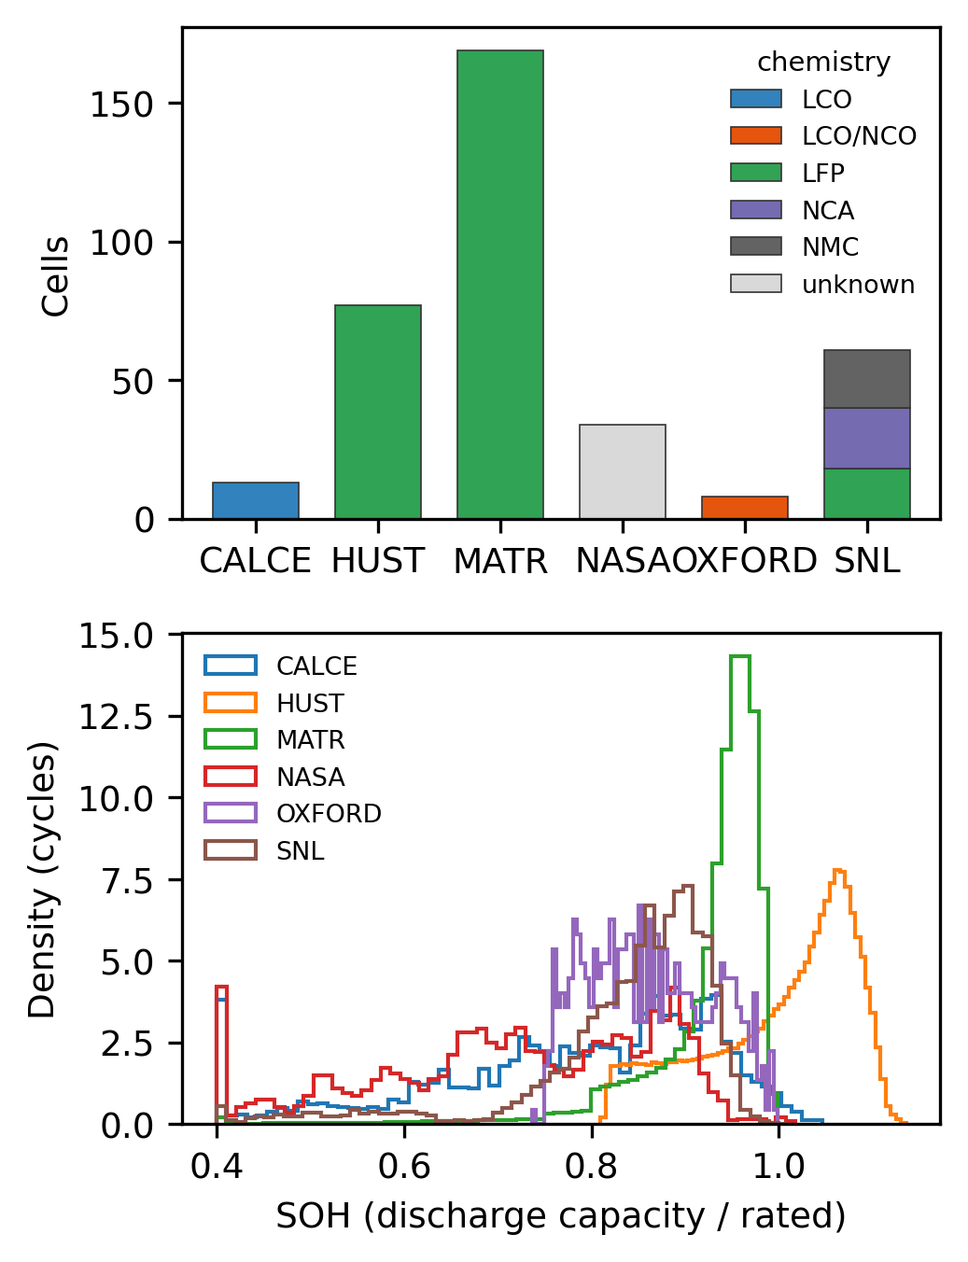
Fig. 3. Dataset overview computed from the harmonized files: cells per source and chemistry (top) and SOH distribution of clean cycles per source (bottom).

C. Partial-Session Construction
For each cell, up to 120 clean cycles with $0.5≤SOH≤1.2$ were selected evenly over life, and two sessions were sampled per cycle with $s∼U(0.05,0.60)$ and $w∼U(0.15,0.40)$, truncated at $e=0.98$. From the stored charging curve $V(q)$, the accumulated charge in a session is $ΔQ=(q−s) Q_{c,n}^{ch}$. The model never receives $s$, $w$, $Q^{ch}$ or $Q^{dis}$. Each session is encoded in two views (Fig. 4): the charge-domain view $x^{a}∈R^{2×48}$, which holds the voltage at fixed accumulated-charge steps $ΔQ/Q^{rated}∈[0,0.40]$ with a mask after the session ends; and the voltage-domain view $x^{v}∈R^{2×64}$, which holds the normalized accumulated charge at fixed voltages (LFP 3.20–3.60 V, others 3.50–4.20 V) with a mask outside the observed range. Normalizing by the rated capacity uses only a datasheet value, and because sessions are defined by their observable endpoints, the ratio $ΔQ/ΔSOC$, which would reveal capacity, is not available to the model.
For the baselines, nine handcrafted session features were computed: start and end voltage, voltage span, accumulated charge, charge per volt, the maximum and location of the incremental capacity $dΔQ/dV$, the charge at mid-voltage, and the number of observed voltage bins. These were combined with five context variables.
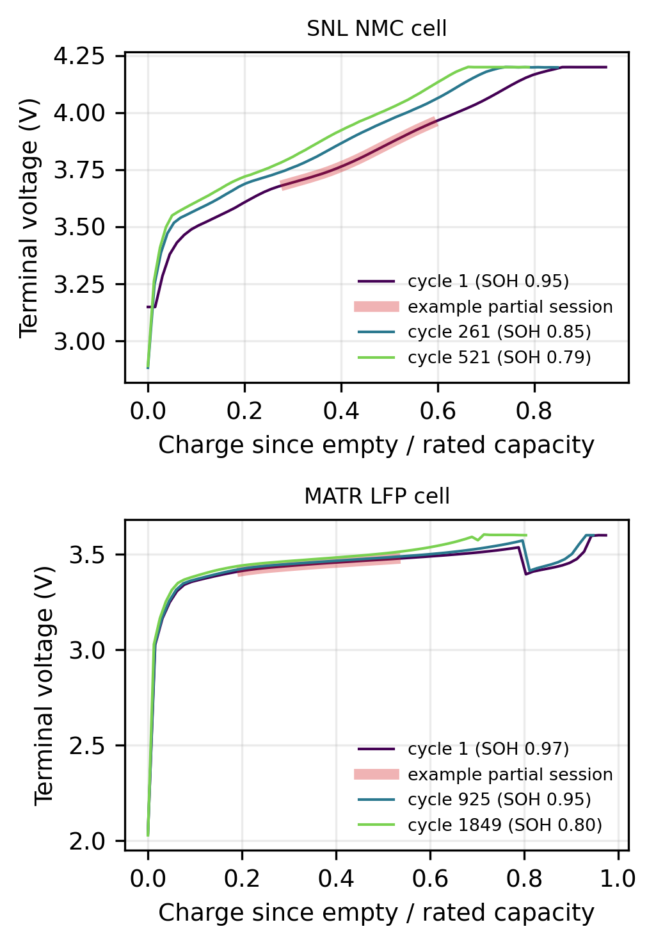
Fig. 4. Measured charging curves at three ages of a Sandia NMC cell (top) and a MATR LFP cell (bottom). The shaded segment illustrates one partial session (window chosen for illustration). The MATR voltage drop near 0.8 reflects its multi-step fast-charging protocol.

IV. Methods

A. Baselines
We use three baselines: ridge regression on standardized handcrafted features and context; LightGBM [29] on the same features; and LightGBM on the features plus the flattened two views (238 inputs). The choice between feature sets was made on a validation split of training cells only, so test cells were never used for model selection.

B. Dual-View Convolutional Encoder
Each view receives a third channel, a hidden-position flag that is zero during fine-tuning, and is processed by its own encoder: three 1-D convolutions with kernel 5, dilations 1, 2 and 4, 48 channels, batch normalization, GELU activation and residual connections (Fig. 5). Masked mean and max pooling over observed positions give 96 features per view, which are concatenated with $u$ and passed to a multilayer perceptron (128 units, dropout 0.1) with three outputs $(a,m,b)$. Quantile ordering is enforced by construction,
$${\hat{q}}_{0.05}=m−softplus(a), {\hat{q}}_{0.5}=m, {\hat{q}}_{0.95}=m+softplus(b),$$ | (4)
and training minimizes the summed pinball loss
Lsup=τ∈{0.05,0.5,0.95}​1Ni=1Nρτyi−qτ,i, ρτ(r)=max{τr,(τ−1)r}. | (5)

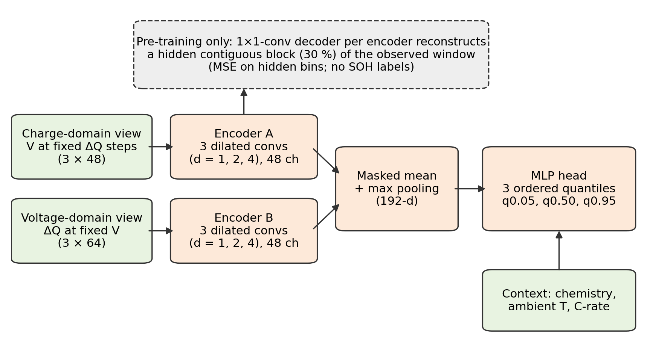
Fig. 5. Dual-view partial-session encoder with an ordered quantile head. The dashed decoder is used only during self-supervised pre-training (conceptual diagram).

C. Self-Supervised Masked-Curve Pre-Training
Before fine-tuning, both encoders are pre-trained on all training-cell sessions without SOH labels. In each session, one contiguous block covering 30 % of the observed positions is hidden: its value and mask are set to zero and its flag to one. A 1×1-convolution decoder then reconstructs the hidden standardized values:
Lssl=v∈{a,v}​1|Hv|k∈Hv​(xkv−xkv)2, | (6)
where $H_{v}$ is the set of hidden positions. The pre-trained weights initialize the supervised model, which is then fine-tuned end-to-end with (5).

D. Split Conformalized Quantile Regression
Quantile models (the CNNs, and LightGBM with quantile objectives at $τ=0.05$ and $0.95$) are fitted on training cells. On disjoint calibration cells $C$, we compute [17]
$$E_{i}=max\{{\hat{q}}_{0.05}(x_{i})−y_{i}, y_{i}−{\hat{q}}_{0.95}(x_{i})\}, i∈C,$$ | (7)
and form the test interval
$$\left[{\hat{q}}_{0.05}(x)−\hat{Q}, {\hat{q}}_{0.95}(x)+\hat{Q}\right],$$ | (8)
where $\hat{Q}$ is the $⌈(|C|+1)(1−α)⌉$-th smallest $E_{i}$. Coverage of (8) is guaranteed only under exchangeability of calibration and test samples. Sessions from one cell are dependent, and sessions from an unseen dataset are not exchangeable with the calibration set, so coverage is measured rather than assumed.
Algorithm 1: Training and evaluation for one split
Input: sessions with cell identifiers; seed r; label fraction f; model M
1. Split cells, stratified by source, into test (20 %); then calibration (15 %), validation (15 %) and training cells.
2. Fit all scalers on training cells only.
3. If M is the self-supervised CNN, pre-train both encoders on all training-cell sessions with (6).
4. Label a random fraction f of the training cells (f = 1 or 0.1).
5. Fit M on the labelled cells, with early stopping on validation cells.
6. Predict quantiles on calibration cells and compute the correction Q from (7)–(8).
7. Predict the test cells once; report RMSE, MAE, R², coverage and interval width.

V. Experimental Setup
Table IV lists the configuration, and Fig. 6 shows the partitioning and leakage controls. With all labels, 201 training cells were used on average; with 10 % labels, 20. Each test set contained 75 cells and 16,686 sessions per seed. RMSE and MAE are reported in % SOH; coverage is the fraction of test sessions whose true SOH lies inside the interval, and width is the mean interval length in % SOH.
TABLE IV
EXPERIMENTAL CONFIGURATION
Item | Setting
Splits | Cell-level, stratified by source: test 20 %; calibration 15 %, validation 15 %, train rest; seeds 0, 1, 2
Label budgets | 100 % and 10 % of training cells (pre-training always uses all training-cell sessions, unlabelled)
Cross-dataset | Leave-one-source-out for MATR, HUST and SNL (seed 0, all labels; seeds 0–2 as a robustness check)
Sessions | $s∼U(0.05,0.60)$, $w∼U(0.15,0.40)$; 2 per cycle; at most 120 cycles per cell
CNN | AdamW, learning rate 2×10⁻³, weight decay 10⁻⁴, cosine schedule, batch 512, at most 25 epochs, patience 5
Pre-training | 10 epochs; contiguous 30 % mask; MSE on hidden positions
LightGBM | Up to 2000 trees, learning rate 0.03, 31 leaves, 40 samples per leaf, 0.8 row and column subsampling, early stopping after 100 rounds
Intervals | α = 0.1 (90 % nominal), split CQR on calibration cells
Software | Python 3.13, PyTorch 2.11 (CUDA 12.8, deterministic cuDNN), LightGBM 4.6 (CPU), scikit-learn 1.7
Hardware | NVIDIA GeForce RTX 5060 Laptop GPU (8 GB) for the encoders; CPU for all other models

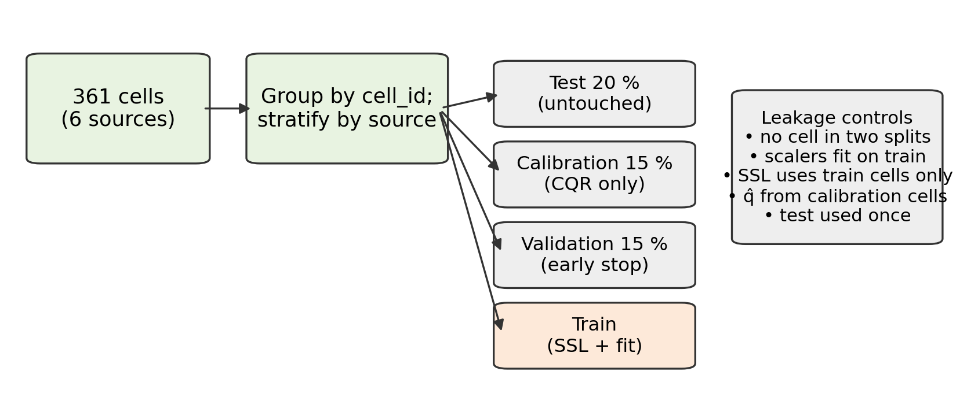
Fig. 6. Cell-separated partitioning and leakage controls (conceptual diagram).

VI. Results and Discussion

A. Accuracy on Unseen Cells
Table V reports test results averaged over three seeds, and Fig. 7 compares the models. With all labels, LightGBM on handcrafted features plus raw views achieved the lowest error, 4.89 ± 0.19 % SOH RMSE (MAE 3.37 %, R² = 0.793), closely followed by LightGBM on handcrafted features alone (4.94 ± 0.14 %). Both convolutional encoders were about one percentage point worse: supervised, 5.81 ± 0.26 % (R² = 0.707); self-supervised, 5.89 ± 0.38 % (R² = 0.699). The gap to LightGBM was consistent within every seed (0.84, 0.97 and 0.96 points for the supervised encoder; 0.78, 1.15 and 1.08 for the self-supervised one). Ridge regression reached 7.46 ± 0.41 %. H1 is therefore not supported: in this setting, a compact set of physically motivated session features with gradient boosting is a stronger estimator than the learned encoder. One caveat is the training budget: in 5 of the 12 encoder runs the best validation epoch fell within the last four epochs of the 25-epoch limit (Fig. 8), so a longer budget could narrow the gap. Fig. 9 shows predicted against measured SOH for the best model.
TABLE V
SOH ESTIMATION ON UNSEEN CELLS (MEAN ± STANDARD DEVIATION OVER THREE SEEDS)

Labels | Model | RMSE (% SOH) | MAE (% SOH) | R² | 90 % PI coverage | PI width (% SOH)
100 % of train cells | Ridge (hand) | 7.46 ± 0.41 | 5.65 | 0.519 | — | —
100 % of train cells | LightGBM (hand) | 4.94 ± 0.14 | 3.43 | 0.788 | 0.897 | 14.05
100 % of train cells | LightGBM (hand+curves) | 4.89 ± 0.19 | 3.37 | 0.793 | 0.895 | 14.12
100 % of train cells | CNN (supervised) | 5.81 ± 0.26 | 4.11 | 0.707 | 0.890 | 17.14
100 % of train cells | CNN (SSL + fine-tune) | 5.89 ± 0.38 | 4.21 | 0.699 | 0.894 | 17.95
10 % of train cells | Ridge (hand) | 17.64 ± 14.38 | 10.30 | -2.321 | — | —
10 % of train cells | LightGBM (hand) | 6.89 ± 0.88 | 4.78 | 0.591 | 0.885 | 18.38
10 % of train cells | LightGBM (hand+curves) | 6.89 ± 0.84 | 4.78 | 0.590 | 0.888 | 18.78
10 % of train cells | CNN (supervised) | 7.30 ± 0.57 | 5.40 | 0.536 | 0.883 | 22.92
10 % of train cells | CNN (SSL + fine-tune) | 7.25 ± 0.74 | 5.29 | 0.545 | 0.883 | 22.72

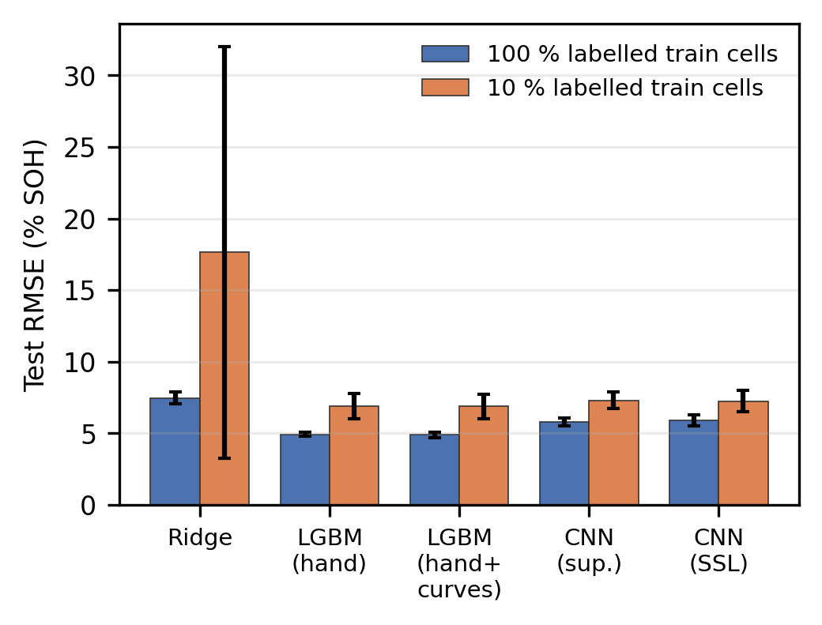
Fig. 7. Test RMSE by model and label budget (mean ± standard deviation over three seeds).
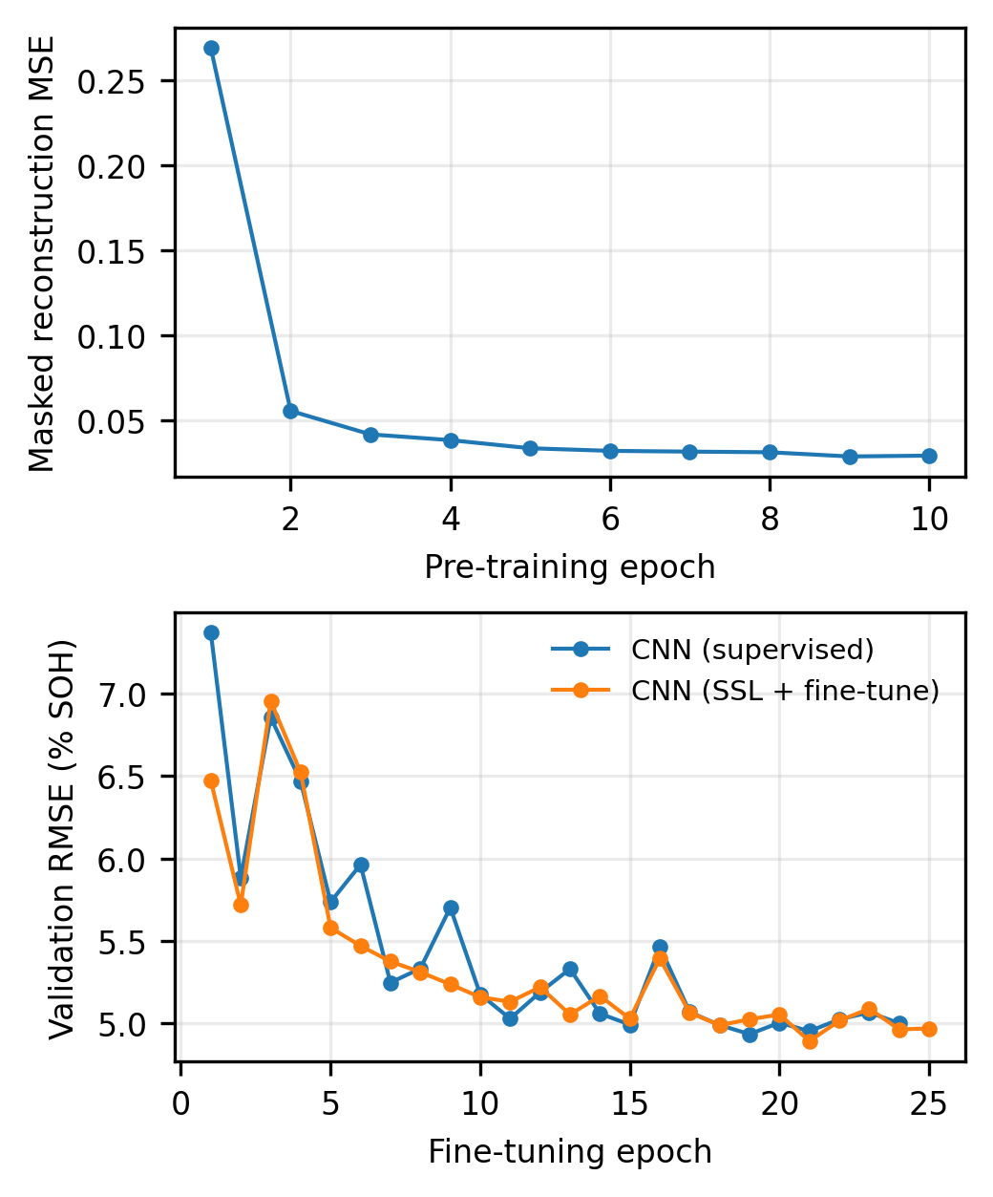
Fig. 8. Training behaviour (seed 0, all labels): masked-reconstruction loss during pre-training (top) and validation RMSE during fine-tuning (bottom).
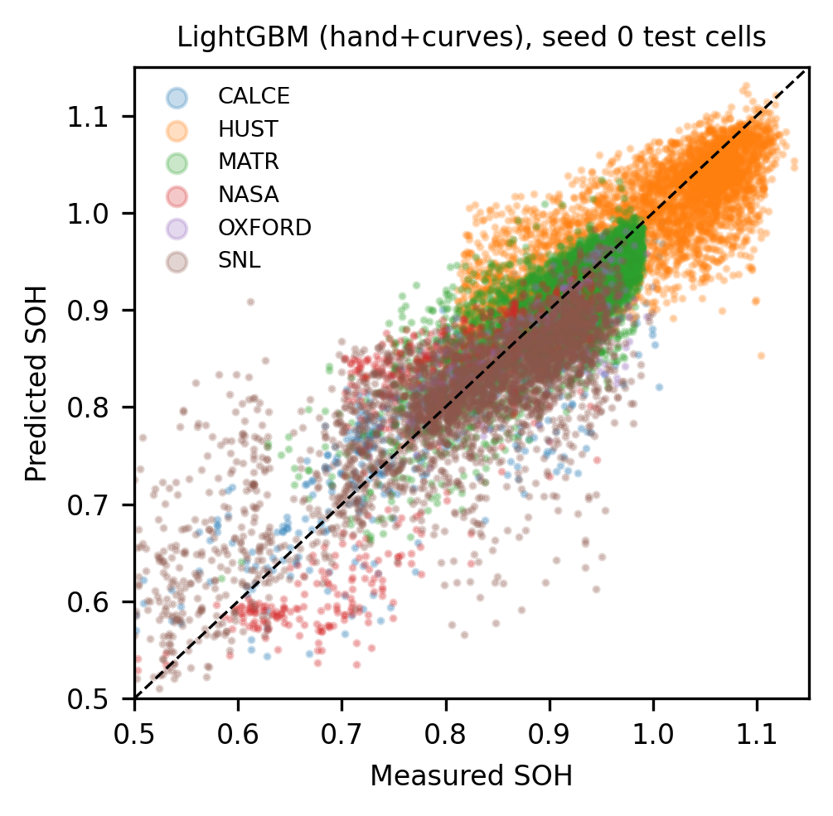
Fig. 9. Predicted against measured SOH for the best model on the seed-0 test cells; the dashed line is the identity.
Errors varied strongly by source (Table VI). For the best model they were lowest on MATR (3.10 %) and Oxford (3.72 %), and highest on NASA (7.59 %) and SNL (6.56 %). These two sources combine the smallest cell counts per condition with the widest range of temperatures, chemistries or protocols. With all labels, LightGBM had the lowest error on every source (Fig. 10); the encoders’ deficit was largest on CALCE (7.65 % and 7.88 %) and SNL (8.28 % and 8.31 %). With 10 % labels, the self-supervised encoder was best on CALCE (9.65 %) and Oxford (6.93 %), the two smallest sources, but LightGBM remained best on HUST, MATR, NASA and SNL. The residuals of the best model are centred near zero for every source (per-source means −0.43 to +0.91 points; Fig. 11), with the widest spread on NASA and SNL. They are, however, biased by SOH level: the mean residual was +6.69 points for sessions with SOH ≤ 0.7, +1.00 for 0.8–0.9 and −1.82 above 1.0, so predictions are shrunk towards the population mean and the most degraded cells are over-estimated.
TABLE VI
TEST RMSE (% SOH) BY SOURCE (MEAN OVER THREE SEEDS)

Labels | Model | CALCE | HUST | MATR | NASA | Oxford | SNL
100 % | CNN (SSL) | 7.88 | 5.95 | 3.89 | 8.37 | 5.52 | 8.31
100 % | CNN (sup.) | 7.65 | 5.82 | 3.81 | 8.38 | 5.08 | 8.28
100 % | LightGBM (hand) | 5.73 | 5.54 | 3.19 | 7.65 | 3.87 | 6.55
100 % | LightGBM (hand+curves) | 5.68 | 5.48 | 3.1 | 7.59 | 3.72 | 6.56
100 % | Ridge | 10.42 | 8.41 | 5.38 | 8.45 | 6.24 | 9.51
10 % | CNN (SSL) | 9.65 | 6.72 | 4.58 | 11.24 | 6.93 | 10.27
10 % | CNN (sup.) | 10.32 | 7.04 | 4.66 | 11.66 | 7.21 | 10.0
10 % | LightGBM (hand) | 10.46 | 5.94 | 4.23 | 11.72 | 8.51 | 9.64
10 % | LightGBM (hand+curves) | 10.72 | 5.93 | 4.26 | 11.17 | 8.59 | 9.72
10 % | Ridge | 14.13 | 7.57 | 5.21 | 47.03 | 22.72 | 24.73

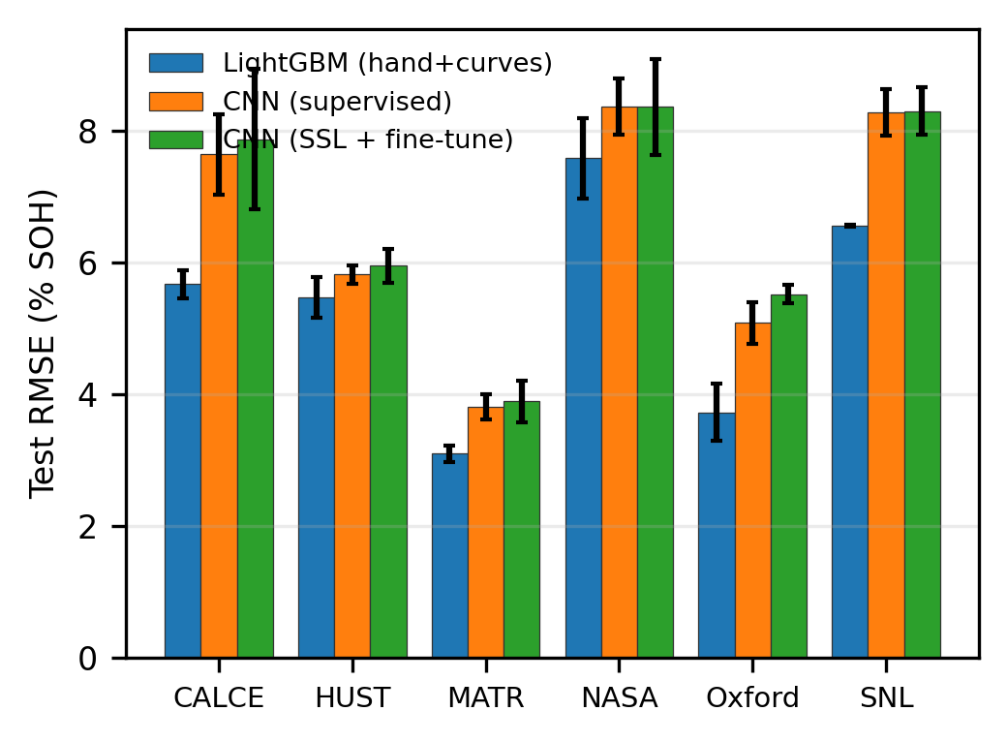
Fig. 10. Test RMSE per source for each model (all labels, mean over three seeds).
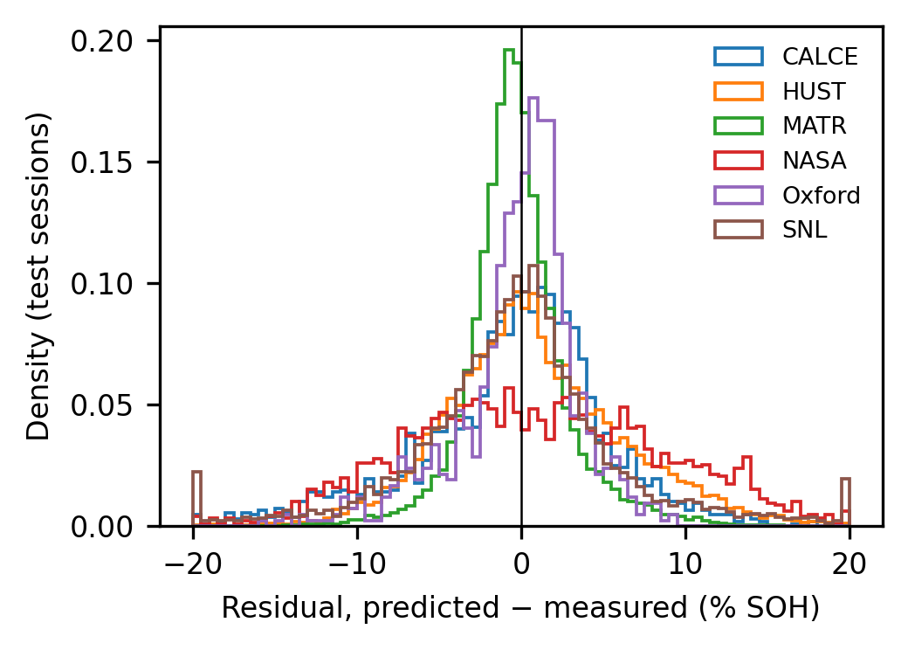
Fig. 11. Distribution of residuals (predicted minus measured SOH) of the best model per source, pooled over three seeds (all labels; clipped to ±20 points).

B. Effect of Self-Supervised Pre-Training and Label Scarcity
Pre-training changed RMSE relative to the supervised encoder by −0.06, +0.18 and +0.13 points with all labels, and by −0.20, −0.21 and +0.25 points with 10 % labels, across seeds 0–2. The average change (+0.08 and −0.05 points) is smaller than the seed-to-seed standard deviation of either encoder (0.26–0.38 and 0.57–0.74 points), and its sign is not consistent across seeds. H2 is therefore not supported at this scale: masked reconstruction of 30 % of an observed session did not yield representations that improved SOH estimation, even when labels were scarce. With 10 % labels (about 20 training cells), every model degraded: LightGBM reached 6.89 ± 0.84 %, the encoders 7.25–7.30 %. Ridge regression was unstable (17.64 ± 14.38 %; 34.21 % on seed 2), consistent with extrapolation from very few cells.

C. Sensitivity to Session Start and Width
Fig. 12 shows test RMSE as a function of the session parameters, which are hidden from the models. For LightGBM on handcrafted features, error decreased from 5.24 % for the shortest sessions (15–20 % of a full charge) to 4.45 % for the longest (35–40 %). Error was highest for sessions starting near empty (5.18 % for $s≤0.15$) and lowest for starts at 35–45 % of the charge (4.56 %). The encoders followed the same trends at a higher level. Longer sessions that cover the mid-SOC region are therefore the most informative, which is consistent with degradation signatures concentrated in the voltage plateaus.
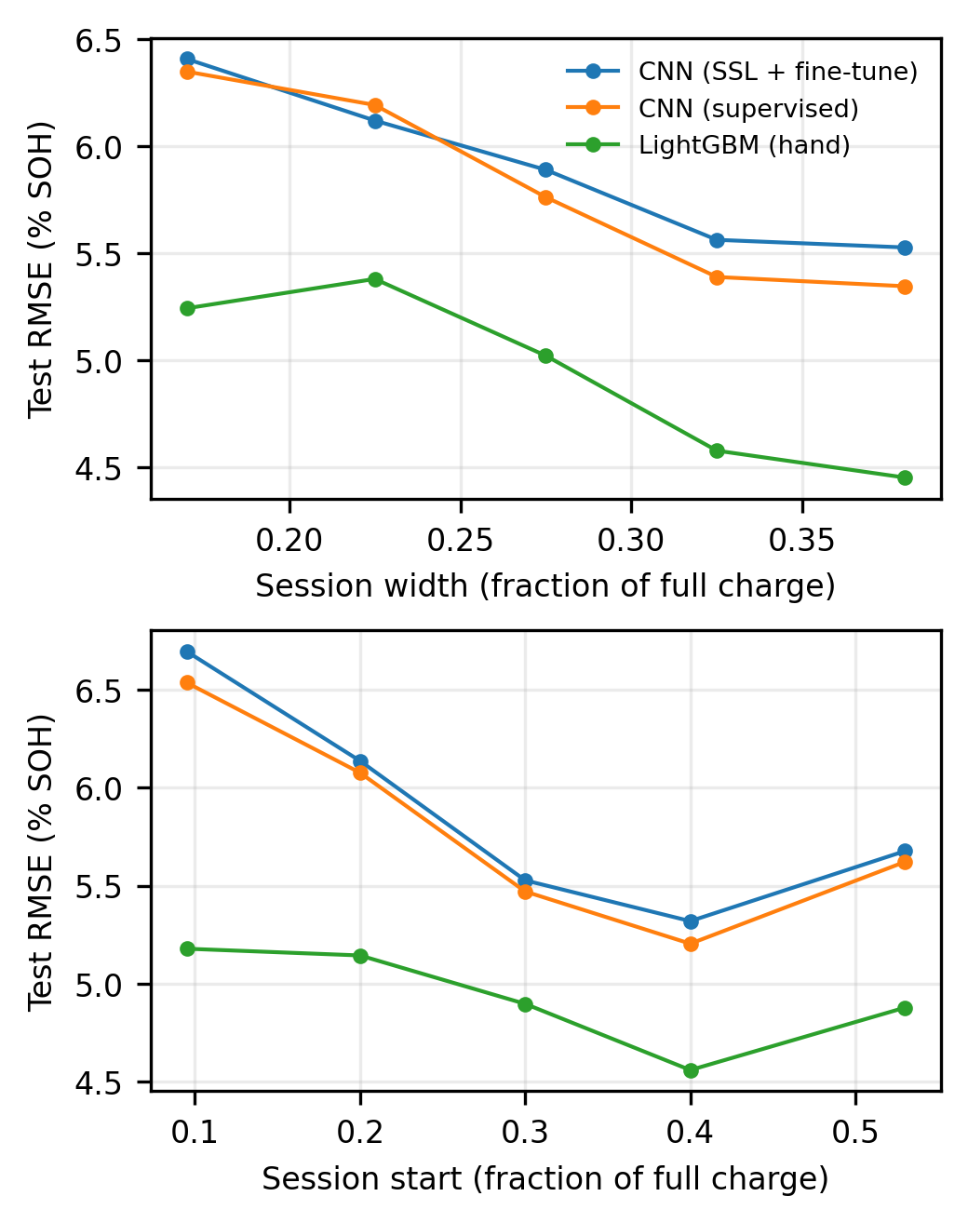
Fig. 12. Test RMSE versus session width (top) and session start (bottom), both as fractions of a full charge (all labels, three seeds pooled).

D. Calibration of Prediction Intervals
With all labels, split CQR produced a marginal coverage of 0.895 with a mean width of 14.1 % SOH for LightGBM, and 0.890 with 17.1 % (supervised) and 0.894 with 17.9 % (self-supervised) for the encoders; with 10 % labels, coverage was 0.883–0.888. The conformal correction acted in opposite directions for the two model families. It widened each side of the LightGBM quantile intervals by 0.74 points on average, because the raw quantiles under-covered, and narrowed each side of the encoder intervals by 0.99 (supervised) and 1.50 points (self-supervised), because the raw quantiles over-covered. Marginal coverage did not hold uniformly, however (Fig. 13). Per-source coverage of the best model ranged from 0.808 (NASA) to 0.914 (MATR), and per-cell coverage had a median of 0.921 but a minimum of 0.099. H3 is partly supported: CQR is approximately calibrated on average over unseen cells, but it provides no per-battery guarantee. An interval about 14 points wide is also too wide for warranty-grade decisions, although it suffices for coarse health categories.
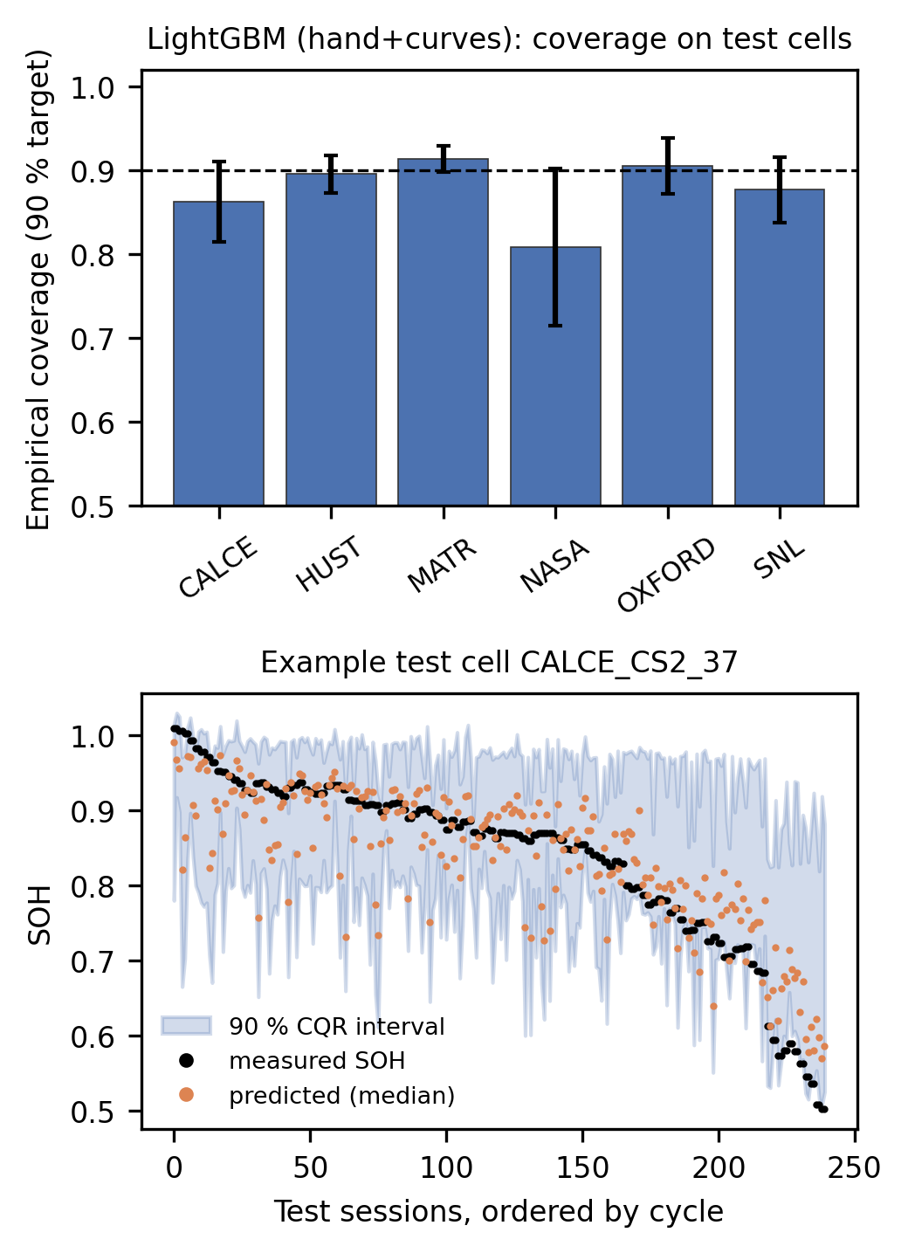
Fig. 13. Calibration of 90 % CQR intervals for the best model: coverage per source over three seeds (top) and intervals for one test cell (bottom).

E. Generalization to an Unseen Dataset
When an entire source was held out (Table VII, Fig. 14), every model failed to generalize. For seed 0, RMSE rose to 6.27–7.51 % (MATR held out), 7.95–8.49 % (HUST) and 10.92–12.20 % (SNL), and $R^{2}$ was below zero in all nine cases; that is, no model predicted SOH of an unseen dataset better than that dataset’s own mean. Coverage collapsed where the held-out SOH distribution differed most from the training sources. For HUST, whose cells have SOH up to 1.14 (above rated capacity), coverage fell to 0.21–0.34; for SNL, with its three chemistries and DoD windows, to 0.63–0.72; for MATR it remained 0.83–0.96.
Because the encoders differed by up to 1.37 points between the CPU (v1) and GPU (v2) runs on held-out datasets, we repeated the protocol over three split seeds (Table VIII). The conclusions held: across all 27 runs, $R^{2}$ never exceeded 0.03 and coverage ranged from 0.20 (HUST) to 0.96 (MATR). The ranking of models was not stable. The encoders had lower mean error than LightGBM on MATR (6.54 ± 0.24 % supervised vs. 7.19 ± 0.65 %) and HUST (7.94 ± 0.14 % vs. 8.59 ± 0.24 %), whereas LightGBM was best on SNL in every seed (11.17 ± 0.31 % vs. 12.53 ± 0.45 %). Self-supervised pre-training was worse than supervised training in 6 of 9 seed–dataset pairs (mean +0.33 points), so it is not a remedy for dataset shift. Because the calibration cells come from the training sources, the exchangeability assumption behind (8) is violated, and the measured coverage shows its practical consequence: a deployment on a new vehicle platform needs labelled calibration data, and likely training data, from that platform.
TABLE VII
LEAVE-ONE-DATASET-OUT RESULTS (SEED 0, ALL LABELS)

Held-out source | Model | Train cells | Test cells | RMSE (% SOH) | MAE (% SOH) | R² | 90 % PI coverage | PI width (% SOH)
MATR | LightGBM (hand) | 135 | 169 | 7.51 | 5.94 | -0.66 | 0.830 | 20.67
MATR | CNN (supervised) | 135 | 169 | 6.28 | 4.70 | -0.16 | 0.957 | 24.65
MATR | CNN (SSL + fine-tune) | 135 | 169 | 6.27 | 4.88 | -0.15 | 0.941 | 23.60
HUST | LightGBM (hand) | 201 | 77 | 8.49 | 7.52 | -0.14 | 0.212 | 6.98
HUST | CNN (supervised) | 201 | 77 | 8.10 | 7.14 | -0.04 | 0.310 | 10.44
HUST | CNN (SSL + fine-tune) | 201 | 77 | 7.95 | 7.02 | -0.00 | 0.336 | 11.05
SNL | LightGBM (hand) | 213 | 61 | 10.92 | 8.91 | -0.19 | 0.626 | 21.27
SNL | CNN (supervised) | 213 | 61 | 12.04 | 9.82 | -0.44 | 0.646 | 22.53
SNL | CNN (SSL + fine-tune) | 213 | 61 | 12.20 | 9.86 | -0.48 | 0.715 | 24.75

TABLE VIII
LEAVE-ONE-DATASET-OUT ROBUSTNESS OVER THREE SPLIT SEEDS (ALL LABELS)

Held-out source | Model | Seeds | RMSE (% SOH) | Max R² | Coverage, mean (range)
MATR | LightGBM (hand) | 3 | 7.19 ± 0.65 | -0.22 | 0.851 (0.811–0.912)
MATR | CNN (supervised) | 3 | 6.54 ± 0.24 | -0.16 | 0.931 (0.904–0.957)
MATR | CNN (SSL + fine-tune) | 3 | 6.89 ± 0.57 | -0.15 | 0.924 (0.912–0.941)
HUST | LightGBM (hand) | 3 | 8.59 ± 0.24 | -0.12 | 0.212 (0.200–0.225)
HUST | CNN (supervised) | 3 | 7.94 ± 0.14 | 0.03 | 0.280 (0.257–0.310)
HUST | CNN (SSL + fine-tune) | 3 | 8.03 ± 0.26 | 0.03 | 0.303 (0.250–0.336)
SNL | LightGBM (hand) | 3 | 11.17 ± 0.31 | -0.19 | 0.595 (0.567–0.626)
SNL | CNN (supervised) | 3 | 12.53 ± 0.45 | -0.44 | 0.592 (0.563–0.646)
SNL | CNN (SSL + fine-tune) | 3 | 13.07 ± 0.97 | -0.48 | 0.618 (0.538–0.715)

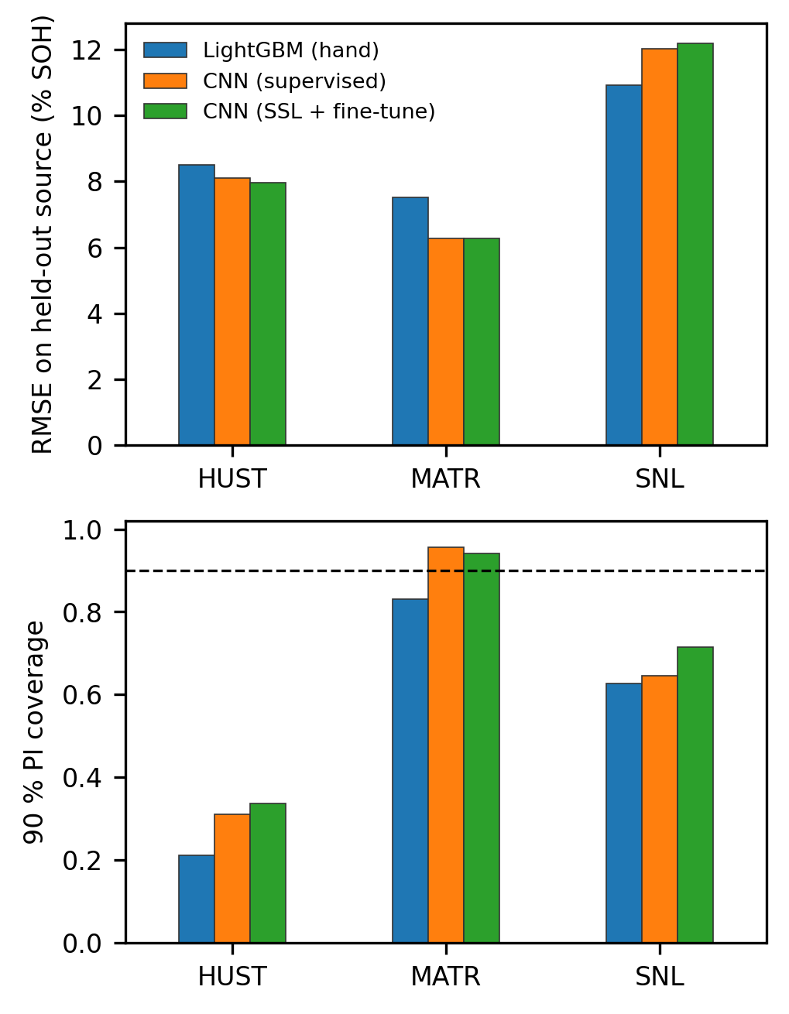
Fig. 14. Leave-one-dataset-out RMSE (top) and 90 % interval coverage (bottom), seed 0; the dashed line marks nominal coverage.

F. Computational Cost
With all labels, training one LightGBM configuration (median and two quantile models, CPU) took 9.6 s on handcrafted features and 22.1 s with the raw views, averaged over seeds. Training one encoder on the GPU took 23.8 s (supervised) and 24.1 s (self-supervised, including the 10-epoch pre-training, which is shared by the two label budgets of a seed). These are wall-clock times on a single laptop and include data transfer. Inference latency was not measured and is not reported.

G. Reproducibility of the Reported Results
The results above come from a complete rerun (v2) of the benchmark that saves every trained model. The session tensors were regenerated from the harmonized data and matched those of the original run (v1) exactly in all 17 stored arrays. For each of the 66 runs (30 unseen-cell, 9 cross-dataset and 27 in the three-seed cross-dataset check), we release the model weights (ridge and LightGBM model files; encoder state dictionaries, the pre-trained encoder and the input-standardization statistics), the cell-level split manifest, and the calibration artifacts (calibration scores, raw quantiles and $\hat{Q}$). An independent script reloads each saved model, re-predicts its test sessions and recomputes $\hat{Q}$, the intervals, coverage and width; all 66 runs matched the reported predictions (maximum difference below ${10}^{−15}$) with calibration cells disjoint from test cells. Seed 0 of the three-seed check reproduced the original cross-dataset run exactly, confirming that GPU training is deterministic under our settings. Relative to v1, the ridge and LightGBM results were bit-identical (21 of 21 runs). The encoders, which v1 trained on the CPU and v2 on the GPU, differed by at most 0.20 points of RMSE on unseen cells (mean +0.02) but by up to 1.37 points on a held-out dataset. Because the original v1 weights were not saved, they could not be recovered, and all numbers in this paper are from v2.

VII. Integration Into SmartEV
SmartEV (Fig. 1) provides charging-station discovery, slot reservation with Redis-based holds, server-verified payments, route planning and a battery dashboard. Its FastAPI service currently hosts heuristic recommendation and demand modules. The estimator studied here has been evaluated offline only. A prototype integration would receive each completed session (voltage and accumulated charge, chemistry, ambient temperature, C-rate) and return the median SOH and its 90 % interval. It would smooth successive estimates per vehicle, show range information with its uncertainty, and use the interval width to decide between an informational message (“estimate improving”) and an alert. Given the coverage loss under dataset shift (Section VI-E), recalibration on field data and continuous coverage monitoring would be prerequisites. The estimator does not guarantee battery safety or optimize charging.

VIII. Limitations and Threats to Validity
Table IX summarizes the main threats to validity and their implications for deployment.
TABLE IX
LIMITATIONS AND DEPLOYMENT IMPLICATIONS
Limitation | Effect | Addressed here
Laboratory cells (0.74–3.2 Ah), controlled protocols | No pack effects, cell imbalance or BMS current/SOC errors | No; requires fleet data
Sessions are simulated crops of measured laboratory full charges, not field plug-in events | Real sessions include rest, temperature and current transients and BMS sensor noise | Partly (random start and width)
LFP dominates (264 of 361 cells) | Aggregate metrics weighted towards LFP | Per-source results reported
Dependent sessions within a cell | CQR exchangeability holds only approximately | Coverage measured per source and cell
Dataset shift | Coverage falls on an unseen dataset | Measured (leave-one-dataset-out)
Six heterogeneous sources (cell formats, protocols, cyclers, preprocessing) | Source effects confounded with chemistry and protocol | Per-source and leave-one-dataset-out results
Four sources taken from a processed release [24], not the raw exports | Upstream preprocessing errors would propagate | No; raw cycler exports not re-processed
Calibration cells from the training sources only | No coverage guarantee under dataset shift | Measured; recalibration needed
Encoder training budget (25 epochs) | Encoders may be under-trained | Disclosed (Fig. 8)
Three seeds; limited hyperparameter search | Coarse variance estimates; results are not an upper bound | Disclosed; cross-dataset repeated over three seeds
Encoders trained on GPU | Not bit-identical to CPU training | Weights released; v1/v2 differences reported
No field SOH labels | Field accuracy unknown | No

IX. Conclusion
From one arbitrary partial charging session, represented only by BMS-observable voltage and accumulated charge, SOH could be estimated on unseen laboratory cells with 4.89 ± 0.19 % RMSE by gradient-boosted trees on physically motivated session features. A dual-view convolutional encoder was about one point worse, and self-supervised masked-curve pre-training did not change its accuracy measurably, even with 10 % labels. Longer sessions that cover the mid-SOC region were the most informative. Split CQR gave near-nominal marginal coverage (0.895) on unseen cells of seen datasets, but coverage varied widely between datasets and individual cells. When a whole dataset was held out, no model generalized ($R^{2}≤0.03$ over three seeds), coverage ranged from 0.20 to 0.96 depending on the dataset, and the ranking of models changed between datasets and seeds. These are negative or qualified findings for H1–H3, and they suggest two priorities. First, partial-session SOH estimators should be benchmarked with cell- and dataset-separated protocols against strong feature-based baselines. Second, interval methods for dependent, shifted battery data, such as group- or domain-conditional conformal prediction, need further work. Future work will test longer encoder training and alternative pre-training objectives, physics-constrained degradation forecasting with explicitly enforced monotonicity [18], and field validation with fleet charging sessions.

References
[1] B. Chinomona, C. Chung, L.-K. Chang, W.-C. Su, and M.-C. Tsai, “Long short-term memory approach to estimate battery remaining useful life using partial data,” IEEE Access, vol. 8, pp. 165419–165431, 2020, doi: 10.1109/ACCESS.2020.3022505.
[2] G. Lyu, H. Zhang, and Q. Miao, “Parallel state fusion LSTM-based early-cycle stage lithium-ion battery RUL prediction under Lebesgue sampling framework,” Reliab. Eng. Syst. Saf., vol. 236, Art. no. 109315, 2023, doi: 10.1016/j.ress.2023.109315.
[3] K. Liu, Y. Shang, Q. Ouyang, and W. D. Widanage, “A data-driven approach with uncertainty quantification for predicting future capacities and remaining useful life of lithium-ion battery,” IEEE Trans. Ind. Electron., vol. 68, no. 4, pp. 3170–3180, Apr. 2021, doi: 10.1109/TIE.2020.2973876.
[4] J. Zhu, T. Tan, L. Wu, and H. Yuan, “RUL prediction of lithium-ion battery based on improved DGWO-ELM method in a random discharge rates environment,” IEEE Access, vol. 7, pp. 125176–125187, 2019, doi: 10.1109/ACCESS.2019.2936822.
[5] Z. Kong, S. Li, and C. Wang, “Estimation and uncertainty quantification of remaining useful life (RUL) of electric vehicle batteries using a temporal deep model,” Sci. Rep., vol. 16, Art. no. 18704, 2026, doi: 10.1038/s41598-026-54385-4.
[6] Y. Wei and D. Wu, “Prediction of state of health and remaining useful life of lithium-ion battery using graph convolutional network with dual attention mechanisms,” Reliab. Eng. Syst. Saf., vol. 230, Art. no. 108947, 2023, doi: 10.1016/j.ress.2022.108947.
[7] Z. Wang, N. Liu, C. Chen, and Y. Guo, “Adaptive self-attention LSTM for RUL prediction of lithium-ion batteries,” Inf. Sci., vol. 635, pp. 398–413, 2023, doi: 10.1016/j.ins.2023.01.100.
[8] K. A. Severson et al., “Data-driven prediction of battery cycle life before capacity degradation,” Nat. Energy, vol. 4, pp. 383–391, 2019, doi: 10.1038/s41560-019-0356-8.
[9] B. Saha and K. Goebel, “Battery data set,” NASA Ames Prognostics Data Repository, NASA Ames Research Center, Moffett Field, CA, USA, 2007.
[10] Y. Xing, E. W. M. Ma, K.-L. Tsui, and M. Pecht, “An ensemble model for predicting the remaining useful performance of lithium-ion batteries,” Microelectron. Reliab., vol. 53, no. 6, pp. 811–820, 2013, doi: 10.1016/j.microrel.2012.12.003.
[11] C. R. Birkl, “Diagnosis and prognosis of degradation in lithium-ion batteries,” Ph.D. dissertation, Dept. Eng. Sci., Univ. Oxford, Oxford, U.K., 2017.
[12] D. Roman, S. Saxena, V. Robu, M. Pecht, and D. Flynn, “Machine learning pipeline for battery state-of-health estimation,” Nat. Mach. Intell., vol. 3, no. 5, pp. 447–456, 2021, doi: 10.1038/s42256-021-00312-3.
[13] J. Tian, R. Xiong, W. Shen, J. Lu, and X.-G. Yang, “Deep neural network battery charging curve prediction using 30 points collected in 10 min,” Joule, vol. 5, no. 6, pp. 1521–1534, 2021, doi: 10.1016/j.joule.2021.05.012.
[14] J. Zhu et al., “Data-driven capacity estimation of commercial lithium-ion batteries from voltage relaxation,” Nat. Commun., vol. 13, Art. no. 2261, 2022, doi: 10.1038/s41467-022-29837-w.
[15] J. Lu, R. Xiong, J. Tian, C. Wang, and F. Sun, “Deep learning to estimate lithium-ion battery state of health without additional degradation experiments,” Nat. Commun., vol. 14, Art. no. 2760, 2023, doi: 10.1038/s41467-023-38458-w.
[16] K. He, X. Chen, S. Xie, Y. Li, P. Dollár, and R. Girshick, “Masked autoencoders are scalable vision learners,” in Proc. IEEE/CVF Conf. Comput. Vis. Pattern Recognit., 2022, pp. 15979–15988, doi: 10.1109/CVPR52688.2022.01553.
[17] Y. Romano, E. Patterson, and E. J. Candès, “Conformalized quantile regression,” in Proc. Adv. Neural Inf. Process. Syst., vol. 32, 2019. [Online]. Available: arXiv:1905.03222.
[18] C. Rackauckas et al., “Universal differential equations for scientific machine learning,” 2020, arXiv:2001.04385.
[19] T. Wang, Z. Ma, S. Zou, Z. Chen, and P. Wang, “Lithium-ion battery state-of-health estimation: A self-supervised framework incorporating weak labels,” Appl. Energy, vol. 355, Art. no. 122332, 2024, doi: 10.1016/j.apenergy.2023.122332.
[20] L. Teng, W. Li, and Z. Li, “Partial charging as natural masking: Self-supervised pre-training for lithium-ion battery state of health prediction,” SSRN preprint, 2026, doi: 10.2139/ssrn.7552735.
[21] J. Yao and J. Kowal, “Degradation-aligned self-supervised learning for state of health estimation of lithium-ion batteries under label sparsity,” 2026, arXiv:2608.16612.
[22] S. F. da Silva, M. F. Ozkan, F. El Idrissi, and M. Canova, “Conformalized transfer learning for Li-ion battery state of health forecasting under manufacturing and usage variability,” 2026, arXiv:2603.24475.
[23] H. Zhang et al., “BatteryML: An open-source platform for machine learning on battery degradation,” 2023, arXiv:2310.14714.
[24] R. Tan et al., “BatteryLife: A comprehensive dataset and benchmark for battery life prediction,” 2025, arXiv:2502.18807.
[25] Y. Preger et al., “Degradation of commercial lithium-ion cells as a function of chemistry and cycling conditions,” J. Electrochem. Soc., vol. 167, no. 12, Art. no. 120532, 2020, doi: 10.1149/1945-7111/abae37.
[26] G. Ma et al., “Real-time personalized health status prediction of lithium-ion batteries using deep transfer learning,” Energy Environ. Sci., vol. 15, pp. 4083–4094, 2022, doi: 10.1039/D2EE01676A.
[27] P. M. Attia et al., “Closed-loop optimization of fast-charging protocols for batteries with machine learning,” Nature, vol. 578, pp. 397–402, 2020, doi: 10.1038/s41586-020-1994-5.
[28] G. S. Oh, D. J. LeBlanc, and H. Peng, “Vehicle energy dataset (VED), a large-scale dataset for vehicle energy consumption research,” 2019, arXiv:1905.02081.
[29] G. Ke et al., “LightGBM: A highly efficient gradient boosting decision tree,” in Proc. Adv. Neural Inf. Process. Syst., vol. 30, 2017.

