WEB Assignment

Time duration – 2.5 hrs
Instructions

- Read the problem statement thoroughly
- Need to follow MVC pattern with appropriate package and folder structure.
- Create the dynamic web project with the name Web_EmpNo_EmpName and copy the
completed web project from your workspace ,zip the folder ( eg. Web_123456_Raj.zip),
upload the same in iON on time.

- Create the following table

TBL_Book_XXXXXX ( Replace XXXXXX with your EMPID)

Field | Datatype | Constraint
BookId | Number | Primary Key
BookName | Varchar2(25) | Not null
BookAuthor | Varchar2(25) | Not null
YearofPublish | Number
BookCost | Number(7,2) | Not null

Sample data for your reference—

BookId | BookName | BookAuthor | YearofPublish | BookCost
101 | Gitanjali | R. Tagore | 1910 | 312.05
105 | Wings Of Fire | A. P. J. Abdul Kalam | 1999 | 179

1. Search Book

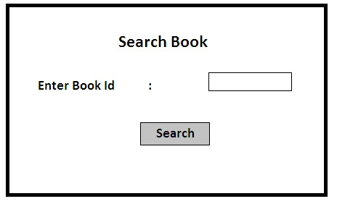

2. Search Result

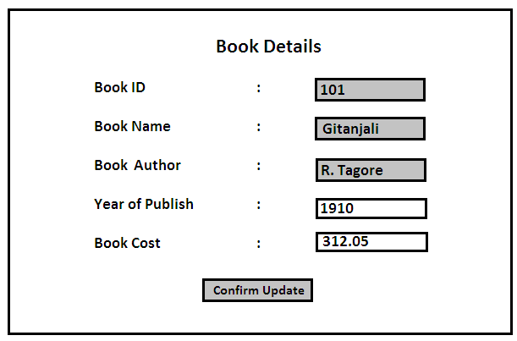

If details of given Book Id is present it should be displayed as above.
Only some fields ( not in grey background)are editable.

After changing the values and clicking on 'Confirm Update' button , it will direct to
below screen.
(Hint:-Table update will not happen at this point)

3. Confirm Update

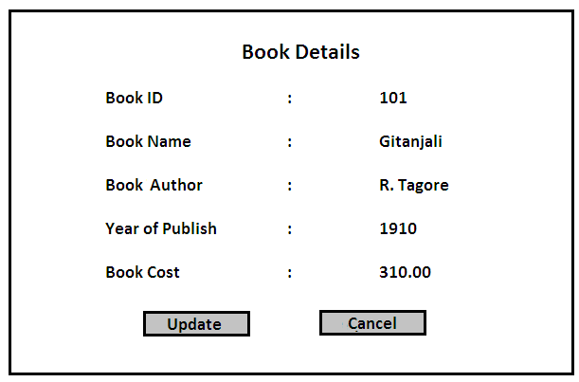

Once you click on Update button ,the details will be updated in the table, and on click of Cancel button ,it will show the Previous page.

4. Result Page

You can also show a successful message like

'The details of book with ID *** has been updated successfully!!'

OR

'Error while updating book with ID ***!!' in case of update failure.

Note: Validations can be provided where ever applicable.

75% weightage is for CRUD
25%weightage is for UI validations.

