* Some terms you need to know before starting analyzing data.

[EEG](https://en.wikipedia.org/wiki/Electroencephalography)[1]: Electroencephalography (EEG) is an [electrophysiological](https://en.wikipedia.org/wiki/Electrophysiology) monitoring method to record the electrical activity of the [brain](https://en.wikipedia.org/wiki/Brain). It is typically noninvasive, with the [electrodes](https://en.wikipedia.org/wiki/Electrode) placed along the [scalp](https://en.wikipedia.org/wiki/Scalp), although invasive electrodes are sometimes used such as in [electrocorticography](https://en.wikipedia.org/wiki/Electrocorticography). EEG measures voltage fluctuations resulting from [ionic current](https://en.wikipedia.org/wiki/Ion_current) within the [neurons](https://en.wikipedia.org/wiki/Neurons) of the [brain](https://en.wikipedia.org/wiki/Brain). In clinical contexts, EEG refers to the recording of the brain's spontaneous electrical activity over a period of time, as recorded from multiple [electrodes](https://en.wikipedia.org/wiki/Electrode) placed on the scalp. Diagnostic applications generally focus either on [event-related potentials](https://en.wikipedia.org/wiki/Event-related_potential) or on the [spectral content](https://en.wikipedia.org/wiki/Frequency_spectrum) of EEG. The former investigates potential fluctuations time locked to an event like stimulus onset or button press. The latter analyses the type of [neural oscillations](https://en.wikipedia.org/wiki/Neural_oscillation) (popularly called "brain waves") that can be observed in EEG signals in the frequency domain.

[ERP](https://en.wikipedia.org/wiki/Event-related_potential)[2]: An event-related potential (ERP) is the measured [brain](https://en.wikipedia.org/wiki/Brain) response that is the direct result of a specific [sensory](https://en.wikipedia.org/wiki/Sense), [cognitive](https://en.wikipedia.org/wiki/Cognition), or [motor](https://en.wikipedia.org/wiki/Motor_system) event. More formally, it is any stereotyped [electrophysiological](https://en.wikipedia.org/wiki/Electrophysiology) response to a stimulus. The study of the brain in this way provides a [noninvasive](https://en.wikipedia.org/wiki/Invasiveness_of_surgical_procedures) means of evaluating brain functioning. ERPs are measured by means of [electroencephalography](https://en.wikipedia.org/wiki/Electroencephalography) (EEG).

* Dataset Description:

This data file contains the ERP averages for each subject and condition from a subset (n=9) of the 64 channel recording montage. Electrode labels correspond to 10-20 locations displayed below (view from above, triangle pointing north is the nose):

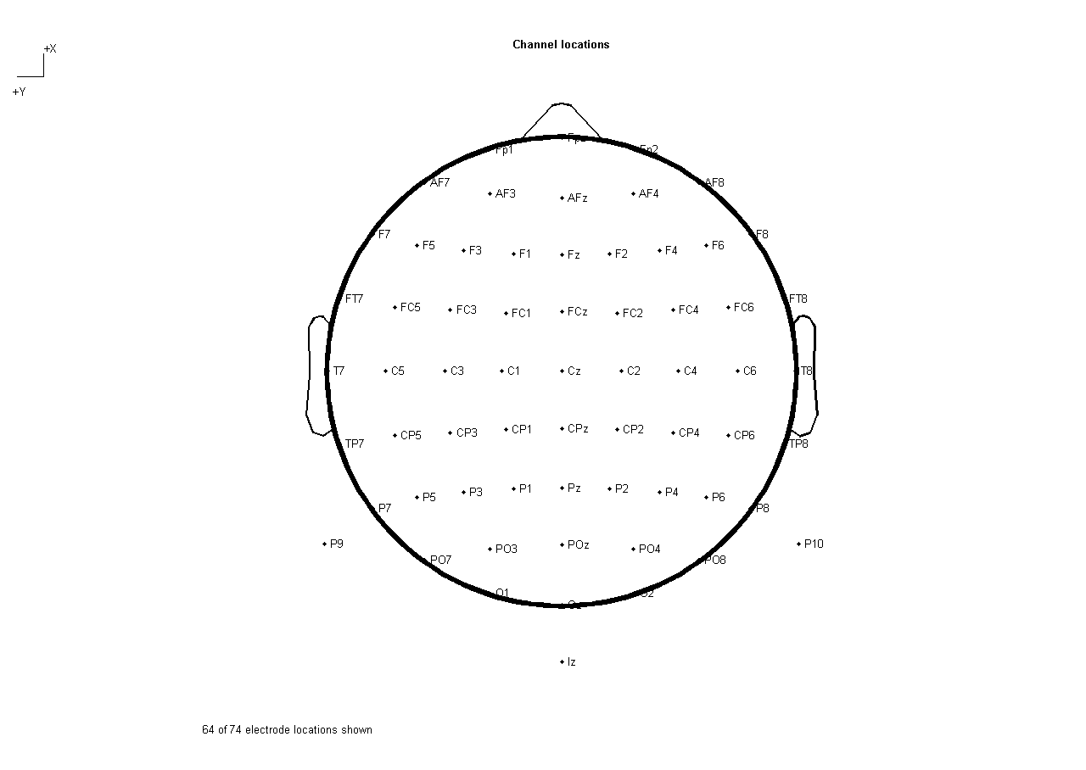

Columns:

subject: a subject identifier, could be used to join with other data files.

Condition: numeric code for condition, where 1 = button press + tones, 2 = playback tones, 3 = control presses.

Fz: ERP amplitude for electrode Fz

FCz: ERP amplitude for electrode FCz

Cz: ERP amplitude for electrode Cz

FC3: ERP amplitude for electrode FC3

FC4: ERP amplitude for electrode FC4

C3: ERP amplitude for electrode C3

C4: ERP amplitude for electrode C4

CP3: ERP amplitude for electrode CP3

CP4: ERP amplitude for electrode CP4

time_ms: time period, 1.5 seconds before and after task events (3s total)

More details on <https://www.kaggle.com/broach/button-tone-sz/home>

* Some Hints:

Please start from one subject. Display and compare the ERP waveforms for each condition for all electrodes.

1. https://en.wikipedia.org/wiki/Electroencephalography
2. https://en.wikipedia.org/wiki/Event-related_potential