User Manual

Steps:

1. Click on the link <http://127.0.0.1:5000/>

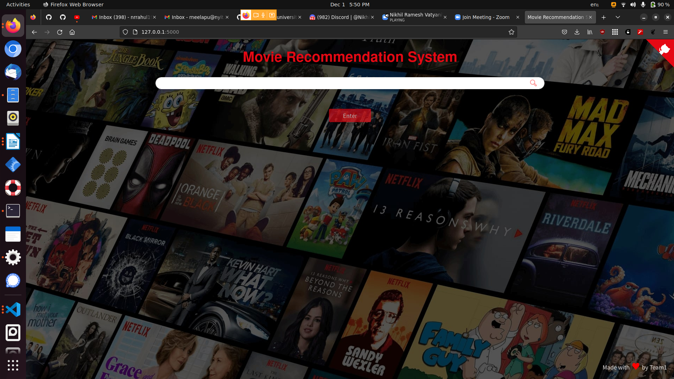

1. Search for a movie of your interest in the seach bar.



1. Press enter and it will be automatically proceeded to results.



1. If we scroll down further we can see top cast and their individual details
2. After the cast user reviews are available
3. Lastly recommended movies are suggested.
4. The button at the top right corner is the website github link for reference.