Cloud Application Development

Week -5

WEEK-5: GOOGLE APP ENGINE LAUNCHER Use Google App Engine (GAE) launcher to launch the web applications

AIM:

To use GAE launcher to launch the web applications.

PROCEDURE:

Installation Process:

Pre-Requisites: Python 2.7

If you don't already have Python 2.7 installed in your computer, download and install Python 2.7 from:

https://www.python.org/download/releases/2.7/

1. Download the Google App Engine (GAE) Launcher using the following link

https://www.npackd.org/p/com.google.AppEnginePythonSDK/1.9.62

2. Install the Google App Engine Launcher using the following steps.

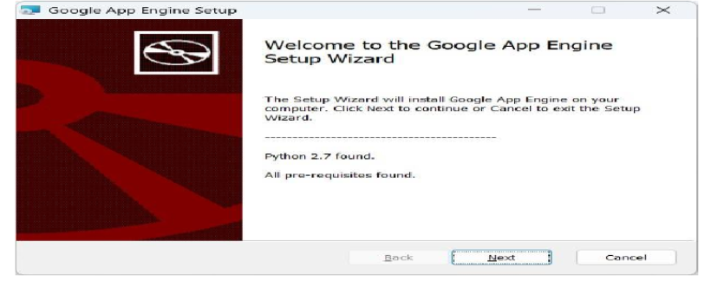

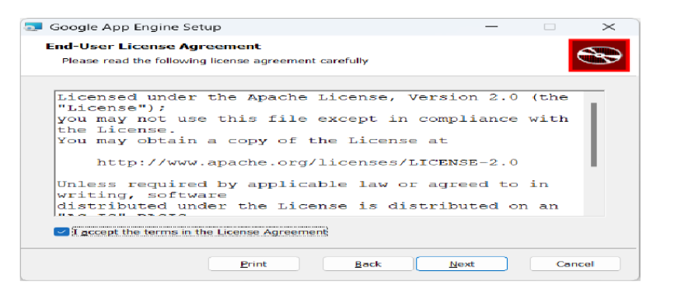

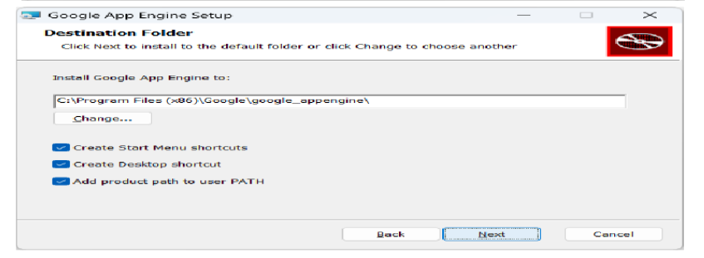

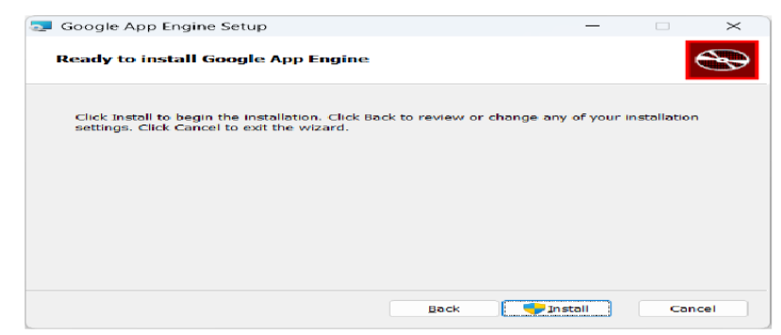

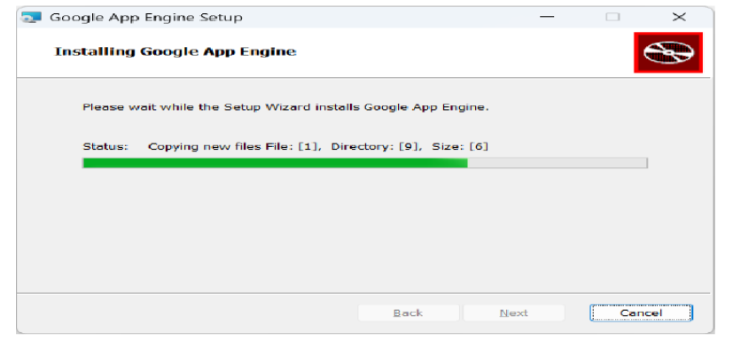

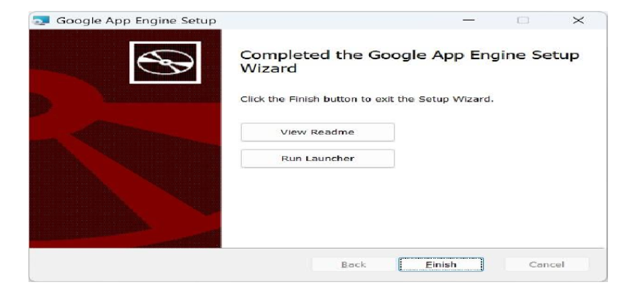

3. Click Run Launcher, the Google App Engine Launcher will open.

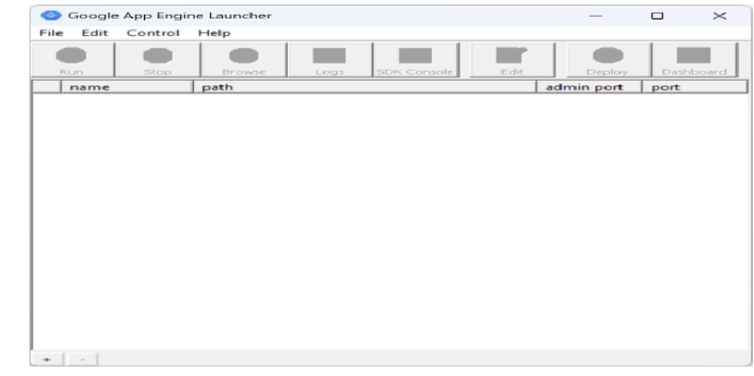

Making Your Applications:

1. To set the paths for python and Google Application Engine, In GAE Launcher menu,

Click Edit ->Preferences.

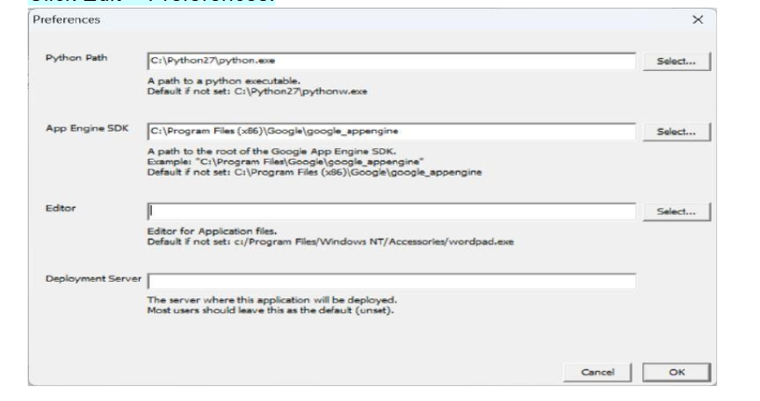

2. Create one folder in Desktop. (E.g., apps)

3. In Google App Engine Launcher Menu, Click File-> Create New Application, and pick a parent

directory for the new applications, then click Create.

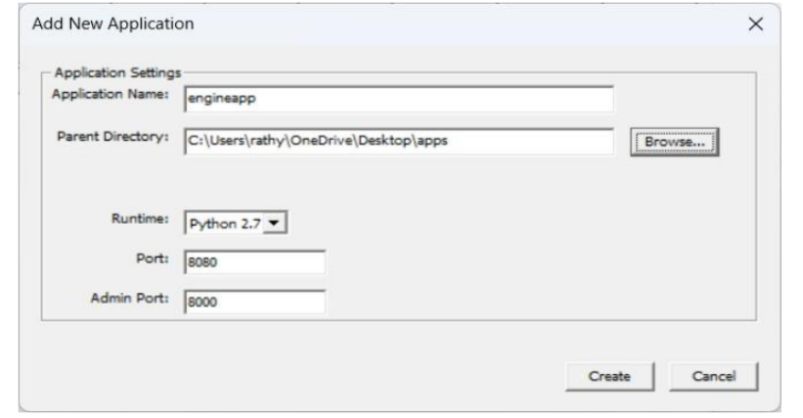

4. Once you have created the new application, the following files (app.yaml, favicon.ico, index.yaml,

main.py) are automatically created in your apps folder.

5. Select the created application, so that you can control the application using the launcher.

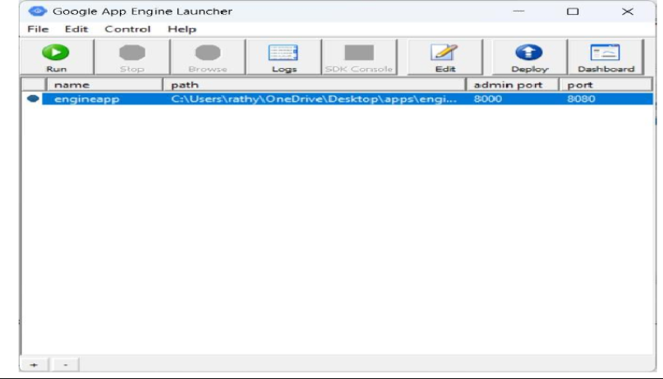

6. Once you have selected your application and click Run. After a few moments your

application will start and the launcher will show a little green icon next to your application.

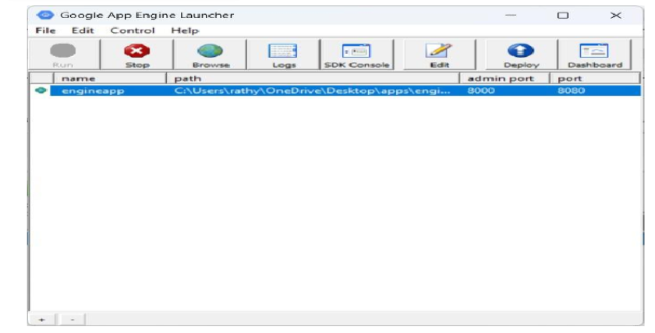

7. Then click Browse to open a browser pointing at your application which is running at

http://localhost:8080/ or type http://localhost:8080 into your browser and you should see

your application as follows:

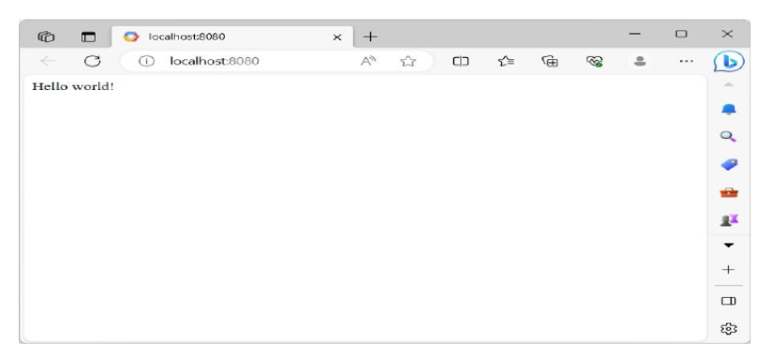

Watching the Log

You can watch the internal log of the actions that the web server is performing

when you are interacting with your application in the browser. Select your

application in the Launcher andpress the Logs button to bring up a log window:

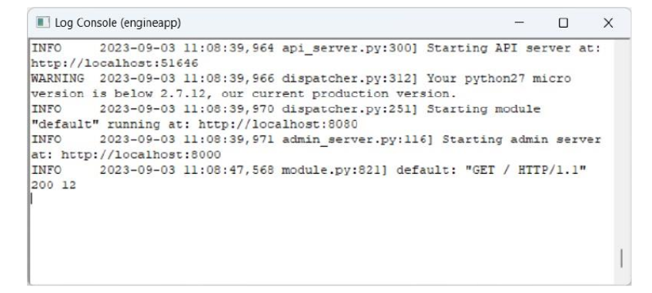

Each time you press Refresh in your browser – you can see it retrieving the output with a GET

request.

Shutting Down the Server :

To shut down the server, use the Launcher, select your application and press the Stop button.

CONCLUSION:

Thus, the installation of GAE launcher was launched and verified successfully.