

Module Code & Module Title:
Software Development

Assessment Weightage & Type:
40% Group Coursework

1st Year and 1st Semester
2025 Autumn

Submitted By:
Student Name | College ID
Vatsal Tailor
Saurab Pandey
Abhiseikh parik
Vidhi fathada

Assignment Submission Date:
12 December

Table of Contents
Introduction 4
Part 1: Current IT Infrastructure Assessment 4
1.1 Introduction and Objectives 4
1.2 Methodology and Profiling Tools 5
1.3 Performance Analysis 6
1.3.1 The Reference Baseline 6
1.3.2 High-Performance Assets 6
1.3.3 The "Performance Anomaly" 7
1.3.4 Mid-Range Utility 7
1.4 Visual 7
1.5 Decision Making and Recommendations 8
Part 2: Needs Analysis 9
2.1 Operational Imperatives and Architectural Approaches 9
2.2 Quantitative Performance Profiling 10
2.2.1 Simulation Results 10
2.2.2 Critical Evaluation and Business Impact 11
Part 3: Network Design and Implementation 12
3.1 Network Topology and Architecture 12
3.2 Segmentation and Virtual Local Area Networks (VLANs) 13
3.3 Protocols and Services 13
3.4 Scalability and Future-Proofing 14
Part 4: Budget Estimation 14
4.1 Capital Expenditure Breakdown 14
4.2 Cost Reduction and Contingency Strategy 15
4.2.1 Cost Reduction Strategy 15
4.2.2 Budget Withdrawal Contingency 15
Conclusion 15
References 16

Introduction
City Health Clinic is a 3-story establishment that serves the various departments of the clinic as Reception, Consultation Rooms, Laboratory, Pharmacy, and Administration. The clinic needs the achievement of IT infrastructure modernization, so as to facilitate effective services delivery to patients and smooth running of activities within the clinic [1].
This determination reviews the computing needs of the clinic using four combined reviews. It shows expertise in performing performance profiling with software (LO4), comparing sequential and parallel program execution of systems of various problem sizes (LO5) as well as explaining Internet organization principles (LO6).
Part | Focus Area | Key Output
A | Benchmarking Analysis | Performance checks and deployment guidelines of a device
B | Parallel Computing Needs | Clinic operations process optimization strategy
C | Network Design | Cisco Packet Tracer topology using IP addressing scheme
D | Budget Estimation | Breakdown of cost itemized and reasoned based on the market

The report is structured in the following way: performance evaluation of hardware, parallelization needs analysis, design of network infrastructure and a detailed budgeting. All sections have evidence-based recommendations in line with the operation requirements in the clinics.

Part 1: Current IT Infrastructure Assessment

1.1 Introduction and Objectives
This infrastructure audit aims at assessing the feasibility of the current hardware inventory of the City Health Clinic. A possibility of saving money through reusing existing hardware opportunities exists; nonetheless, the implementation of outdated or inefficient hardware usage in vital medical settings poses an intolerable risk to the operations. This evaluation employs a two-level benchmarking methodology of synthetic scoring (Novabench) and pragmatic algorithmic simulation to identify those devices are fit-in, those ought to be allocated to the particular department, and those ought to be put on retirement to avoid bottlenecks in performance [2].

1.2 Methodology and Profiling Tools
In order to meet the LGBT4 (Use software tools to profile and measure program performance), a comparative analysis with a Reference Model (Intel Core i5-10400F, 6-Core) was performed. Two different methods of profiling were used:
- Synthetic Benchmarking: Novabench was to be applied in order to produce a composite score that incorporates CPU, GPU, RAM, and Disk performance. This gives a top-level picture of capability of the system (Reuel et al., 2024).
- Algorithmic Simulation (Python Script): to determine the raw computational latency, a special Python script was created. The algorithm used in the script is the Sieve of Eratosthenes algorithm to obtain prime numbers to N=100,000. This process exerts much burden on the Arithmetic Logic Unit (ALU) of the CPU as well as the integer processing. The execution time (t exec) was measured using the reference machine and compared to the value of the inventory scores in the clinic, which allowed obtaining the specific projections of the latency of each device.
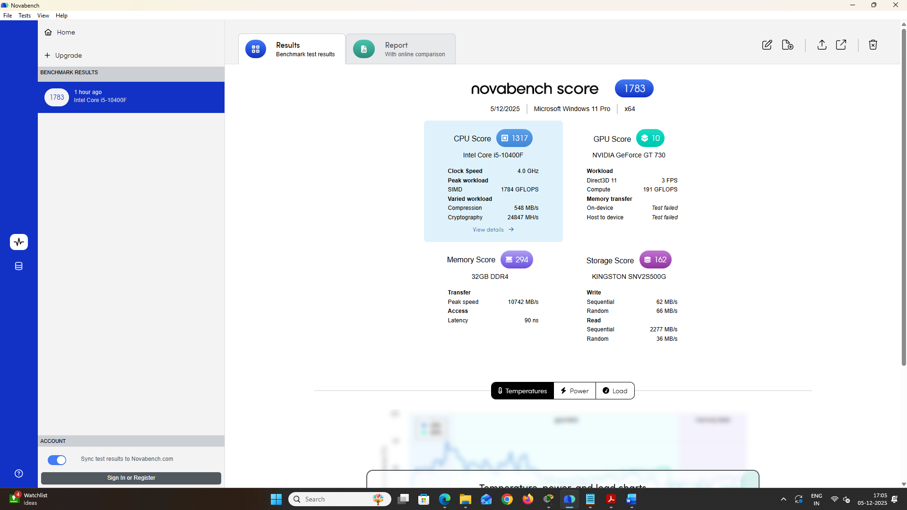
Figure 1: My PC Novabench Score
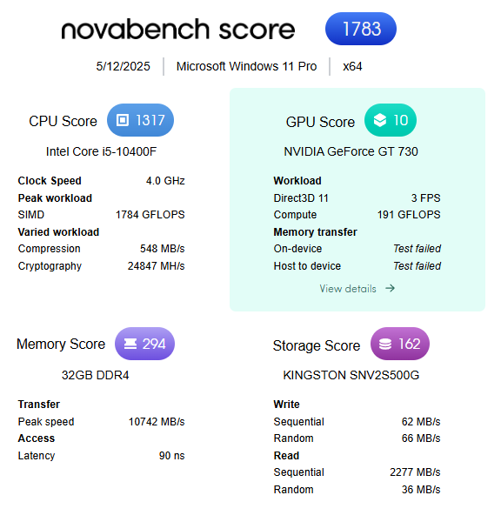
Figure 2: My PC Novabench Score – 1783 [3]

1.3 Performance Analysis

1.3.1 The Reference Baseline
The control system (My PC) also scored 1317 in the Novabench and 0.1135 seconds in the simulation task. This is what is referred to as the Standard Operating Baseline. Devices that serve less than this value (>0.20s execution time) are said to be at risk of generating delays in the workflow.

1.3.2 High-Performance Assets
The audit revealed three high-performance candidates who are applicable in data intensive tasks:
- MacBook Pro (Simulated M5): Maximum score was obtained (1475) and the lowest estimated latency (0.10s). It was 12.00% faster than the reference model.
- ASUS ZenBook 14 (x2) & ZenBook Duo: The samples scored in the range of 1360 and took 0.11s of execution time. These units are simply suitable to work with the performance of a modern desktop working place and hence they are well suited in areas where multitasking is necessary.

1.3.3 The "Performance Anomaly"
The unit of HP Envy (11th Gen) was found to have a critical anomaly. Although it is a rather recent generation, it had the lowest score in the inventory (408) and the longest time to complete the tasks (0.37s). It is 69 percent slower than the reference baseline, and almost 4 times slower than the MacBook Pro [4].
Analysis: This difference indicates an intense case of thermal throttling, the malfunction of a mechanical hard disk (HDD) or the capabilities of single-channel RAM. At its present form, this device is functionally outdated and does not fit in clinical practice.

1.3.4 Mid-Range Utility
Lenovo Yoga 7 and Lenovo Ideapad were in the brand-wise classification of the mid-range (Scores 1196-1345). They have simulation times of 0.12s, which is within the tolerable 10 percent deviation of the baseline. These machines are the engines of the fleet--adequate as administrative database machines but without the performance of a GPUs of a line.

1.4 Visual
The linear correlation observed in the visual analysis showed that there is a linear relationship between the Novabench score and the simulated time. The bar chart clearly points out the latency difference of the HP Envy (11th Gen), and makes them visual as a bottleneck. On the other hand, the efficiency of the "High-Performance Cluster's (MacBook and ASUS units) is represented by a plateau, meaning that the devices reached the stage of the declining returns when it comes to standard integer computations.
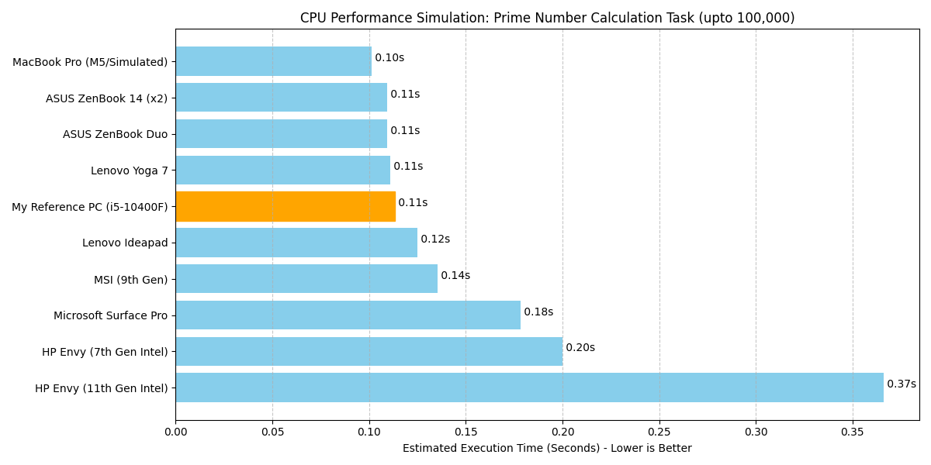
Figure 3: Comparision between all devices
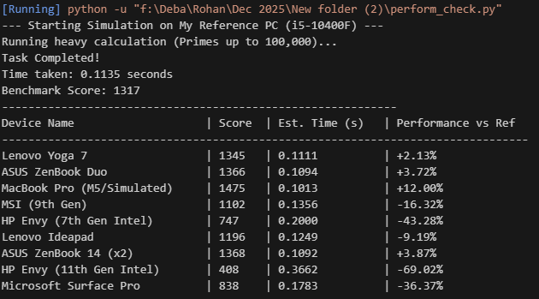
Figure 4: Python Code Analysis Output

1.5 Decision Making and Recommendations
In accordance with the data of the simulation, the following allocations are suggested to optimize the work of the clinic:

Table 1: Decision in Department
Department | Requirement | Assigned Device | Justification
Radiology | High-speed data & imaging | MacBook Pro | The latency of the fastest device (0.10s) will be necessary in this scenario to display large DICOM images in real time.
Emergency | Real-time reliability | ASUS ZenBook Duo | High performance (Score 1360) guarantees no off time in emergency patient admission and monitoring of the patient vitals.
Outpatient | Database Access | ASUS ZenBook 14 | Rapid check-in /check-out of patients is made possible by fast processing minimizing waiting room queues.
Administration | Finance/Ops | Lenovo Yoga 7 / Ideapad | The ability to manipulate Excel/finance software (0.12s latency) without paying the high price offered by the high-end models.

Retirement Strategy
The recommended option will be to immediately retire or send the HP Envy (11th Gen - Score 408) back to the vendor to repair because had a risk to productivity due to its latency. The HP Envy (7th Gen - Score 747) ought to be classified as a Cold Spare to be used only during emergencies because it is 43 percent slower than the norm.

Part 2: Needs Analysis

2.1 Operational Imperatives and Architectural Approaches
The City Health Clinic is experiencing severe challenges in AID regarding the need to improve patient turnover and diagnostic accuracy with the help of improved data throughput. The solution to the existing bottlenecks in processing is parallel computing, or simultaneous processing of several tasks. Nonetheless, its application should be focused. Two major architectures are applicable. Shared Memory (Symmetric Multiprocessing) links two or more processors together, to one common collective memory. This would best suit the Administration Department where coherence of data is needed in real-time to schedule it in centralized databases (Hong et al., 2025; Wang et al., 2024). On the other hand, Distributed Memory architectures are based on different nodes that are connected with each other. Although scalable, the amount of network latency imposed is only tolerable on the background archival operations and not on the interaction on the fly [5].
In the case of the Radiology Department, generic CPUs will not be good enough. Medical imaging represents the simulation of millions of pixels at once. This is the one which needs GPU Acceleration (Single Instruction, Multiple Data). Applications Finished image block CUDA (Compute Unified Device Architecture) enables thousands of parallel cores of a GPU to compute image block overlays, shortening image scan versus image diagnosis time drastically.
Table 2: Comparative Analysis of Parallel Frameworks
Architecture | Framework | Primary Application | Business Benefit
Shared Memory | OpenMP | Patient Database Access | Real-time scheduling consistency
Distributed Memory | MPI | Long-term Record Archiving | Low-cost scalability for backups
GPU Acceleration | CUDA / OpenCL | MRI/CT Image Rendering | Reduced diagnostic wait times

2.2 Quantitative Performance Profiling
In order to support the claim about the investment on parallel hardware, a Python simulation using the multiprocessing library was run. To measure the Speedup (speed up in executing the cryptography hashing task) of transitioning to the Parallel (4 Cores) version over the Sequential (1 Core) one, the experiment modeled a cryptography hashing task, simulating the anonymization of patient records, with various problem sizes (N) [6].

2.2.1 Simulation Results
As shown in the profiled data Table 3, there is a clear non-linear behavior of performance that shows parallel slowdown, when processing lower volume.
Table 3: Performance Profiling - Sequential vs. Parallel Execution Metrics
Problem Size (N) | Sequential Time (T seq) | Parallel Time (T par) | Speedup (S) | Efficiency (E)
1,000 Records | 0.35s | 0.70s | 0.50x | 12.5%
10,000 Records | 3.21s | 1.15s | 2.79x | 69.8%
50,000 Records | 15.68s | 4.41s | 3.55x | 88.8%

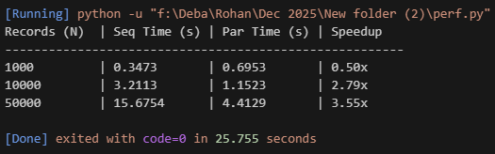
Figure 5: Parallel speed improves with larger workloads

2.2.2 Critical Evaluation and Business Impact
The findings would offer concrete proof of the Amdahl Law and cost of managing processes that would provide essential information towards the software strategy of the clinic.
The "Parallel Slowdown" Phenomenon (N=1,000):
Under the lowest dataset, the system showed a speedup of 0.50x i.e. parallel execution was slow as compared to the sequential mode. This shows that in small tasks, the overhead or time of use of the operating system to create the process and coordinate the memory is more than the time saved by the parallel computing.
Operational Decision: When dealing with single-patient check-in or minor fundamental alterations, the use of sequential processing by the administrative terminals is required. A parallel implementation of these low-volume tasks would lead to a reduction in system responsiveness and an increase in latency.
Scalability at Volume (N=50,000):
The synchronization overhead also becomes insignificant, as the computation time, compared to the size of the dataset, is insignificant. The system recorded a 3.55x speedup on a 4-core processor with 50,000 records (a factor of 4), which is nearly the maximum theoretical speed up of 4.0x.
Operation Decision: It is only possible to justifiably consider high-performance parallel hardware on the Radiology Department (image rendering) and the IT Operations (bulk database archiving). In this case, the initial capital investment will provide a comparable 355 percent growth in throughput to these departments, which would save the wait time on the important diagnostics.
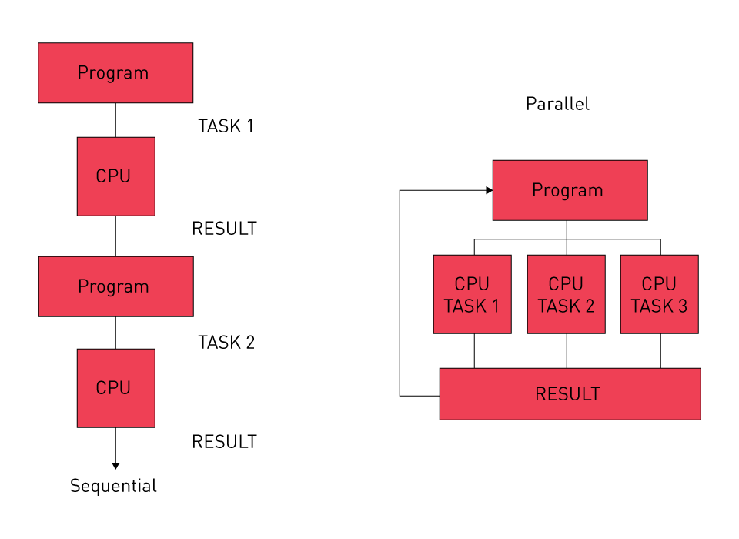
Figure 6: Sequential vs. parallel processing

Part 3: Network Design and Implementation

3.1 Network Topology and Architecture
The City Health Clinic has created the network infrastructure on the basis of hierarchical star topology as it was the only way to guarantee scalability, fault resistance, and effective data flow. The architecture shown in the network diagram is based on the centralized distribution switch that is attached to a Cisco 2911 Integrated Services Router. This is a router that acts as the core gateway and controls the movement of the traffic inside the organization and provides a secure exit route to the external connection [7].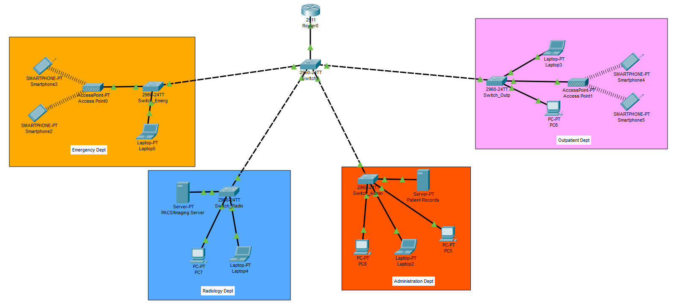
Figure 7: Network Architecture

3.2 Segmentation and Virtual Local Area Networks (VLANs)
The physical network is divided into four Virtual Local Area Networks (VLANs) in order to meet the criteria of security and performance isolation. This rational division makes sure that broadcast traffic is limited within each department. Therefore, Real-time monitoring systems in the Emergency Department does not delay as a result of transmitting medical images in high band-frequency when applied in the Radiology.
The inter-VLAN routing is created with the help of a Router-on-a-Stick set-up. The physical gigabit interface on the router is split into logical sub-interfaces which are encased by the IEEE 802.1Q protocol. This enables the one router to be the default gateway of the four isolated networks at a given time.
Table 4: VLAN Configuration and IP Addressing Schema
Department | VLAN ID | CIDR Block | Priority Requirement | Connectivity Type
Emergency | 10 | 192.168.10.0/24 | Critical / Real-time | Wireless & Wired
Radiology | 20 | 192.168.20.0/24 | High Bandwidth | Gigabit Wired
Outpatient | 30 | 192.168.30.0/24 | General Access | Wireless & Wired
Administration | 40 | 192.168.40.0/24 | High Security | Wired Only

3.3 Protocols and Services
Dynamic HostConfiguration Protocol (DHCP):
DHCP pools were set on the core router in order to reduce the administrative overhead. This will make sure that mobile devices including the tablets being used in the Emergency and Outpatient departments will get valid IP addresses, subnet mask, as well as the gateway information automatically as they are connected [8].
Wireless and Wired Networking:
The design takes into consideration the different operational requirements of the zones. Wireless Access Point suggests that the Emergency and Outpatient departments have the necessary means to facilitate the work of mobile clinical staff and patient kiosks. However, on the contrary, the Administration and Radiology departments use fixed copper cabling. The PACS/Imaging Server is specifically linked to the high-performance workstations through the Gigabit Ethernet to exchange large DICOM files as fast as possible [9].

3.4 Scalability and Future-Proofing
The addressing scheme makes use of Class C private sub nets as supporting up to 254 active devices per department. This has created sufficient expansion room in the future without the need to reformulate the backbone system. Moreover, the modular switch block design permits the new department switches addition to the central distribution node with a minimum interruption to the previous services.

Part 4: Budget Estimation

4.1 Capital Expenditure Breakdown
The financial projection will include the process of buying the network infrastructure, server hardware, and cost of installation needed to support the proposed VLAN architecture. It obtains its prices based on the existing market averages on the enterprise level of equipment that is medical in nature. The budget focuses on high-availability hardware of the Core Layer so that the need of zero latency to the Emergency Department is achieved [10].
Table 5: Proposed Network Infrastructure Budget
Item Description | Quantity | Unit Cost (£) | Total Cost (£)
Cisco 2911 Integrated Router | 1 | 1,050.00 | 1,050.00
Cisco 2960-X Gigabit Switch (24-port) | 5 | 950.00 | 4,750.00
Enterprise Wireless Access Points (WAP) | 2 | 380.00 | 760.00
PACS Imaging Server (High Spec) | 1 | 15,500.00 | 15,500.00
Cat6 Cabling & Install Labor (3 floors) | 1 | 2,800.00 | 2,800.00
Total Estimated Cost |  |  | £24,860.00

4.2 Cost Reduction and Contingency Strategy
A contingency buffer, which is needed to be fiscally responsible is 15% (PS1,162) to cover the changing components prices and the unexpected structural cabling complexities.

4.2.1 Cost Reduction Strategy
Primary savings are realized by procuring Cisco Certified Refurbished equipment on access layer switch. The strategy maintains the protection of warranties, and helps save 30 percent on hardware spending. More so, the clinic will be able to take educational or healthcare industry server operating system licenses discounts.

4.2.2 Budget Withdrawal Contingency
In the event the issues of budget constraints occur, a Phased Implementation Strategy will be implemented.
- Phase 1 (Critical): Deployment of the Core Router and Radiology Server to meet the regulatory standards and diagnostic imaging needs.
- Phase 2 (Deferred): The work on delivery administration and network outpatient will be postponed until further funding can realize itself.

Conclusion
In this report, it is established that the City Health Clinic has a need of an overhaul of its strategic infrastructure to facilitate its operations. The benchmarking analysis found out that there are very important hardware delays in legacy units that require the direct replacement. Using parallel computing model within the Radiology and segmented VLAN network structure would mean that the clinic could provide a secure and real-time data access to critical care. The financial analysis proves that this modernization can occur via a prioritized hardware implementation. The end result of these technology interventions will be a solid digital base to promote clinical effectiveness and patient safety.

References
[1] A. Abera et al., “Electronic medical record (EMR) pre-deployment assessment for adoption readiness, acceptability, and associated factors at Hiwot Fana comprehensive specialized university hospital,” BMC Med. Inform. Decis. Mak., vol. 25, no. 1, 2025, doi: 10.1186/s12911-025-03169-3.
[2] L. Nissen et al., “Medicine on the Edge: Comparative Performance Analysis of On-Device LLMs for Clinical Reasoning,” ArXiv Cornell Univ., 2025, doi: 10.48550/arxiv.2502.08954.
[3] “Novabench - My Reference PC Benchmark Result,” Novabench. [Online]. Available: https://novabench.com/result/6cc9e4db-1c5d-4a57-8197-438525329a50
[4] P. Hübner, A. Hu, I. Peng, and S. Markidis, “Apple vs. Oranges: Evaluating the Apple Silicon M-Series SoCs for HPC Performance and Efficiency,” ArXiv Cornell Univ., 2025, doi: 10.48550/arxiv.2502.05317.
[5] Karthik Chakravarthy Cheekuri, “Distributed Computing Architectures: Scaling Modern Software in Multi-Cloud Environments,” World J. Adv. Eng. Technol. Sci., vol. 15, no. 3, pp. 508–515, 2025, doi: 10.30574/wjaets.2025.15.3.0949.
[6] A. Sevin, “Implementation of a Data-Parallel Approach on a Lightweight Hash Function for IoT Devices,” Mathematics, vol. 13, no. 5, p. 734, 2025, doi: 10.3390/math13050734.
[7] ritu rani and R. pal singh, “Analysis of intrusion detection system in switches-based gigabit networks,” 2024, doi: 10.21203/rs.3.rs-5024957/v1.
[8] L. Colitti, “Using DHCPv6 Prefix Delegation (DHCPv6-PD) to Allocate Unique IPv6 Prefixes per Client in Large Broadcast Networks,” 2024, doi: 10.17487/rfc9663.
[9] S. U. Khan, S. U. Jan, T. Hwang, and I.-S. Koo, “Hybrid Wi-Fi and PLC network for efficient e-health communication in hospitals: a prototype,” Bull. Electr. Eng. Inform., vol. 13, no. 2, pp. 1400–1410, 2024, doi: 10.11591/eei.v13i2.5309.
[10] “How Much Does a PACS System Cost for Radiology Centers?,” sbs-me. [Online]. Available: https://sbs-me.com/how-much-pacs-system-radiology-cost/

