Programme: M.Sc. Computing Module: Database CMPL003-3
Student Name (1) :- Vatsal Nileshbhai Tailor Student ID (1):- A00067312
Student Name (2) :- Abhishek Maheshkumar Parikh Student ID (2) :A00075992

ORNAMENT RETAIL MANAGEMENT SYSTEM

- ORNAMENT RETAIL MANAGEMENT SYSTEM SUMMARY
- BUSINESS IDEA OVERVIEW :-

The Database Management System will help the shop to easily find product details, record sales, check stock, customer information, manage the inventory and keep track of its daily operations. At present, most ornament shops store their data manually or in a business book, which can lead to mistakes, missing information, and delays. The objective of this system is to make all business data organised, accurate, and easy to access in one place. The database will make it simple to find product details, record sales, check stock, manage suppliers, and keep customer information safe.

- WORK OBJECTIVES:-

- To build a database that can store, find, and manage ornaments store details effectively.
- To show how customers, employees, branch, catogry, products, orders, and payments are all linked together.
- To make sure the data is correct by using special links to connect everything correctly.
- To let people quickly see customer purchases, what items are available, and the performance of each store.
- To keep things simple between the product, inventory and supplier by keeping good records of the data.
- To include useful features like sales, membership, and ways to give feedback to improve business operations.

ERD

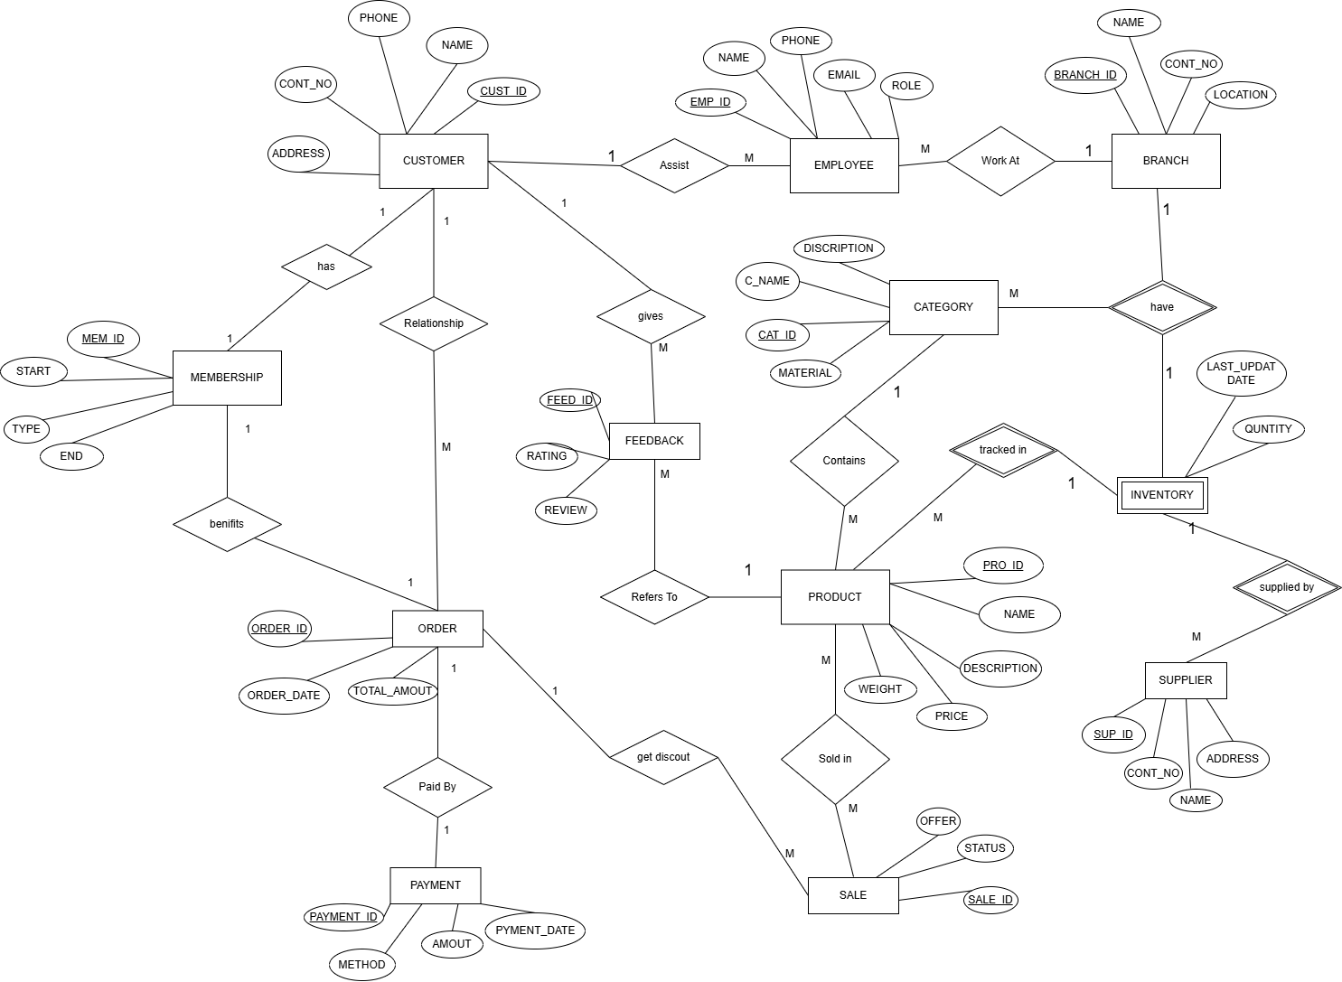

PHYSICAL DATA MODEL
CUSTOMER
Column | Type | Key
cust_id | INT(20) | PK
name | VARCHAR(50)
Cont_no | BIGINGT(10)
email | VARCHAR(50)
address | VARCHAR(100)

BRANCH
Column | Type | Key
branch_id | INT(20) | PK
name | VARCHAR(50)
Cont_no | BIGINGT(10)

EMPLOYEE
Column | Type | Key
emp_id | INT(20) | PK
name | VARCHAR(50)
role | VARCHAR(30)
phone | BIGINT (10)
branch_id | INT(20) | FK

CATEGORY
Column | Type | Key
cat_id | INT(20) | PK
c_name | VARCHAR(30)
material | VARCHAR(30)
description | VARCHAR(50)

Column | Type | Key
Sup_id | INT | PK
name | VARCHAR(50)
cont_no | BIGINT(10)
address | VARCHAR(30)

SUPLIER

Column | Type | Key
pro_id | INT(20) | PK
name | VARCHAR(50)
cat_id | INT(20) | FK
weight | VARCHAR(20)
description | VARCHAR(50)
price | DECIMAL(10,2)
sup_id | INT(20) | FK
PRODUCT

INVENTORY
Column | Type | Key
pro_id | INT(20) | FK
branch_id | INT(20) | FK
qunitity | INT(20)
last_update | DATE

MEMBERSHIP
Column | Type | Key
mem_id | INT(20) | PK
cus_id | INT(20) | FK
type | VARCHAR(30)
start | DATE
end | DATE

SALE
Column | Type | Key
sale_id | INT(20) | PK
pro_id | INT(20) | FK
offer | VARCHAR(40)
status | VARCHAR(30)

Column | Type | Key
order_id | INT(20) | PK
cust_id | INT(20) | FK
Mem_id | INT(20) | FK
order_date | DATE
sale_id | INT(20) | FK
total_amount | DECIMAL(10,2)
ORDERS

PAYMENT
Column | Type | Key
payment_id | INT(20) | PK
order_id | INT(20) | FK
payment_date | DATE
method | VARCHAR(20)
amount | DECIMAL(10,2)

FEEDBACK
Column | Type | Key
feed_id | INT(20) | PK
cust_id | INT(20) | FK
pro_id | INT(20) | FK
rating | INT(20)
review | VARCHAR(200)

