1)linked list
#include<stdio.h>
#include<stdlib.h>
/*----Function Prototypes-----*/
void create();
void display();
void insert_begin();
void insert_end();
void insert_pos();
void delete_begin();
void delete_end();
void delete_pos();
/*-----------------------------*/
struct node
{
int info;
struct node *next;
};
struct node *start=NULL;
int main() //main() starts
{
int choice;
while(1){
printf("\n***SINGLE LINKED LIST OPERATIONS:****\n");
printf("\n MENU \n");
printf("---------------------------------------\n");
printf("\n 1.Create \n");
printf("\n 2.Display \n");
printf("\n 3.Insert at the beginning \n");
printf("\n 4.Insert at the end \n");
printf("\n 5.Insert at specified position \n");
printf("\n 6.Delete from beginning \n");
printf("\n 7.Delete from the end \n");
printf("\n 8.Delete from specified position \n");
printf("\n 9.Exit \n");
printf("\n--------------------------------------\n");
printf("Enter your choice:\t");
scanf("%d",&choice);
switch(choice)
{
case 1:
create();
break;
case 2:
display();
break;
case 3:
insert_begin();
break;
case 4:
insert_end();
break;
case 5:
insert_pos();
break;
case 6:
delete_begin();
break;
case 7:
delete_end();
break;
case 8:
delete_pos();
break;
case 9:
exit(0);
break;
default:
printf("\n Wrong Choice:\n");
break;
}//end of switch()
}
return 0;
}//end of main()
void create()
{
struct node *temp,*ptr;
temp=(struct node *)malloc(sizeof(struct node));
if(temp==NULL)
{
printf("\nOut of Memory Space:\n");
exit(0);
}
printf("\nEnter the data value for the node:\t");
scanf("%d",&temp->info);
temp->next=NULL;
if(start==NULL)
{
start=temp;
}
else
{
ptr=start;
while(ptr->next!=NULL)
{
ptr=ptr->next;
}
ptr->next=temp;
}
}//end of create()
void display()
{
struct node *ptr;
if(start==NULL)
{
printf("\nList is empty:\n");
return;
}
else
{
ptr=start;
printf("\nThe List elements are:\n");
while(ptr!=NULL)
{
printf("%d\t",ptr->info );
ptr=ptr->next ;
}//end of while
}//end of else
}//end of display()
void insert_begin()
{
struct node *temp;
temp=(struct node *)malloc(sizeof(struct node));
if(temp==NULL)
{
printf("\nOut of Memory Space:\n");
return;
}
printf("\nEnter the data value for the node:\t" );
scanf("%d",&temp->info);
temp->next =NULL;
if(start==NULL)
{
start=temp;
}
else
{
temp->next=start;
start=temp;
}
}//end of insert_begin()
void insert_end()
{
struct node *temp,*ptr;
temp=(struct node *)malloc(sizeof(struct node));
if(temp==NULL)
{
printf("\nOut of Memory Space:\n");
return;
}
printf("\nEnter the data value for the node:\t" );
scanf("%d",&temp->info );
temp->next =NULL;
if(start==NULL)
{
start=temp;
}
else
{
ptr=start;
while(ptr->next !=NULL)
{
ptr=ptr->next ;
}
ptr->next =temp;
}
}//end of insert_end
void insert_pos()
{
struct node *ptr,*temp;
int i,pos;
temp=(struct node *)malloc(sizeof(struct node));
if(temp==NULL)
{
printf("\nOut of Memory Space:\n");
return;
}
printf("\nEnter the position for the new node to be inserted:\t");
scanf("%d",&pos);
printf("\nEnter the data value of the node:\t");
scanf("%d",&temp->info) ;

temp->next=NULL;
if(pos==0)
{
temp->next=start;
start=temp;
}
else
{
for(i=0,ptr=start;i<pos-1;i++)
{
ptr=ptr->next;
if(ptr==NULL)
{
printf("\nPosition not found:[Handle with care]\n");
return;
}
}
temp->next =ptr->next ;
ptr->next=temp;
}//end of else
}//end of insert_pos
void delete_begin()
{
struct node *ptr;
if(ptr==NULL)
{
printf("\nList is Empty:\n");
return;
}
else
{
ptr=start;
start=start->next ;
printf("\nThe deleted element is :%d\t",ptr->info);
free(ptr);
}
}//end of delete_begin()
void delete_end()
{
struct node *temp,*ptr;
if(start==NULL)
{
printf("\nList is Empty:");
exit(0);
}
else if(start->next ==NULL)
{
ptr=start;
start=NULL;
printf("\nThe deleted element is:%d\t",ptr->info);
free(ptr);
}
else
{
ptr=start;
while(ptr->next!=NULL)
{
temp=ptr;
ptr=ptr->next;
}
temp->next=NULL;
printf("\nThe deleted element is:%d\t",ptr->info);
free(ptr);
}
}//end of delete_begin()
void delete_pos()
{
int i,pos;
struct node *temp,*ptr;
if(start==NULL)
{
printf("\nThe List is Empty:\n");
exit(0);
}
else
{
printf("\nEnter the position of the node to be deleted:\t");
scanf("%d",&pos);
if(pos==0)
{
ptr=start;
start=start->next ;
printf("\nThe deleted element is:%d\t",ptr->info );
free(ptr);
}
else
{
ptr=start;
for(i=0;i<pos;i++)
{
temp=ptr;
ptr=ptr->next ;
if(ptr==NULL)
{
printf("\nPosition not Found:\n");
return;
}
}
temp->next =ptr->next ;
printf("\nThe deleted element is:%d\t",ptr->info );
free(ptr);
}
}//end of else
}
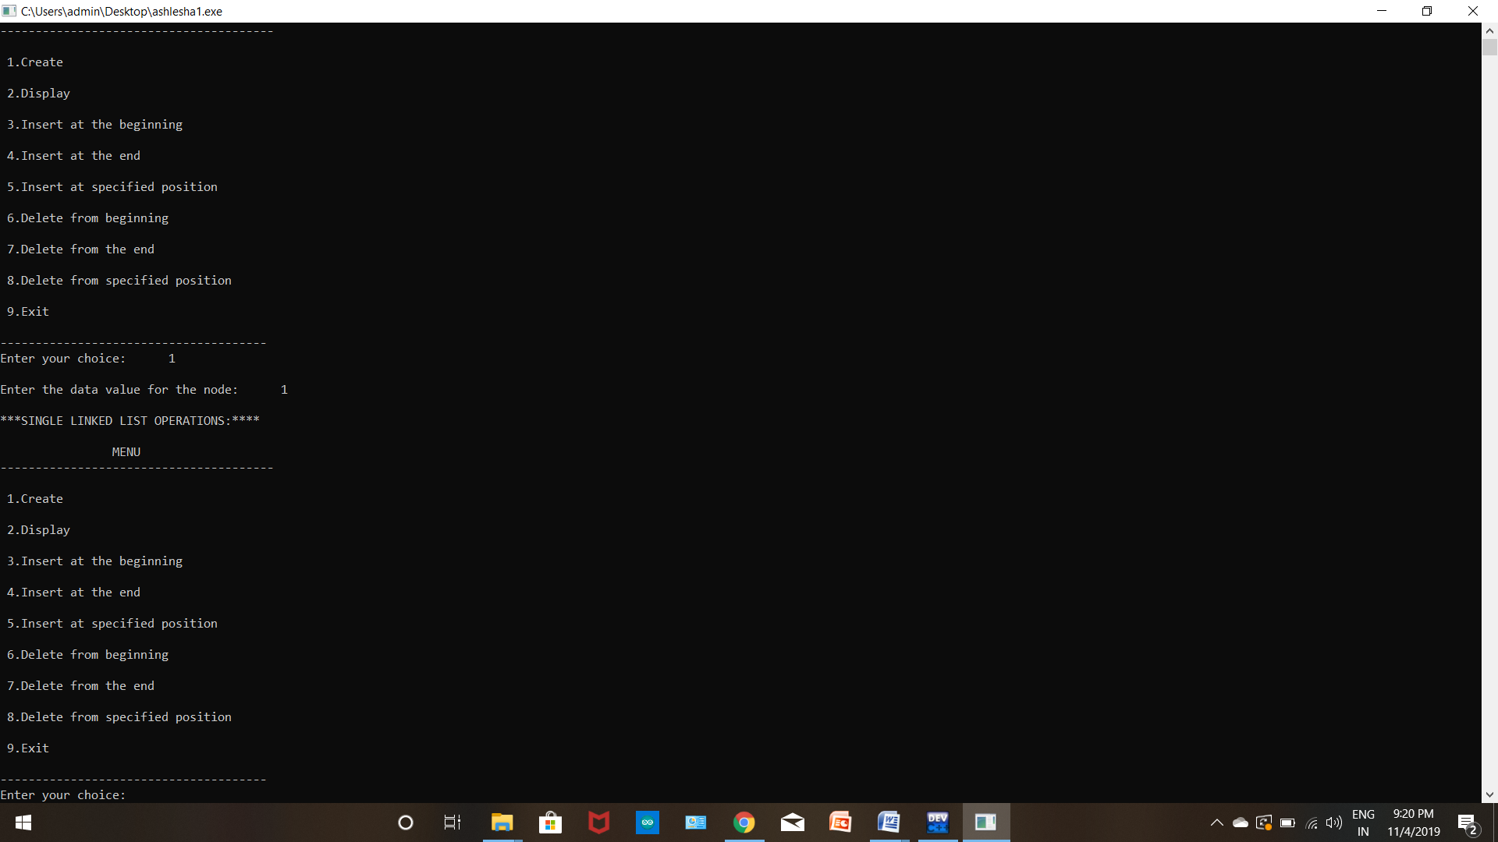
2)priority queue
#include <stdio.h>
#include <stdlib.h>

// Node

typedef struct node {

int data;

// Lower values indicate higher priority

int priority;

struct node* next;

} Node;

// Function to Create A New Node

Node* newNode(int d, int p)
{

Node* temp = (Node*)malloc(sizeof(Node));

temp->data = d;

temp->priority = p;

temp->next = NULL;

return temp;
}

// Return the value at head

int peek(Node** head)
{

return (*head)->data;
}

// Removes the element with the
// highest priority form the list

void pop(Node** head)
{

Node* temp = *head;

(*head) = (*head)->next;

free(temp);
}

// Function to push according to priority

void push(Node** head, int d, int p)
{

Node* start = (*head);

// Create new Node

Node* temp = newNode(d, p);

// Special Case: The head of list has lesser

// priority than new node. So insert new

// node before head node and change head node.

if ((*head)->priority > p) {

// Insert New Node before head

temp->next = *head;

(*head) = temp;

}

else {

// Traverse the list and find a

// position to insert new node

while (start->next != NULL &&

start->next->priority < p) {

start = start->next;

}

// Either at the ends of the list

// or at required position

temp->next = start->next;

start->next = temp;

}
}

// Function to check is list is empty

int isEmpty(Node** head)
{

return (*head) == NULL;
}

// Driver code

int main()
{

// Create a Priority Queue

// 7->4->5->6

Node* pq = newNode(4, 1);

push(&pq, 5, 2);

push(&pq, 6, 3);

push(&pq, 7, 0);

while (!isEmpty(&pq)) {

printf("%d ", peek(&pq));

pop(&pq);

}

return 0;
}
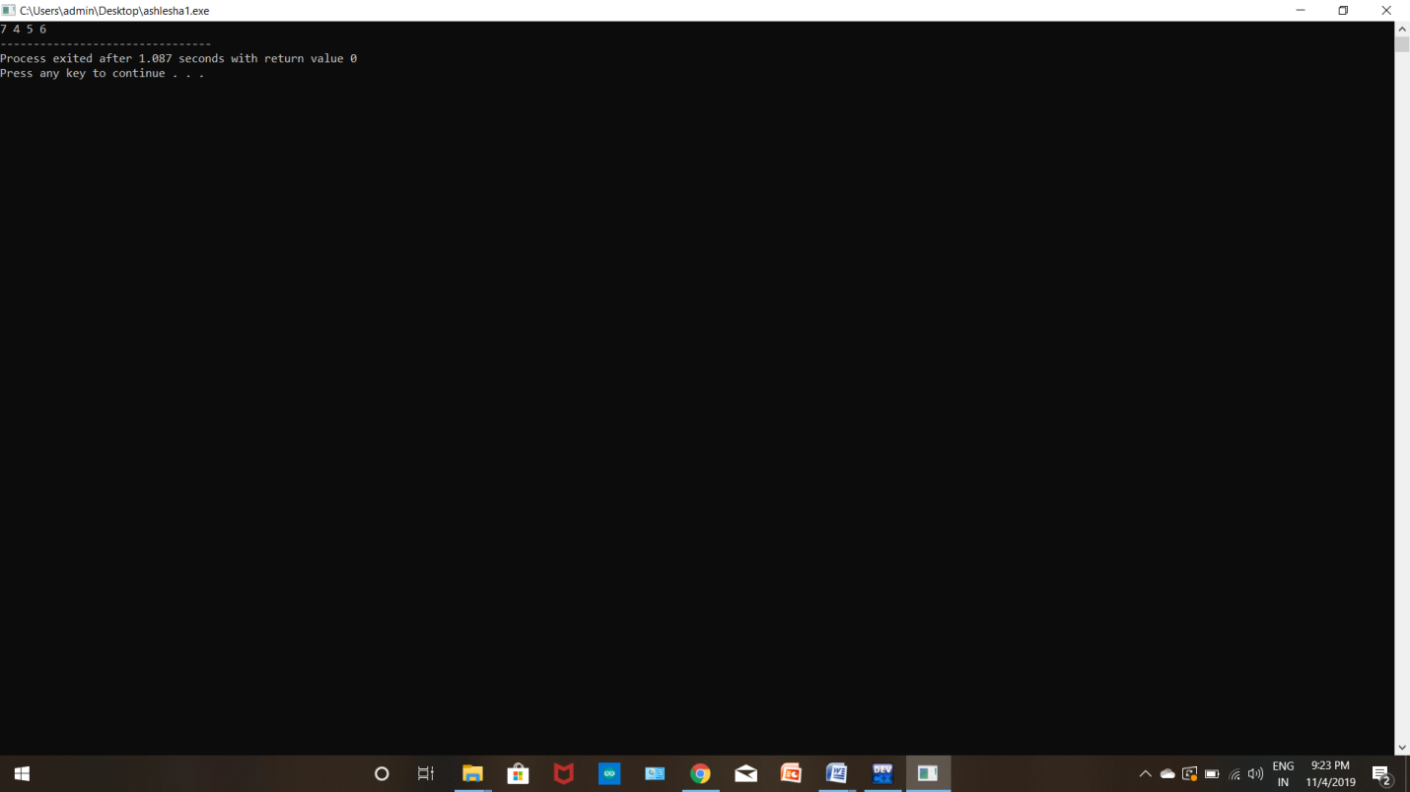
3)selection sort
#include <stdio.h>

void swap(int *xp, int *yp)
{
int temp = *xp;
*xp = *yp;
*yp = temp;
}

void selectionSort(int arr[], int n)
{
int i, j, min_idx;

// One by one move boundary of unsorted subarray
for (i = 0; i < n-1; i++)
{
// Find the minimum element in unsorted array
min_idx = i;
for (j = i+1; j < n; j++)
if (arr[j] < arr[min_idx])
min_idx = j;

// Swap the found minimum element with the first element
swap(&arr[min_idx], &arr[i]);
}
}

/* Function to print an array */
void printArray(int arr[], int size)
{
int i;
for (i=0; i < size; i++)
printf("%d ", arr[i]);
printf("\n");
}

// Driver program to test above functions
int main()
{
int arr[] = {64, 25, 12, 22, 11};
int n = sizeof(arr)/sizeof(arr[0]);
selectionSort(arr, n);
printf("Sorted array: \n");
printArray(arr, n);
return 0;
}
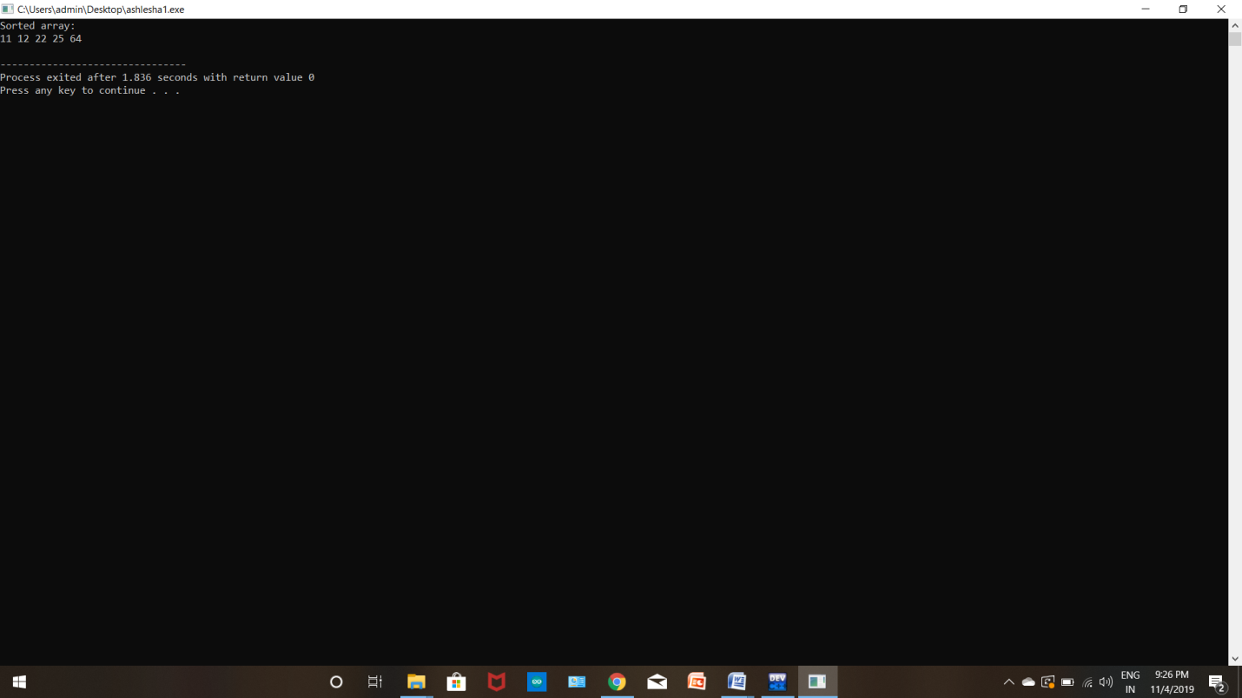
4)insertion sort
#include <math.h>
#include <stdio.h>

/* Function to sort an array using insertion sort*/
void insertionSort(int arr[], int n)
{
int i, key, j;
for (i = 1; i < n; i++) {
key = arr[i];
j = i - 1;

/* Move elements of arr[0..i-1], that are
greater than key, to one position ahead
of their current position */
while (j >= 0 && arr[j] > key) {
arr[j + 1] = arr[j];
j = j - 1;
}
arr[j + 1] = key;
}
}

// A utility function to print an array of size n
void printArray(int arr[], int n)
{
int i;
for (i = 0; i < n; i++)
printf("%d ", arr[i]);
printf("\n");
}

/* Driver program to test insertion sort */
int main()
{
int arr[] = { 12, 11, 13, 5, 6 };
int n = sizeof(arr) / sizeof(arr[0]);

insertionSort(arr, n);
printArray(arr, n);

return 0;
}
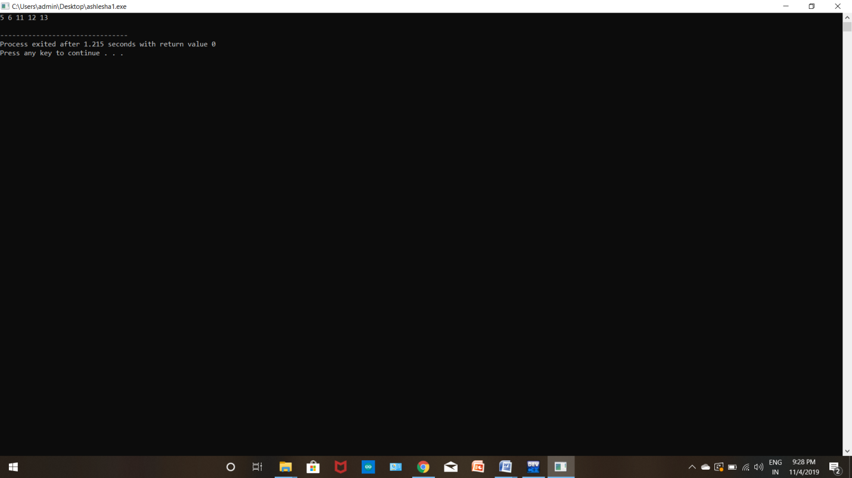
5)merge sort
#include <stdio.h>
#define max 10
int a[11] = { 10, 14, 19, 26, 27, 31, 33, 35, 42, 44, 0 };
int b[10];
void merging(int low, int mid, int high)
{
int l1, l2, i;
for(l1 = low, l2 = mid + 1, i = low; l1 <= mid && l2 <= high; i++)
{
if(a[l1] <= a[l2])
b[i] = a[l1++];
else
b[i] = a[l2++];
}

while(l1 <= mid)
b[i++] = a[l1++];

while(l2 <= high)
b[i++] = a[l2++];

for(i = low; i <= high; i++)
a[i] = b[i];
}
void sort(int low, int high)
{
int mid;
if(low < high)
{
mid = (low + high) / 2;
sort(low, mid);
sort(mid+1, high);
merging(low, mid, high);
}
else
{
return;
}
}
int main()
{
int i;
printf("List before sorting\n");
for(i = 0; i <= max; i++)
printf("%d ", a[i]);
sort(0, max);
printf("\nList after sorting\n");
for(i = 0; i <= max; i++)
printf("%d ", a[i]);
}
