**Pizza Sales SQL Queries**

**KPI’s Requirement**

**1 Total Revenue:**

SELECT SUM(total_price) AS Total_Revenue FROM pizza_sales

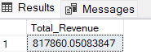

**2 Average Order Value:**

SELECT SUM(total_price) / COUNT(DISTINCT order_id) AS Avg_Order_Value FROM pizza_sales

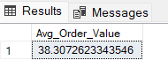

3 **Total Pizzas Sold:**

SELECT SUM(quantity) AS Total_Pizzas_Sold FROM pizza_sales

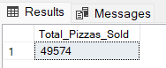

**4 Total Orders:**

SELECT COUNT(DISTINCT order_id) AS Total_Orders FROM pizza_sales

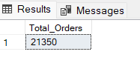

**5 Average Pizzas Per Order:**

SELECT CAST(CAST(SUM(quantity) AS DECIMAL(10,2)) /

CAST(COUNT(DISTINCT order_id) AS DECIMAL(10,2)) AS DECIMAL(10,2))

AS Avg_Pizzas_Per_Order FROM pizza_sales

