**GROUP NO: E1**

**Air Quality Detector**

**SEMESTER- VI**

**BCA-606(A) ROBOPEDIA-III**

**PROJECT REPORT - VI**

SUBMITTED IN PARTIAL FULFILLMENT OF THE REQUIREMENTS

FOR THE TERM WORK OF SEMESTER-VI

**BACHELOR OF COMPUTER APPLICATIONS**

### SUBMITTED TO



**A constituent college of**

**KADI SARVA VISHWAVIDYALAYA**



**SUBMITTED BY**

|  |  |  |  |
| --- | --- | --- | --- |
| S.No | Student Number | Enrollment Number | Exam Number |
| 1. | Aman Singh Bhadoriya | 19BCA04014 | 016016 |
| 2. | Rohit Singh | 19BCA04265 |  |
| 3. | Abbhishak Patel | 19BCA01006 |  |

**March-2022**



**Gandhinagar**

(Constituent colleges of KADI SARVA VISHWAVIDYALAYA)

**CERTIFICATE**

This is to certify that the project documentation entitled Air Quality Detector is allotted project work done

By, Aman Singh Bhadoriya, Abhishek Patel, Rohit Singh in partial fulfilment of the requirement for the award of degree of Bachelor of Computer Application at B. P. College of Computer Studies & S. V.

Institute of Computer Studies, Gandhinagar, constituent colleges of KADI SARVA VISHWAVIDYALAYA. To the best of our knowledge, the work is done satisfactorily. During the tenure, they were found hard working and sincere. They completed all the tasks assigned and suggested to them.

Comments:

1.

2.

3.

 **Director**

**Table of Contents**

**S. NO. PARTICULAR PAGE NO.**

### PHASE I: BUILDING A PROJECT PLAN FROM SCRATCH

1.1 PROJECT TITLE----------------------------------------------------------------------------------4

1.2 PROJECT DEFINITION -------------------------------------------------------------------------5

1.3 GROUP DETAILS---------------------------------------------------------------------------------6

1.4 PLANNING ACTIVITIES -----------------------------------------------------------------------7

1.5 SYSTEM REQUIREMENTS SPECIFICATION ---------------------------------------------8

1.6 DESIGNATING WITH SOFTWARE ----------------------------------------------------------9

1.7 DEVICE COST SPECIFICATION--------------------------------------------------------------10

### PHASE II: ASSEMBLING AND PROGRAMMING IN VIRTUAL ENVIRONMENT

2.1 SELECTION OF THE HARDWARE COMPONENTS --------------------------------------11-12

2.2 ESTABLISHING THE CONNECTIONS BETWEEN THE COMPONENTS ------------13-17

2.3 DEVELOPING THE LOGIC ---------------------------------------------------------------------18 -20

2.4 BURNING THE CODE INTO THE PROCESSOR -------------------------------------------21

### PHASE III: DEMONSTRATING ON THE KIT

3.1 OPTIMIZING THE COMPONENTS ----------------------------------------------------------22

3.3 DETAIL UNDERSTANDING THE HARDWARE COMPONENTS ON PCB ---------23

3.4 IMPLEMENTATION OF THE PROJECT-----------------------------------------------------24

3.4 ADVANTAGES------------------------------------------------------------------------------------25

3.5 CHALLENGES-------------------------------------------------------------------------------------26

3.6 REAL LIFE APPLICATIONS--------------------------------------------------------------------27

3.7 CONCLUSION--------------------------------------------------------------------------------------28

3.8 REFERENCES---------------------------------------------------------------------------------------29

# PHASE I: BUILDING A PROJECT PLAN FROM SCRATCH

## 1.1 PROJECT TITLE

**Air Quality Detector**

## 1.2 PROJECT DEFINITION

Air quality detector are devices that monitor the presence of air pollution in the surrounding area. They can be used for both indoor and outdoor environments. Air quality detector are devices used to detect contaminants in the air. This includes particulates, pollutants and noxious gases that may be harmful to human health.

## 1.3 GROUP DETAILS

|  |  |  |  |
| --- | --- | --- | --- |
| **Sr.No** | **Group Member Name** | **Enrollment no.** | **Exam no.** |
| 1. | Aman Singh Bhadoriya | 19BCA04014 |  |
| 2. | Rohit Singh | 19BCA04265 |  |
| 3. | Abhishek Patel | 19BCA04006 |  |

## 1.4 PLANNING ACTIVITIES

* In this project we are show you how to measure air Quality.

* In this project, we are going to use an MQ-135 Sensor with Arduino to measure the CO2 concentration.

* CO2 concentration values will be displayed on the OLED module.

* We can also measure the concentration of using Arduino. LPG, SMOKE, and Ammonia gas.

* Our project is use to School, home, hospital and heavy Air polluted place etc.

## 1.5 SYSTEM REQUIREMENTS SPECIFICATION

|  |
| --- |
| Arduino Uno with  ATMEGA328p |
| MQ-135 Air Quality Sensor |
| Jumper Wires |
| 16x4 LCD display |
| Breadboard |
| Coper board |
| 3x 200k register |
| 1x 16.000 MHZ crystal |
| 3x R,Y,G LED |
| 1x Atmega328P IC |
| 5v battery Charging Module |
| Buzzer |

## 1.6 DESIGNATING WITH SOFTWARE

**1. First Device**

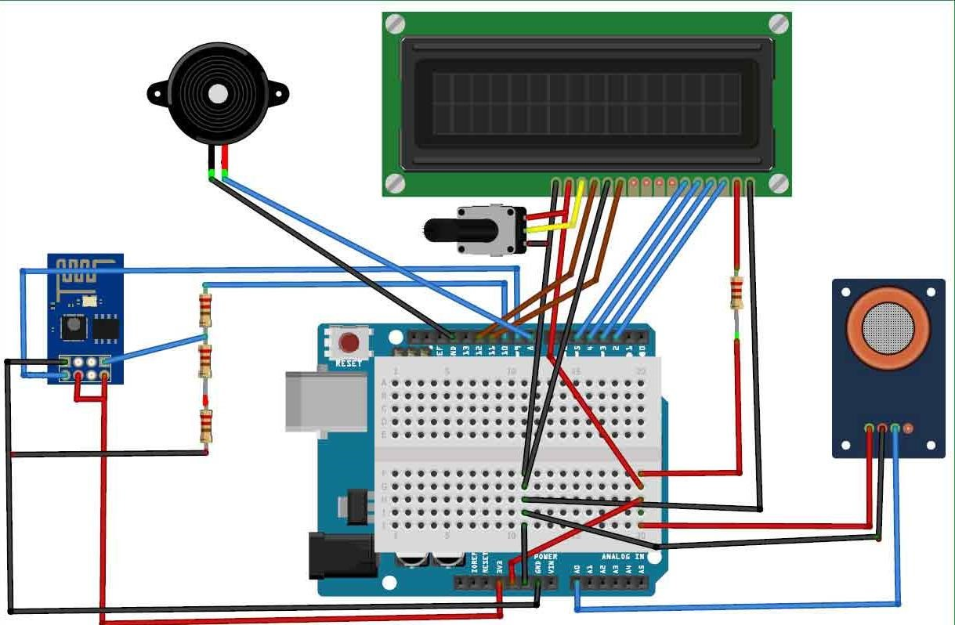

**2. Second device**

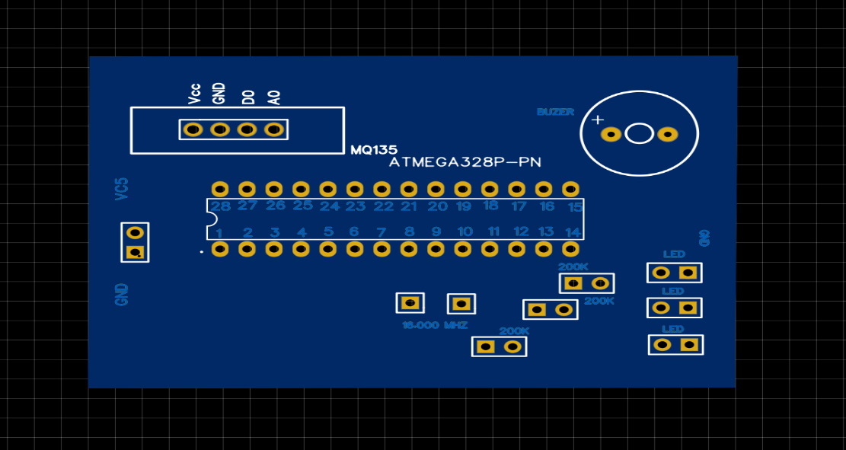

## 1.7 DEVICE COST SPECIFICATION

|  |  |  |  |  |
| --- | --- | --- | --- | --- |
| **Component** | **Quantity** | **Price** | **Configuration** | **Vendor** |
| Arduino Uno | 1 | 600 | R3 | Krishna Electronics |
| Gas Sensor | 1 | 120 | MQ-135 | Krishna Electronics |
| Jumper Wires | 40 | 40 | Male To Male | Krishna Electronics |
| 16x4 LCD display | 1 | 300 | 16*4 | Krishna Electronics |
| Breadboard | 1 | 60 |  | Krishna Electronics |
| Buzzer | 1 | 10 |  | Krishna Electronics |
| Atmega328p IC | 1 | 250 | 328P | Krishna Electronics |
| 5V charging Module | 1 | 50 |  | Krishna Electronics |
| LED | 3 | 15 | R,Y,G | Krishna Electronics |
| 200k Register | 3 | 6 |  | Krishna Electronics |
| 16.000Mhz Crystal | 1 | 10 |  | Krishna Electronics |
| Coper Board | 1 | 90 |  | Krishna Electronics |
| Total |  | 1685 |  | Krishna Electronics |

# PHASE II: ASSEMBLING AND PROGRAMMING IN VIRTUAL ENVIRONMENT

## 2.1 SELECTION OF THE HARDWARE COMPONENTS

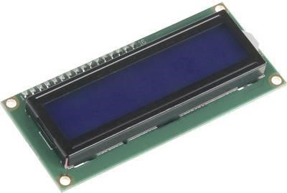

##### 16*4 LCD Display

The system displays the air quality on a 16x4 LCD display. It will show the air quality in PPM on the LCD so that we can monitor it very easily.

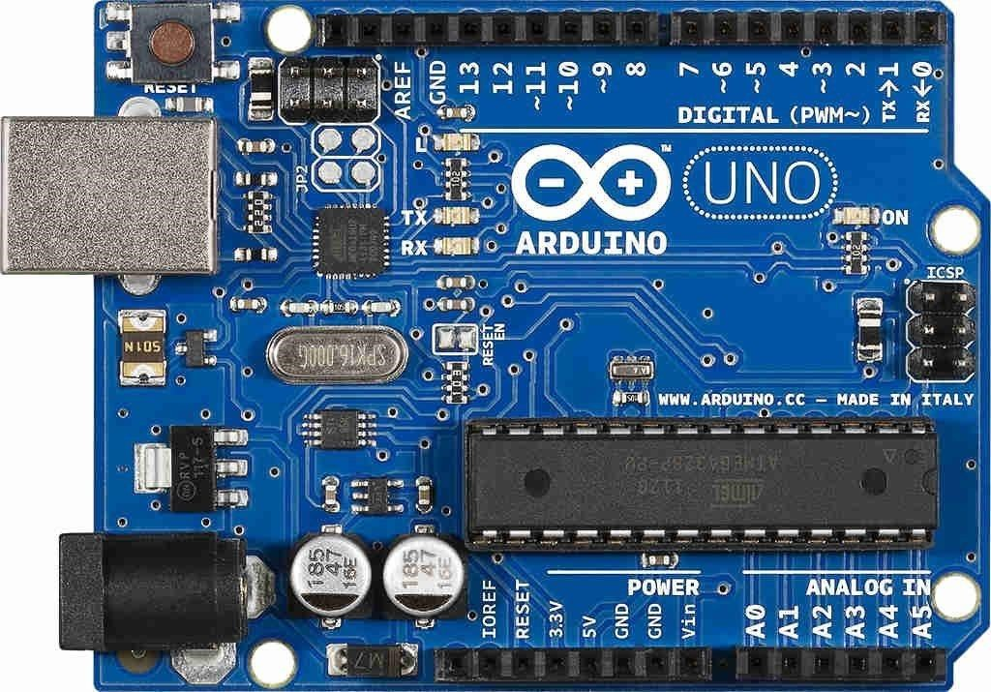

##### Arduino Uno

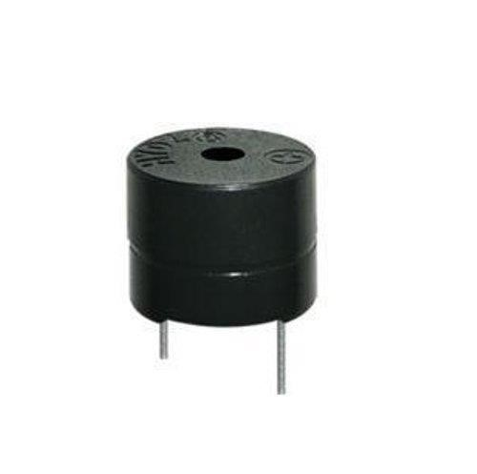

##### Buzzer

Focusing on the device produced, it detects high temperature and sense the dusty air immediately. Once the sensitivity is high, the buzzer module will active to alert user.

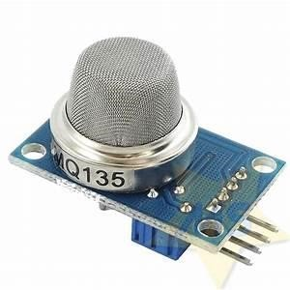

##### MQ-135 Sensor

➢ This sensor is suitable for home and industrial use, it has fast response and recovery characteristics, long life and reliable stability.

#### 2.2 ESTABLISHING THE CONNECTIONS BETWEEN THE COMPONENTS

#### I. First Device

1. Circuit connection (Back Side)

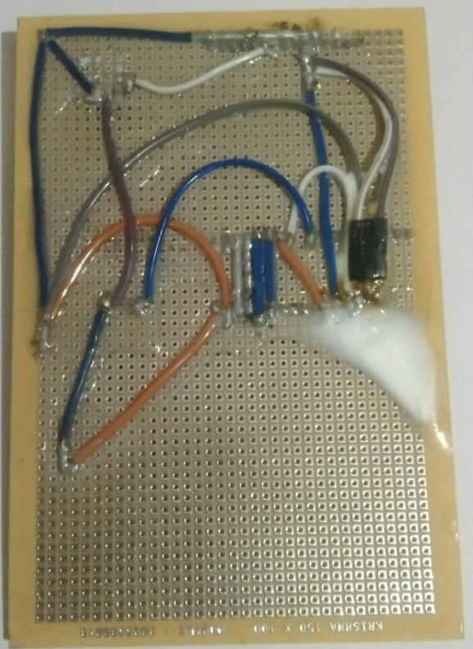

1. Front side

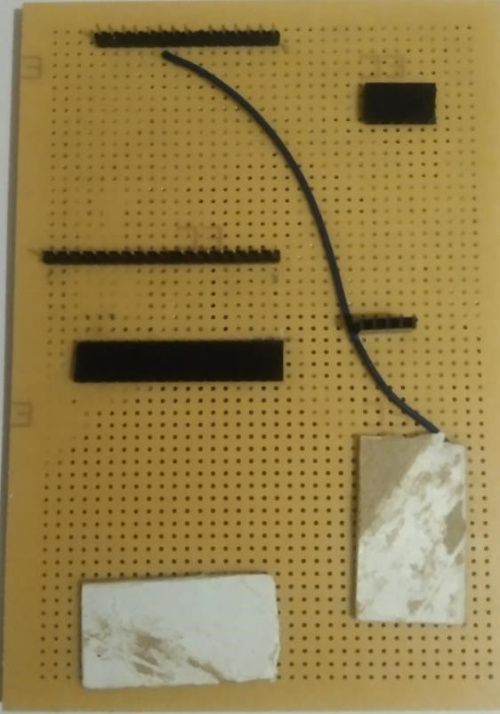

1. Arduino connection with Circuit

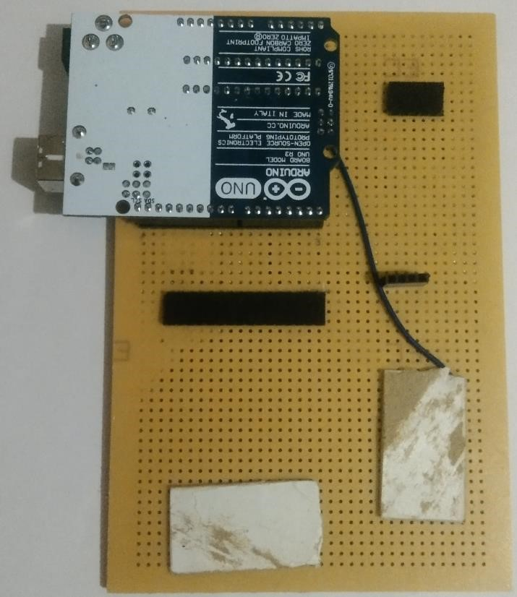

1. MQ-135 sensor and Buzzer connection with circuit

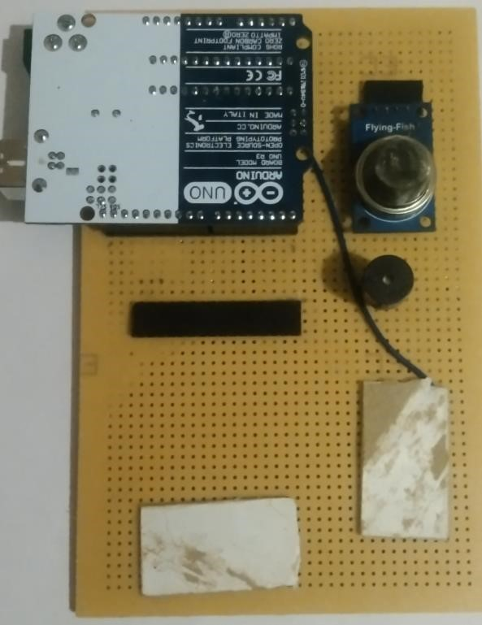

1. Display connection with circuit & Complete Circuit

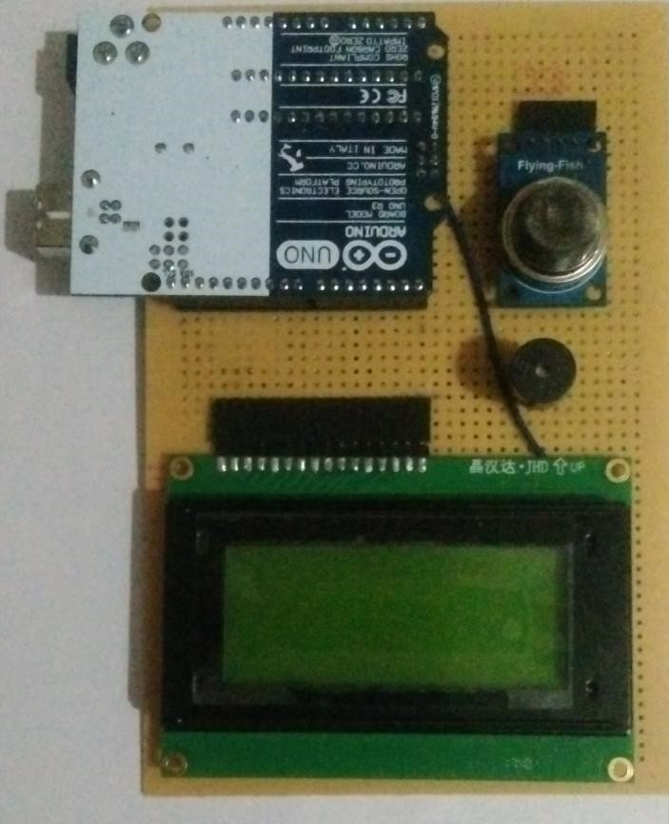

1. Working Module

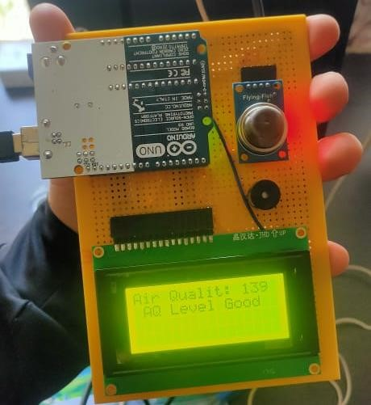

**II. Second Device**

1. Front Side

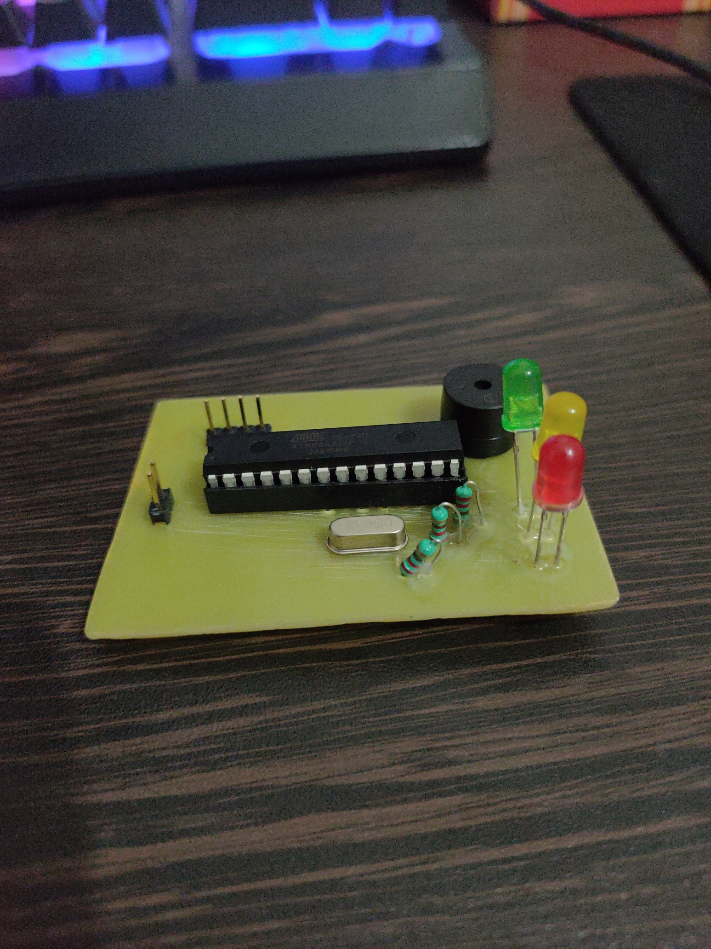

1. Back Side

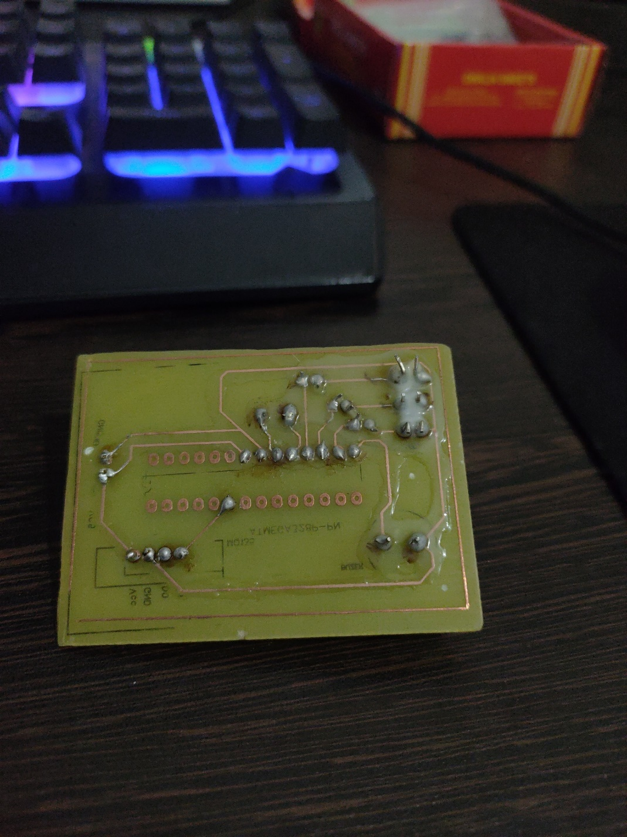

#### DEVELOPING THE LOGIC

1. **First Device Code**

#include <LiquidCrystal.h> //Header file for LCD

const int rs=7, en=6, d4=5, d5=4, d6=3, d7=2; //pins of LCD connected to Arduino LiquidCrystal lcd (rs,en,d4, d5,d6,d7); //lcd function from LiquidCrystal

int buz = 8; //buzzer connected to pin 8 int led = 9; //led connected to pin 9

const int aqsensor = A0; //output of mq135 connected to A0 pin of Arduino

int threshold = 250; //Threshold level for Air Quality

void setup() {

pinMode (buz,OUTPUT); // buzzer is connected as Output from Arduino

pinMode (aqsensor,INPUT); // MQ135 is connected as INPUT to arduino

Serial.begin (9600); //begin serial communication with baud rate of 9600

lcd.clear(); // clear lcd lcd.begin (16,4); // consider 16,4 lcd }

void loop() {

int ppm = analogRead(aqsensor); //read MQ135 analog outputs at A0 and store it in ppm

Serial.print("Air Quality: "); //print message in serail monitor

Serial.println(ppm); //print value of ppm in serial monitor

lcd.setCursor(0,0); // set cursor of lcd to 1st row and 1st column

lcd.print("Air Quality: "); // print message on lcd lcd.print(ppm); // print value of MQ135

If (ppm > threshold) // check is ppm is greater than threshold or not { lcd.setCursor(1,1); //jump here if ppm is greater than threshold lcd.print("AQ Level HIGH");

Serial.println("AQ Level HIGH");

digitalWrite(buz,HIGH); //Turn ON Buzzer }

Else { digitalWrite(buz,LOW); //Turn off Buzzer lcd.setCursor(1,1); lcd.print ("AQ Level Good"); Serial.println("AQ Level Good");

} delay (500);

}

1. **Second Device Code**

int buz = 8; //buzzer connected to pin 8

int green = 7; //led connected to pin 9

int yello = 6; //led connected to pin 9

int red = 5; //led connected to pin 9

const int aqsensor = A0; //output of mq135 connected to A0 pin of Arduino

int threshold = 230;//Threshold level for Air Quality

int threshold1 = 200;

void setup() {

pinMode (buz,OUTPUT); // buzzer is connected as Output from Arduino

pinMode (green,OUTPUT); // led is connected as output from Arduino

pinMode (yello,OUTPUT); // led is connected as output from Arduino

pinMode (red,OUTPUT); // led is connected as output from Arduino

pinMode (aqsensor,INPUT); // MQ135 is connected as INPUT to arduino

Serial.begin (9600); //begin serial communication with baud rate of 9600

}

void loop() {

int ppm = analogRead(aqsensor); //read MQ135 analog outputs at A0 and store it in ppm

Serial.print("Air Quality: "); //print message in serail monitor

Serial.println(ppm); //print value of ppm in serial monitor

if (ppm > threshold) // check is ppm is greater than threshold or not

{

Serial.println("AQ Level HIGH");

tone(red,1000,200); //blink led with turn on time 1000mS, turn off time 200mS

digitalWrite(green,LOW);

digitalWrite(yello,LOW);

digitalWrite(buz,HIGH); //Turn ON Buzzer

}

else if (ppm < threshold) // check is ppm is greater than threshold or not

{

if (ppm <= threshold1) // check is ppm is greater than threshold or not

{

Serial.println("AQ Level good");

tone(green,1000,200); //blink led with turn on time 1000mS, turn off time 200mS

digitalWrite(yello,LOW);

digitalWrite(red,LOW);

digitalWrite(buz,LOW);

}

Serial.println("AQ Level medium");

tone(yello,1000,200); //blink led with turn on time 1000mS, turn off time 200mS

digitalWrite(green,LOW);

digitalWrite(red,LOW);

digitalWrite(buz,LOW);

}

else

{

Serial.println("AQ Level Good");

digitalWrite(green,HIGH);

digitalWrite(yello,LOW);

digitalWrite(red,LOW);

digitalWrite(buz,LOW);

}

delay (500);

}

## 2.4 BURNING THE CODE INTO THE PROCESSOR

* Connect your Arduino using the USB cable.

* Choose Tools→Board→Arduino Uno to find your board in the Arduino menu.

* Choose the correct serial port for your board.

* Click the Upload button.

# PHASE III: DEMONSTRATING ON THE KIT

## 3.1 OPTIMIZING THE COMPONENTS

* The biggest problem with connecting components is when connecting the wires between them in the right places.

* The most important thing was to make this device smaller so that its size can be reduced and it can be more effectively carried by anyone anywhere and can be disabled or enabled anywhere.

* Creating this device is the most common problem is a connecting each wire with a soldering so that soldering work is a most complicated and a time consuming work

* The most serious thing when making this device was that if we put a single wire in the wrong place, there could be a problem with the components of our equipment, which could cost our equipment more.

## 3.2 DETAIL UNDERSTANDING THE HARDWARE COMPONENTS ON PCB

* This devise is Portable.

* It is easy to implement any place.

* This device gives output to current situation and current place

* We can disassemble and add any element of this device at any place

## 3.3 IMPLEMENTATION OF THE PROJECT

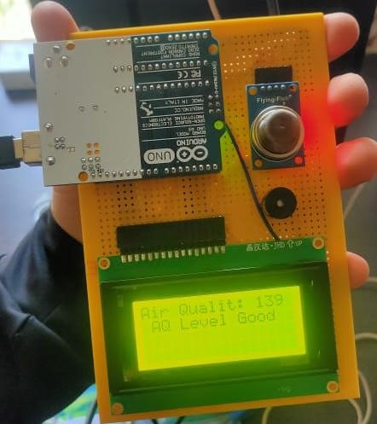

## 3.4 ADVANTAGES

* Thus, installing an air quality monitoring system helps monitor the presence of pollutants, resulting in better environmental conditions for humans to reside.

* This also impacts their health and reduces the chances of occurring any health issues by maintaining a moderate ambiance or as required.

* Monitoring helps in assessing the level of pollution in relation to the ambient air quality standards.

* Standards are a regulatory measure to set the target for pollution reduction and achieve clean air.

## 3.5 CHALLENGES

* The main problem to build this device was to find a compatible sensor for that device.

* The second main challenge is a connecting a circuit with a correct pin

* Main challenge of this device is a make this device portable for everyone

* The most important thing was to make this device smaller so that its size can be reduced and it can be more effectively carried by anyone anywhere and can be disabled or enabled anywhere.

## 3.6 REAL LIFE APPLICATIONS

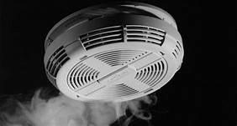

Smock Detector

* Smoke sensors detect the presence of Smoke, Gases and Flame surrounding their field.

* It can be detected either optically or by the physical process or by the use of both the methods

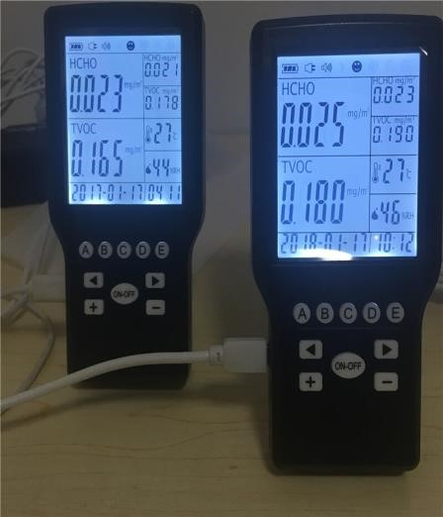

Air Pollution detector

* + The air pollution monitoring system was designed to monitor and analyse air quality in realtime and log data to a remote server, keeping the data updated over the internet.

* + Air quality measurements were taken based on the Parts per Million (PPM) metrics and analysed using Microsoft Excel.

## 3.7 CONCLUSION

* This Air quality detector is devices that monitor the presence of air pollution and LPG GAS or Smock detector in the surrounding area.

* This device will be able to work in all three conditions

## 3.8 REFERENCES

To make this device we got a reference from online websites and Youtube.com platform.

##### Link of the Website :-

[**https://circuitdigest.com/arduino-projects**](https://circuitdigest.com/arduino-projects)  **Link of the similar project :- https://circuitdigest.com/microcontroller-projects/interfacing-mql35-gas-sensor- witharduino-to-measure-co2-levels-in-ppm**