Setting Fixed Host ID on VM / Machine

From XPI 4.12 onwards the License mechanism has been changed.
If unknowingly the VM restarts the HostID will change as the virtual hardware ID are not maintained between restart.

To handle this scenario, we suggest using a fixed MAC address/HostID, as it will not change after the restart of the VM/Machine.

VM’s that in Hyper-V – you can set a fixed MAC address / HostID as follows:

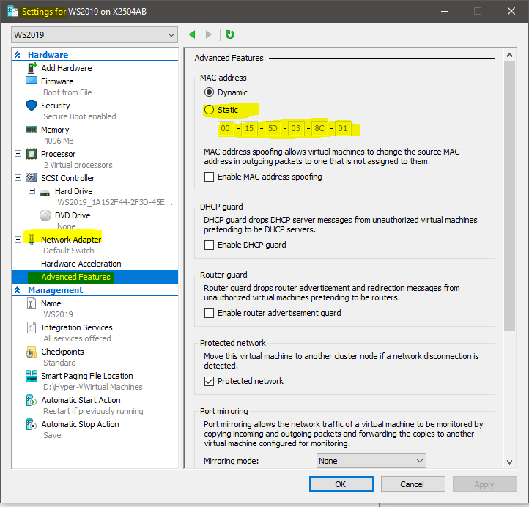

For VMWare the settings are as follows:

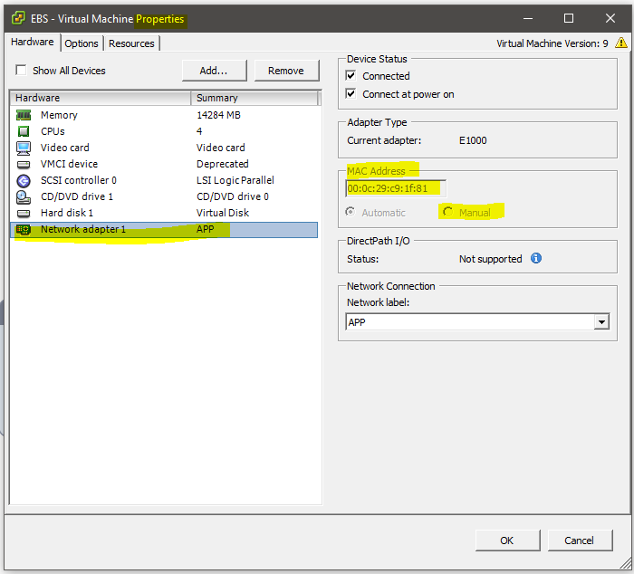

Magic Support
Anand

