Knowi Connector Demo
The following article will demonstrate the use of the new “KNOWI” connector.
https://www.knowi.com/api/1.0/login
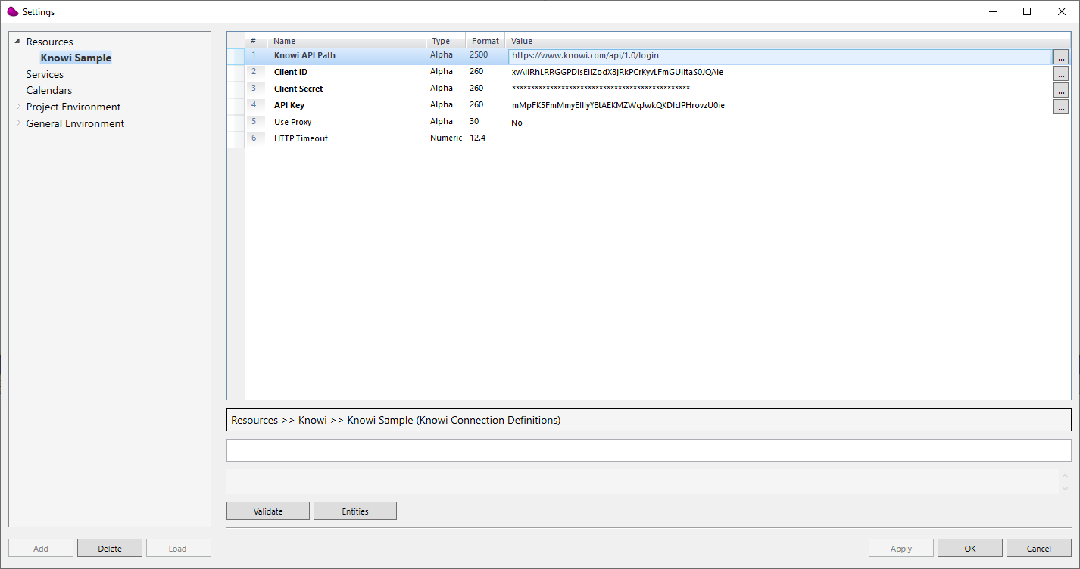
- Adding the KNOWI resource:

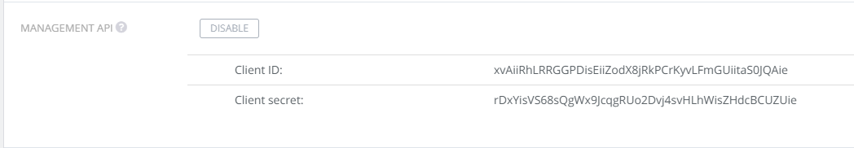

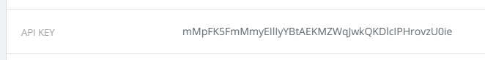

Remarks:
- Knowi API PATH is usually:
  - https://www.knowi.com/api/1.0/login
- Client ID& Client Secret & API KEY – are available in the user settings in Knowi .

- Defining Knowi entities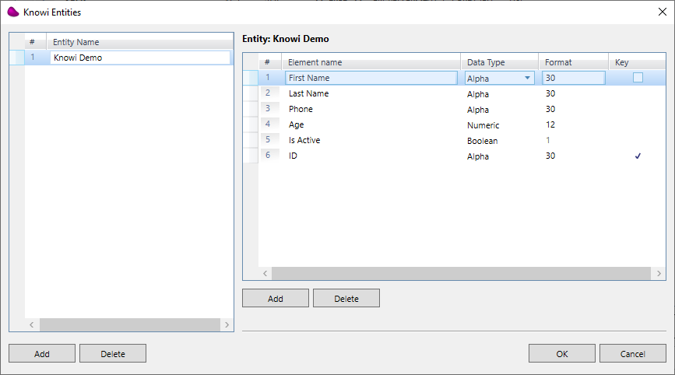

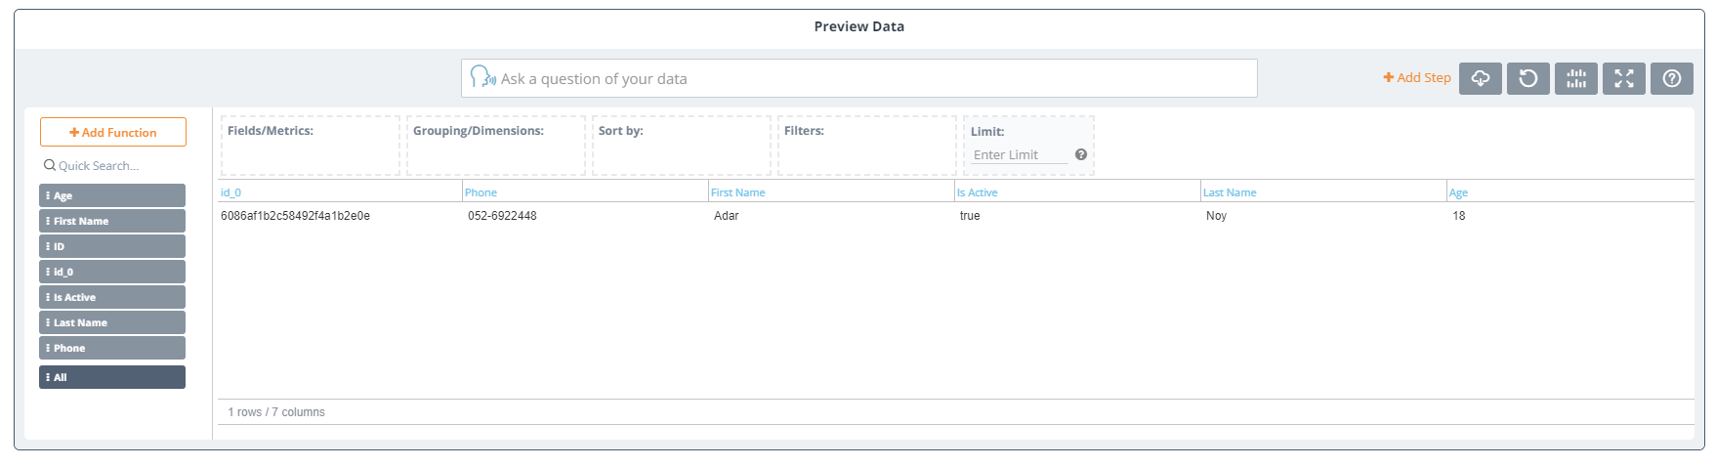

- Using the connector
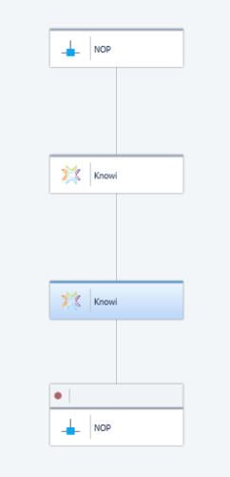
  - Write Operation
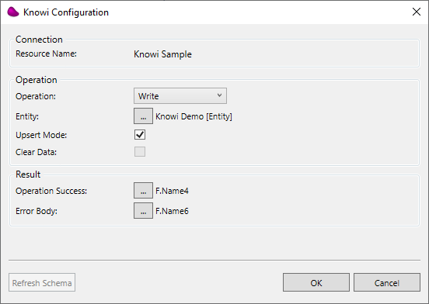
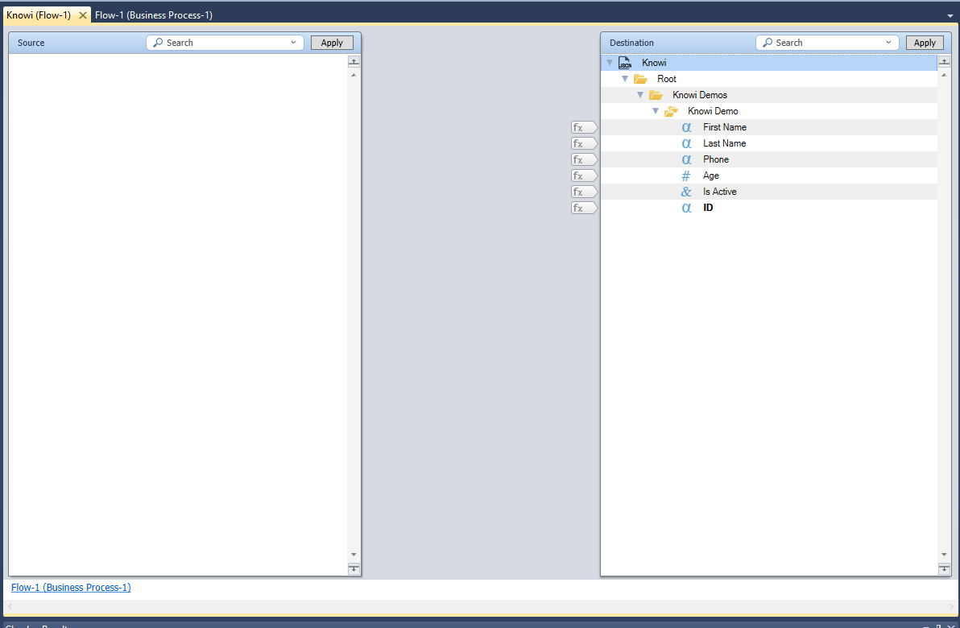
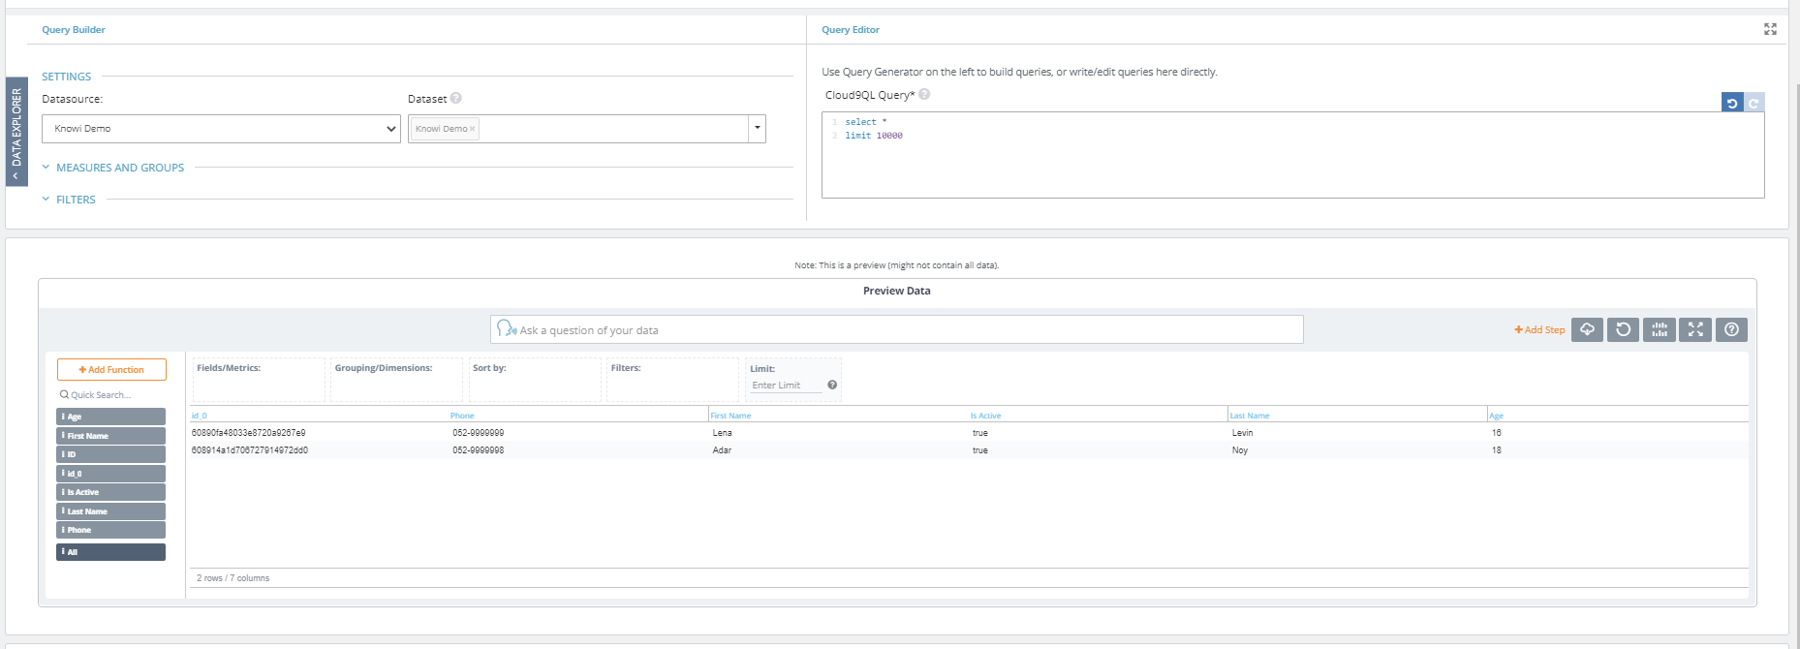

- Read Operation
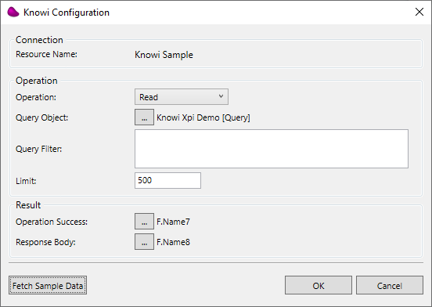
“Fetch Sample Data”

