**Project​​Proposal**



**Project​​Title​​:​​​**Visualization​​of​​Indian​​Cricket​​Premier​​League

**Team​​Members:**​​Zeeshan​​Hakim​​(u1143824)​​,​​Abishek​​Penujuri​​Nataraj​​(u1080870)

**Link​​to​​Project​​Repository:**​​https://github.com/zeeshanhakim/dataviscourse-pr-2017

Our​​project​​idea​​is​​based​​on​​“Visualizing​​Indian​​Premier​​League”​​dataset.

**Background​​and​​Motivation:**

Almost​​every​​kid​​in​​India​​and​​Pakistan​​grew​​up​​playing​​cricket​​and​​idolizes​​its​​players.​​It​​is​​one of​​the​​most​​loved​​games​​in​​the​​world.​​USA​​has​​football,​​Europe​​has​​Soccer​​and​​we​​have Cricket.

After​​introducing​​T20​​format,​​the​​craze​​for​​it​​increased.​​One​​of​​the​​most​​successful​​premier league​​based​​on​​this​​format​​is​​IPL​​(Indian​​Premier​​League).​​IPL​​brought​​together​​players​​from all​​the​​countries​​to​​play​​in​​different​​teams.​​The​​Dream​​of​​seeing​​players​​from​​different​​countries playing​​for​​the​​same​​team​​came​​true.

So,​​while​​deciding​​on​​the​​Project,​​our​​main​​interest​​was​​to​​find​​something​​interesting​​related​​to Cricket.​​We​​found​​a​​dataset​​related​​to​​IPL​​and​​after​​going​​through​​its​​features​​and​​asking opinion​​from​​TA’s,​​we​​decided​​to​​go​​with​​this​​Project.

Our​​goal​​here​​is​​to​​visualize​​various​​trends​​covering​​9​​seasons​​of​​the​​IPL.​​The​​data​​has​​lot​​of features​​which​​can​​be​​used​​to​​generate​​good​​visualizations,​​the​​preliminary​​designs​​are​​shown in​​the​​upcoming​​sections.​​we​​also​​show​​interesting​​insights​​such​​as​​how​​participants​​from global​​countries​​change​​with​​respect​​to​​years​​especially​​in​​the​​context​​of​​India​​and​​Pakistan.

**Project​​Objectives:**

The​​main​​objective​​of​​our​​project​​is​​to​​visualize​​the​​trends​​and​​season,​​match,​​and​​player specifics​​of​​IPL.

Things​​we​​are​​going​​to​​answer​​with​​our​​visualization​​are:

1.​​​**​​​**One​​​is​​visualizing​​the​​number​​of​​matches​​played​​throughout​​the​​country,​​showing​​on​​the map​​(maybe​​by​​using​​google​​API).​​We​​can​​learn​​where​​most​​number​​of​​matches​​are​​being played.

We​​can​​also​​find​​the​​change​​is​​trends​​from​​each​​season​​by​​observing​​where​​the​​most​​games have​​been​​played​​for​​the​​season

2.​​​**​​​**From​​​the​​map,​​using​​hover​​feature​​we​​can​​see​​other​​important​​details​​regarding​​the matches.

3.​​​**​​​**We​​​are​​also​​going​​to​​visualize​​various​​statistics​​of​​the​​IPL,​​for​​example​​player​​is​​awarded Orange​​Cap​​and​​Purple​​Cap​​based​​on​​their​​performances​​in​​the​​season,​​we​​would​​like​​to visualize​​these​​for​​every​​season​​and​​other​​statistics​​like​​Man​​of​​series,​​number​​of​​sixes​​and number​​of​​fours​​etc.

4.​​​**​​​**Also,​​​we​​like​​to​​find​​out​​about​​player​​skills,​​like​​which​​all​​players​​are​​Right-Handed batsman​​or​​Left-Handed​​and​​their​​bowling​​skills,​​whether​​they​​were​​captains​​or​​not,​​whether they​​umpired​​or​​not,​​etc.

5.​​​**​​​**One​​​of​​the​​important​​things​​which​​we​​try​​to​​understand​​is​​the​​trend​​in​​international​​players in​​the​​IPL,​​like​​how​​many​​players​​are​​there​​for​​each​​country​​in​​the​​given​​season.

There​​may​​be​​many​​other​​things,​​which​​can​​be​​answered​​using​​our​​visualizations,​​on​​forward we​​hope​​to​​convey​​many​​interesting​​trends​​and​​visualizations​​and​​answer​​many​​questions​​in this​​project

**Data:**

we​​collected​​our​​data​​set​​from​​Kaggle

<https://www.kaggle.com/harsha547/indian-premier-league-csv-dataset>

**Data​​Processing:**

Yes,​​we​​may​​need​​to​​do​​some​​data​​cleaning​​to​​remove​​unwanted​​elements.

We​​have​​the​​data​​in​​the​​CSV​​files,​​we​​may​​need​​to​​data​​processing​​to​​convert​​some​​of​​the​​data into​​JSON​​Files.​​In​​total​​we​​have​​6​​data​​files​​covering​​all​​the​​data​​related​​to​​9​​seasons.​​There​​is player​​data,​​match​​data,​​season​​data​​and​​team​​data.​​All​​these​​data​​files​​are​​interlinked​​with common​​id’s

**Visualization​​Design:**

VIEW​​1​​:​​Showing​​the​​IPL​​Seasons​​Statistics

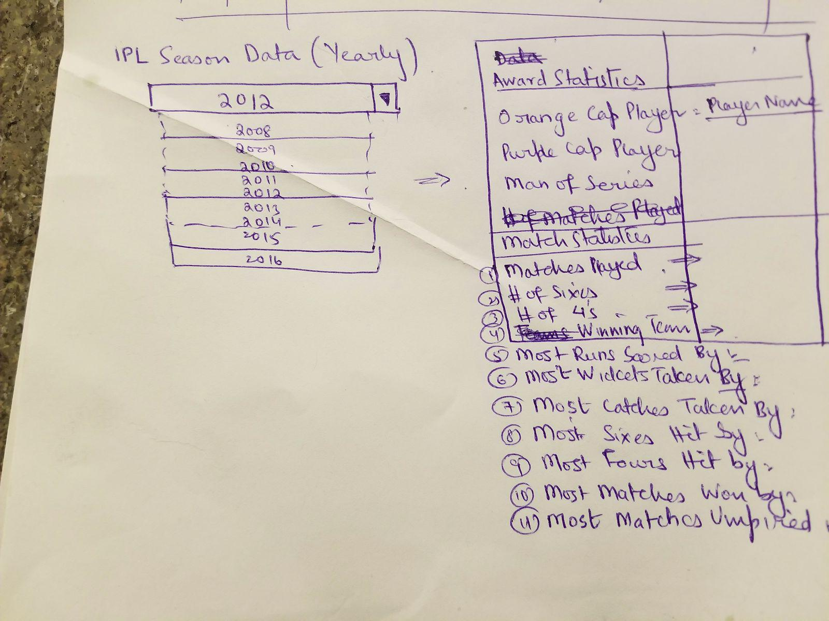

VIEW​​2​​:​​Showing​​the​​Season​​Matches​​Venues

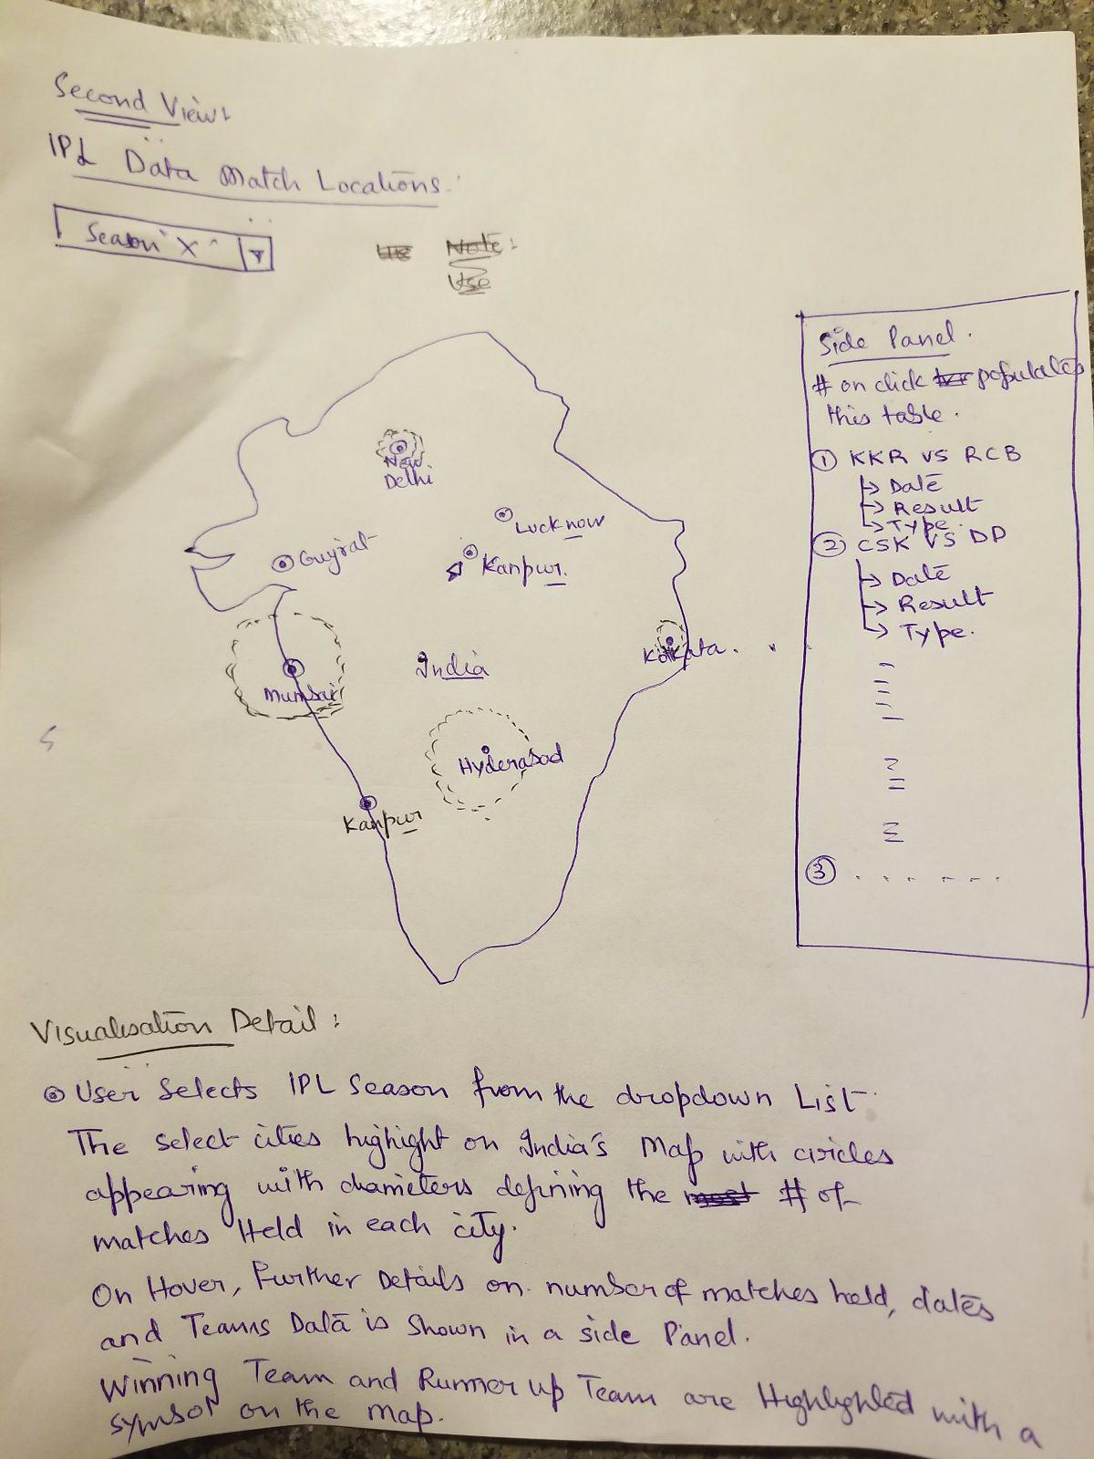

VIEW​​3​​:​​Global​​Countries​​Participation​​In​​IPL​​Seasons

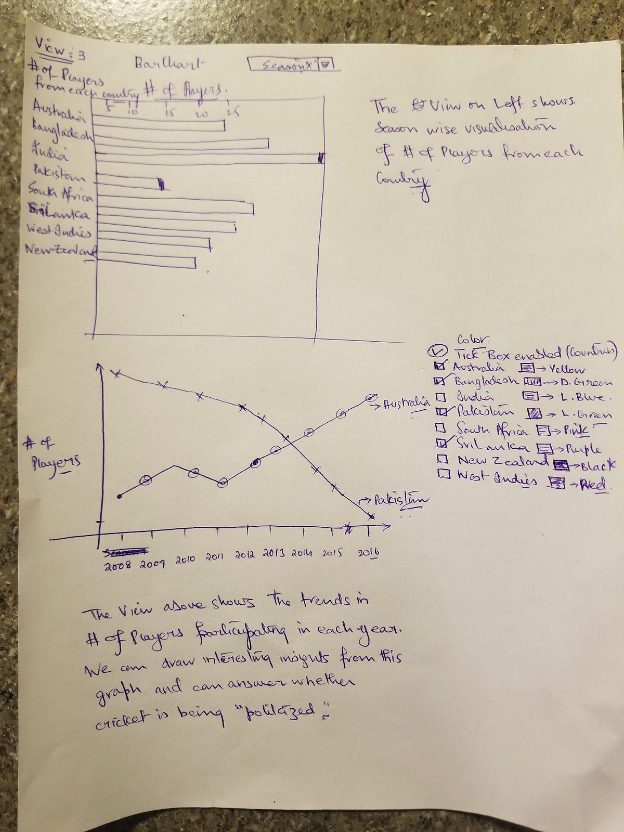

**Final​​Design:**

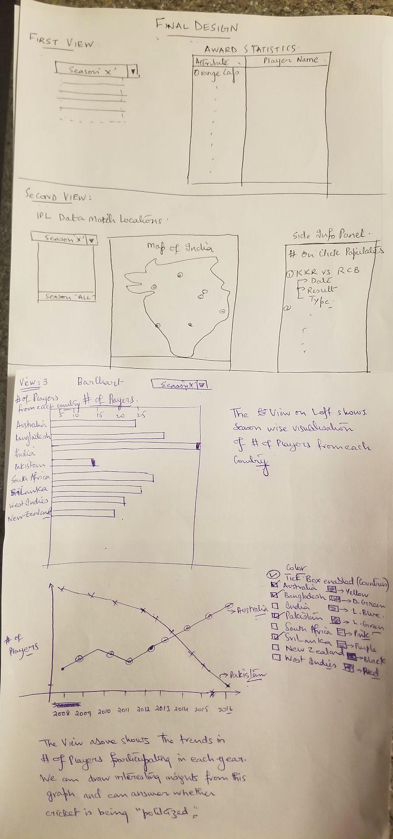

**MUST-HAVE​​/​​NICE​​TO​​HAVE​​FEATURES:**

* The​​View​​1​​showing​​season's​​statistics​​should​​have​​basic​​information​​about​​each season. A​​Nice​​to​​have​​feature​​in​​this​​visualization​​would​​be​​displaying​​more​​interesting​​options for​​users​​to​​choose​​from.​​From​​Example,​​a​​similar​​drop​​down​​list​​of​​showing​​each​​team would​​display​​team​​specific​​data.
* The​​View​​2​​would​​have​​a​​map​​of​​India​​showing​​each​​venue​​and​​the​​circles’​​diameter representing​​the​​#​​of​​matches​​played​​in​​each​​venue​​for​​the​​Season. A​​Nice​​to​​have​​feature​​would​​have​​a​​side​​panel​​in​​the​​side​​which​​shows​​venue​​specific match​​details​​for​​the​​season​​i.e.​​What​​matches​​played?​​Between​​which​​teams​​?​​and Winning​​Team.​​This​​side​​panel​​can​​contain​​more​​interesting​​information​​for​​the visualization.
* The​​View​​3​​is​​the​​Star​​of​​the​​project.​​This​​visualization​​shows​​the​​global​​countries participation​​in​​the​​events​​and​​how​​the​​trend​​changes​​with​​respect​​to​​years/season. A​​nice​​to​​have​​feature​​would​​be​​drawing​​further​​trends​​showing​​the​​performance​​of players​​from​​each​​country​​like​​Avg​​runs​​scored​​by​​players​​from​​each​​country,​​Which Country’s​​players​​scored​​most​​6’s​​etc.

Project​​Schedule:

We​​are​​planning​​to​​commit​​around​​10​​hours​​per​​week.

Week1:​​Data​​Cleaning,​​Data​​Processing,​​Initial​​Setup

Week2:​​View​​1​​and​​View​​2

Week3:​​View​​3​​and​​Process​​book

Week4:​​Final​​design​​and​​Process​​book