Take a recoded speech signal which you have done earlier .consider the voiced frame and unvoiced frame of your choice apply the following

1. No.of points in N-point DFT
2. Size of wind
3. Shape of window

**Sol:)**

Python code for the voiced and unvoiced frame of “I am abhishek”

import numpyimport scipy.io.wavfilefrom scipy.fftpack import dct

sample_rate, signal **=** scipy.io.wavfile.read('abhishekponnamofficial07(module3).wav') signal **=** signal[0:int(3.5 **\*** sample_rate)]

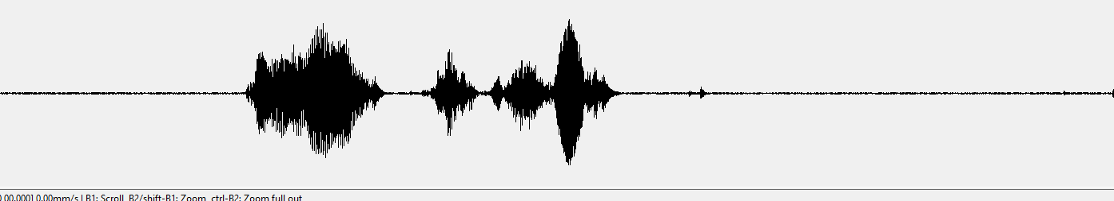

Time

frame_length, frame_step **=** frame_size **\*** sample_rate, frame_stride **\*** sample_rate *# Convert from seconds to samples*signal_length **=** len(emphasized_signal)frame_length **=** int(round(frame_length))frame_step **=** int(round(frame_step))num_frames **=** int(numpy.ceil(float(numpy.abs(signal_length **-** frame_length)) **/** frame_step)) *# Make sure that we have at least 1 frame*pad_signal_length **=** num_frames **\*** frame_step **+** frame_lengthz **=** numpy.zeros((pad_signal_length **-** signal_length))pad_signal **=** numpy.append(emphasized_signal, z) *# Pad Signal to make sure that all frames have equal number of samples without truncating any samples from the original signal*indices **=** numpy.tile(numpy.arange(0, frame_length), (num_frames, 1)) **+** numpy.tile(numpy.arange(0, num_frames **\*** frame_step, frame_step), (frame_length, 1)).Tframes **=** pad_signal[indices.astype(numpy.int32, copy**=**False)]

frames **\*=** numpy.hamming(frame_length)

mag_frames **=** numpy.absolute(numpy.fft.rfft(frames, NFFT)) *# Magnitude of the FFT*pow_frames **=** ((1.0 **/** NFFT) **\*** ((mag_frames) **\*\*** 2))

low_freq_mel **=** 0high_freq_mel **=** (2595 **\*** numpy.log10(1 **+** (sample_rate **/** 2) **/** 700)) *# Convert Hz to Mel*mel_points **=** numpy.linspace(low_freq_mel, high_freq_mel, nfilt **+** 2) *# Equally spaced in Mel scale*hz_points **=** (700 **\*** (10**\*\***(mel_points **/** 2595) **-** 1)) *# Convert Mel to Hz*bin **=** numpy.floor((NFFT **+** 1) **\*** hz_points **/** sample_rate)

fbank **=** numpy.zeros((nfilt, int(numpy.floor(NFFT **/** 2 **+** 1))))**for** m **in** range(1, nfilt **+** 1):

f_m_minus **=** int(bin[m **-** 1]) *# left* f_m **=** int(bin[m]) *# center* f_m_plus **=** int(bin[m **+** 1]) *# right*

**for** k **in** range(f_m_minus, f_m):

fbank[m **-** 1, k] **=** (k **-** bin[m **-** 1]) **/** (bin[m] **-** bin[m **-** 1])

**for** k **in** range(f_m, f_m_plus):

fbank[m **-** 1, k] **=** (bin[m **+** 1] **-** k) **/** (bin[m **+** 1] **-** bin[m])filter_banks **=** numpy.dot(pow_frames, fbank.T)filter_banks **=** numpy.where(filter_banks **==** 0, numpy.finfo(float).eps, filter_banks) *# Numerical Stability*filter_banks **=** 20 **\*** numpy.log10(filter_banks) *# dB*

mfcc **=** dct(filter_banks, type**=**2, axis**=**1, norm**=**'ortho')[:, 1 : (num_ceps **+** 1)]

(nframes, ncoeff) **=** mfcc.shapen **=** numpy.arange(ncoeff)lift **=** 1 **+** (cep_lifter **/** 2) **\*** numpy.sin(numpy.pi **\*** n **/** cep_lifter)mfcc **\*=** lift

filter_banks **-=** (numpy.mean(filter_banks, axis**=**0) **+** 1e-8)

mfcc **-=** (numpy.mean(mfcc, axis**=**0) **+** 1e-8)

## Signal windowing

1, rectangular window

$$w(n)=\left\{\begin{matrix} 1&&0\leq n\leq L-1\\ 0&&Other \end{matrix}\right.$$

2, Hamming window (Hamming)

$$w(n)=\left\{\begin{matrix} \frac{1}{2}(1-cos(\frac{2\pi n}{L-1}))&&0\leq n\leq L-1\\ 0&&Other\end{matrix}\right.$$

3. Haining window (Hanning)

$$w(n)=\left\{\begin{matrix} 0.54-0.46cos(\frac{2\pi n}{L-1})&&0\leq n\leq L-1\\ 0&&Other\end {matrix}\right.$$

Usually, the signal is truncated and framing needs to be windowed, because the truncation has frequency domain energy leakage, and the window function can reduce the impact of truncation.

## **Signal framing**

In the framing, there will be a partial overlap between adjacent frames, the frame length (wlen) = overlap + frame shift (inc), if the adjacent two frames do not overlap, then due to the shape of the window function, There is a loss in the edge of the intercepted speech frame, so the overlap is set. Inc is frame shift, indicating the offset of the previous frame of the next frame, fs is the sampling rate, and fn is the number of frames of a speech signal.

$$\frac{N-overlap}{inc}=\frac{N-wlen+inc}{inc}$$

The theoretical basis of signal framing, where x is the speech signal and w is the window function:

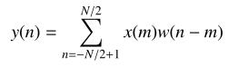

Windowing truncates similar sampling. In order to ensure that adjacent frames are not too different, usually there is a frame shift between frames, which is actually the effect of interpolation smoothing.

FRAMING CODE

import numpy as npimport waveimport os#import math

def enframe(signal, nw, inc):

'''Convert audio signals into frames.

Parameter meaning:

Signal: original audio model

Nw: the length of each frame (here, the length of the sampling point, that is, the sampling frequency multiplied by the time interval)

Inc: interval of adjacent frames (as defined above)

'''

signal_length=len(signal) #Total signal length

if signal_length<=nw: #If the signal length is less than the length of one frame, the number of frames is defined as 1

nf=1

else: #Otherwise, calculate the total length of the frame

nf=int(np.ceil((1.0*signal_length-nw+inc)/inc))

pad_length=int((nf-1)*inc+nw) #All frames add up to the total flattened length

zeros=np.zeros((pad_length-signal_length,)) #Not enough length to fill with 0, similar to the extended array operation in FFT

pad_signal=np.concatenate((signal,zeros)) #The signal after the padding is recorded as pad_signal

indices=np.tile(np.arange(0,nw),(nf,1))+np.tile(np.arange(0,nf*inc,inc),(nw,1)).T #Equivalent to extracting the time points of all frames to obtain a matrix of nf*nw length

indices=np.array(indices,dtype=np.int32) #Convert indices to matrix

frames=pad_signal[indices] #Get the frame signal

# Win=np.tile(winfunc(nw),(nf,1)) #windowWindow function, here defaults to 1

# Return frames*win #return frame signal matrix

return framesdef wavread(filename):

f = wave.open(filename,'rb')

params = f.getparams()

nchannels, sampwidth, framerate, nframes = params[:4]

strData = f.readframes(nframes)#Read audio, string format

waveData = np.fromstring(strData,dtype=np.int16)#Convert a string to an int f.close()

waveData = waveData*1.0/(max(abs(waveData)))#Wave amplitude normalization

waveData = np.reshape(waveData,[nframes,nchannels]).T

return waveData

filepath = "./data/" #Add path

dirname= os.listdir(filepath) #Get all the file names under the folder

filename = filepath+dirname[0]

data = wavread(filename)

nw = 512

inc = 128

Frame = enframe(data[0], nw, inc)

**VOICED FRAMING WITHOUT WINDOWING**

def enframe(signal, nw, inc, winfunc):

'''Convert audio signals into frames.

Parameter meaning:

Signal: original audio model

Nw: the length of each frame (here, the length of the sampling point, that is, the sampling frequency multiplied by the time interval)

Inc: interval of adjacent frames (as defined above)

'''

signal_length=len(signal) #Total signal length

if signal_length<=nw: #If the signal length is less than the length of one frame, the number of frames is defined as 1

nf=1

else: #Otherwise, calculate the total length of the frame

nf=int(np.ceil((1.0*signal_length-nw+inc)/inc))

pad_length=int((nf-1)*inc+nw) #All frames add up to the total flattened length

zeros=np.zeros((pad_length-signal_length,)) #Not enough length to fill with 0, similar to the extended array operation in FFT

pad_signal=np.concatenate((signal,zeros)) #The signal after the padding is recorded as pad_signal

indices=np.tile(np.arange(0,nw),(nf,1))+np.tile(np.arange(0,nf*inc,inc),(nw,1)).T #Equivalent to extracting the time points of all frames to obtain a matrix of nf*nw length

indices=np.array(indices,dtype=np.int32) #Convert indices to matrix

frames=pad_signal[indices] #Get the frame signal

win=np.tile(winfunc,(nf,1)) #Window window function, here defaults to 1

return frames*win #Return frame signal matrix

**WINDOWED FRAMING**

import numpy as npimport matplotlib.pyplot as pltfrom scipy.io import wavfilefrom python_speech_features import mfcc, logfbank

# Read input audio file

sampling_freq, audio = wavfile.read("input_freq.wav")

# Extract MFCC and filter bank features

mfcc_features = mfcc(audio, sampling_freq)

filterbank_features = logfbank(audio, sampling_freq)

print('\nMFCC:\nNumber of windows =', mfcc_features.shape[0])print('Length of each feature =', mfcc_features.shape[1])print('\nFilter bank:\nnumber of windows =', filterbank_features.shape[0])print('Length of each feature =', filterbank_features.shape[1])

# Draw a feature map to visualize the MFCC. Transpose the matrix so that the time domain is horizontal

mfcc_features = mfcc_features.T

plt.matshow(mfcc_features)

plt.title('MFCC')# Visualize filter bank features. Transpose the matrix so that the time domain is horizontal

filterbank_features = filterbank_features.T

plt.matshow(filterbank_features)

plt.title('Filter bank')

plt.show()

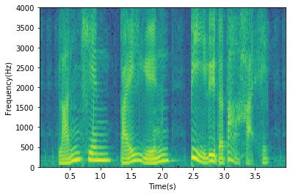

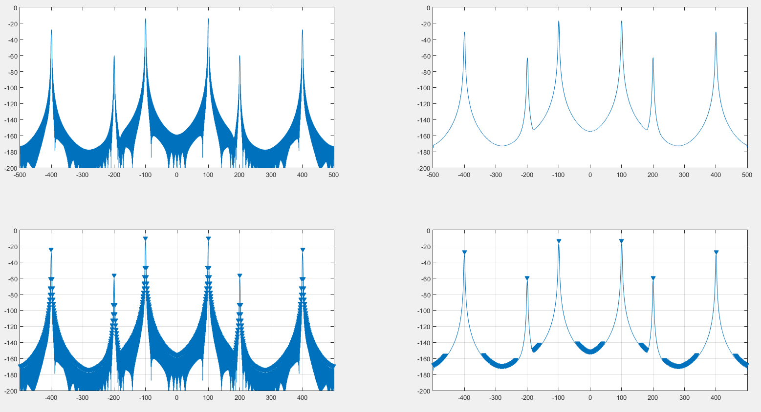

left is the original spectrum generated with a hanning window. Right is the spectrum convoluted by the DFT of a hanning window.