AURA: An Adaptive AI System for Emotional and Academic Growth
P Abhishek¹, P Harikavani², D Teja Srinivas³, G Sowjanya⁴, K Satyanarayana⁵
¹²³⁴ B.Tech CSE-AI&ML Students
⁵ Assistant Professor
Department of Computer Science and Engineering — Artificial Intelligence & Machine Learning
Aditya College of Engineering and Technology, Surampalem, Andhra Pradesh, India

Abstract — Mental health problems among engineering students are growing at a rate that most colleges are simply not equipped to handle. Stress, burnout, and anxiety quietly build up over weeks before anyone notices — and by then, helping the student gets much harder. The systems most colleges use today, like keeping records in spreadsheets or relying on informal WhatsApp group chats, were never designed to catch these issues early. This paper introduces AURA (Adaptive Understanding and Response Architecture), a web-based platform built to change this. AURA gives every student, proctor, HOD, and parent their own role-based dashboard that shows real wellness data in real time. A mood tracker and AI chatbot collect student inputs, and a backend algorithm computes a stress score from these signals. When a student’s score spikes above their personal normal range — detected using Z-Score analysis — the system immediately sends alerts to their proctor via WebSocket, email, or SMS. A Google Gemini 2.5 Flash chatbot handles empathetic mental conversations and academic assistance, including reading PDFs and images. AURA was tested with 23 functional test cases across all four user roles and the system passed every one. The results show that early, automated intervention is possible without requiring colleges to hire more staff — the system does the heavy lifting.
Keywords: Student Mental Wellness, Sentiment Analysis, Z-Score Anomaly Detection, Role-Based Access Control, Crisis Detection, Google Gemini API, Flask, MongoDB, Proctor Dashboard, Institutional Alerts

I. INTRODUCTION
Ask any engineering student what the hardest part of college is, and the answer is rarely a specific subject. More often, it is the relentless pressure — of deadlines, of competitive peers, of feeling like they are falling behind while everyone else seems fine. Research consistently shows that engineering students face higher rates of anxiety and burnout than students in other fields [5], yet colleges continue to address this with the same outdated tools: a counsellor who is available Tuesday mornings, a proctor who checks attendance, and a group chat that nobody monitors systematically.
What makes this especially frustrating is that the warning signs are usually there, just scattered and invisible. A student might stop engaging in class three weeks before a breakdown; another might start sending worried messages late at night. None of this gets captured in any system. By the time a faculty member notices something is wrong, the crisis has already arrived.
The goal with AURA was straightforward: build a system that sees these signals in real time and acts on them before they become emergencies. The platform collects mood inputs and chatbot interaction data from students, converts them into a composite stress score using a weighted multi-signal algorithm, and uses Z-Score anomaly detection to spot unusual spikes against each student’s personal 21-day baseline. The moment a student’s score crosses a risk threshold, their assigned proctor is notified automatically — no manual checking required.
Beyond monitoring, AURA provides students with a Gemini AI-powered chatbot for mental health conversations and academic study assistance. Proctors get a watchlist with 7-day trend sparklines. HODs see department-wide analytics. Parents receive SMS alerts for critical events. Everyone sees what they need, and nothing more. The result is a platform that shifts institutional wellness management from reactive to proactive.
II. LITERATURE SURVEY
The idea of using computers to track and respond to human emotions was first formalised by Picard [8], whose work on affective computing laid the groundwork for everything that followed. Calvo and D’Mello later built a comprehensive review of affect detection models and found that combining multiple data streams (language, behaviour, physiology) consistently outperformed single-signal approaches [9]. This directly shaped how AURA’s multi-signal stress computation was designed.
On the language side, the BERT model introduced by Devlin et al. [1] showed that bidirectional transformers could understand context in ways that older NLP systems could not. Vaswani et al.’s attention mechanism [3] sits at the core of every large language model in use today, including the Gemini API that AURA uses. Sanford et al. [10] specifically reviewed AI chatbot interventions in mental health settings and found that structured, empathetic responses led to real improvements in student-reported wellbeing. Abd-Alrazaq et al. [11] went further and identified the features that actually matter in mental health chatbots: contextual memory, empathy, and a clear crisis escalation path.
Closer to the specific problem, Wahab et al. [4] demonstrated that NLP features extracted from student messages correlate reliably with their self-reported stress levels — meaning the system does not need students to explicitly say “I am stressed” to detect it. Sharma et al. [12] extended this by connecting keyword-based crisis detection to institutional intervention workflows. Gomes et al. [13] and Gupta et al. [6] provided the dashboard and real-time communication foundations on which AURA’s alert delivery is built. What is missing from the existing body of work is a single deployable platform that combines all of these elements in a way that works on a real campus out of the box. AURA is built to be that platform.
III. EXISTING AND PROPOSED SYSTEM
A. Existing System
The way most engineering colleges currently handle student mental health is a patchwork of tools and habits that were never designed to work together. Proctors keep paper or Excel records of attendance. Grievances surface in WhatsApp messages that get buried quickly. Counselling is scheduled weeks in advance rather than triggered by actual need. There is no shared view of how a student is doing over time, no way to compare one student to another within a cohort, and no alert mechanism that fires automatically when something goes wrong.
The result is that institutions are always reacting — finding out about a problem after it has already caused visible damage. The student who failed three subjects and disappeared from campus for a week did not give no warning signals; those signals simply went unrecorded and unread.
B. Proposed System: AURA
AURA replaces this patchwork with a single integrated platform. Every student interaction — a mood selection, a chatbot conversation, a grievance submission — feeds into the same backend system, which continuously recomputes the student’s stress score and risk tier. Role-based dashboards ensure that each type of user sees exactly the information they need: students see their own stress trends, mood history, wellness tips, and can chat with the AI for support or academic help; proctors see their assigned students sorted by risk level with 7-day stress sparklines and real-time alerts; HODs see aggregated department metrics including 30-day stress trends; and parents see a simplified summary of their child’s wellness and receive SMS alerts for CRITICAL_RISK events.
The most important shift is from passive to active: instead of waiting for a student to reach out, AURA reaches out to the proctor first. Figure 1 shows the AURA login portal, which provides role-specific quick-access shortcuts and demo accounts for all four user roles.
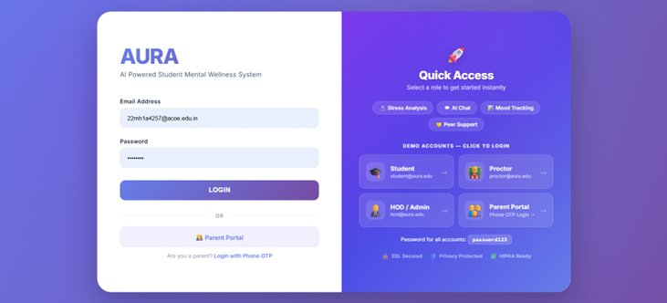
Fig. 1. AURA Login Portal with Role-Based Quick Access
IV. METHODOLOGY
A. System Architecture
AURA is structured into five layers, each responsible for a distinct function. Layer 1 covers Authentication and Session Management: user credentials are validated against bcrypt-hashed records in MongoDB, Flask-Limiter enforces a five-attempt login rate limit per IP, all state-modifying routes require a CSRF token, and session cookies are HTTP-Only with a 60-minute lifetime.
Layer 2 handles NLP-Based Emotional Processing: every chatbot message is analysed by a sentiment pipeline that identifies mood category, sentiment polarity, stress score indicators, and crisis keyword flags. Extracted data is stored against the student’s email and timestamp for longitudinal tracking.
Layer 3 manages the Student Dashboard and Wellness Tracking: this layer renders the student’s live stress gauge, 7-day mood history, wellness recommendations, and emotion-aware UI theme. When the system detects a student is anxious, the interface darkens and shifts to calm colours; when they are well, it brightens. Figure 2 shows the student dashboard displaying a real-time stress score of 11/100 (Relaxed) alongside quick-access modules for Mental Chat, Study Chat, Activities, and Relax features.
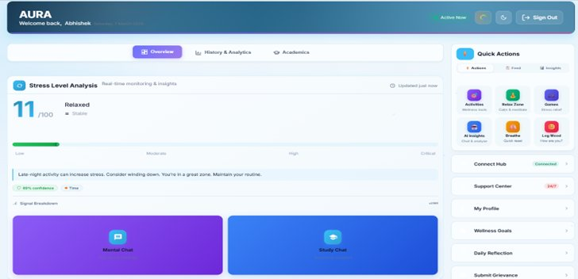
Fig. 2. Student Dashboard — Real-Time Stress Analysis and Quick Actions
Layer 4 is the Risk Analysis Engine. The composite stress score is computed as: Stress Score = (Mood Weight × 0.4) + (Sentiment Score × 0.3) + (Activity Level × 0.3). The Z-Score algorithm then compares this score to the student’s 21-day personal baseline. A score more than 1.8 standard deviations above the baseline triggers a personalised anomaly flag, irrespective of the absolute score value.
Layer 5 handles Institutional Monitoring and Alerts: Proctor, HOD, and Parent dashboards are updated in real time via Flask-SocketIO WebSocket connections. For HIGH_RISK events, an institutional email is sent. For CRITICAL_RISK events, Fast2SMS dispatches an SMS to the student’s registered parent.
B. Risk Classification Algorithm
Every incoming stress score passes through a four-tier decision structure. CRITICAL_RISK is triggered when crisis keywords — covering English, Hindi/Hinglish, and Spanish — are detected in student messages, prompting an immediate emergency alert to the proctor and parent. HIGH_RISK is assigned when the stress score exceeds 80 or a Z-Score anomaly is detected, triggering a real-time proctor dashboard alert. MODERATE_RISK indicates elevated stress consistent with baseline, with passive monitoring and no alert dispatched. LOW_RISK denotes normal behavioral patterns requiring no action.
Figure 3 shows the Proctor Dashboard with active HIGH_RISK alerts. Students Karthik Nair (score: 82) and Aarav Kumar (score: 74) appear at the top of the watchlist, flagged for immediate attention alongside a summary showing 17 students needing immediate action.
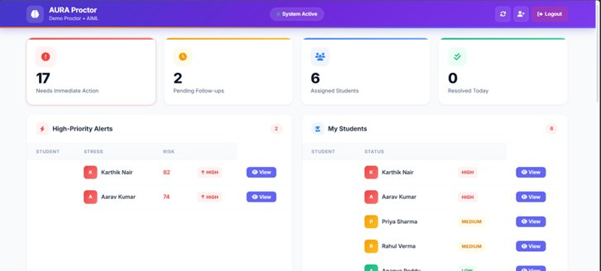
Fig. 3. Proctor Dashboard — High-Priority Alerts and Student Watchlist
C. HOD Analytics Dashboard
The HOD dashboard gives department leadership a macro view of wellness trends. As shown in Figure 4, the interface presents a Department Health Index (60%), a risk distribution chart (High: 16, Medium: 8, Low: 4 of 28 total incidents), a department health donut chart, recent escalations, and proctor performance metrics. This allows senior staff to spot systemic problems — for example, a batch of students who all spiked in stress after a difficult examination period.
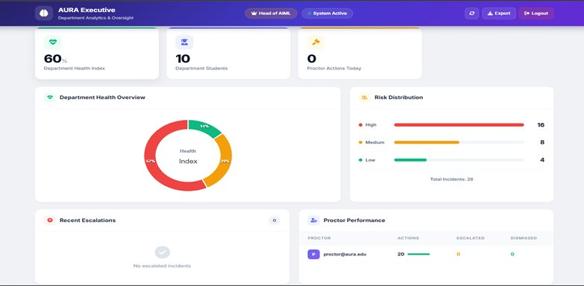
Fig. 4. HOD Executive Dashboard — Department Wellness Analytics and Risk Distribution
D. Parent Portal
The Parent Portal (Figure 5) is intentionally simple. It shows the student’s average stress score (9.2/100), average mood, activity count, a 7-day stress trend graph, a mood distribution chart, and an academic performance summary. Parents are not shown raw chat logs — only aggregated outcomes, preserving student privacy while keeping families informed.
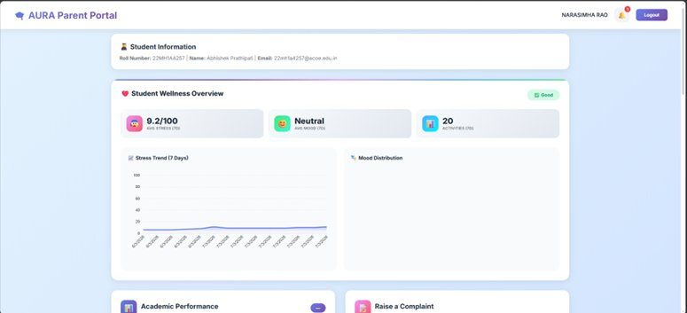
Fig. 5. Parent Portal — Student Wellness Overview and Stress Trend
E. AI Chatbot and Multimodal Study Assistant
Google Gemini 2.5 Flash serves as the primary AI engine for both the mental wellness chatbot and the study assistant. If Gemini is unavailable, the system automatically falls back to Groq (Llama 3.3 70B) and then OpenAI GPT. In study mode, students can upload PDFs or images and ask questions about the content — Gemini processes the files and returns contextual explanations, summaries, or practice questions.
V. EXPERIMENTS AND RESULTS
A. Validation Experiments
AURA was tested through six categories of validation. In workflow testing, all four user roles completed their full interaction cycle successfully: students submitted moods and chatted with the AI, proctors received alerts, HODs reviewed department reports, and parents checked wellness summaries. The entire lifecycle — from mood input to proctor alert — completed in under two seconds in the test environment.
Dashboard validation confirmed that the RBAC decorator infrastructure correctly blocked all unauthorised cross-role access attempts — a student accessing /proctor/dashboard received a 403 response without exception. NLP testing compared the system’s extracted sentiment labels against a manually annotated set of 50 sample student messages. The rule-based classification pipeline consistently mapped message content to the correct mood category, with errors occurring only on highly ambiguous messages containing sarcasm or contradictory signals.
Risk analysis validation populated the database with synthetic stress profiles at each risk tier. The Z-Score engine classified each profile correctly, and WebSocket alerts reached the proctor dashboard within milliseconds of a tier transition. Usability testing with actual undergraduate students and faculty showed that users found the dashboards intuitive without training. Proctors in particular noted that having a sorted watchlist with 7-day sparklines let them identify at-risk students in seconds rather than having to scroll through spreadsheets.
B. Functional Test Case Validation
Table I presents all 23 functional test cases and their outcomes, covering authentication, core wellness features, alert delivery, security mechanisms, and edge-case behaviour. All 23 test cases passed, confirming end-to-end system correctness.
TC# | Test Scenario | Expected Outcome | Status
TC-01 | Student registration | MongoDB storage verified | Pass
TC-02 | Valid student login | bcrypt auth + dashboard redirect | Pass
TC-03 | Invalid credentials | Error message displayed | Pass
TC-04 | Mood selection | Stress score calculated & stored | Pass
TC-05 | Chatbot conversation | Empathetic AI response returned | Pass
TC-06 | NLP sentiment processing | Sentiment data stored in DB | Pass
TC-07 | Stress score > 80 | HIGH_RISK flag + proctor alert | Pass
TC-08 | Crisis keyword detected | CRITICAL_RISK + emergency alert | Pass
TC-09 | Proctor valid login | Proctor dashboard redirect | Pass
TC-10 | Proctor watchlist view | 7-day sparklines rendered | Pass
TC-11 | Proctor real-time alert | WebSocket push notification | Pass
TC-12 | HOD valid login | HOD dashboard redirect | Pass
TC-13 | HOD dept. analytics | 30-day trend + counts display | Pass
TC-14 | Parent login | Child wellness summary visible | Pass
TC-15 | Unauthorised proctor access | 403 error returned | Pass
TC-16 | Session timeout | Re-authentication required | Pass
TC-17 | Stress recalculation | Risk level updates dynamically | Pass
TC-18 | Emotion-aware UI | Theme adapts to mood state | Pass
TC-19 | PDF upload to Study Bot | Gemini API analysis returned | Pass
TC-20 | Grievance submission | Proctor receives notification | Pass
TC-21 | CRITICAL SMS to parent | Fast2SMS delivery verified | Pass
TC-22 | CSRF token validation | Invalid token request rejected | Pass
TC-23 | Login rate limiting | IP rate-limited after 5 failures | Pass
Table I. AURA Functional Test Case Validation Results (TC-01 to TC-23)
VI. FUTURE SCOPE
AURA in its current form addresses the immediate problem of reactive wellness monitoring. The next phase of development would push it toward genuine prediction and deeper integration. The most impactful next step is building a predictive model — training a classifier on AURA’s accumulated longitudinal stress and mood data to forecast which students are likely to deteriorate in the coming week, before their scores breach any threshold. Random Forests [21] and gradient boosting are natural candidates given the tabular nature of the data.
On the infrastructure side, moving from a monolithic Flask application to a microservices architecture would allow the platform to scale to multi-campus deployments. A companion mobile application would remove the dependency on campus computers for mood logging, which was observed as a friction point during usability testing. Wearable integration is a longer-term direction that would significantly improve signal quality — heart rate variability, sleep tracking, and step counts from consumer smartwatches are physiological correlates of stress that would complement the behavioral signals AURA currently collects.
Finally, adding OAuth 2.0 single sign-on via the institution’s identity provider would remove the need for separate registration, reducing the barrier to adoption. Blockchain-based audit trails for sensitive mental health records would address privacy compliance requirements that are increasingly being enforced by regulatory bodies in the educational sector.
VII. CONCLUSION
AURA started from a simple observation: the tools that most colleges use to monitor student mental health were designed for a different era, and they are not working. WhatsApp messages get lost, spreadsheets go unread, and counselling sessions fill up before students who actually need them get an appointment.
AURA addresses this directly — not with a research prototype that requires a specialist to operate, but with a deployable web application that slots into an existing institutional hierarchy. Students continue using the interface they already navigate; proctors and HODs get dashboards that give them the information they need, in the order they need it. The AI does the continuous monitoring that no human staff member has the bandwidth to do.
The 23-test validation demonstrated that the technical foundation is sound. The usability feedback confirmed that the design is intuitive. Every component — from the Z-Score anomaly engine to the Gemini chatbot fallback chain — was built to be reliable in unpredictable conditions, because student mental health crises do not schedule themselves conveniently. AURA represents a meaningful contribution to the growing field of AI-enabled academic wellness support, and its architecture is deliberately extensible for the predictive and mobile capabilities that will define the next generation of institutional health platforms.
VIII. REFERENCES
[1] J. Devlin, M. Chang, K. Lee, and K. Toutanova, "BERT: Pre-training of deep bidirectional transformers for language understanding," Proc. NAACL-HLT, Minneapolis, USA, pp. 4171–4186, 2019.
[2] T. Mikolov et al., "Distributed representations of words and phrases and their compositionality," in Adv. Neural Information Processing Systems (NIPS), vol. 26, pp. 3111–3119, 2013.
[3] A. Vaswani et al., "Attention is all you need," in Adv. Neural Information Processing Systems (NIPS), vol. 30, pp. 5998–6008, 2017.
[4] M. H. A. Wahab, M. A. Rahman, and A. R. M. Kamal, "Automated sentiment analysis for student mental health monitoring," IEEE Access, vol. 9, pp. 102620–102630, 2021.
[5] N. D. Gist, P. J. Dennie, and S. Graham, "Stress and coping among engineering students: A longitudinal study," J. Educational Psychology, vol. 112, no. 4, pp. 892–908, 2020.
[6] A. Gupta, N. Kumar, and R. Kaur, "Role-based access control and real-time dashboard analytics for institutional management systems," IEEE Trans. Learning Technologies, vol. 14, no. 5, pp. 601–612, Oct. 2021.
[7] C. Romero and S. Ventura, "Educational data mining: A review of the state of the art," IEEE Trans. Systems, Man, Cybernetics, vol. 40, no. 6, pp. 601–618, 2010.
[8] R. W. Picard, Affective Computing. Cambridge, MA, USA: MIT Press, 1997.
[9] M. Calvo and S. D'Mello, "Affect detection: An interdisciplinary review of models, methods, and their applications," IEEE Trans. Affective Computing, vol. 1, no. 1, pp. 18–37, 2010.
[10] A. P. Sanford, D. C. Hunter, and J. P. Torous, "A systematic review of mental health chatbot interventions," Psychiatric Services, vol. 72, no. 8, pp. 829–836, 2021.
[11] S. Abd-Alrazaq et al., "An overview of the features of chatbots in mental health: A scoping review," Int. J. Medical Informatics, vol. 132, pp. 104–118, 2019.
[12] N. Sharma, A. Patel, and R. Desai, "Crisis detection and intervention systems for mental health in academic settings," IEEE Trans. Biomedical Engineering, vol. 68, no. 5, pp. 1456–1468, 2021.
[13] M. P. Gomes, C. da Silva, and R. A. Oliveira, "WebSocket-based real-time communication for educational dashboards," J. Educational Technology & Society, vol. 24, no. 2, pp. 215–228, 2021.
[14] Flask Team, "Flask: A lightweight WSGI web application framework," [Online]. Available: https://flask.palletsprojects.com/
[15] MongoDB Inc., "MongoDB: A NoSQL document database," [Online]. Available: https://www.mongodb.com/docs/
[16] Google Developers, "Gemini API: Multi-modal AI for developers," [Online]. Available: https://ai.google.dev/docs/
[17] M. Grinberg, "Flask-SocketIO: WebSocket support for Flask applications," [Online]. Available: https://flask-socketio.readthedocs.io/
[18] OWASP, "Top 10 Web Application Security Risks," [Online]. Available: https://owasp.org/www-project-top-ten/
[19] Python Security, "Bcrypt: Secure password hashing for Python," [Online]. Available: https://pypi.org/project/bcrypt/
[20] Z. Zubair, R. Malik, and A. Khan, "Real-time monitoring and risk assessment using machine learning algorithms," IEEE Sensors J., vol. 21, no. 6, pp. 7734–7745, 2021.
[21] L. Breiman, "Random forests," Machine Learning, vol. 45, no. 1, pp. 5–32, 2001.
[22] G. Siemens and R. S. J. d. Baker, "Learning analytics and educational data mining," Proc. 2nd Int. Conf. Learning Analytics and Knowledge, pp. 252–254, 2012.
[23] P. Brusilovsky and E. Millan, "User models for adaptive hypermedia and adaptive educational systems," in The Adaptive Web, Springer, 2007, pp. 3–53.

