**A**

**MAJOR PROJECT REPORT**

**ON**

VIBESPACE - College Hackathon Management System

**SUBMITTED IN THE PARTIAL FULFILLMENT OF**

**THE DEGREE OF**

**BACHELOR OF COMPUTER APPLICATION**

**Dr. B. R. AMBEDKAR UNIVERSITY, AGRA**

**Summitted BY:**

**STUDENT NAME: Abhishek Pundhir**

**ROLL NO: 2202325010011**

**ENROLMENT NO: A-** **22184588**

**Under the Guidance of**

**Internal Guide External Guide**

**Dr. VINEET MISHRA**

Head Of Department (HOD)

**(Designation)**



**AGRA PUBLIC TEACHER’S TRAINING COLLEGE, ARTONI , AGRA**

**Session 2024 -** **25**

**DECLARATION**

**I do hereby declare that this project work entitled “ VIBESPACE - College Hackathon Management System” submitted by me for the partial fulfilment of the requirement for the award of Bachelors In Computer Applications (BCA) is a record of my own project work. The project report has not been submitted earlier for the award of any degree or diploma to any Institute or University.**

**Date:   
Name:**

**Sign of Student**

**ACKNOWLEDGEMENT**

**This report acknowledges the intense drive and technical competence of all the individuals who have contributed to its success.**

**Any work of this nature would not have possible without the support and guidance of others around me. Hence, I feel to be my first and foremost duty to express my deep sense of gratitude and pay my genuine and thanks to .Vineet Mishra. (H.O.D.,CS) and all C.S. faculty for giving me this opportunity to work on this project.**

**Whenever a complex and complicated problem confronted me, the spontaneous guidance of all my team members was ever at hand to solve any difficulty.**

**Last but not the least; I would like to express my thanks to Principal. Agra Public Teachers Training College, Artoni , Agra who has been a huge support thought.**

**Student Name – Abhishek Pundhir**

**B.C.A. -VI Sem**

**Roll No – 2202325010011**

**CERTIFICATE**

It is certified that the work contained in the project report titled **“VIBESPACE - College Hackathon Management System”** by *“***Abhishek Pundhir***”* , Roll No.- 2202325010011 has been carried out under my/our supervision and that this work has not been submitted elsewhere for a degree to the best of my knowledge and belief.

**Signature of Supervisor**

**Table of Contents**

**Chapter 1: Introduction**

**1.1 Project Overview – Brief description of the project idea, its inspiration, and purpose.**

**1.2 Purpose and Importance – Why the project matters and how it solves a real-world problem.**

**1.3 Objectives – Clear goals the project aims to achieve.**

**Chapter 2: Problem Statement**

* **Clearly articulate the core problem your project addresses, with real-life context if possible.**

**Chapter 3: System Study and Analysis**

**3.1 Study of Existing System – Compare with current solutions (manual or digital).**

**3.2 System Requirements – Hardware, software, and functional requirements.**

**3.3 Feasibility Study – Technical, operational, and economic feasibility.**

**3.4 System Analysis Diagram – DFD, flowcharts, or use case diagrams.**

**Chapter 4: System Design**

**4.1 Architectural Design – Overall architecture (client-server, MVC, etc.)**

**4.2 UML Diagram – Class, use case, sequence, or activity diagrams.**

**4.3 Database Design – ER diagrams or schema structure.**

**4.4 Data Dictionary – Table structure with field names, types, and constraints.**

**Chapter 5: Software Development Life Cycle (SDLC)**

**5.1 Agile Methodology – Explain Agile principles adopted.**

**Chapter 6: Implementation**

**6.1 Frontend Development – UI with React and Tailwind CSS.**

**6.2 Backend Development – APIs with Node.js and Express.**

**6.3 Database Setup – Use of Local Storage or JSON objects as pseudo-database.**

**6.4 Code Samples – Key code snippets with explanation.**

**6.5 UI Screenshots – Real screenshots of the interface.**

**Chapter 7: Testing**

**7.1 Testing Methodology – Manual, unit, integration, or automated testing approach.**

**7.2 Test Cases – Input/output test cases in table format.**

**Chapter 8: Security**

**8.1 Authentication and Authorization – Describe login/signup mechanism, JWT/token if used.**

**Chapter 9: Future Scope**

* **Features to be added, potential for scaling, or integration with other services.**

**Chapter 10: Project Deployment**

**Chapter 11: Conclusion**

* **Summary of the learning experience, project outcome, and goals achieved.**

**Chapter 12: References**

* **Site resources like documentation, tutorials, books, StackOverflow, GitHub repos.**

**Introduction**

Hackathons have become a powerful tool for innovation and skill development, especially within educational institutions. These events encourage students to explore their creativity, work in teams, and develop real-world solutions to problems. However, the management of hackathons in many colleges is often chaotic and inefficient. Manual processes, scattered communication, and lack of a centralized platform for project submission and evaluation create significant challenges for both students and faculty.

VibeSpace is designed to address these challenges. It is a comprehensive web-based application that simplifies the process of organizing, participating in, and managing college hackathons. The system provides a user-friendly interface for students to explore hackathon events, form teams, and submit their projects without the need for login. Faculty members, on the other hand, can use the platform to create events, monitor submissions, review projects, and provide structured feedback.

The primary objective of VibeSpace is to streamline the hackathon process, making it accessible to all students while offering a robust management system for faculty. The platform ensures transparency by providing feedback for each project submission and helps maintain a record of all events and their outcomes. By using VibeSpace, colleges can cultivate a culture of innovation and collaboration among students.

This project report provides a detailed analysis of VibeSpace, starting with an overview of existing hackathon management systems and their limitations. It then explores the design, development, and deployment of VibeSpace, covering all aspects of software development life cycle (SDLC) including system analysis, design, implementation, testing, and security. The report also highlights the future scope of the project, outlining potential upgrades that can enhance the system's functionality.

The implementation of VibeSpace is based on modern web development technologies, including React for the frontend, Node.js with Express for the backend, and MongoDB for database management. These technologies ensure that the system is scalable, secure, and efficient, making it a reliable solution for hackathon management in educational institutions. The use of an agile methodology during development allowed for continuous improvement and user feedback integration, resulting in a user-centric product.

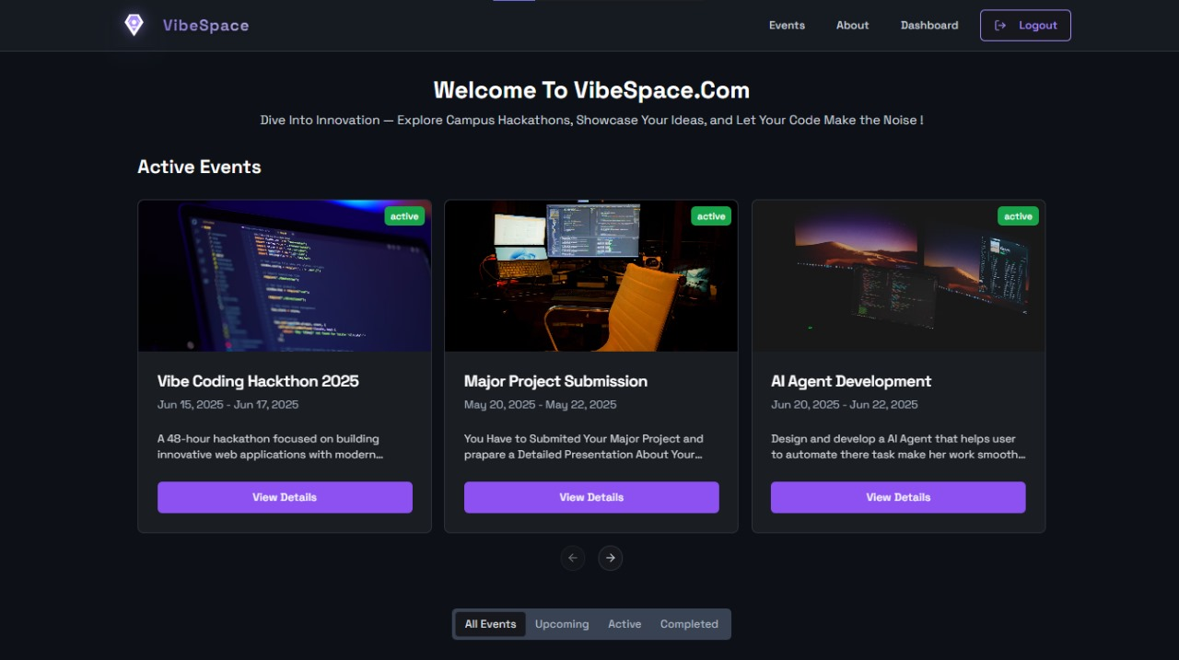l

**1.1 Project Overview**

In the contemporary landscape of technical education, hackathons have emerged as pivotal events fostering innovation, collaboration, and the practical application of theoretical knowledge among students. These intensive, time-bound coding events encourage participants to develop solutions to real-world problems, thereby enhancing their problem-solving skills, teamwork abilities, and proficiency in various technologies. However, the effective organization and management of such events, especially within large educational institutions, present considerable logistical and administrative challenges. Manual processes, fragmented communication channels, and lack of centralized data management often lead to inefficiencies, errors, and suboptimal experiences for both organizers and participants.

"VibeSpace" is conceived as a comprehensive, web-based College Hackathon Management System designed to address these challenges by providing a centralized, streamlined, and automated platform for managing the entire lifecycle of a hackathon. From event creation and participant registration to project submission, evaluation, and communication, VibeSpace aims to digitalize and optimize key administrative workflows.

The system is built using modern web technologies – React for the frontend, Node.js/Express for the backend, and MongoDB as the database – employing a robust client-server architecture to ensure scalability, responsiveness, and data integrity.

The primary purpose of the VibeSpace system is to offer a unified digital platform that simplifies the complexities inherent in managing college-level hackathons. It seeks to replace disparate tools and manual tasks with integrated, automated processes, thereby reducing administrative overhead, minimizing the potential for human error, and enhancing the overall efficiency and transparency of the hackathon organization. By providing intuitive interfaces for both administrators and student participants, VibeSpace aims to improve user experience, facilitate better engagement, and ensure that hackathons can be conducted more frequently and on a larger scale within educational institutions.

**1.2 Purpose And Importance**

The primary purpose of the "VibeSpace - College Hackathon Management System" project is to design and implement a comprehensive digital solution that streamlines and automates the management of hackathon events within educational institutions. This involves replacing inefficient manual processes with a centralized, web-based platform that caters to the needs of both event administrators and student participants. The system is intended to cover all critical phases of a hackathon lifecycle, from initial event announcement and registration through project submission and evaluation. By achieving this purpose, VibeSpace aims to significantly improve the operational efficiency of hackathon organization and enhance the overall experience for all stakeholders involved.

The importance of this project stems from several factors, particularly in the context of the growing emphasis on practical, project-based learning and skill development in technical education:

* **Facilitating Skill Development:** Hackathons are invaluable platforms for students to apply theoretical knowledge, learn new technologies, collaborate in teams, and develop innovative solutions under pressure. An efficient management system makes it easier for colleges to organize such events frequently, thereby providing more opportunities for students to hone these crucial skills.
* **Enhancing Administrative Efficiency:** The manual processes currently in use consume significant time and resources that could be better allocated. Automating tasks such as registration management, submission collection, and data organization liberates administrators to focus on the strategic aspects of event planning, sponsorship, and fostering a positive environment for participants. This increased efficiency can lead to the successful organization of larger and more frequent events.
* **Improving Participant Experience:** A user-friendly, centralized platform simplifies the process for students to discover events, register, submit their work, and receive timely updates. This seamless experience encourages greater participation and allows students to focus on their projects rather than navigating complex administrative hurdles. Easy access to event rules, schedules, and submission guidelines ensures clarity and reduces participant frustration.
* **Ensuring Data Integrity and Accessibility:** Centralizing all hackathon-related data – participant information, project details, evaluation scores – in a single, secure database eliminates data fragmentation and inconsistency issues. This provides a reliable source of truth for all event-related information, making it easier to track progress, generate reports, and analyze outcomes.
* **Promoting Transparency and Fairness:** A structured online submission and evaluation system can introduce greater transparency into the judging process. Standardized submission formats and a clear interface for evaluators help ensure that all projects are reviewed consistently and fairly.
* **Scalability for Future Growth:** A well-designed automated system is inherently more scalable than manual processes. As the college grows or the popularity of hackathons increases, VibeSpace can handle a larger volume of participants and events without a proportional increase in administrative effort.
* **Demonstrating Technical Proficiency**: From an academic perspective, the development of VibeSpace serves as a practical application of the concepts and technologies learned during the BCA program. It demonstrates the ability to analyze a real-world problem, design a software architecture, implement a full-stack application using modern frameworks and databases, and consider aspects like security and user experience – all critical skills for a computer applications professional.
* **Potential for Institutional Impact:** A successful hackathon management system can become a valuable asset for the college, establishing a standard for technical event management and potentially serving as a model for managing other types of college events.

In essence, the purpose of VibeSpace extends beyond merely creating a software application; it aims to provide a tangible solution that enhances the educational environment by facilitating more frequent, better organized, and more impactful technical events. Its importance lies in its potential to transform how colleges manage hackathons, making them more accessible, efficient, and valuable for both the organizing body and the student community. This project represents a significant step towards leveraging technology to optimize academic and extracurricular activities, aligning with the broader goals of digital transformation in education.

**1.3 Main Objective**

The development of the VibeSpace - College Hackathon Management System is guided by a set of specific, measurable, achievable, relevant, and time-bound (SMART) objectives. These objectives collectively aim to deliver a functional, reliable, and user-centric system that significantly improves the hackathon management process. The main objectives of this project are:

* **To Develop a Centralized Platform for Event Management**: To create a single,secure, and accessible web application where administrators can create, configure, publish, and manage multiple hackathon events. This includes defining event details, timelines, rules, themes, and other relevant information.

* **To Streamline Participant Registration**: To provide students with a simple and intuitive online interface for browsing available hackathon events, registering their participation, and managing their registration details. This objective aims to eliminate manual registration processes and associated data entry errors.
* **To Facilitate Online Project Submission**: To enable registered participants to easily submit their hackathon projects, including project descriptions, team details, code repositories, and demo videos, through the system. This objective seeks to standardize the submission process and centralize all project artifacts.
* **To Implement an Efficient Evaluation Process**: To provide administrators with tools to manage the evaluation process, including assigning evaluators, tracking evaluation progress, and recording scores and feedback for submitted projects. This objective aims to bring structure and transparency to the judging phase.
* **To Enhance Communication Channels**: To integrate features that allow administrators to communicate effectively with registered participants, sending announcements, updates, reminders, and important notifications through the platform, thereby reducing reliance on manual communication methods like emails or group chats.
* **To Provide Comprehensive Reporting and Analytics:** To enable administrators to generate reports and gain insights into event statistics, such as participant demographics, registration numbers, submission rates, and evaluation outcomes, to aid in analyzing event success and planning future events.
* **To Ensure System Security and Data Integrity:** To implement robust security measures, including user authentication, authorization, input validation, and secure data handling practices, to protect sensitive user and event data and ensure the system's reliability.

**1.4 Project Scope**

The scope of the VibeSpace - College Hackathon Management System project is clearly defined to manage expectations and focus development efforts within the constraints of a BCA final year project. The system is scoped to cover the core functionalities required for managing typical college-level hackathons. The defined scope includes the following key areas:

* **User Management:**
  + Creation and management of two primary user roles:
  + Administrator and Student.
  + Secure registration and login mechanisms for both roles.
  + Role-based access control to restrict functionalities based on user type.

* **Event Management (Admin Functionality):**
  + Creation, editing, and deletion of hackathon events.
  + Setting event details: title, description, dates (start, end, registration deadline, submission deadline), location (virtual/physical), themes, rules, and judging criteria.
  + Publishing and unpublishing events.
  + Viewing a list of registered participants for specific events.
  + Managing submitted projects (viewing, downloading artifacts).
  + Assigning evaluators to projects (manual assignment within scope).
  + Recording evaluation scores and feedback.
  + Generating basic reports on event participation and submission counts.
* **Participant Functionality (Student Functionality):**
  + Browsing and viewing details of published hackathon events.
  + Registering for available events.
  + Viewing their registered events.
  + Submitting projects for registered events.
  + Editing or updating their project submissions within the allowed timeframe.
  + Viewing status updates related to their submissions (e.g., received, under evaluation).
* **Project Submission Management:**
  + Form-based submission allowing details like project title, description, team members (manual entry or selection of registered participants), links to code repository (e.g., GitHub), and potentially a demo video link.
  + Storing submission data linked to the specific event and participants.
* **Basic Communication:**
  + System-generated notifications for key actions (e.g., registration confirmation, submission confirmation).
  + An administrative interface to send general announcements to all participants of a specific event.
* **Evaluation (Basic):**
  + An interface for assigned evaluators (implicitly handled as Admin users with evaluation privileges within this scope) to view project details and record scores/feedback.
* **Core Technologies:** Development using React (Frontend), Node.js/Express (Backend), and JavaScript Object (Database)

**The project scope explicitly excludes functionalities such as:**

* Advanced user profiles beyond basic registration information.
* Real-time chat or messaging between participants or with organizers.
* Integrated payment gateways for registration fees (if applicable).
* Automated team formation features.
* Complex data analytics or visualization dashboards.
* Certificate generation directly within the system.
* Integration with external APIs beyond core authentication/authorization necessities.
* Mobile application development (scope is limited to a web application).
* Complex workflow automation (e.g., automatic evaluator assignment based on specific criteria).

Adhering to this defined scope ensures that the project remains manageable within the given timeframe and resources, while still delivering a complete and valuable system addressing the primary challenges of hackathon management.

**Chapter 2: Problem Statement**

**Problem Statement**

The current methods employed for managing hackathon events in many educational institutions, particularly at the college level, are predominantly manual or reliant on a collection of disparate, non-integrated tools. This approach, while functional for small-scale events, becomes increasingly inefficient and problematic as the scale and complexity of hackathons grow. The inherent limitations and challenges of the existing system can be categorized into several key areas:

* **Manual Registration and Data Management:**
  + Registration often involves manual collection of participant details via forms, spreadsheets, or emails. This process is time-consuming, prone to data entry errors, and makes it difficult to track the status of registrations in real-time.
  + Managing participant data across multiple documents or platforms leads to data silos and inconsistencies.
* **Inefficient Project Submission and Tracking:**
  + Project submissions are typically handled via email, cloud storage links, or physical submissions. This lacks standardization and makes it challenging for organizers to track received submissions, verify completeness, and organize projects for evaluation.
  + Version control and tracking updates to submitted projects become cumbersome.
* **Complex Communication Flow:** 
  + Disseminating information, updates, and announcements to all participants relies on mass emails, social media groups, or manual broadcasts. This can lead to missed communications, information overload, and difficulty in ensuring that critical information reaches the intended audience effectively and reliably.
  + Handling queries and providing support to participants in a centralized manner is difficult.
* **Laborious Evaluation Process:**
  + Organizing projects for evaluators, providing them access to submission details, and collecting their scores and feedback often involves manual distribution of materials (physical or digital) and manual compilation of results. This process is time-consuming, lacks transparency, and can introduce errors in calculation and aggregation.
  + Tracking the progress of evaluations across multiple judges is challenging.
* **Lack of Centralized Information and Reporting:**
  + Event details, rules, schedules, participant lists, submissions, and evaluation results are often scattered across different platforms or documents. There is no single source of truth.
  + Generating reports on event participation, demographics, or outcomes requires manually consolidating data, which is time-consuming and limits the depth of analysis possible for future event planning.
* **Limited Scalability:**
  + As the number of participants and events increases, the manual workload grows exponentially, making it unsustainable to manage large-scale hackathons efficiently.
  + The current systems struggle to handle concurrent events or a significant increase in participant numbers.
* **Suboptimal User Experience:**
  + For students, finding event information, registering, and submitting projects can be fragmented and confusing.
  + For administrators, the manual processes are tedious and require significant effort, detracting from focusing on the strategic aspects of organizing a successful event.

These problems collectively highlight a significant need for a dedicated, automated system. The inefficiencies waste valuable time and resources, increase the potential for errors, and ultimately impact the quality and reach of the hackathon events. This forms the core problem statement that the VibeSpace system aims to resolve: **"To develop a unified, automated, and user-friendly platform that addresses the inefficiencies, data fragmentation, and communication challenges inherent in the manual or disparate systems currently used for managing college hackathons, thereby improving the administrative process and enhancing the participant experience."** By automating key workflows and centralizing information, VibeSpace seeks to provide a robust solution to these prevalent issues.

**Chapter 3: System Study and Analysis**

**System Study and Analysis**

This chapter delves into the foundational analysis conducted to understand the requirements for the "VibeSpace - College Hackathon Management System". It begins with a critical examination of the existing system, primarily manual processes, highlighting its limitations and the challenges it presents. Subsequently, it defines the functional and non-functional requirements derived from this analysis. The feasibility of the proposed automated system is then evaluated from technical, economic, and operational perspectives. Finally, the chapter presents the system analysis using diagrams such as the Context Diagram and Data Flow Diagrams (Level 0 and Level 1), along with a functional decomposition, to visually represent the system boundary, data flow, and core processes.

**Study of Existing System**

Before proposing and developing an automated system, it is crucial to understand the existing methods and processes employed for managing college hackathons. The current system, prevalent in many educational institutions, is largely manual or relies on a fragmented collection of generic tools like spreadsheets, email, messaging apps, and generic forms. This approach lacks integration and automation, leading to significant inefficiencies and challenges throughout the hackathon lifecycle.

**Manual Hackathon Management Process**

A typical manual hackathon management process involves a series of steps, each fraught with potential difficulties:

1. **Event Planning and Announcement:** Organizers define event details (theme, dates, rules), create posters, and announce the event through college notice boards, emails, social media groups, or word-of-mouth. Information dissemination is often decentralized and inconsistent.
2. **Participant Registration:** Interested students register by filling out physical forms, sending emails, or submitting details via generic online forms (e.g., Google Forms). Collection is manual, requiring organizers to collate data from various sources.
3. **Data Consolidation and Management:** Registration data is manually transferred into spreadsheets. Maintaining accurate lists, tracking payments (if applicable), and handling updates or cancellations is a tedious and error-prone process. Data validation is often minimal.
4. **Communication:** Updates, reminders, and important information are sent via mass emails, WhatsApp groups, or college announcements. Ensuring all participants receive and read the information is difficult, leading to frequent queries and confusion. Personalized communication is nearly impossible at scale.
5. **Project Submission:** Teams submit their projects via email, shared cloud folders (like Google Drive or Dropbox), or sometimes even physical copies of documentation. This lacks standardization; file naming conventions vary, links might be broken, and organizing submissions for evaluation requires significant manual effort to download and categorize files.
6. **Evaluation Preparation:** Organizers manually compile lists of submitted projects, download all project artifacts, and share them with judges (often via email or shared drives). Ensuring judges have access to the correct, latest versions of submissions is challenging. Scheduling evaluation sessions and allocating projects to judges requires manual coordination.
7. **Evaluation and Scoring:** Judges review projects based on the shared materials. Scores and feedback are typically recorded on paper forms or separate spreadsheets. Organizers then manually collect these scores, consolidate them, and calculate final results. This process is prone to calculation errors and lacks transparency.
8. **Results Compilation and Announcement:** Final results are manually compiled. Announcing winners involves creating lists and sharing them via email or notice boards. Generating certificates often requires manually merging data into templates. separate spreadsheets. Organizers then manually collect these scores, consolidate them, and calculate final results. This process is prone to calculation errors and lacks transparency.
9. **Results Compilation and Announcement:** Final results are manually compiled. Announcing winners involves creating lists and sharing them via email or notice boards. Generating certificates often requires manually merging data into templates.

**Drawbacks of the Existing System**

The manual and fragmented nature of the existing hackathon management system leads to numerous significant drawbacks that impede efficiency, limit scalability, and detract from the overall hackathon experience. These drawbacks form the core justification for developing an automated solution like VibeSpace:

* **High Administrative Overhead:** Every stage of the process, from registration data entry to compiling results, requires substantial manual labor from organizers. This is time-consuming, tedious, and diverts valuable resources away from focusing on the strategic aspects of organizing a high-quality event, such as securing sponsors, arranging mentors, or planning engaging workshops. The administrative burden increases exponentially with the number of participants and events, making it difficult to scale operations.
* **Increased Risk of Errors:** Manual data handling, entry, and compilation are inherently prone to human error. Mistakes can occur during registration data transcription, project submission file management, score calculation, or communication. Such errors can lead to incorrect participant lists, lost submissions, unfair evaluation outcomes, and misinformation, negatively impacting the credibility of the event.
* **Data Fragmentation and Inconsistency**: Participant details, event information, submission artifacts, and evaluation results are often scattered across various spreadsheets, email chains, cloud folders, and physical documents. There is no single, centralized source of truth. This makes it challenging to get a complete overview, track progress, and ensure data consistency. Retrieving specific information quickly becomes difficult.
* **Inefficient Communication:** Relying on mass emails or group messages for communication is inefficient. Emails can be missed, filtered as spam, or lost in crowded inboxes. Group chats can become noisy and disorganized, making it hard to disseminate critical information effectively. There is no integrated mechanism for targeted communication or handling participant queries in a structured manner. This lack of efficient communication leads to confusion among participants and requires organizers to spend significant time answering repetitive questions.
* **Lack of Transparency:** The manual process offers limited transparency to participants regarding their registration status, submission status, or evaluation progress. Similarly, evaluators may lack a clear, standardized interface for reviewing projects and submitting scores, which can impact the fairness and consistency of evaluations. Administrators lack real-time dashboards or easy-to-generate reports to monitor the event's progress.
* **Suboptimal User Experience:** For students, the process of finding events, registering, submitting projects, and getting updates can be fragmented and confusing. They might have to navigate multiple platforms or rely on passive announcements. This friction can discourage participation. For administrators, the tedious manual tasks make the organizing experience stressful and less rewarding.
* **Difficulty in Tracking and Reporting:** Without a centralized system, tracking key metrics such as total registrations, attendance rates, submission numbers, or evaluation timelines is difficult. Generating reports for post-event analysis, stakeholder reviews, or future planning requires significant manual effort to aggregate data from disparate sources. This limits the ability to gain insights and improve future events.
* **Security and Privacy Concerns:** Storing sensitive participant data (names, contact information, enrollment details) in spreadsheets or unsecured cloud storage raises significant security and privacy risks. Manual processes often lack robust access controls and audit trails, making data vulnerable.
* **Limited Scalability:** As mentioned earlier, the linear relationship between participant numbers/events and the administrative workload makes the manual system unsustainable for large-scale or multiple concurrent hackathons. Colleges looking to grow their technical event calendar are severely constrained by the limitations of manual management.
* **Lack of Standardization:** The process lacks inherent standardization. How submissions are made, how data is collected, and how evaluations are conducted can vary, leading to inconsistencies across different events or even within the same event handled by different organizers.

These drawbacks collectively highlight a critical need for a dedicated, automated system designed specifically for hackathon management. The VibeSpace system is proposed as a solution to overcome these challenges by providing a centralized, efficient, secure, and user-friendly platform, automating manual tasks, improving communication, and offering better data management capabilities.

**System Requirements**

Defining the system requirements is a critical step in the software development process. It involves specifying what the system must do (functional requirements) and the conditions under which it must perform (non-functional requirements). These requirements are gathered through analyzing the problems of the existing system, understanding the needs of the potential users (administrators and students), and considering the overall project objectives.

**Functional Requirements**

Functional requirements specify the behaviors or functions that the system must perform. For VibeSpace, these requirements define the specific actions that administrators and students can perform using the system. The key functional requirements are outlined below:

**Table 2.2 To See the summary of Functional Requirements:**

* **FR1: User Authentication and Authorization:**
  + The system shall allow users (both students and administrators) to register and log in securely using unique credentials.
  + The system shall differentiate users based on their roles (Student, Admin) and grant access to functionalities accordingly.
  + The system shall allow users to reset their passwords securely.
* **FR2: Event Management (Admin):**
  + The system shall allow administrators to create new hackathon events, specifying details such as title, description, theme, dates (start date, end date, registration deadline, submission deadline), location, rules, and judging criteria.
  + The system shall allow administrators to edit existing event details before the registration deadline.
  + The system shall allow administrators to publish an event to make it visible and open for registration to students.
  + The system shall allow administrators to unpublish an event, making it invisible and preventing further registration.
  + The system shall allow administrators to delete an event (potentially with restrictions if registrations or submissions exist).
* **FR3: Participant Registration:**
  + The system shall allow logged-in student users to browse a list of published events.
  + The system shall allow student users to view detailed information about a specific published event.
  + The system shall allow student users to register for a published event within the registration deadline.
  + The system shall prevent student users from registering for an event if the registration deadline has passed or if they are already registered.
  + The system shall allow student users to view a list of events they are registered for.
  + The system shall send a confirmation notification (within the system) upon successful registration.
* **FR4: Project Submission:**
  + The system shall allow student users registered for an event to submit their project details.
  + The submission form shall capture details such as project title, detailed description, team members (selecting from registered participants), link to the code repository, and potentially a link to a demo video or presentation file.
  + The system shall allow student users to edit or update their project submission details before the submission deadline.
  + The system shall prevent submissions or updates after the submission deadline has passed.
  + The system shall send a confirmation notification (within the system) upon successful project submission or update.
  + The system shall display the status of their submission to the student (e.g., Submitted, Under Evaluation).
* **FR5: Submission Management (Admin):**
  + The system shall allow administrators to view a list of all submitted projects for a specific event.
  + The system shall allow administrators to view detailed information for each submitted project, including links provided by the students.
  + The system shall allow administrators to download or access project artifacts (if uploaded directly, though scoped for links).
  + The system shall allow administrators to mark a submission as received or incomplete.
* **FR6: Evaluation Management (Admin):**
  + The system shall provide an interface for assigned administrators/evaluators to view project submissions assigned for evaluation.
  + The system shall allow evaluators to input scores and feedback for each project based on predefined criteria (defined during event creation).
  + The system shall store the evaluation scores and feedback securely.
  + The system shall allow administrators to view the aggregated scores for each project.
  + The system shall allow administrators to mark projects as winners (manual selection).
* **FR7: Communication (Admin):**
  + The system shall allow administrators to send announcements or notifications to all registered participants of a specific event.
  + The system shall display these announcements within the student user interface (e.g., a dashboard or notifications section).
* **FR8: Reporting (Admin):**
  + The system shall allow administrators to view the list of registered participants for an event.
  + The system shall allow administrators to view the number of submissions received for an event.
  + The system shall allow administrators to view the list of projects and their evaluation statuses/scores.
  + The system shall allow administrators to generate basic reports or export lists (e.g., participant list, submission list) in a simple format (e.g., CSV).

**Table 2.1: Functional Requirements Summary**

|  |  |  |
| --- | --- | --- |
| Requirement ID | Description | Role(s) |
| FR1 | User Authentication and Authorization | Student, Admin |
| FR2 | Event Management (Create, Edit, Publish, Delete) | Admin |
| FR3 | Participant Registration (Browse, View, Register, View Registered) | Student |
| FR4 | Project Submission (Submit, Edit, View Status) | Student |
| FR5 | Submission Management (View, Access Details) | Admin |
| FR6 | Evaluation Management (Assign Evaluators, Record Scores/Feedback, View Results) | Admin |
| FR7 | Communication (Send Announcements, View Announcements) | Admin, Student |
| FR8 | Reporting (View Participant List, Submission Counts, Results) | Admin |
|  |  |  |

**Non – Functional Requirements**

Non-functional requirements specify quality attributes of the system, such as performance, usability, security, and reliability. These requirements are crucial for ensuring that the system is not only functional but also robust, efficient, and user-friendly in a college environment.

**See Table 2.2 for a summary of Non-Functional Requirements**

* **NFR1: Usability:**
  + The system shall have an intuitive and easy-to-navigate user interface for both administrators and students.
  + Key functionalities, such as event registration and project submission, shall be easily discoverable and simple to use.
  + Error messages shall be clear, concise, and helpful, guiding the user on how to resolve issues.
  + The system shall provide timely feedback to the user regarding the status of their actions (e.g., 'Registration Successful', 'Submission Saved').
* **NFR2: Performance:**
  + The system shall load pages and display information within an acceptable time frame, even under moderate load (e.g., less than 3-5 seconds for most pages).
  + Database queries and operations (like fetching event lists or submitting data) shall be responsive.
  + The system shall be able to handle a reasonable number of concurrent users (e.g., typical for a college-level event with several hundred participants) without significant degradation in performance.
* **NFR3: Security:**
  + The system shall implement secure authentication and authorization mechanisms to prevent unauthorized access to data and functionalities.
  + Sensitive user data (like passwords) shall be stored securely using hashing techniques.
  + Input data shall be validated and sanitized on the server-side to prevent common web vulnerabilities (e.g., Injection attacks).
  + Communication between the client and server shall be secured using HTTPS.
  + Role-based access control shall be strictly enforced.
  + The system shall protect against common web security threats within the scope of the project.
* **NFR4: Reliability:**
  + The system shall be available and operational during scheduled hackathon periods and for general use, with minimal downtime.
  + The system shall handle errors gracefully, preventing data loss and providing informative error messages.
  + Data persistence shall be ensured through proper database management.
* **NFR5: Scalability:**
  + The system architecture (Client-Server, using technologies like Node.js and MongoDB) shall be designed to accommodate an increasing number of users, events, and submissions over time with potential infrastructure upgrades.
  + The system should not face fundamental architectural limitations when scaled to manage multiple concurrent events or significantly larger events than initially anticipated for testing.
* **NFR6: Maintainability:**
  + The codebase shall be well-structured, modular, and documented to facilitate future updates, bug fixes, and feature enhancements.
  + Dependencies shall be managed properly to simplify updates.
* **NFR7: Compatibility:**
  + The web application shall be accessible and functional across major modern web browsers (e.g., Chrome, Firefox, Edge, Safari).
  + The user interface shall be responsive, providing a usable experience on different screen sizes (desktops, tablets, mobile phones).

**Table 2.2: Non-Functional Requirements Summary**

|  |  |  |
| --- | --- | --- |
| Requirement ID | Attribute | Description |
| NFR1 | Usability | Intuitive UI, easy navigation, clear feedback, helpful error messages. |
| NFR2 | Performance | Responsive page loads and operations under moderate load. |
| NFR3 | Security | Secure authentication, authorization, data storage, input validation, HTTPS. |
| NFR4 | Reliability | High availability, graceful error handling, data persistence. |
| NFR5 | Scalability | Ability to handle increasing users, events, and submissions with potential infrastructure upgrades. |
| NFR6 | Maintainability | Well-structured, modular, documented codebase. |
| NFR7 | Compatibility | Cross-browser compatibility, responsive design for various devices. |

**Feasibility Study**

A feasibility study is conducted to determine whether the proposed VibeSpace system is practical and viable from various perspectives. It assesses whether the project is technically achievable, economically justifiable, and operationally implementable within the college environment and project constraints.

**Table 2.3: Feasibility Study Summary**

|  |  |  |
| --- | --- | --- |
| Aspect | Assessment | Justification |
| Technical | Feasible | Uses mature, available technologies (React, Node.js, MongoDB). Infrastructure is accessible via cloud hosting. Development team has relevant skills under guidance. |
| Economic | Feasible | Development cost is primarily student effort. Operational costs (hosting) are minimal. Significant benefits in time savings, efficiency, and improved experience. |
| Operational | Feasible | System addresses user pain points and improves workflow. Designed for usability to promote user acceptance. Integration into college process is manageable. |

Overall, the feasibility study concludes that the VibeSpace - College Hackathon Management System project is a feasible undertaking, possessing the necessary technical foundation, offering clear economic justification, and demonstrating practical operational viability within the target college environment.

**Technical Feasibility**

Technical feasibility assesses whether the proposed system can be developed and implemented using existing technology and whether the development team possesses the necessary technical expertise.

* **Technology Stack:**
  + The proposed technology stack includes React for the frontend, Node.js/Express for the backend, and MongoDB as the database. .
  + Node.js is a powerful JavaScript runtime environment, and Express is a popular framework for building robust backend APIs.
  + MongoDB is a NoSQL document database, well-suited for handling the flexible data structures typical of web applications and offering good scalability.
* All these technologies are open-source, widely supported, and have extensive documentation and community support. They are mature and proven technologies suitable for building a modern web application.
* **Infrastructure:** Implementing VibeSpace requires server infrastructure to host the backend application and the MongoDB database, and a web server to serve the React frontend. Cloud hosting providers (like Heroku, AWS, DigitalOcean, or even free tiers/credits for student projects) offer readily available, scalable, and affordable options. The college's existing network infrastructure is sufficient for accessing the web application.
* **Technical Expertise:** The development team consists of BCA final year students who have acquired foundational knowledge in web development technologies, databases, and software engineering principles through their coursework. While mastering the chosen technologies requires dedicated learning and practice, the core concepts are within the team's capability to grasp and apply under academic guidance. The learning curve for React, Node.js, and MongoDB is manageable within the project timeframe.
* **Integration:** The client-server architecture relies on standard HTTP requests and JSON data exchange, ensuring seamless integration between the frontend and backend. MongoDB integrates well with Node.js applications using Mongoose ODM. Authentication using JWT is a standard and well-understood security pattern.
* **Conclusion on Technical Feasibility:** Based on the availability and maturity of the proposed technologies, the suitability of the architecture, the feasibility of infrastructure deployment, and the technical proficiency of the development team, the project is considered technically feasible.

**Economic Feasibility**

Economic feasibility assesses the cost-effectiveness of the proposed system. It evaluates whether the benefits derived from the system justify the investment in its development and implementation.

* **Development Costs:** As a student project, the primary development cost is the time and effort invested by the students. This is considered part of the academic curriculum. There are no significant personnel costs in a commercial sense. Any software required (development tools, IDEs) are typically free or have student licenses.
* **Implementation Costs:** Costs might include domain name registration (optional, can use IP or free subdomain for development), and hosting costs for the server and database. These costs can be minimized by leveraging free tiers offered by cloud providers or utilizing college infrastructure resources if available. For a student project demonstration, costs can be kept very low.
* **Operational Costs:** Ongoing costs primarily involve hosting and potential maintenance efforts. Again, these can be managed affordably for a college project.
* **Tangible Benefits:** The system will lead to significant time savings for administrators involved in organizing hackathons by automating manual tasks like registration, data management, submission collection, and basic reporting. This frees up time for more impactful activities. It reduces the need for paper forms and physical storage.
* **Intangible Benefits:** Improved efficiency leads to the ability to organize more events. A centralized platform enhances communication and transparency, leading to a better experience for both organizers and participants. Reduced errors improve the credibility of the events. Enhanced data management allows for better analysis and planning of future events. It fosters a culture of digital adoption for event management within the college.
* **Comparison to Alternatives:** The cost of developing VibeSpace is significantly lower than purchasing a commercial event management system, which may also be overly complex or lack specific features tailored for college hackathons. The benefits clearly outweigh the minimal costs associated with developing and deploying this system as a project.

**Conclusion on Economic Feasibility:** Given that the primary development cost is student effort (aligned with academic goals) and operational costs can be managed affordably using available hosting options, the VibeSpace project is economically feasible. The benefits in terms of time savings, efficiency, improved experience, and data management justify the required investment.

**Operational Feasibility**

Operational feasibility assesses whether the proposed system can be successfully integrated into the college's existing operations and whether it will be usable and accepted by the intended users.

* **User Acceptance:** The system is designed with two primary user groups: administrators (college staff/faculty/student organizers) and students.
* For administrators, the system automates tedious manual tasks, making their work easier and more efficient. An intuitive administrative interface is crucial for acceptance.
* For students, the system provides a convenient, single platform to find events, register, and submit projects, replacing fragmented and confusing manual processes. A user-friendly interface is essential for high adoption rates.
* The system's design focuses on usability (NFR1) to ensure user acceptance.
* **Integration with Existing Processes:** VibeSpace replaces existing manual workflows rather than needing complex integration with multiple disparate college systems (at least within the defined scope). The operational change involves shifting from manual/tool-based management to using the VibeSpace platform. This transition should be manageable.
* **Required Training :** The system's emphasis on usability should minimize the need for extensive training. Administrators may require a brief orientation on using the event management and evaluation features. Students should find registration and submission intuitive. User documentation or simple tutorials can support this.
* **Availability of Resources :** The college environment provides the necessary user base (students and staff) and the context (hackathon events) for the system to operate. Standard computing resources (web browsers) are readily available to all users.
* **Maintainability and Support :** While ongoing support will initially rely on the development team (as part of the project lifecycle), the system's maintainability (NFR6) is designed to allow future developers or college IT staff to manage and update it. The use of popular technologies ensures that expertise is widely available.

**Conclusion on Operational Feasibility :** The VibeSpace system is operationally feasible. It directly addresses the pain points of the existing manual system, is designed with user-friendliness in mind to promote acceptance, and its integration into the

**System Analysis Diagrams**

System analysis involves modeling the system to understand its components, processes, and data flows. Diagrams are powerful tools for this purpose, providing a visual representation of the system's structure and behavior from different perspectives. This section presents the Context Diagram, Data Flow Diagram (Level 0), and Data Flow Diagram (Level 1) for the VibeSpace system, along with a functional decomposition.

**Context Diagram**

The Context Diagram (Level 0 DFD) provides a high-level view of the system, depicting it as a single process and illustrating the major external entities that interact with the system and the primary data flows between them. It defines the system's boundary and its interfaces with the external world.

In the Context Diagram for VibeSpace, the central bubble represents the entire "**VibeSpace System**". The external entities interacting with the system are:

* **Admin:** Represents the college staff, faculty, or authorized students responsible for organizing and managing hackathons.
  + **Student**: Represents the individuals participating in the hackathon events.
  + **Evaluator**: Represents the individuals responsible for judging project submissions. Within the scope of this project, Evaluators are considered to operate with Admin privileges regarding evaluation, but are shown separately here to highlight the role.

**The major data flows between these entities and the VibeSpace System are:**

* **From Admin to System:** Event Details (creating/updating events), Evaluation Criteria, Evaluation Scores/Feedback (submitted by Evaluators acting with Admin rights), Announcements.
* **From Student to System**: Registration Information, Project Submission Details (including links).
* **From Evaluator to System**: Evaluation Scores/Feedback.
* **From System to Admin**: Event Lists, Participant Lists, Submission Lists, Project Details, Evaluation Results, Reports.
* **From System to Student**: Event Information (list and details), Registration Status, Submission Status, Announcements, Notifications.
* **From System to Evaluator**: Assigned Project Submissions, Evaluation Guidelines.
* This diagram clearly shows that the VibeSpace System acts as the central hub managing interactions between administrators, students, and evaluators regarding hackathon events and submissions.

**Chapter 4: System Design**

**System Design**

System design is a critical phase in the software development lifecycle where the overall architecture, components, modules, interfaces, and data for a system are defined to satisfy specified requirements. This chapter details the design decisions made for the "VibeSpace - College Hackathon Management System", translating the functional and non-functional requirements identified in the System Study and Analysis phase into a concrete blueprint for implementation. It covers the chosen architectural pattern, key visual representations through Unified Modeling Language (UML) diagrams, the structure of the database, and a detailed data dictionary.

**Architectural Design**

The architectural design provides the high-level structure of the system, defining how the different components interact with each other and the external world. For the VibeSpace system, a [Client-Server architecture](https://en.wikipedia.org/wiki/Client%E2%80%93server_model) has been adopted. This is a standard and widely used pattern for web applications, offering several advantages suitable for the project's goals and constraints.

**Client - Server Model Description**

**In the client-server model, the application is divided into two major parts: the client and the server.**

* **Client**: The client is the user interface that runs on the user's device (e.g., web browser on a laptop, tablet, or smartphone). It is responsible for presenting information to the user and capturing user input. The VibeSpace client is a web application developed using **React** and **Tailwind CSS**. It handles user interaction, data visualization, and navigation. The client sends requests to the server to fetch data or perform actions and receives responses from the server. It does not directly access the database or contain core business logic beyond handling UI state and formatting.

* **Server** : The server is a powerful computer or set of computers that hosts the backend application and the database. It is responsible for receiving requests from clients, processing business logic, interacting with the database, and sending responses back to the clients. The VibeSpace server is built using **Node.js** and the **Express** framework. It exposes a set of [RESTful APIs](https://en.wikipedia.org/wiki/Representational_state_transfer) (Application Programming Interfaces) that the client consumes. The server handles user authentication, authorization, data validation, and all operations related to managing events, registrations, submissions, and evaluations.

**UML Diagrams**

Unified Modeling Language (UML) is a standard modeling language used for specifying, visualizing, constructing, and documenting the artifacts of software systems. UML diagrams provide different perspectives on the system, including its behavior (Use Case, Sequence) and structure (Class). These diagrams help in understanding the system's functionality, interactions, and static structure before and during the implementation phase.

**Sequence Diagram**

Sequence diagrams illustrate the interactions between objects or processes in a time-ordered sequence. They are particularly useful for visualizing specific use case scenarios and understanding the flow of messages between components. We will detail the sequence for typical workflows: User Login and Event Creation.

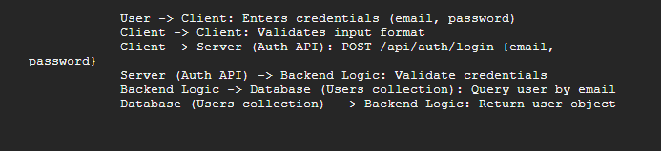

**Database Design**

The database design defines how the system's data is structured, stored, and managed. VibeSpace utilizes JavaScript Object Arrays , a NoSQL document database, known for its flexible schema, scalability, and ease of integration with Node.js applications. This section

describes the conceptual database structure using an Entity-Relationship (ER) Diagram and details the schema for the main collections.

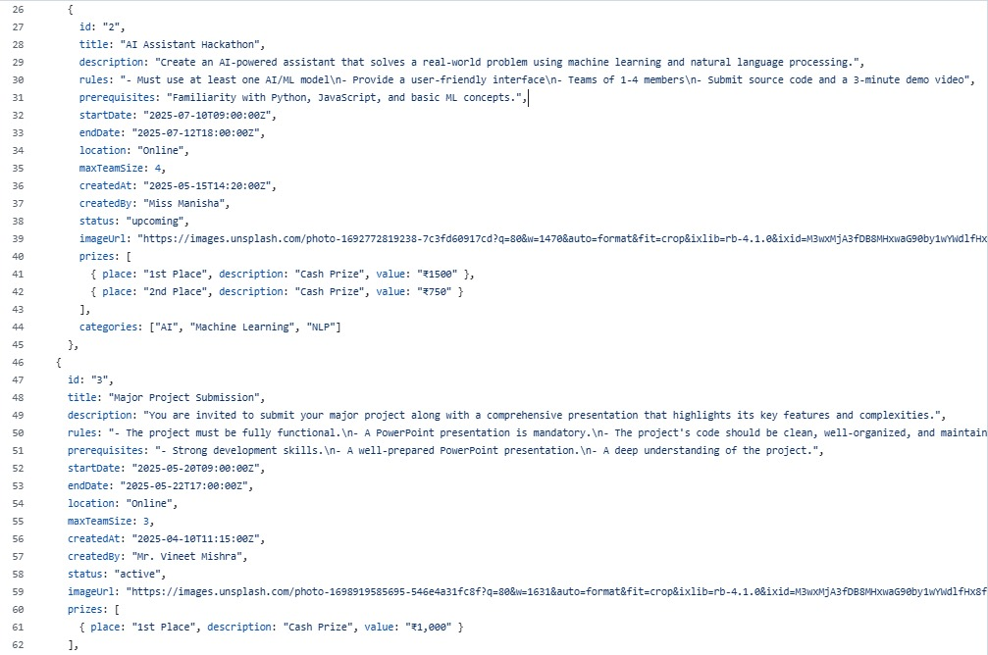

**Data Dictionary**

A Data Dictionary provides detailed information about each data element (attribute or field) used within the database. It defines the name, description, data type, constraints, and other relevant properties for each field in the system's collections. This serves as a comprehensive reference for developers and helps ensure data consistency and understanding.

**Below is a data dictionary for the major collections in the VibeSpace MongoDB database.**

**Table 3.1: Data Dictionary for Users Collection**

|  |  |  |  |
| --- | --- | --- | --- |
| Field Name | Description | Data Type | Constraints/Notes |
| _id | Unique identifier for the user document. | ObjectId | Primary Key, Auto-generated |
| email | User's email address. Used for login. | String | Required, Unique, Indexed |
| passwordHash | Hashed value of the user's password. | String | Required, Stored securely (e.g., using bcrypt) |
| name | User's full name. | String | Required |
| role | User's role in the system. | String | Required, Enum ('student', 'admin'), Default: 'student' |
| createdAt | Timestamp when the user document was created. | Date | Auto-set |
| updatedAt | Timestamp when the user document was last updated. | Date | Auto-set on updates |

**Table 3.2: Data Dictionary for Events Collection**

|  |  |  |  |
| --- | --- | --- | --- |
| Field Name | Description | Data Type | Constraints/Notes |
| _id | Unique identifier for the event document. | ObjectId | Primary Key, Auto-generated |
| title | Title of the hackathon event. | String | Required, Unique (Recommended) |
| description | Detailed description of the event, including goals and context. | String | Required |
| theme | The central theme or focus of the hackathon. | String | Optional |
| startDate | The date and time the event begins. | Date | Required |
| endDate | The date and time the event ends. | Date | Required, Must be after startDate |
| regDeadline | The deadline for participant registration. | Date | Required, Must be before startDate |
| subDeadline | The deadline for project submission. | Date | Required, Typically during or after endDate |
| location | Physical or virtual location details for the event. | String | Required |
| rules | Rules and guidelines for participants. Can be text or a list. | String or Array of Strings | Optional |
| judgingCriteria | List of criteria used for evaluating submissions, with details. | Array of Objects | Optional. Each object: { name: String, description: String, maxScore: Number } |
| status | Current status of the event. | String | Required, Enum ('draft', 'published', 'ongoing', 'completed', 'cancelled'), Default: 'draft' |
| createdBy | Reference to the Admin user who created the event. | ObjectId | Required, Foreign Key reference to users._id |
| createdAt | Timestamp when the event document was created. | Date | Auto-set |
| updatedAt | Timestamp when the event document was last updated. | Date | Auto-set on updates |

**Table 3.3: Data Dictionary for Registrations Collection**

|  |  |  |  |
| --- | --- | --- | --- |
| Field Name | Description | Data Type | Constraints/Notes |
| _id | Unique identifier for the registration document. | ObjectId | Primary Key, Auto-generated |
| userId | Reference to the user (student) who registered. | ObjectId | Required, Foreign Key reference to users._id |
| eventId | Reference to the event the user registered for. | ObjectId | Required, Foreign Key reference to events._id |
| registrationDate | Timestamp when the user registered. | Date | Required, Auto-set |
| status | Status of the registration. | String | Required, Enum ('registered', 'cancelled'), Default: 'registered' |
| createdAt | Timestamp when the registration document was created. | Date | Auto-set |
| updatedAt | Timestamp when the registration document was last updated. | Date | Auto-set on updates |

**Table 3.4: Data Dictionary for Submissions Collection**

|  |  |  |  |
| --- | --- | --- | --- |
| Field Name | Description | Data Type | Constraints/Notes |
| _id | Unique identifier for the submission document. | ObjectId | Primary Key, Auto-generated |
| eventId | Reference to the event the submission is for. | ObjectId | Required, Foreign Key reference to events._id |
| submittedBy | Reference to the user who created/submitted the entry (e.g., team lead). | ObjectId | Required, Foreign Key reference to users._id |
| teamMembers | Array of objects representing team members. | Array of Objects | Optional. Each object: { userId: ObjectId (ref to users._id), name: String } or just { name: String } depending on how detailed team tracking is. |
| title | Title of the project submission. | String | Required |
| description | Detailed description of the project. | String | Required |
| repoLink | URL link to the project's code repository (e.g., GitHub). | String | Required, URL format validation |
| demoLink | URL link to a demo video or presentation of the project. | String | Optional, URL format validation |
| submissionDate | Timestamp when the submission was created/last updated. | Date | Required, Auto-set |
| status | Current status of the submission in the evaluation process. | String | Required, Enum ('submitted', 'under evaluation', 'evaluated'), Default: 'submitted' |
| createdAt | Timestamp when the submission document was created. | Date | Auto-set |
| updatedAt | Timestamp when the submission document was last updated. | Date | Auto-set on updates |

**Table 3.5:** Data Dictionary for Evaluations Collection

|  |  |  |  |
| --- | --- | --- | --- |
| Field Name | Description | Data Type | Constraints/Notes |
| _id | Unique identifier for the evaluation document. | ObjectId | Primary Key, Auto-generated |
| submissionId | Reference to the submission being evaluated. | ObjectId | Required, Foreign Key reference to submissions._id |
| evaluatorId | Reference to the user (Admin role) who performed the evaluation. | ObjectId | Required, Foreign Key reference to users._id |
| scores | Array of objects containing scores for each judging criteria. | Array of Objects | Required. Each object: { criteriaName: String, score: Number } (Corresponds to criteria in Event) |
| feedback | Text feedback provided by the evaluator. | String | Optional |
| evaluationDate | Timestamp when the evaluation was recorded. | Date | Required, Auto-set |
| createdAt | Timestamp when the evaluation document was created. | Date | Auto-set |
| updatedAt | Timestamp when the evaluation document was last updated. | Date | Auto-set on updates |

* This data dictionary provides a structured definition for all significant fields within the VibeSpace database collections, serving as a vital reference during the implementation and testing phases to ensure data integrity and consistency.

**Chapter 5: Software Development Life Cycle ( SDLC )**

**Software Development Life Cycle ( SDLC )**

The Software Development Life Cycle (SDLC) is a structured framework that describes the phases involved in the development, deployment, and maintenance of a software system. Selecting an appropriate SDLC methodology is crucial for managing project complexity, ensuring quality, and delivering the final product effectively. For the development of the "VibeSpace - College Hackathon Management System," the **Agile methodology** was chosen.

Agile is an iterative and incremental approach to software development that emphasizes flexibility, customer collaboration, and rapid delivery of working software. It is particularly well-suited for projects where requirements may evolve or are not fully defined at the outset, and where continuous feedback is valuable. The VibeSpace project, being developed by a small team within an academic timeframe with potential for evolving feature understanding and feedback from academic guides, benefited significantly from the adaptability and focus on working increments that Agile provides.

**The core principles of Agile, as outlined in the Agile Manifesto, prioritize**:

* **Individuals and interactions**: over processes and tools.
* **Working software**: over comprehensive documentation.
* **Customer collaboration**: over contract negotiation.
* **Responding to change**: over following a plan.

While 'customer' in this academic project context primarily refers to the academic guide and the envisioned end-users (college administrators and students), collaboration and feedback were actively sought and incorporated. The iterative nature allowed the project to adapt to new insights or refinements identified during development and testing, ensuring the final system was aligned with the practical needs of hackathon management.

**Agile Methodology for VibeSpace**

The implementation of the Agile methodology for the VibeSpace project involved breaking down the development process into short, time-boxed iterations called 'sprints'. Each sprint aimed to deliver a potentially shippable increment of the software, incorporating vertical slices of functionality from frontend to backend and database. This iterative approach allowed the team to demonstrate progress frequently, gather feedback, and integrate changes early in the development cycle.

The typical phases within an Agile SDLC (Requirement Gathering, Design, Development, Testing, Deployment, and Maintenance) were not treated as strictly sequential stages executed once. Instead, elements of these phases were present and repeated within or across sprints.

**Requirement Gathering in Agile**

In the initial phase, a foundational understanding of the VibeSpace system requirements was established by analyzing the existing manual system and defining the core functional and non-functional requirements (as detailed in Chapter 2). This formed the initial product backlog.

**However, Agile recognizes that requirements can evolve. In VibeSpace's case, this involved:**

* Refining user stories based on discussions and a deeper understanding of specific use cases (e.g., exactly what details are needed for a project submission, how evaluators should view information).
* Incorporating feedback from the academic guide during sprint reviews. For example, feedback on the initial UI design might lead to refinements in the display of event information or the flow of the registration process.
* Clarifying technical constraints or possibilities discovered during early development sprints which might influence the implementation details of subsequent features.

Requirement gathering was therefore an ongoing activity. User stories were elaborated and prioritized continuously in the product backlog before being selected for inclusion in a sprint during the sprint planning meeting.

**Design in Agile**

Similar to requirement gathering, design in an Agile context is not a single, upfront phase covering the entire system in minute detail. While initial architectural design (Chapter 3) provided the overall structure (Client-Server, technology stack, major data entities), detailed design happened iteratively.

* **Sprint-level Design**: Before starting development on selected user stories for a sprint, the team discussed and designed how those specific features would be implemented. This included API endpoint design for new functionalities, UI component design, database schema adjustments (if necessary for new data types or relationships), and decisions on specific algorithms or logic.
* **Refinement of Overall Design** : As the project progressed, feedback from implementation and testing might necessitate minor adjustments to the initial architectural or database design. For example, discovering performance bottlenecks might lead to rethinking how certain data is queried or structured.

The iterative design approach allowed the team to make design decisions based on the most current understanding of the requirements and the technical landscape encountered during development, rather than being locked into potentially flawed upfront designs.

**Chapter 6: Implementation**

**Implementation**

The implementation phase translates the architectural design and detailed requirements into a functional software system. This chapter provides an in-depth look into the technical realization of the "VibeSpace - College Hackathon Management System," focusing on the chosen technology stack: React and Tailwind CSS for the frontend, Node.js with Express for the backend, and MongoDB as the database. It details the development process, including the structure of the codebase, key components, API design, database schema implementation, and illustrates these aspects with code samples and annotated UI screenshots.

**Frontend Development**

The frontend of the VibeSpace system is the user interface that students and administrators interact with directly. It was developed as a Single Page Application (SPA) using React, a popular JavaScript library for building user interfaces. Tailwind CSS , a utility-first CSS framework, was employed for styling, enabling rapid UI development and ensuring a consistent design language

**UI Overview for User**

This is a UI and Available Features Overview for Students and User visit Vibespace for the First Time.

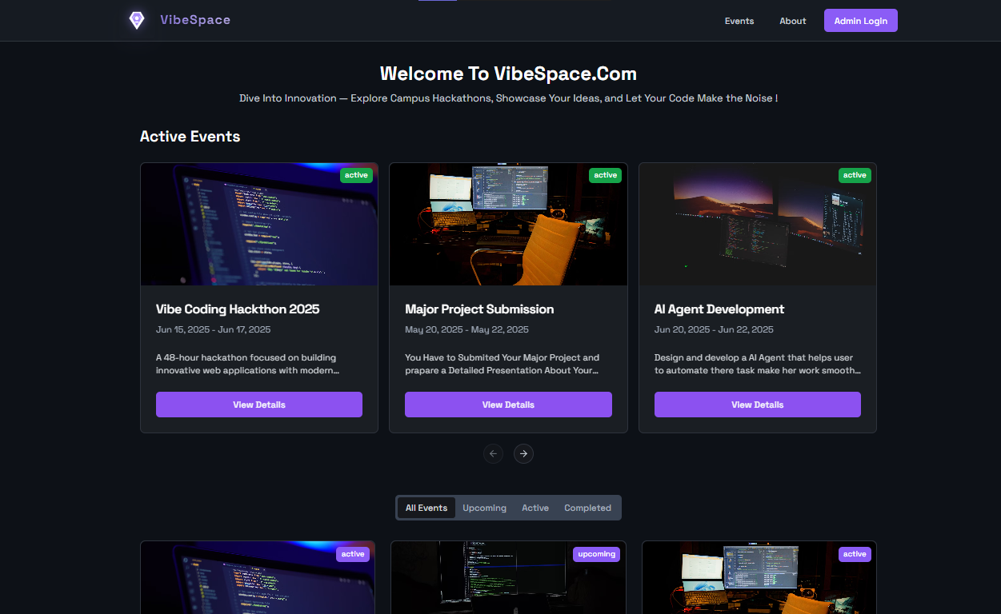 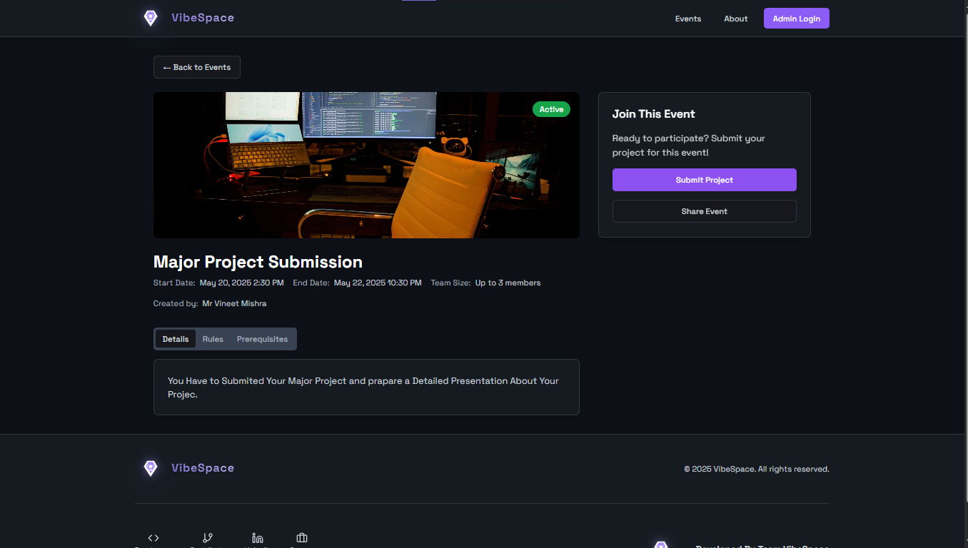

1 Event Details with Event Sharing Feature 2 Index Page With Active Event Panel

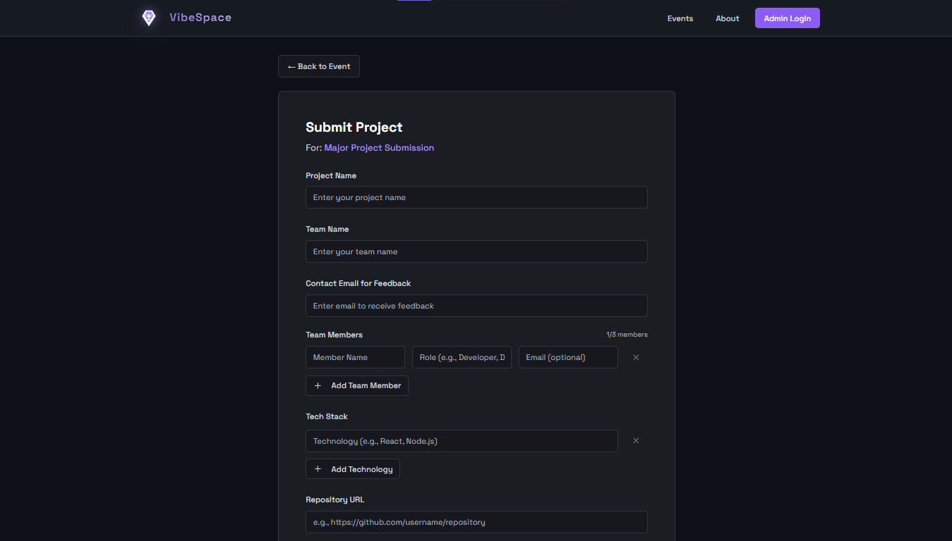 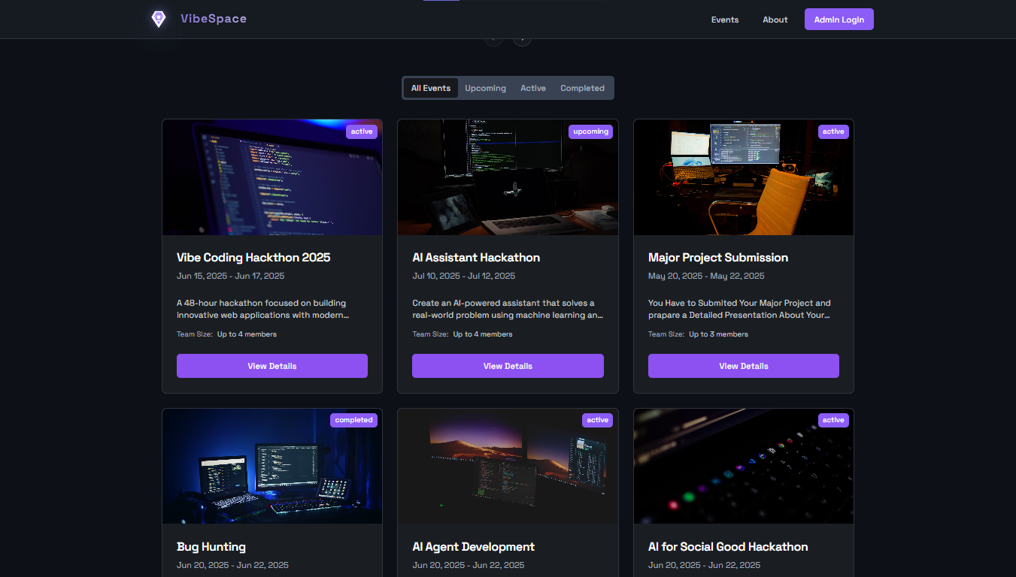

3 Project Submission And Team Building 4 All Event Listing

**UI Overview for Admin / Teachers**

This is a UI and Available Features Overview for Students When they visit Vibespace for the First Time.

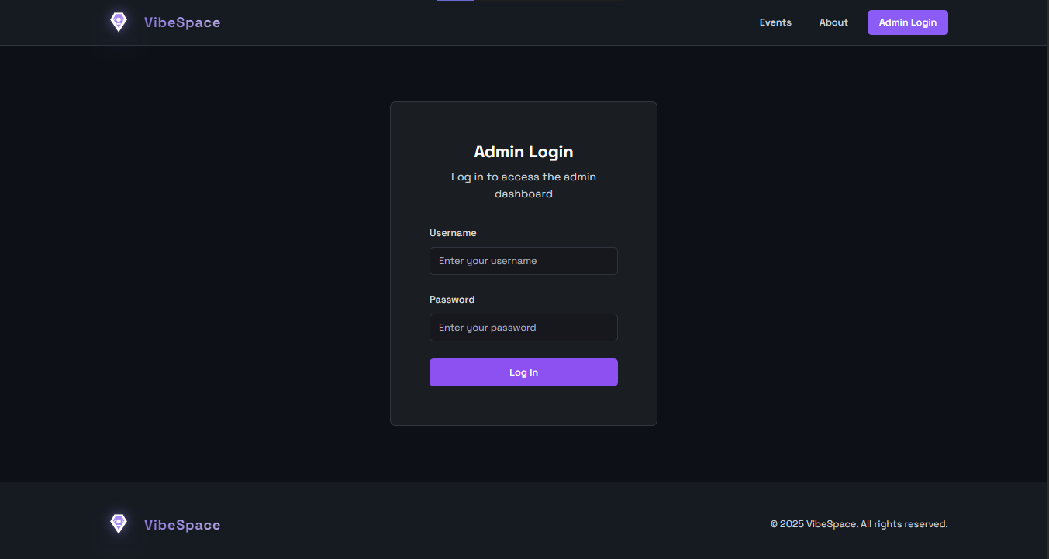 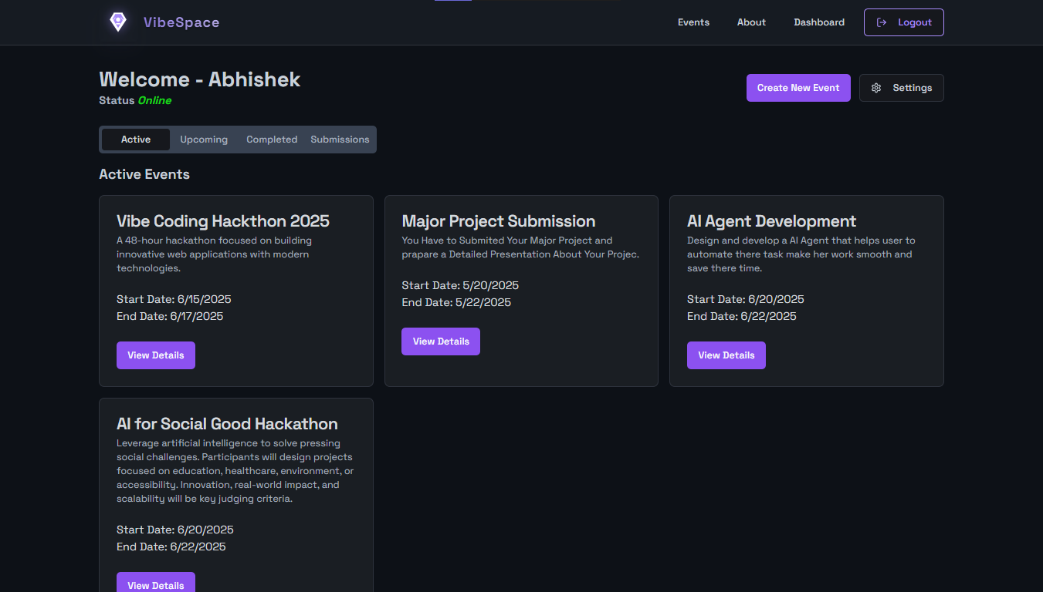

4 Admin Login 5 Admin Welcome Dashboard

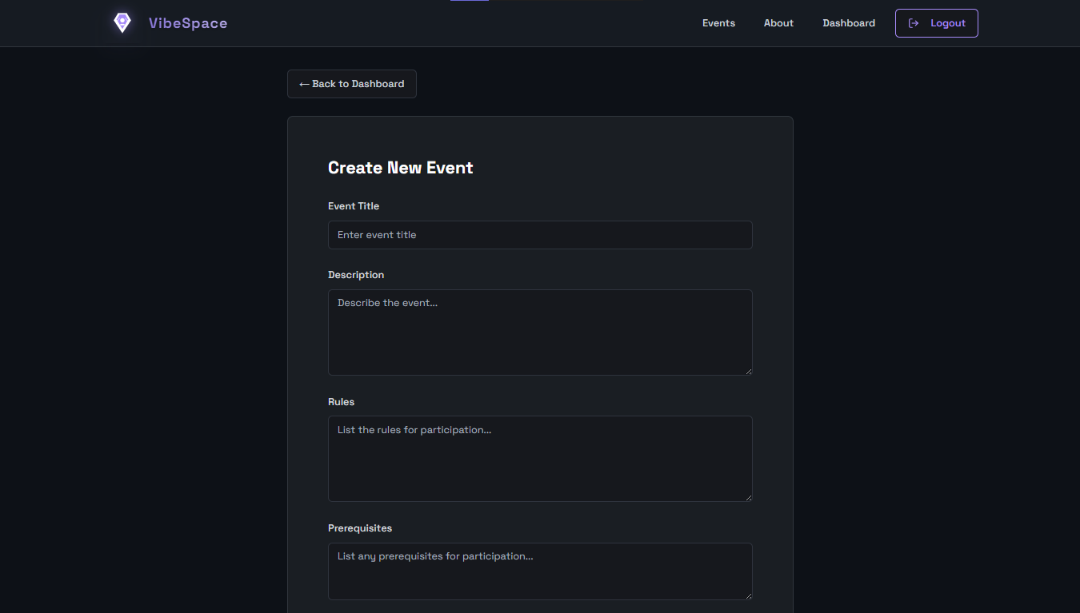 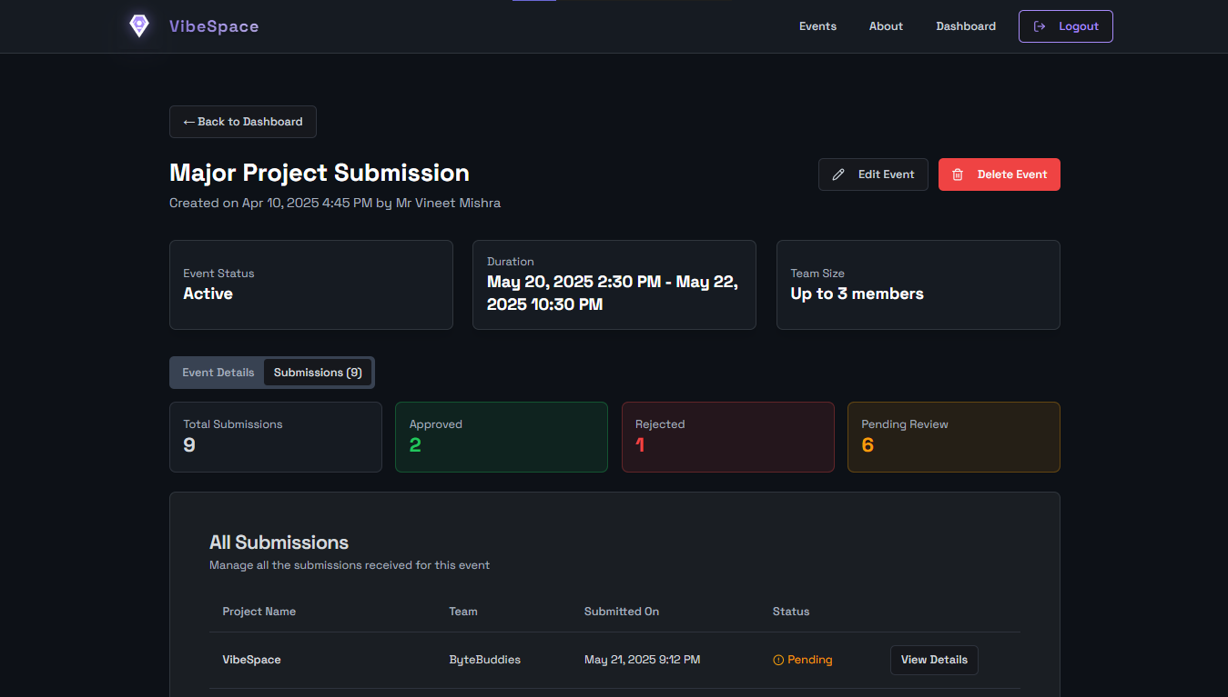

5 Create Event  **6** Event Manager And Allow Event CRUD Operations

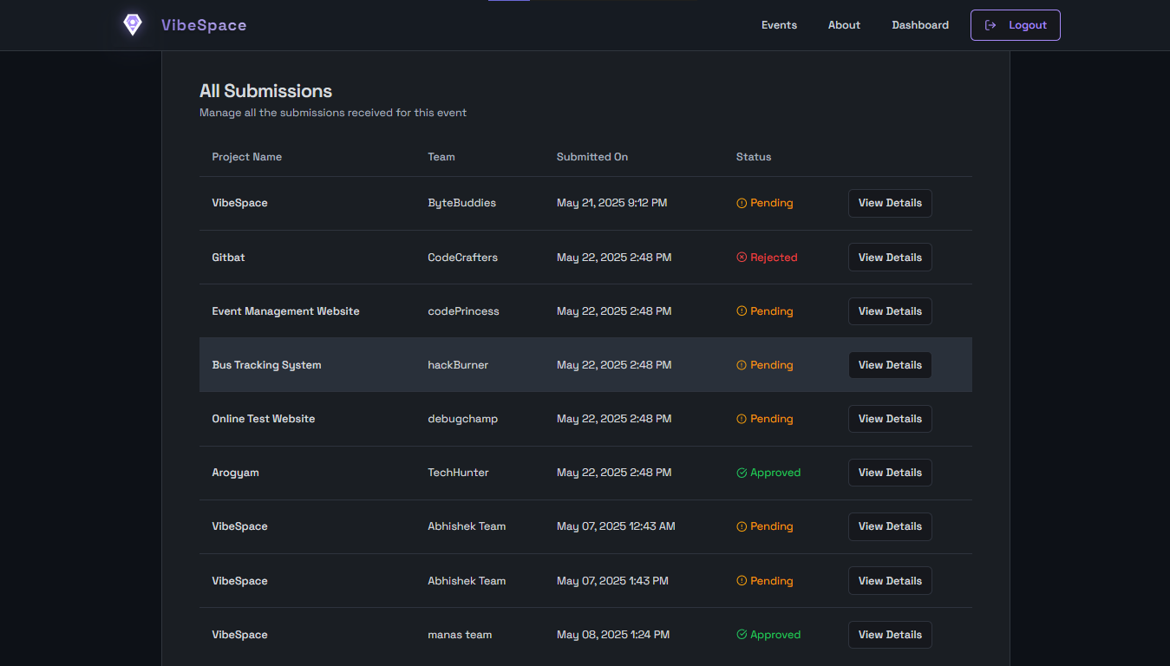 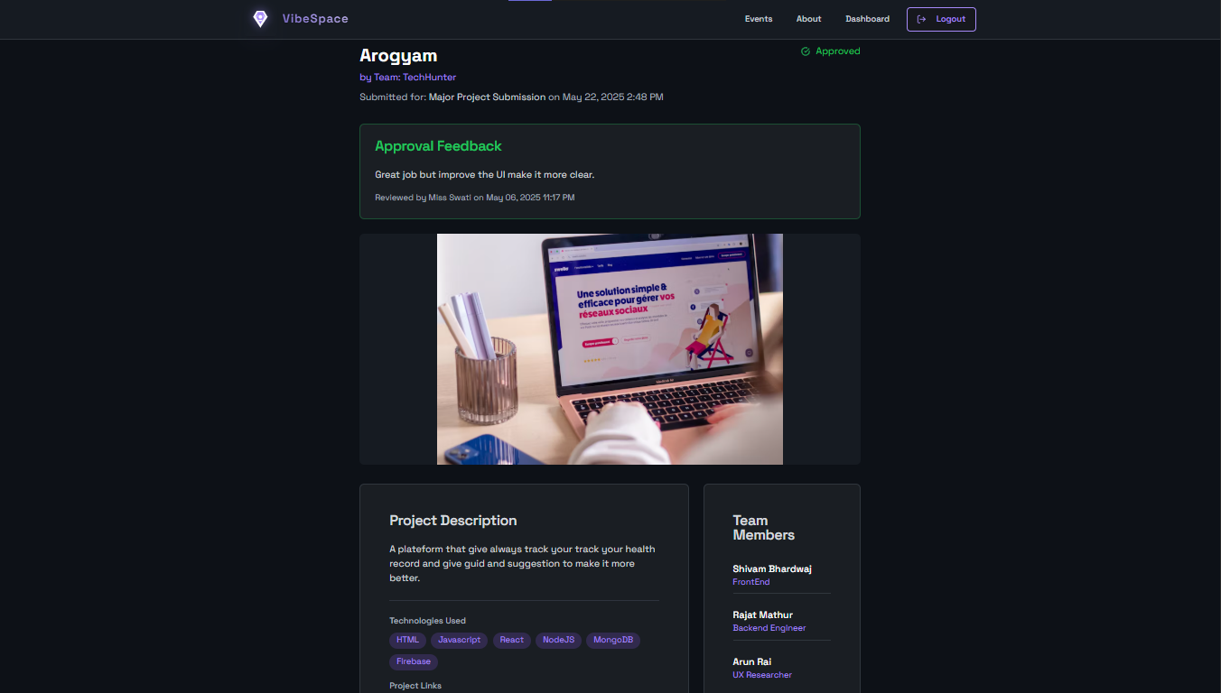

6 Submissions Tracker **7 Project Viewer , Approvals & Feedback System**

**React Framework and Component Architecture**

React was chosen for its component-based architecture, which promotes code reusability, modularity, and maintainability (aligning with NFR6 Maintainability). The UI is broken down into small, independent components (e.g., a Button, an Input field, an Event Card, a Modal). These components are then composed to build complex user interfaces, such as the Event Listing page or the Project Submission form.

**Key aspects of using React in VibeSpace include:**

* **Component Lifecycle and State Management**:: React components manage their own state using hooks like useState. Application-level state (e.g., user authentication status, loading indicators) is managed using React's Context API or simple state drilling for smaller applications, allowing data to be shared efficiently across the component tree without excessive prop passing.
* **Props** : Data is passed from parent components to child components via props, enabling customization and data flow down the component hierarchy.
* **Hooks** : Functional components are used extensively, leveraging hooks like useEffect for side effects (e.g., fetching data from the backend when a component mounts), useState for managing component-specific state,
* and useContext for accessing shared context.
* **React Router**: The react-router-dom library is used for navigation between different pages or views within the SPA, providing a seamless user experience without full page reloads. Routes are defined for different paths (e.g., /, /login, /events, /admin/events), and protected routes are implemented using authentication checks to restrict access based on user role (aligning with FR1 and FR8).
* **API Integration** : Frontend components interact with the backend API using asynchronous requests, typically using the built-in fetch API or libraries like Axios. Data fetched from the API is stored in the component's state and rendered dynamically. Error handling and loading states are managed within components to provide feedback to the user.

**Key Components and Structure**

The frontend application is typically structured into folders for components, pages (which compose components to form views), contexts, hooks, and utilities.

**Key components developed include:**

* **Layout Components**:
  + **Header**: Displays the site title/logo and main navigation links (conditionally shown based on authentication status and user role).
  + **Footer**: Contains copyright information and potentially links to relevant pages.
  + **Layout**: A wrapper component that includes the Header and Footer and renders the main content, providing a consistent page structure.
* **Authentication Components**:
  + **LoginForm**: Handles user input for email and password, submits data to the login API endpoint.
  + **RegistrationForm**: (If implemented) Handles user input for registration details.
* **Event Components**:
  + **EventCard**: Displays a summary of an event (title, dates, description snippet) on listing pages.
  + **EventDetails**: Displays comprehensive information about a single event on its dedicated page.
  + **EventForm** (Admin): A form for creating or editing event details.
  + **EventList**: Fetches and renders a list of EventCard components.
* **Submission Components:**
  + **SubmissionForm**: A form for users to submit project details (title, description, links, team members).
  + **SubmissionList** (Admin): Displays a list of submitted projects for an event.
  + **SubmissionDetails** (Admin/Evaluator): Displays full details of a specific project submission.
* **Evaluation Components**:
  + **EvaluationForm (Admin/Evaluator):** A form to input scores and feedback for a submission.
  + **EvaluationSummary (Admin):** Displays aggregated evaluation results for an event or submission.
* **Common UI Components**:
  + **Input**, Button, TextArea: Reusable form elements.
  + **Modal**: For displaying information or forms in a popup.
  + **LoadingSpinner**: Indicates data fetching or processing.
  + **Notification/Alert**: Displays system messages (e.g., success, error).

Pages (e.g., HomePage.js, EventListPage.js, LoginPage.js, AdminDashboard.js) are responsible for fetching necessary data using hooks (like useEffect), managing the page's state, and composing the relevant components to render the complete view. For instance, the EventListPage fetches event data via the API and maps over the array of events to render multiple EventCard components.

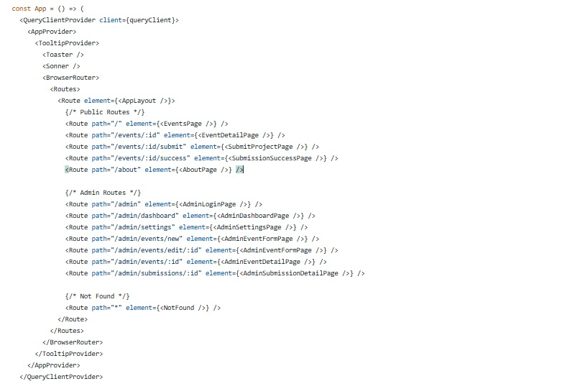

**Backend Development**

The backend serves as the application's engine, handling business logic, processing client requests, interacting with the database, and enforcing security rules. It was built using **Node.js ,** a JavaScript runtime environment, and the **Express.js** framework.

**Node.js and Express Framework**

Node.js was selected for its non-blocking, event-driven architecture, which makes it efficient for building scalable network applications, including web APIs. Its ability to use JavaScript on both frontend and backend streamlines development by allowing developers to work with a single language.

Express.js is a minimal and flexible Node.js web application framework that provides a robust set of features for web and mobile applications. It provides structure for handling routing, middleware, and serving static files.

**Key aspects of using Node.js and Express in VibeSpace**:

* **Routing:** Express's routing system maps incoming HTTP requests (GET, POST, PUT, DELETE) to specific handler functions based on the URL path and HTTP method (e.g., a GET request to /api/events is handled by a function that fetches events). Routes are organized logically (e.g., /api/auth for authentication, /api/events for event management, /api/admin for admin-specific actions).
* **Middleware**: Middleware functions are used to process requests before they reach the final route handler. Common middleware used includes:
* **body-parser**: Parses incoming request bodies (e.g., JSON payloads).
* **cors**: Enables Cross-Origin Resource Sharing, allowing the frontend running on a different origin to make requests to the backend API.
* **Custom authentication middleware**: Verifies JWT tokens attached to requests and sets the authenticated user's information (including role) on the request object.
* **Custom authorization middleware**: Checks the user's role (obtained from the authentication middleware) to ensure they have permission to access a specific route.
* **Asynchronous Operations**: Node.js's non-blocking nature is leveraged for I/O operations, particularly database interactions. Async/await syntax is used to write asynchronous code in a more readable, synchronous-like style.

* **Modularity**: The backend code is structured into modules for routes, controllers (containing business logic), models (interacting with the database via Mongoose), and middleware, promoting code organization and maintainability.

**API Design Patterns (RESTful API)**

The VibeSpace backend exposes a **RESTful API** to the frontend client. REST (Representational State Transfer) is an architectural style for designing networked applications. It treats server-side objects as resources that can be accessed and manipulated using standard HTTP methods.

* **Resources**: Key resources in the VibeSpace API include Users, Events, Registrations, Submissions, and Evaluations.
  + **HTTP Methods**: Standard HTTP methods are used for operations on these resources:
  + **GET**: Retrieve a resource or a collection of resources (e.g., GET /api/events to get all events, GET /api/events/:id to get a specific event).
  + **POST**: Create a new resource (e.g., POST /api/auth/register to create a new user, POST /api/events to create a new event).
  + **PUT**: Update an existing resource (e.g., PUT /api/events/:id to update an event). (Note: PATCH could also be used for partial updates, but PUT is often sufficient for typical CRUD).
  + **DELETE**: Remove a resource (e.g., DELETE /api/events/:id).
* **URLs**: Resource identifiers are typically noun-based URLs (e.g., /api/users, /api/events), not verb-based.
* **Statelessness**: Each request from the client to the server must contain all the information necessary to understand and process the request. The server does not store any client context between requests (except for session/token information managed by the client/middleware, which is verified on each request). This is crucial for scalability.
* **Data Format**: Data exchanged between the client and server is primarily in JSON format.

Designing the API using RESTful principles provides a clear, standardized, and scalable way for the frontend and backend to communicate.

**Authentication and Authorization Mechanisms**

Security is paramount, especially when handling user data and restricted functionalities (aligning with FR1 and NFR3 Security). VibeSpace implements a **JWT (JSON Web Token) based authentication** system.

* **Authentication (Who is the user?):**
  + When a user logs in with valid credentials (email and password), the server verifies their identity against the database.
  + If successful, the server generates a JWT. This token contains claims, typically including the user's ID and role. The token is signed using a secret key on the server, making it tamper-proof.
  + The JWT is sent back to the client in the login response.
  + The client stores this token (e.g., in local storage or a state management solution).
  + For subsequent requests to protected routes, the client includes the JWT in the Authorization header (commonly in the format Bearer <token>).
  + A custom authentication middleware on the server intercepts these requests, extracts the token, verifies its signature using the secret key, and decodes the claims. If the token is valid, the user's information (ID, role) is attached to the request object (req.user), and the request proceeds to the next middleware or route handler. If the token is missing or invalid, the middleware rejects the request, typically with a 401 Unauthorized status code.
* **Authorization (What can the user do?):**
  + After a user is authenticated by the JWT middleware, an authorization middleware (or logic within the route handler) checks the user's role (e.g., req.user.role).
  + Admin-specific routes (e.g., creating/editing events, viewing all submissions) are protected by authorization middleware that checks if req.user.role is 'admin'. If not, the request is rejected with a 403 Forbidden status code.
  + Routes accessible to logged-in students (e.g., viewing events, submitting projects, viewing their registrations) only require the user to be authenticated (role 'student' or 'admin' in some cases).
  + Specific operations (e.g., updating a submission, cancelling a registration) also include checks to ensure the logged-in user is the owner of the resource being modified.

This combination of JWT for authentication and role-based access control (RBAC) for authorization provides a robust and stateless security model for the VibeSpace API. Passwords are never stored in plain text; they are hashed using a strong, one-way hashing algorithm like bcrypt before being saved in the database.

Input validation and sanitization are also crucial security measures implemented on the backend to prevent attacks like Injection (e.g., validating data types, length, and format, and sanitizing inputs to remove potentially malicious code or characters). This is often done using middleware or within the route handlers before interacting with the database. HTTPS is configured for secure communication in production environments.

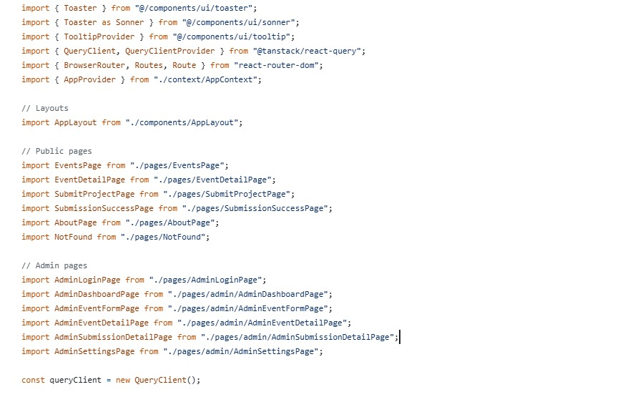

**Database Implementation**

VibeSpace uses MongoDB as its database. MongoDB is a NoSQL document database that stores data in flexible, JSON-like documents, organized into collections. Its schema-less nature (while Mongoose provides schema-like structure) and horizontal scalability make it suitable for web applications with evolving data requirements.

**MongoDB Collections and Document Schemas**

**Based on the database design (Chapter 3), VibeSpace utilizes several key collections**:

* **users**: Stores user information. Documents include fields for email, hashed password, name, and role. The email field has a unique index to prevent duplicate user registrations. The passwordHash stores the result of bcrypt hashing.
* **events**: Stores details about each hackathon event. Documents include fields for title, description, dates, location, status, etc. Complex data like judgingCriteria is embedded as an array of objects within the event document, as this data is closely tied to the event and usually accessed along with it. A reference to the creating admin user (`createdBy`) is stored using ObjectId.
* **registrations**: Acts as a join collection to represent the many-to-many relationship between users (students) and events. Each document links a userId to an eventId. A compound unique index on userId and eventId ensures a student cannot register for the same event twice. This collection allows easy querying for all registrations for a specific event or all events a specific user has registered for.
* **submissions**: Stores details about submitted projects. Each document links to an eventId and the submittedBy user (team lead or primary contact). teamMembers is stored as an embedded array, potentially referencing user IDs if members also need to be tracked, or just storing names/basic info for simplicity. Fields for project title, description, and links are included. The `status` field tracks the submission's lifecycle.
* **evaluations**: Stores evaluation records. Each document links to a specific submissionId and the evaluatorId (the admin user performing the evaluation). scores are embedded as an array of objects, aligning with the judging criteria defined in the event document. Text feedback can also be stored.

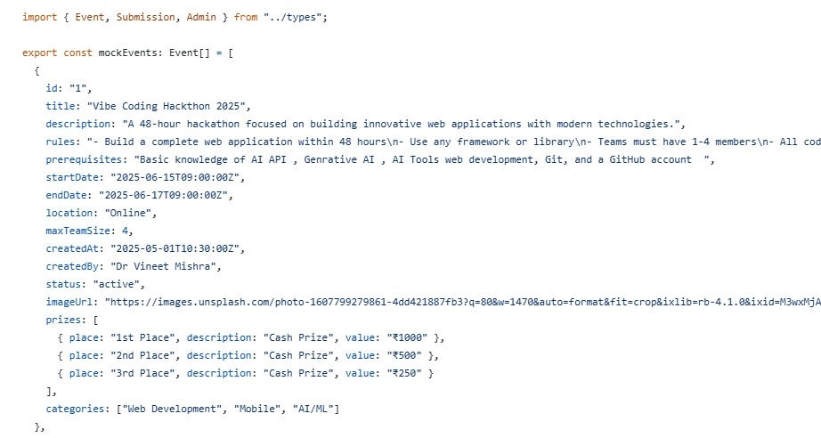

**Chapter 7: Testing**

**Testing**

Software testing is a critical phase in the Software Development Life Cycle (SDLC) that aims to identify defects, verify that the system meets specified requirements, and ensure the overall quality and robustness of the application. For the "VibeSpace - College Hackathon Management System," a comprehensive testing approach was adopted, combining automated and manual testing techniques to cover different layers and functionalities of the system. Testing was integrated throughout the Agile development process, allowing for early detection and resolution of issues, thereby contributing to a more stable and reliable final product.

**Testing Methodology**

The testing strategy for VibeSpace employed a combination of different testing methodologies to ensure thorough coverage and validation across the application stack. The primary methodologies utilized were:

* **Unit Testing**: Focused on testing individual components or functions in isolation.
* **Integration Testing**: Focused on testing the interactions and data flow between integrated units or modules.
* **Manual Testing**: Involved human testers interacting with the application through its user interface to simulate real-world usage and identify usability, visual, and end-to-end workflow issues.

This layered approach ensured that problems were caught at the lowest possible level (Unit Testing), interactions between modules were validated (Integration Testing), and the overall user experience and end-to-end flows were verified from the user's perspective (Manual Testing). The iterative nature of the Agile SDLC meant that testing activities were performed continuously within each sprint, rather than being concentrated in a single phase at the end of development.

**Unit Testing**

Unit testing involves testing the smallest testable parts of an application, called units, in isolation from the rest of the code. The goal is to validate that each unit of the software performs as designed. In the context of VibeSpace, units typically included individual functions, methods within classes or modules (backend), or small, isolated components (frontend).

**Approach to Unit Testing**

Unit tests were written by the developers during or immediately after writing the code for a specific unit. This practice, sometimes referred to as Test-Driven Development (TDD) if tests are written before the code, or simply unit testing, helps ensure that code is modular, testable, and meets its functional specification at a granular level.

**For the VibeSpace project, unit testing primarily focused on:**

* **Backend Utility Functions**: Testing standalone functions that perform specific tasks, such as password hashing, date formatting/parsing utilities, or input validation helpers.
* **Mongoose Model Methods**: Testing static or instance methods defined on Mongoose schemas (e.g., a method to compare passwords).
* **Controller Logic (partially):** Testing the core logic within controller functions, often by mocking external dependencies like database calls or external API requests to isolate the controller's logic.
* **Frontend Component Logic (basic):** Testing isolated logic within React components, such as state updates based on props or local interactions, though extensive frontend unit testing (like DOM manipulation tests) might be less emphasized in a project of this scope compared to integration and manual testing.

A testing framework (e.g., Jest or Mocha with testing libraries) is typically used to write and run these tests. These frameworks provide assertion libraries to check if the output of a unit matches the expected result and runners to execute tests and report results. **Integration Testing**

Integration testing focuses on verifying that different modules or services within the application interact correctly. While unit tests validate individual pieces, integration tests ensure that these pieces work together seamlessly when combined. For VibeSpace, integration testing was crucial to validate the communication between the frontend and backend, and the interaction between the backend and the database.

**Integration Testing Strategies**

**Several strategies were applied for integration testing:**

* **API Endpoint Testing**: Testing the backend API endpoints was a primary focus. This involved sending HTTP requests (GET, POST, PUT, DELETE) to specific **API routes and verifying that the server responded correctly. This included**:
  + Checking response status codes (e.g., 200 OK, 201 Created, 400 Bad Request, 401 Unauthorized, 403 Forbidden, 404 Not Found, 500 Server Error).
  + Validating the structure and content of the JSON response payload.
  + Testing with valid and invalid input data, including edge cases.
  + Verifying that data is correctly saved to or retrieved from the database.
  + Tools like Jest with libraries like `supertest` (for testing Express routes without a running HTTP server) or using HTTP client libraries (like Axios or `node-fetch`) to test a running server instance were used.
* **Backend Service Integration**: Testing the interaction between different backend services or modules, such as the authentication middleware interacting with the user service, or the event controller interacting with the event model and potentially the registration model.
* **Frontend-Backend Integration**: Testing the user interface interacting with the live or mocked backend API. This involves:
* Triggering actions in the UI (e.g., submitting a form).
* Observing that the correct API request is sent by the frontend.
* Verifying that the UI updates correctly based on the API response (success, error, loading states).
* Ensuring data displayed in the UI matches the data received from the API.
* This often overlaps with manual testing but can also involve automated tests using frameworks like Jest and testing libraries for React (`@testing-library/react`) with tools for mocking API calls (e.g., Mock Service Worker or jest.mock).
* **Database Integration**: While Mongoose abstracts direct database interactions, integration tests verified that the models correctly interacted with the MongoDB database (or a test database). This involved performing CRUD operations via Mongoose models and verifying that the data was persisted and retrieved accurately in the database. Running tests against an in-memory MongoDB instance (like `mongodb-memory-server`) or a dedicated test database ensured these interactions were validated without affecting the development or production database

.

Integration tests are typically slower than unit tests as they involve multiple components and external resources (like the database). However, they are essential for catching issues that only arise when components interact, such as incorrect API endpoint URLs, data format mismatches, or failure in passing data between layers.

**Bug Fixes**

During the testing phase (both automated and manual), several bugs were identified. A systematic approach was followed for bug tracking, debugging, and resolution. Identified bugs were documented, prioritized based on their severity and impact, and tracked through to resolution.

**Bug Tracking Process**

When a bug was discovered, the following information was typically recorded:

* **Bug ID**: A unique identifier.
* **Description**: A clear and concise summary of the problem.
* **Steps to Reproduce**: Detailed steps required to trigger the bug consistently.
* **Expected Result**: What should have happened .
* **Actual Result**: What actually happened.
* **Severity**: Assessment of the impact (e.g., Blocker, Critical, Major, Minor, Cosmetic).
* **Module/Feature**: The part of the system affected.
* **Fix Details**: Description of the code change or fix implemented.
* **Date Fixed**: When the fix was completed.
* **Verified By**: The tester or developer who verified the fix.
* **Date Verified**: When the fix was verified.

While a formal bug tracking system (like Jira, Trello, or GitHub Issues) might be used in a larger project, for the scope of VibeSpace as an academic project, tracking could be done using shared documents, spreadsheet, or even project board tools. The key was to ensure that bugs were documented and not lost.

*Debugging Process*

Debugging involved identifying the root cause of a reported bug. The process typically included:

* Understanding the Report
* Analyzing Logs
* Using Debugging Tools
* Code Inspection
* Isolating the Problem
* Hypothesizing and Testing Fixes

**Examples of Bugs and Fixes**

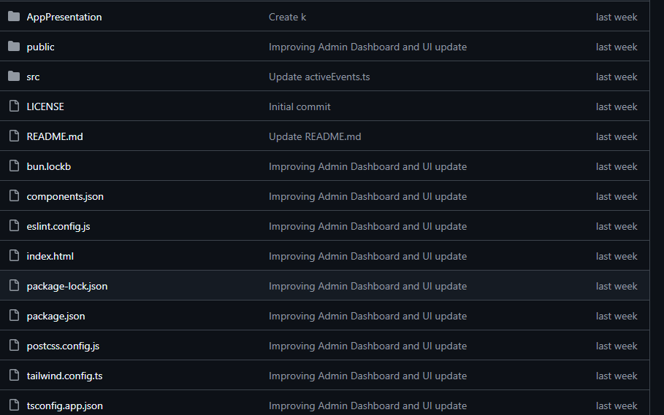

**Chapter 8: Security**

**Security**

Security is a paramount concern in the design and implementation of any modern web application, especially one handling user authentication, roles, and sensitive data like project submissions. For the VibeSpace - College Hackathon Management System, robust security measures have been integrated at multiple layers to protect against common web vulnerabilities, ensure the confidentiality and integrity of data, and control access based on user roles. This chapter details the key security features implemented, including user authentication mechanisms, input validation and sanitization practices, and secure data handling and communication protocols.

**Authentication and Authorization**

Authentication is the process of verifying the identity of a user, while authorization is the process of determining what actions an authenticated user is permitted to perform. VibeSpace implements a secure system for both, specifically focusing on distinguishing between administrators and students and granting appropriate access.

**User Authentication with JWT (JSON Web Tokens)**

VibeSpace utilizes JSON Web Tokens (JWT) for managing user authentication sessions. This approach is stateless on the server side, which aligns well with RESTful API design and contributes to scalability (NFR5 Scalability). The authentication process for users (both students and administrators) proceeds as follows:

1. **User Login Request**: When a user attempts to log in via the frontend, they submit their credentials (email and password) to a dedicated authentication API endpoint on the backend (e.g., POST /api/auth/login).
2. **Server-Side Verification**: The backend receives the credentials. It queries the users collection in the MongoDB database to find a user with the provided email.
3. **Password Comparison**: The submitted plain-text password is compared with the securely hashed password stored in the database using a cryptographic hashing function (like bcrypt). This comparison is done server-side using the `matchPassword` method defined on the User model (as shown in the Implementation chapter code sample).
4. **Token Generation**: If the email and password are valid, the server considers the user authenticated. It then generates a JSON Web Token (JWT). The JWT contains claims about the user, typically including their unique identifier (_id) and their role (e.g., 'student' or 'admin'). The token is signed using a secret key that is stored securely on the server and known only to the application. This signature ensures that the token's contents have not been tampered with after it was issued.
5. **Token Issuance**: The generated JWT is sent back to the frontend client in the response to the login request.
6. **Client-Side Token Storage**: The frontend client receives the JWT and stores it. Common practices include storing it in browser's local storage or in memory within the application's state management system. Storing in local storage allows the token to persist across browser sessions, enabling "remember me" functionality, but requires careful handling to mitigate XSS risks.
7. **Subsequent Authenticated Requests**: For almost all subsequent requests to backend API endpoints that require the user to be logged in or to have a specific role (e.g., fetching event details, submitting a project, accessing admin panels), the frontend includes the stored JWT in the Authorization header of the HTTP request. The standard format is Bearer <token>.
8. **Server-Side Token Verification (Authentication Middleware)**: A custom middleware function is implemented on the backend to intercept incoming requests that have the Authorization header. This middleware extracts the JWT, verifies its signature using the secret key, and checks if the token is valid and not expired. If the token is valid, the user's information (ID and role) is extracted from the token's claims and attached to the request object (e.g., req.user = { id: token.userId, role: token.userRole }). The request then proceeds to the next handler. If the token is invalid, missing, or expired, the middleware stops the request and sends a 401 Unauthorized response to the client.

This JWT-based flow provides a stateless authentication mechanism that is efficient and widely compatible. The server does not need to maintain session state for each logged-in user, only the secret key to verify tokens. The tokens themselves carry the necessary user information, reducing the need for additional database lookups on every request for basic authentication.

**Role-Based Access Control (Authorization)**

Once a user's identity and role have been verified by the authentication middleware using the JWT, the system enforces authorization rules to determine whether the authenticated user is permitted to perform the requested action on the requested resource. This is known as Role-Based Access Control (RBAC) (aligning with FR1, Chapter 8).

1. **Admin Privileges**: Administrators have elevated permissions. They can create, edit, publish, and delete events (FR2). They can view all registrations and submissions for any event (FR5). They can manage evaluations and view results (FR6, FR8). Admin-specific API routes (e.g., those under /api/admin) are protected by authorization middleware that specifically checks if the authenticated user's role (`req.user.role`) is 'admin'. If not, the request is denied with a 403 Forbidden status code, even if the user is authenticated as a student.
2. **Student Privileges**: Students have permissions related to their participation. They can browse published events (FR3), register for events (FR3), view their own registered events (FR3), submit projects for events they are registered for (FR4), and view the status of their own submissions (FR4). API routes for these actions are protected by authentication middleware to ensure the user is logged in, but may also include logic within the route handler to verify that the user is acting on their own behalf or within the context of their own registration/submission. For example, a student trying to edit another student's submission would be denied, even if authenticated.
3. **Public Access**: Some API endpoints may be public, not requiring any authentication (e.g., fetching the initial list of published events for a logged-out user, if that feature were in scope, or potentially a public landing page). These routes bypass the authentication middleware.

**User Roles and Permissions**

Effective management of a system like VibeSpace necessitates a clear definition of user roles and the specific permissions associated with each role. This role-based access control (RBAC) model is fundamental to ensuring system security, maintaining data integrity, and providing tailored user experiences. VibeSpace is designed with two primary user roles: **Student** and **Admin**. Each role is granted a distinct set of capabilities and access levels aligned with their responsibilities and interactions within the hackathon management process. This chapter defines these roles, details their respective abilities, and explains the implementation of RBAC to enforce these permissions securely.

**Defining User Roles**

The architecture of VibeSpace is built around the interactions of different types of users. Identifying and defining these user types into distinct roles is the first step in establishing an access control system.

**The Student Role**

The Student role represents the primary end-users of the VibeSpace system – the participants of the hackathon events. Students use the platform to discover relevant events, manage their participation, and submit their projects. Their interactions are focused on the event lifecycle from a participant's perspective. A user is assigned the 'student' role upon initial registration, which is the default role in the system (as defined in the User schema, Table 3.1).

**Key characteristics and context of the Student role**:

* Students are individuals or members of teams participating in hackathons.
* They need easy access to information about current and upcoming events.
* They require a straightforward process for registering their interest and participation.
* They need a dedicated mechanism for submitting their developed projects and related materials.
* They should be able to view their own registration status and submission details.
* Their access is primarily limited to viewing public event information and managing data specifically related to their own participation and submissions.

**The Admin Role**

The Admin role represents the users responsible for organizing, managing, and overseeing the hackathon events using the VibeSpace system. These users typically include college staff, faculty advisors, or designated student organizers with elevated privileges. Admin users have comprehensive control over the system's content and user-generated data, enabling them to set up events, manage participants, and handle the evaluation process. A user is typically assigned the 'admin' role manually or through a specific administrative process outside the standard student registration flow.

**Key characteristics and context of the Admin role**:

* Admins are responsible for the entire lifecycle management of one or more hackathon events.
* They require full access to create, configure, and control event details and availability.
* They need tools to monitor participant registrations and manage lists.
* They must be able to access, organize, and prepare submitted projects for evaluation.
* They are involved in managing the evaluation process, including recording scores and identifying winners.
* They may need access to system-wide information or reports on event performance and participation.
* Admins are the entities that conceptually hold the power to manage user roles or system configurations, although the extent of direct user permission management UI in the current scope is focused on enforcing the defined roles rather than dynamic assignment through a user interface.

**Abilities and Permissions by Role**

Based on their defined responsibilities, each user role in VibeSpace is granted specific permissions to access features and perform actions within the system. These permissions are carefully designed to provide users with the necessary functionality while restricting access to sensitive data or administrative controls to authorized personnel only.

**Student Abilities**

Student users interact with VibeSpace primarily through the public-facing parts of the application and their personal dashboard view. Their core abilities revolve around event discovery, registration, and project submission. These capabilities align directly with the Student-specific Functional Requirements (FR3, FR4) outlined in Chapter 2.

* **View Public Events**: Students can browse a list of all hackathon events that have been published by administrators and are currently open for registration or are ongoing (aligned with FR3). They can view summary information for each event, such as title, dates, and location.
* **View Event Details**: Upon selecting an event from the list, students can access a dedicated page displaying comprehensive details about the event (aligned with FR3). This includes the full description, theme, rules, judging criteria, important deadlines (registration, submission), and contact information or location details. This allows students to make informed decisions about which events to participate in.
* **Register for Events**: For published events whose registration deadline has not passed, students can use a dedicated interface (typically a button or form) to register their participation (aligned with FR3). The system records their registration, linking their user account to the specific event. The system prevents duplicate registrations for the same event by the same user.
* **View Registered Events**: Students have access to a personal section or dashboard where they can see a list of all the events they have successfully registered for (aligned with FR3). This provides them with a personalized view of their commitments.
* **Submit Projects**: For events they are registered for and where the submission deadline has not passed, students can access a project submission form (aligned with FR4). This form allows them to provide details about their project, such as title, description, list of team members, and crucially, links to their code repository (e.g., GitHub, GitLab) and potentially a demo video or presentation. The system records this submission, linking it to the student (or team lead) and the specific event.
* **Edit Project Submissions**: Students are typically allowed to edit or update their submitted project details (e.g., update the repository link, revise the description) as long as the submission deadline for the event has not passed (aligned with FR4). This allows teams to continue working on their project and update the submission with the latest version or information before the deadline.
* **View Submission Status**: Students can view the current status of their submitted projects (aligned with FR4). While the system might not provide detailed evaluation feedback within the core scope, it can indicate statuses like 'Submitted', 'Under Review', or 'Evaluation Complete'.
* **View Announcements**: Students can receive and view announcements or notifications sent by administrators regarding events they are registered for (aligned with FR7).

Students cannot access administrative features such as creating or editing events, viewing lists of all system users, or accessing evaluation interfaces. Their access is strictly confined to their personal participation within events managed on the platform.

**Admin Abilities**

Admin users possess comprehensive control over the VibeSpace system related to event management and oversight. Their abilities encompass the full lifecycle of a hackathon from setup to post-event review, aligning with Administrative Functional Requirements (FR2, FR5, FR6, FR7, FR8).

* **Create Events**: Administrators can initiate the process of organizing a hackathon by creating new event entries in the system (aligned with FR2). This involves filling out a form with all relevant details, including title, description, theme, dates (start, end, registration deadline, submission deadline), location, rules, and judging criteria. Initially, events are typically saved in a 'Draft' status.
* **Edit Events**: Admins can modify the details of existing events (aligned with FR2). This is particularly useful during the planning phase ('Draft' or even 'Published' before key deadlines) to update information or correct errors.
* **Publish/Unpublish Events**: Administrators control the visibility and registration availability of an event by changing its status (aligned with FR2). Publishing an event makes it visible to students and opens it for registration. Unpublishing can hide an event or close registration prematurely if needed.
* **Delete Events**: Admins have the permission to remove event entries from the system (aligned with FR2). This action might be restricted if there are existing registrations or submissions tied to the event to prevent data loss.
* **View All Events (Admin View)**: Admins can view a list of all events in the system, regardless of their status (Draft, Published, Ongoing, Completed, Cancelled), providing a complete overview of all hackathons managed through VibeSpace. This includes events created by other administrators.
* **View Registered Participants**: For any specific event, administrators can access a list of all students who have registered (aligned with FR2, FR8). This information is crucial for tracking attendance, managing logistics, and communication.
* **View Project Submissions**: Admins can view a list of all projects submitted for a particular event (aligned with FR5, FR8). They can access the details of each submission, including descriptions, team members, and provided links (e.g., to repositories or demos). This allows them to organize and prepare submissions for the evaluation phase.
* **Manage Evaluations**: This is a critical administrative function (aligned with FR6). Admins can access submitted projects within the evaluation interface. While direct 'evaluator assignment' might be manual outside the system in the core scope, the system provides the interface for administrators (or users acting in the 'Evaluator' capacity with admin permissions) to view submissions and record scores and feedback based on the event's defined judging criteria. They can track which submissions have been evaluated.
* **View Evaluation Results**: Administrators can view the recorded scores and feedback for each submission and see aggregated results to facilitate the process of identifying winners (aligned with FR6, FR8).
* **Send Announcements**: Admins can use the system to broadcast announcements or send notifications to all students registered for a specific event (aligned with FR7). This provides a centralized and reliable communication channel.
* **Generate Reports**: Admins can generate basic reports or export lists, such as a list of registered participants for an event, the number of submissions received, or a summary of evaluation results (aligned with FR8).
* **Manage User Roles (Conceptual/Limited Scope**): While a full UI for assigning roles might be future scope, the Admin role is the only entity type within the VibeSpace system conceptually authorized to grant or revoke administrative access. In the context of this project, this means setting up initial Admin accounts or manually changing a user's role in the database if required for system administration, rather than having a dedicated user management screen for role assignment within the core application UI. The system's RBAC enforces that *only* users with the 'admin' role can access administrative functions, inherently reflecting this capability.

Administrators typically have read and write access to most data related to events, registrations, submissions, and evaluations, but their access to sensitive user credentials (like plain-text passwords) is prohibited due to secure hashing.

**Table 8.1: User Role Permissions Matrix**

|  |  |  |
| --- | --- | --- |
| Feature/Action | Student Permission | Admin Permission |
| Login to System | ✔ | ✔ |
| Register New Account | ✔ (Default Role) | ✔ (Manual/Specific Process) |
| Browse Published Events | ✔ | ✔ |
| View Any Event Details | Limited (Published only) | ✔ (All statuses) |
| Register for an Event | ✔ (If deadline permits) | - |
| View Own Registered Events | ✔ | - |
| Create New Event | - | ✔ |
| Edit Event Details | - | ✔ (Based on status/deadlines) |
| Publish/Unpublish Event | - | ✔ |
| Delete Event | - | ✔ (With potential restrictions) |
| Submit Project for Registered Event | ✔ (If deadline permits) | - |
| Edit Own Project Submission | ✔ (If deadline permits) | - |
| View Own Submission Status | ✔ | - |
| View All Submissions for an Event | - | ✔ |
| Access Individual Submission Details (for Review) | - | ✔ |
| Record Evaluation Scores/Feedback | - | ✔ (Acting as Evaluator) |
| View Evaluation Results/Summary | - | ✔ |
| Send Announcements to Participants | - | ✔ |
| View Announcements | ✔ | ✔ |
| View List of Registered Participants | - | ✔ |
| Generate Basic Reports (Participant List, Submission Count) | - | ✔ |
| Manage User Roles/Permissions via UI | - | (Limited/Future Scope) |

Note: '-' indicates no direct permission for this role for this action within the defined scope.

✔ indicates permission granted.

**Role-Based Access Control (RBAC) Implementation**

To enforce the defined roles and permissions, VibeSpace implements a Role-Based Access Control (RBAC) model primarily on the backend. This ensures that access decisions are made server-side, providing a secure and reliable mechanism for controlling which users can perform which actions, regardless of the client application used. The implementation leverages the authentication mechanism (JWT) described in Chapter 7.

**Core Principle: Permissions tied to Roles**

In RBAC, permissions (the ability to perform a specific action, like create event or view submission) are not assigned directly to individual users. Instead, permissions are granted to roles (admin, student), and users are assigned to one or more roles. VibeSpace uses a simplified model with two mutually exclusive primary roles ('student' and 'admin'). A user's capabilities are determined solely by their assigned role.

**Backend Enforcement via Middleware**

The enforcement of RBAC in VibeSpace is primarily handled by middleware functions integrated into the Node.js/Express backend. These middleware functions intercept incoming API requests and check the authenticated user's role against the required role(s) for the specific route or action.

1. **Authentication Middleware (`protect`):** As detailed in Chapter 7, the authentication middleware is the first line of defense for protected routes. It extracts the JWT from the request header, verifies its validity using the secret key, and if valid, it extracts the user's ID and, crucially, their role from the token's payload. This user information, including the role, is then attached to the request object (e.g., req.user). If the token is invalid or missing, the middleware prevents the request from proceeding and returns an authentication error (401 Unauthorized).
2. **Authorization Middleware (`authorizeRoles`):** This custom middleware is specifically responsible for RBAC enforcement. It is placed after the authentication middleware in the request processing chain for routes that require specific roles. The middleware is configured with a list of roles that are permitted to access the route it protects (e.g., authorizeRoles('admin') for admin-specific routes, or potentially authorizeRoles('student', 'admin') for routes accessible by any authenticated user). The middleware checks the req.user.role property (set by the preceding `protect` middleware) against its list of permitted roles.
3. **Access Decision**: If the user's role is found within the list of allowed roles for the route, the middleware calls next(), allowing the request to proceed to the route's handler function (which contains the core business logic, e.g., saving event data to the database). If the user's role is *not* in the allowed list, the middleware stops the request and sends an authorization error response (403 Forbidden), clearly indicating that the user does not have the necessary permissions.

This middleware pattern provides a centralized and modular way to protect API endpoints based on roles. Every administrative endpoint (like creating, editing, deleting events, viewing all submissions) is protected with protect, authorizeRoles('admin') middleware. Student-facing endpoints requiring authentication (like submitting a project, viewing own registrations) are protected with protect middleware, and the route handler might contain additional logic to ensure the action applies only to the resources owned by req.user.id. Public endpoints (like viewing published events summary for non-logged-in users, if in scope) have no authentication or authorization middleware applied.

The structure of the JWT payload containing the `userRole` claim is essential here, as it allows the system to make authorization decisions on each request without requiring an extra database query to fetch the user's role after authentication. The secure signing of the JWT ensures that the role information within the token cannot be altered by the client.

**Frontend Role Awareness (Presentation Layer)**

While security enforcement is strictly server-side, the frontend React application is designed to be 'role-aware' to enhance the user experience and provide a functional interface tailored to the logged-in user.

1. **UI Customization**: After a user successfully logs in, the frontend receives the JWT which contains the user's role. The frontend application stores this role information (e.g., in React context or state). Based on this stored role, the frontend dynamically adjusts the user interface.
2. **Conditional Rendering**: This includes rendering different dashboards (Student Dashboard vs. Admin Dashboard), displaying or hiding navigation links (e.g., "Admin Panel" link only visible to Admins), showing or hiding buttons (e.g., "Create Event" button only visible to Admins, "Register" button only visible to logged-in Students for open events), and structuring content specific to the user's role.
3. **Preventing Client-Side Actions**: Although not a security measure, the frontend also uses the role information to prevent users from *attempting* actions they are not authorized for, by disabling or hiding the relevant UI controls. This improves usability by preventing unnecessary requests that would ultimately be rejected by the backend.

It is critical to understand that this frontend UI customization is purely for usability and presentation. A malicious user could potentially bypass these client-side checks. Therefore, the backend RBAC enforcement is the definitive and secure layer that prevents unauthorized access to data and functionalities. The frontend's role awareness provides a convenient and intuitive interface, but the backend provides the necessary security guarantees.

**Managing User Permissions (Administrative Task)**

As noted in the Admin abilities, the conceptual power to manage user roles rests with the Admin role. In the current scope of VibeSpace as a final year project, a sophisticated user management interface for assigning/changing roles might not be fully implemented. However, the design supports this capability at an administrative level.

* New administrator accounts would typically be created by an existing administrator or through direct database manipulation by authorized personnel during system setup or administration.
* Changing a user's role from 'student' to 'admin' (or vice versa) would be an administrative task, likely performed via an administrative interface (if implemented) or through backend tools/scripts. The security of such an operation relies on ensuring that only authenticated users with sufficient privileges (i.e., existing admins) can perform it, which is enforced by the RBAC on the API endpoint responsible for updating user roles.
* Thus, while the complexity of the UI for "managing user permissions" is scoped appropriately for a project, the core concept that only the 'admin' role has the underlying system permission to alter user roles is established and would be enforced by the backend RBAC if such functionality were exposed via an API.

* In summary, the implementation of RBAC in VibeSpace relies on securely

identifying the user's role via JWT during authentication and then using backend middleware to verify that the user's role is authorized to access specific API endpoints. This layered approach ensures that the system's functionalities and data are protected and accessible only to users with the appropriate permissions, forming a cornerstone of the system's overall security architecture.

**Chapter 9: Future Scope**

**Future Scope**

The current implementation of the VibeSpace - College Hackathon Management System provides a robust foundation for streamlining the core processes of organizing and participating in college hackathons, encompassing event creation, registration, project submission, basic evaluation management, and essential communication.

However, the nature of software development is iterative, and there are numerous opportunities to enhance the system further to provide richer functionality, improve user engagement, and automate additional administrative tasks. This chapter outlines potential future enhancements that could be integrated into VibeSpace, focusing on features that address identified limitations or offer significant value to both users and administrators. The proposed future scope includes the implementation of detailed student profiles and personalized dashboards, integration of real-time notification capabilities, and automation of certificate generation.

**Student Profiles and Personalized Dashboards**

The current system primarily focuses on event-specific interactions for students (registration and submission). A significant enhancement would be to introduce comprehensive student profiles and personalized dashboards. This would transform the student experience from merely interacting with events to having a persistent identity and a central hub for their hackathon journey within the college.

**Description**: Implementing student profiles would allow users to provide and maintain richer personal information beyond basic registration details. This could include:

* Academic details (e.g., course, year of study, major).
* Technical skills and programming languages proficiency.
* Links to personal portfolios, LinkedIn profiles, or other online presence.
* A history of their participation in past hackathons managed through VibeSpace.
* Information about projects they have submitted, potentially linking back to their submissions within the system.

**Building upon these profiles**, a personalized student dashboard would serve as the central landing page for logged-in students. This dashboard could aggregate relevant information and provide quick access to their activities:

* Overview of upcoming registered events.
* Status updates on their recent project submissions.
* List of past events participated in.
* Quick links to browse upcoming events or update their profile.
* Personalized announcements or notifications.
* Recommendations for upcoming events based on their profile or past participation (advanced).

**Benefits for Users (Students):**

* **Enhanced Engagement**: A personalized dashboard makes the platform feel more relevant and engaging, serving as a central point for all their hackathon activities.
* **Showcasing Skills and Experience**: Profiles allow students to build a digital resume of their hackathon participation and skills, valuable for academic records and future job applications.
* **Improved Navigation**: A dashboard provides quick access to the most important information and actions, reducing the need to navigate through multiple pages.
* **Community Building**: While not direct social networking, richer profiles could potentially facilitate finding teammates with complementary skills for future events (if team formation features are added).
* **Motivation**: Seeing a history of participation and projects can be motivating and provide a sense of accomplishment.

**Benefits for Administrators:**

* **Better Participant Insights**: Detailed profiles can provide administrators with valuable demographic and skill-based information about their participant pool, aiding in planning event themes, workshops, or connecting participants with mentors/companies.
* **Streamlined Data Collection**: Centralizing profile data reduces the need to collect redundant information for every event registration.
* **Facilitating Team Management**: With profile data, future features could potentially support automated or guided team formation based on skills or interests.
* **Targeted Communication**: Profile data could enable administrators to send targeted announcements or opportunities to specific groups of students based on their interests or past participation.

**Implementation Considerations:**

* Database schema extension to store profile data in the users collection or a separate profiles collection linked to users.
* Development of frontend components for editing and viewing profiles.
* Development of backend API endpoints for managing profile data, ensuring proper authentication and authorization (users can only edit their own profile).
* Design and implementation of the personalized dashboard page, aggregating data from events, registrations, and submissions relevant to the logged-in user.
* Consideration of privacy settings, allowing users to control which information in their profile is visible to others (if any, beyond administrators).
* Potential integration with college student information systems (requires significant effort and institutional support).

**Real-time Notifications**

Currently, communication in VibeSpace is primarily handled through administrative announcements which students view when they log in or visit specific pages. Integrating a real-time notification system would significantly enhance communication efficiency and timeliness, crucial for dynamic events like hackathons where information needs to be disseminated quickly.

**Description:** A real-time notification system would alert users instantly (or near-instantly) about important updates directly within the application interface or via push notifications (if implementing web push). This moves away from users needing to actively check for announcements to the system proactively informing them.

**Notifications could be triggered by various events within the system:**

* New announcements posted by event administrators.
* Changes to event details (e.g., schedule updates, location changes).
* Updates on the status of a user's project submission (e.g., 'Under Evaluation', 'Scores Available').
* Approaching deadlines (e.g., registration ending soon, submission deadline reminder).
* Messages from administrators related to their participation or submission (if a messaging feature is added).
* Winning announcements (if the system is extended to handle final results notification).

**The system would need a mechanism to:**

* Generate notifications on the backend when specific events occur.
* Store notification data (e.g., recipient(s), message content, timestamp, link to relevant item).
* Send notifications to the relevant users. This could involve WebSockets for real-time in-app display or integrating with browser push notification APIs for web push.
* Provide a notification center or list in the frontend for users to view past notifications.
* Allow users to manage notification preferences (e.g., opt-in/out of certain types).

**Benefits for Users (Students):**

* **Timely Information**: Critical updates are received promptly, ensuring students don't miss important announcements or deadline changes during a fast-paced hackathon.
* **Reduced Cognitive Load**: Students don't have to constantly check multiple sources (email, dashboard, etc.) for updates; relevant information comes to them.
* **Improved Engagement**: Feeling constantly connected and informed through notifications can keep users engaged with the platform and the event.
* **Clarity**: Direct notifications reduce the chance of missing important information buried in general announcements.

**Benefits for Administrators**:

* **Ensured Delivery of Critical Information**: Notifications provide a more reliable channel for critical updates compared to relying solely on users checking the dashboard.
* **Reduced Queries**: Timely and clear notifications can potentially reduce the volume of repetitive questions from participants regarding schedules, deadlines, or submission status.
* **Increased Control**: Administrators have a direct and immediate channel to reach specific participants or groups (e.g., all participants of an event) with important messages.

**Implementation Considerations**:

* Backend logic to trigger notification generation based on actions (e.g., saving an announcement, updating submission status).
* Database collection to store notification records (e.g., notifications collection with fields like userId, message, link, timestamp, readStatus).
* Integration with a real-time communication technology like WebSockets (e.g., Socket.IO) for pushing notifications to active users' browsers.
* Development of frontend components for displaying notifications (e.g., a notification icon, a dropdown list, a dedicated notification page).
* Implementation of logic to mark notifications as read and manage user preferences.
* Consideration of browser compatibility and user permissions for web push notifications if that approach is taken.
* Scalability of the notification system as the number of users and events grows.

**Automated Certificate Generation**

Recognizing participants' efforts and achievements through certificates is a standard practice in hackathons. Manually generating personalized certificates for potentially hundreds of participants and winners can be a time-consuming and laborious task for administrators after an event concludes. Automating this process is a high-value future enhancement.

**Description**: This feature would allow administrators to define certificate templates within or outside the system. After an event is marked as completed and potentially winners are identified (via evaluation results), the system could automatically generate personalized certificates for all eligible participants (e.g., those who registered and/or submitted a project) and potentially distinct certificates for winners.

**The automation process would involve**:

* **Template Management**: A way to define or upload certificate templates, including placeholders for dynamic data (e.g., [[Participant Name]], [[Event Title]], [[Date]], [[Role - e.g., Participant/Winner]]).
* **Data Merging**: The system would fetch the necessary data (participant names from registrations, event title from event details, winner status from evaluation results/manual marking) and merge it with the template.
* **Certificate Generation**: Using a library or service capable of generating PDF documents (or other formats) from the merged data and template.
* **Distribution/Access**: Providing participants with a way to access and download their personalized certificates, perhaps through their student dashboard or a dedicated link. Administrators would also need access to generate and download certificates in bulk.

**Benefits for Users (Students):**

Timely Recognition: Receive certificates promptly after the event concludes without delays caused by manual processing.

* **Convenient Access**: Easily download their digital certificates for printing, sharing, or adding to professional portfolios.
* **Standardized Documentation**: Receive professional-looking, standardized documentation of their participation.

**Benefits for Administrators**:

* **Significant Time Saving**: Eliminates the tedious and time-consuming manual process of creating and personalizing each certificate.
* **Reduced Errors**: Automation minimizes the risk of typos or errors in participant names or event details on certificates.
* **Scalability**: The process scales easily with the number of participants, allowing administrators to manage larger events without a proportional increase in post-event workload.
* **Standardization**: Ensures all certificates for an event or across events follow a consistent format.
* **Efficiency**: Streamlines the post-event wrap-up process.

**Implementation Considerations**:

* Backend logic to trigger the generation process (e.g., an admin action button on a completed event's page).
* Integration with a PDF generation library or external service (e.g., Puppeteer for generating PDFs from HTML templates, or dedicated PDF generation APIs). This requires researching and selecting a suitable technology that can handle templates and data merging.
* Design of certificate templates, potentially requiring a simple template syntax recognized by the generation library.
* Frontend interface for administrators to initiate the process and potentially upload templates.
* Frontend interface for students to view and download their certificates.
* Secure storage and retrieval of generated certificates (e.g., storing PDFs in cloud storage and providing secure links).
* Mapping data fields from the database (Users, Events, Submissions, Evaluations) to template placeholders.

**Chapter 10:**

**Project Deployment**

**Project Deployment**

**Deployed the site on Netlify, ensuring lightning-fast performance, secure HTTPS, and effortless scalability.**

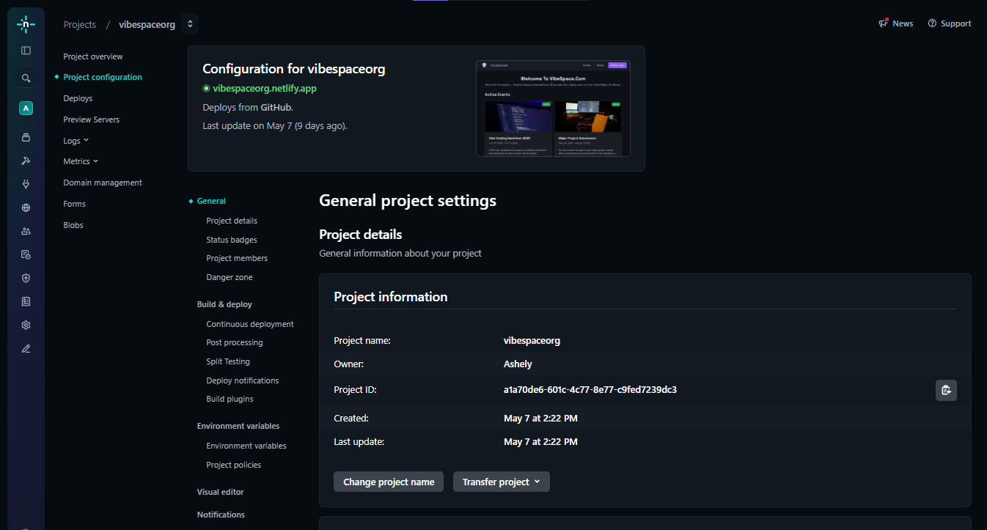

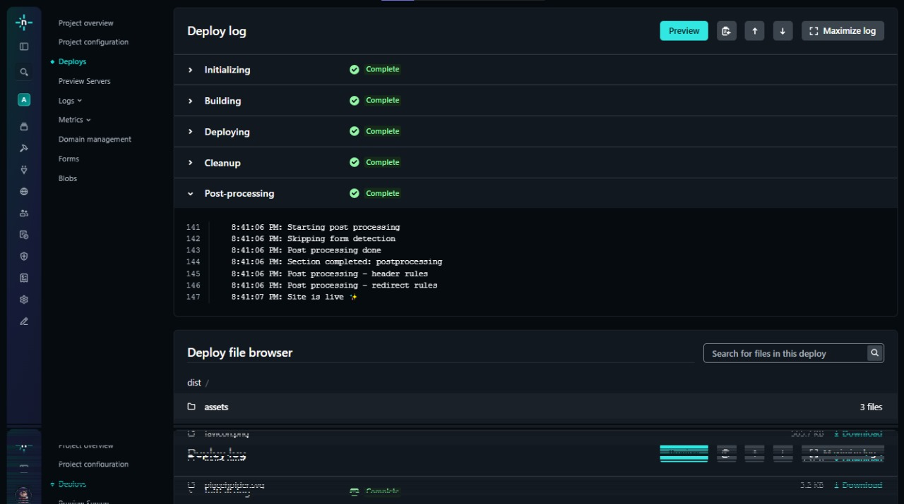

**Chapter 11: Conclusion**

**Conclusion**

This project report details the analysis, design, development, and testing of "VibeSpace - College Hackathon Management System," a comprehensive web-based application aimed at revolutionizing the way hackathon events are organized and managed within educational institutions. Conceived to address the inherent inefficiencies and limitations of traditional manual or fragmented management methods, VibeSpace set out with the primary purpose of providing a centralized, automated, and user-friendly platform for administrators and student participants alike.

The initial system study highlighted significant challenges prevalent in the existing manual processes, including time-consuming manual registrations and data management, inefficient project submission tracking, fragmented communication channels, laborious evaluation procedures, and a general lack of centralized information and reporting capabilities. These issues collectively resulted in high administrative overhead, increased risk of errors, suboptimal user experiences, and limited scalability, making it difficult for colleges to host large, frequent, and well-organized hackathons. The core problem statement identified the critical need for an automated solution to mitigate these challenges.

The VibeSpace project was specifically undertaken to provide a tangible, technology-driven solution to these problems. Its core purpose was to streamline workflows from event announcement and participant registration through project submission and initial evaluation. The key objectives guiding the development included creating a centralized event management platform, simplifying participant registration and project submissions, facilitating a more efficient evaluation process, enhancing communication, providing basic reporting, ensuring system security, and delivering a user-friendly interface. Adhering to a well-defined scope, the project focused on delivering these fundamental functionalities using modern web technologies.

**Summary of Key Achievements**

The development of VibeSpace represents a successful endeavor in applying theoretical knowledge to build a practical software application. Several significant achievements were realized throughout the project lifecycle, demonstrating proficiency in various aspects of software engineering:

* Implementation of Core Functional Requirements: The project successfully translated the identified functional requirements into a working application. Modules for user authentication and authorization (FR1), comprehensive event management by administrators (FR2), seamless participant registration (FR3), structured project submission (FR4), administrator views for submissions (FR5), a basic framework for managing evaluations (FR6), centralized announcement capabilities (FR7), and preliminary reporting features (FR8) were designed and implemented.
* Adoption of Modern Technology Stack and Architecture: VibeSpace was built upon a robust Client-Server architecture utilizing the React framework for a dynamic and responsive frontend, Node.js and Express for a scalable backend API, and MongoDB as a flexible NoSQL database managed via Mongoose. This choice of technology stack enabled efficient development, promoted modularity, and laid the groundwork for potential future scalability (NFR5 Scalability). The implementation effectively leveraged the strengths of each technology, such as React's component-based UI development, Node.js's asynchronous processing for API handling, and MongoDB's document model for managing diverse data structures.
* Application of Agile Methodology: The project successfully adopted and applied the Agile software development methodology. Development proceeded through iterative sprints, allowing for continuous requirement refinement, adaptive design adjustments, and integration of feedback. The practices of Sprint Planning, Review, and Retrospective fostered effective teamwork, enabled rapid prototyping and delivery of working increments, and promoted a culture of continuous improvement throughout the development process, proving the methodology's effectiveness for managing projects with potentially evolving requirements.
* Implementation of Multi-Layered Security Measures: Security was integrated as a core consideration, not an afterthought. A robust JWT-based authentication system was implemented to securely verify user identities, complemented by Role-Based Access Control (RBAC) on the backend to enforce specific permissions for Student and Admin roles (FR1, NFR3 Security, Chapter 8). Critical security practices such as bcrypt hashing for password storage, comprehensive server-side input validation and sanitization, and mandatory use of HTTPS for secure data transmission were successfully incorporated, significantly mitigating common web vulnerabilities (NFR3 Security, Chapter 7).
* Structured Database Design and Implementation: The database schema in MongoDB, designed based on the Entity-Relationship model, was implemented using Mongoose ODM. Collections for Users, Events, Registrations, Submissions, and Evaluations were structured with appropriate fields, data types, validation rules, and referencing to manage relationships between entities efficiently (Chapter 3). This provides a solid foundation for data storage and retrieval, ensuring data integrity.
* Comprehensive Testing and Bug Resolution: A combination of unit, integration, and manual testing methodologies was employed to identify and resolve defects throughout the development lifecycle (Chapter 6). Automated unit tests validated individual code components, integration tests verified the interaction between different parts of the system (e.g., frontend-backend communication, backend-database interaction), and manual testing focused on end-to-end workflows and user experience. A systematic approach to bug reporting and fixing ensured that identified issues were tracked and resolved, leading to a more stable and reliable application (NFR4 Reliability).
* Creation of a User-Friendly Interface: Leveraging React and Tailwind CSS, the frontend was designed with a focus on usability and responsiveness (NFR1 Usability, NFR7 Compatibility). Intuitive navigation, clear forms, and tailored views for different user roles (Student Dashboard vs. Admin Dashboard) were implemented to provide a positive user experience and simplify the process of managing or participating in hackathons. Annotated UI screenshots demonstrate the practical interface design (Chapter 5).

These achievements underscore the successful transformation of a conceptual solution into a functional system that meets the defined requirements and demonstrates competence in full-stack web application development.

**Impact of VibeSpace on Hackathon Management**

The successful implementation of VibeSpace offers a significant positive impact on the process of managing college hackathons compared to the manual methods it replaces. Its key contributions lie in enhancing both administrative efficiency and the overall user experience for participants.

* Increased Administrative Efficiency: VibeSpace dramatically reduces the manual workload for event organizers. Tasks such as participant registration, data collection and management, project submission handling, and organizing information for evaluation, which were previously time-consuming and prone to errors (as identified in the Problem Statement), are now largely automated and centralized. Administrators can create and manage events through a single interface, easily access lists of registered participants and submitted projects, and utilize the system to structure the evaluation process. This frees up valuable administrative time and resources, allowing organizers to focus more on the quality of the event itself – securing sponsors, arranging mentors, and providing a better experience for participants – rather than being bogged down by tedious paperwork and data entry. The ability to generate basic reports also provides administrators with quicker access to event statistics for analysis and future planning (FR8).
* Enhanced User Experience for Students: For students, VibeSpace provides a streamlined and transparent experience. They no longer need to navigate fragmented channels to find event information or use cumbersome manual methods for registration and submission. The centralized platform allows them to easily browse available events, view detailed information, register with a few clicks, and submit their projects through a standardized form (FR3, FR4, NFR1 Usability). Receiving system notifications (even if basic in the current scope, FR7) and being able to view their registration and submission status provides clarity and reduces uncertainty. The accessibility of event details and rules ensures participants are well-informed, leading to smoother participation.
* Improved Data Management and Integrity: Centralizing all event-related data (users, registrations, events, submissions, evaluations) in a single MongoDB database eliminates data silos and inconsistencies inherent in spreadsheet-based or manual tracking. Mongoose schema validation and backend input validation further ensure that the data stored is accurate and in the correct format. This improved data integrity provides a reliable single source of truth for all hackathon information, reducing errors in participant lists, submissions, and evaluation results.
* Increased Transparency: The system introduces a degree of transparency for participants by allowing them to view event details, registration status, and submission status. For administrators and evaluators, the system provides a structured view of submissions and evaluation records, making the process more organized and potentially fairer than entirely manual methods.
* Potential for Scalability: While the current deployment is scoped for a college environment, the chosen architecture and technologies are inherently more scalable than manual processes. The system is designed to handle a growing number of events, participants, and submissions with potential infrastructure upgrades (NFR5 Scalability), allowing the college to host larger or more frequent hackathons in the future without proportional administrative bottlenecks.

In essence, VibeSpace transforms a complex, labor-intensive administrative process into a more efficient, digital workflow, significantly improving the quality of hackathon management and providing a better, more engaging experience for the student participants.

**Key Takeaways and Final Thoughts**

The VibeSpace - College Hackathon Management System project successfully met its primary goals and delivered a functional application that addresses the identified challenges in college hackathon management. The key takeaways from this project are:

* Validation of Project Purpose: The project successfully demonstrated that an automated, centralized system is a viable and effective solution for overcoming the limitations of manual hackathon management.
* Effective Technology Stack Selection: The choice of React, Node.js/Express, and MongoDB proved appropriate for building a modern, full-stack web application within the project constraints, providing necessary performance, flexibility, and maintainability.
* Benefits of Agile Development: The Agile methodology facilitated iterative development, enabled the team to respond to feedback, and ensured continuous progress, highlighting its suitability for projects where adaptability is key.
* Importance of Integrated Security: Implementing security measures like JWT, password hashing, input validation, and HTTPS as integral parts of the development process is crucial for building a trustworthy system.
* Practical Application of Software Engineering Principles: The project provided hands-on experience in applying principles of system analysis, architectural design, database design, full-stack implementation, testing, and security within a structured SDLC framework.
* Understanding User Needs: Focusing on the distinct needs and workflows of both administrators and students was essential in designing a system that provides value to both user groups.
* VibeSpace, as developed in this project, stands as a testament to the potential of technology to streamline administrative processes and enhance educational activities. It successfully provides a proof-of-concept for an integrated hackathon management solution tailored for the college environment.

Considering the successful implementation of core features and the positive impact it can have on efficiency and user experience, the potential for VibeSpace's adoption within the college or similar institutions is significant. It offers a clear upgrade from current practices and provides a solid base upon which further enhancements can be built. While the current scope is limited by the constraints of a final year project, the identified future scope (Chapter 9), including student profiles, real-time notifications, and automated certificate generation, represents logical and valuable extensions that would make VibeSpace even more powerful and appealing for broader deployment.

**Chapter 12:**

**References**

**References**

This section lists the sources and resources that were consulted, studied, and utilized during the analysis, design, implementation, and testing phases of the "VibeSpace - College Hackathon Management System" project. The successful completion of this project relied heavily on leveraging existing knowledge, official documentation, technical guides, and various online resources pertaining to the chosen technologies, architectural patterns, software development methodologies, and best practices in web application development and security.

The references are categorized below for clarity and include official documentation for the core technologies (React, Node.js, Express, MongoDB, Mongoose, Tailwind CSS), libraries used for specific functionalities (authentication, validation, testing, date handling), resources on architectural and design principles, and guides related to the adopted development methodology and modeling techniques. These resources provided the foundational knowledge, practical examples, and detailed API references necessary to build VibeSpace.

**Core Technology Documentation**

The official documentation for the primary technologies forming the VibeSpace stack served as the most critical source of information regarding their features, APIs, usage patterns, and best practices. These documents were indispensable during the implementation phase.

1. React Documentation. Meta. Available at: <https://react.dev/>.

* This served as the primary reference for building the VibeSpace frontend user interface. It provided detailed guides on React's core concepts, including components, hooks (useState, useEffect, useContext), state management, props, and the component lifecycle. Understanding these concepts was fundamental to creating the modular and dynamic UI. The documentation's examples and explanations were heavily relied upon for implementing various frontend features and structuring the React application.
* Node.js Documentation. OpenJS Foundation. Available at: <https://nodejs.org/en/docs/>.

The official Node.js documentation was essential for understanding the Node.js runtime environment, its core modules (like http, path, fs), asynchronous programming patterns, and how to set up a Node.js project. It provided the foundation for developing the backend application and understanding its event-driven architecture, crucial for handling multiple client requests efficiently.

1. Express.js Documentation. Express. Available at: <https://expressjs.com/>.

* This documentation was central to building the VibeSpace backend API. It offered comprehensive guides on setting up an Express application, defining routes to handle different HTTP requests, using middleware for request processing (e.g., body parsing, CORS), and structuring the backend application. The routing and middleware concepts were key to designing and implementing the RESTful API endpoints for managing users, events, and submissions.

1. MongoDB Manual. MongoDB, Inc. Available at: <https://www.mongodb.com/docs/manual/>.