**How to Add/Import SSL certificate in AWS Console**

1. Login in AWS Console Account
2. Select Account/Project and click on Manage Console
3. Go/Search AWS “Certificate Manager”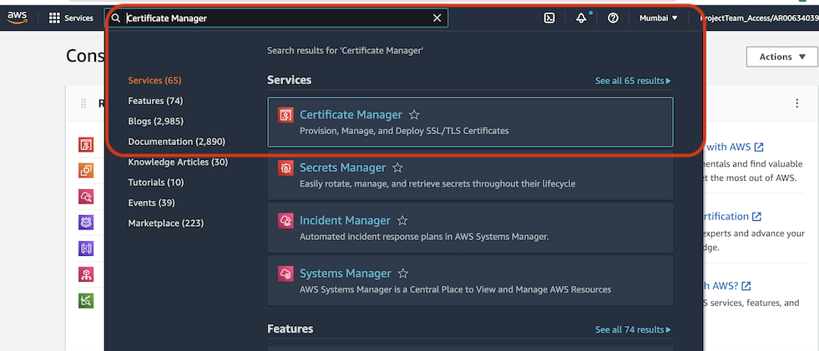
4. Select/Click Import certificate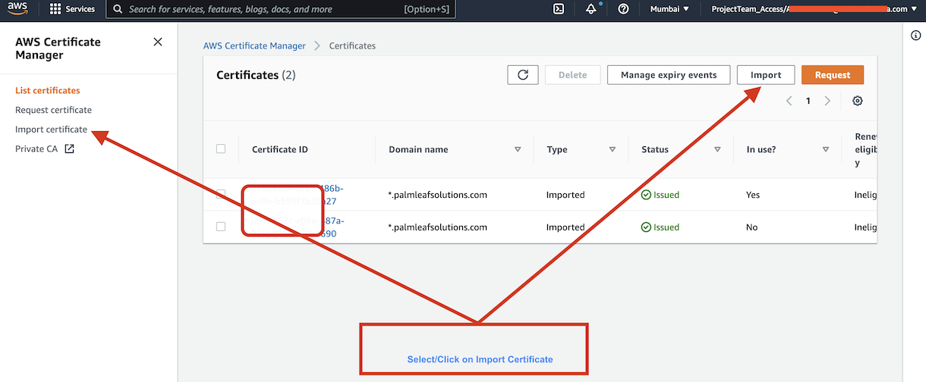
5. Fill the all details certificate(cron, private, intermediate, root)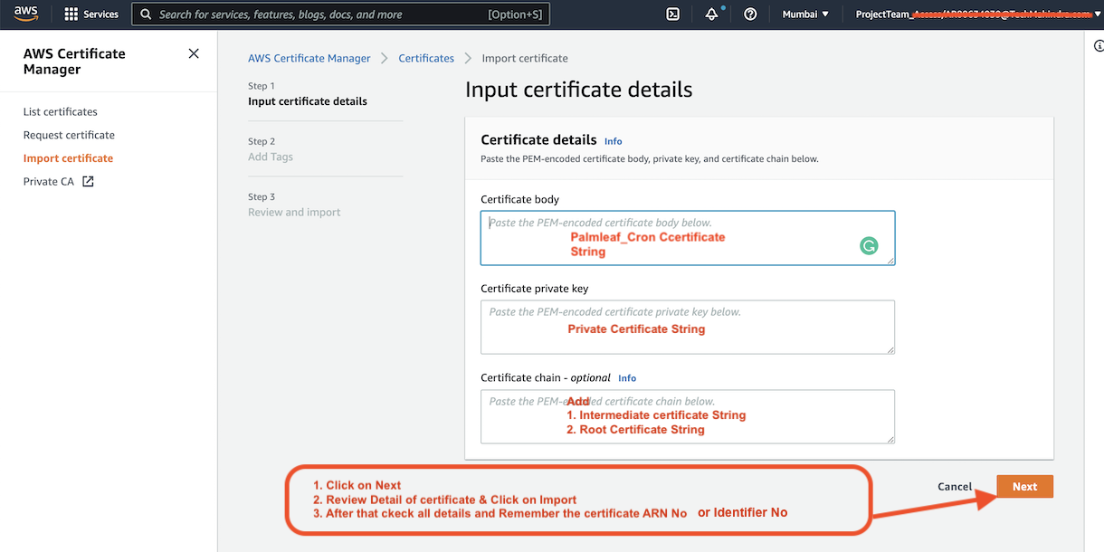
6. Go EC2 Load Balancer

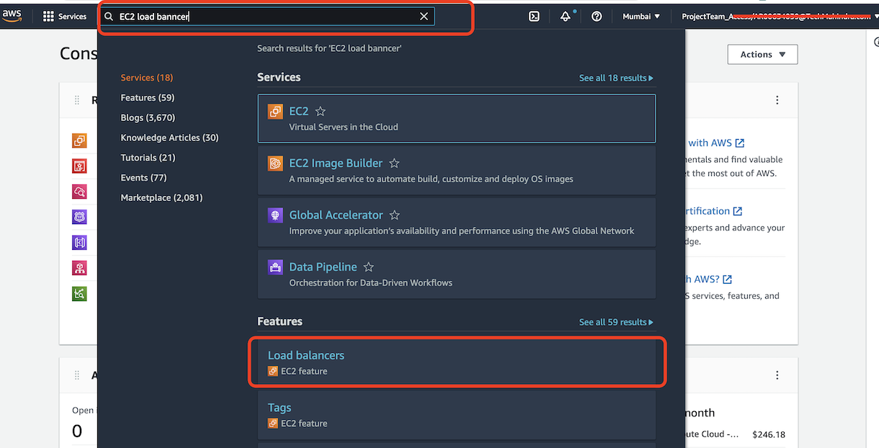

1. Select Load Balancer and update all ACM SSL certificate with new one

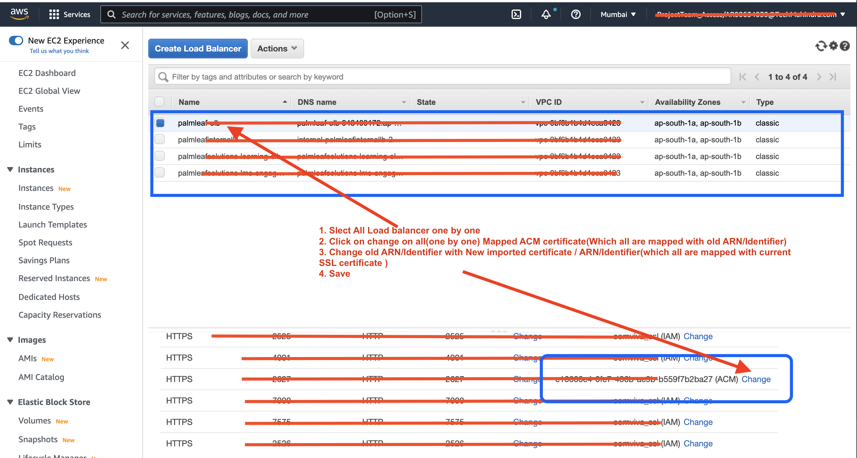

1. Check & make sure all domain/subdomain are working fine
2. Check all domain with running with update SSL certificate