1. Introduction
The Pizza Sales Dashboard was developed in Microsoft Power BI to analyze one year of pizza sales data. It provides interactive visualizations, key performance indicators (KPIs), and business insights that help management monitor sales performance, identify trends, evaluate product performance, and support data-driven decision-making.

2. Dashboard Overview
2.1 Home Page
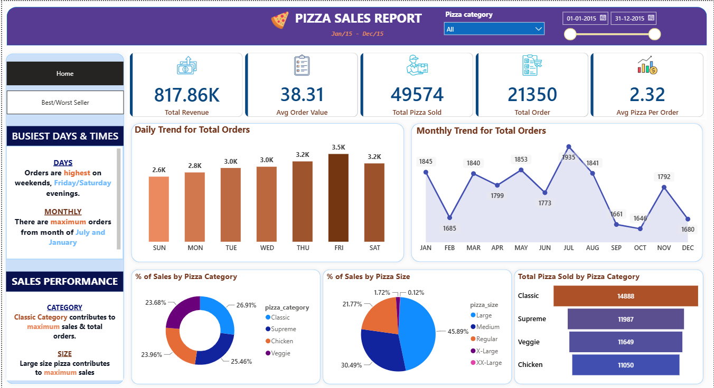
Overview:
The Home Dashboard provides a comprehensive overview of pizza sales performance. It displays key business metrics, sales trends, category-wise analysis, size-wise analysis, and total pizzas sold by category. Interactive slicers allow users to filter the report by pizza category and order date.

2.2 Best/Worst Seller Dashboard
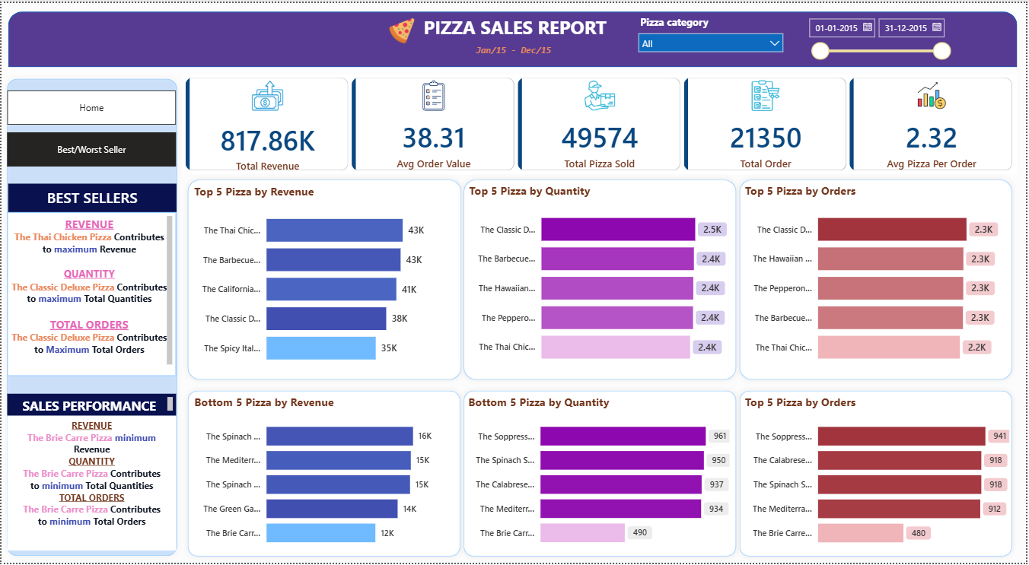
Overview:
The Best/Worst Seller Dashboard highlights the highest and lowest performing pizzas based on revenue, quantity sold, and total orders. This page helps management identify top-performing products as well as products that may require promotional strategies or menu optimization.

3. Dashboard Features
- Interactive KPI Cards
- Date Range Slicer
- Pizza Category Filter
- Daily Sales Trend Analysis
- Monthly Sales Trend Analysis
- Pizza Category Analysis
- Pizza Size Analysis
- Best Seller Analysis
- Worst Seller Analysis
- Dashboard Page Navigation

4. KPI Cards
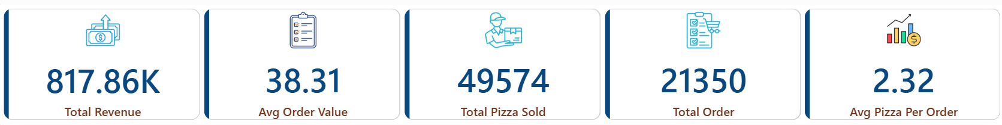

Purpose:
KPI | Description
Total Revenue | Total revenue generated from pizza sales
Average Order Value | Average revenue generated per customer order
Total Pizzas Sold | Total number of pizzas sold
Total Orders | Total customer orders received
Average Pizzas Per Order | Average number of pizzas purchased in each order

5. Dashboard Visualizations
5.1 Daily Trend for Total Orders
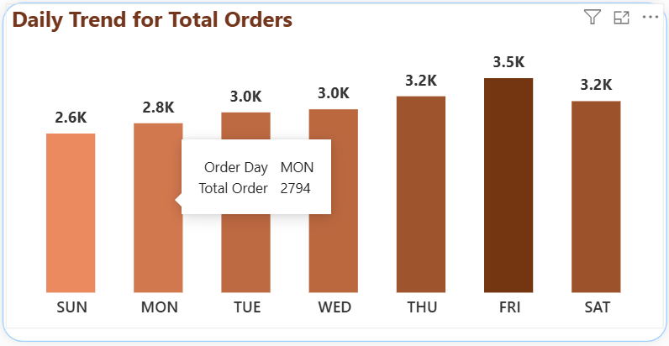

Purpose: Displays the number of customer orders received on each day of the week.
Business Value: Helps identify peak business days for better staffing and inventory planning.
5.2 Monthly Trend for Total Orders
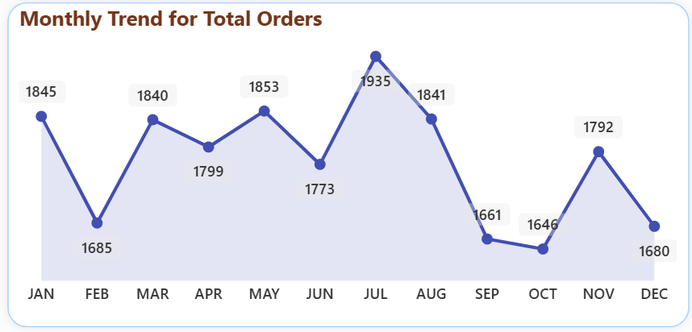
Purpose: Shows monthly customer ordering trends throughout the year.
Business Value: Helps identify seasonal demand patterns and sales fluctuations.
5.3 Percentage of Sales by Pizza Category
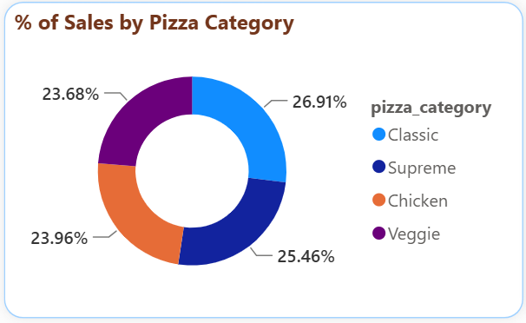
Purpose: Displays the percentage contribution of each pizza category to total sales.
Business Value: Helps identify which pizza categories generate the highest revenue.
5.4 Percentage of Sales by Pizza Size
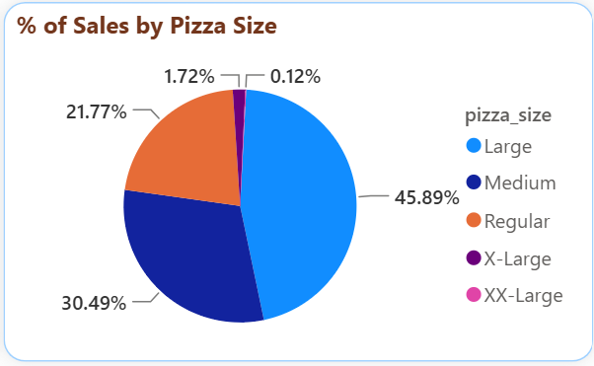
Purpose: Displays the percentage contribution of each pizza size to total sales.
Business Value: Helps understand customer preferences for pizza sizes and supports inventory planning.
5.5 Total Pizzas Sold by Pizza Category
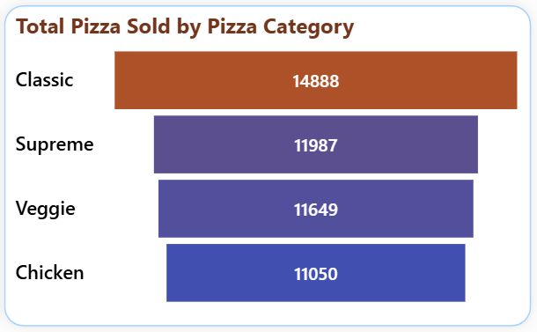
Purpose: Compares the total quantity of pizzas sold across different categories.
Business Value: Helps identify the most popular pizza categories based on customer demand.
5.6 Top & Bottom 5 Pizzas by Revenue
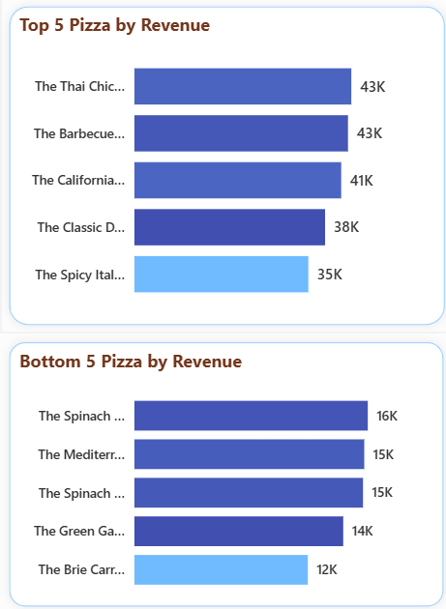

Purpose: Displays the highest and lowest revenue-generating pizzas.
Business Value: Helps management identify products that drive revenue and products requiring improvement.

5.7 Top & Bottom 5 Pizzas by Quantity Sold
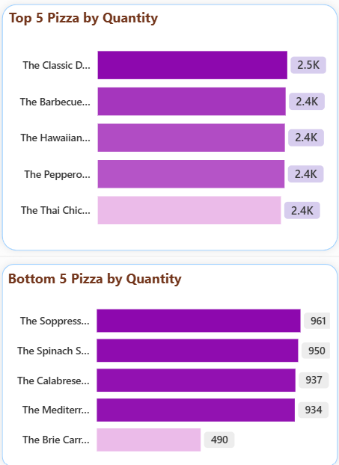

Purpose:
Displays the most and least sold pizzas based on quantity.
Business Value:
Helps evaluate product popularity and customer preferences.

5.8 Top & Bottom 5 Pizzas by Total Orders
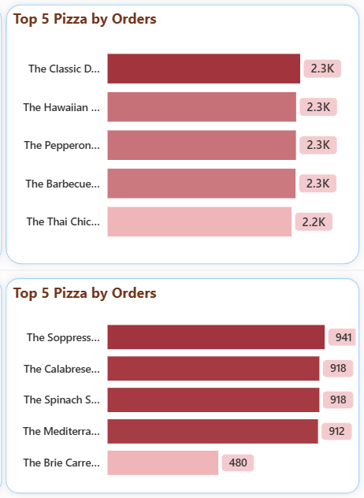
Purpose: Displays pizzas with the highest and lowest number of customer orders.
Business Value: Helps identify frequently ordered products and underperforming menu items.
6. Dashboard Filters
The dashboard includes interactive filters that allow users to customize the analysis.
Filters | Purpose
Pizza Category | Analyze sales for a selected pizza category
Order Date | Analyze sales within a selected date range

7. Dashboard Navigation
The dashboard consists of two report pages:
- Home Dashboard
- Best/Worst Seller Dashboard
Navigation buttons are provided to switch between the pages for a better user experience.

8. Learning Outcomes
Through this project, I gained hands-on experience in designing interactive dashboards using Power BI. I learned to create KPI cards, implement slicers and filters, build business visualizations, and present data-driven insights that support business decision-making.

