**Title: TO-DO LIST WEB APPLICATION USING BY HTML , CSS , JAVASCRIP**

**1. Introduction:**

* Start by introducing the TODO project and its purpose, which is to help users manage their tasks efficiently.

**2. Design Overview:**

* Explain the design choices made for the TODO app, such as the color scheme, layout, and use of icons.
* Highlight the user-friendly interface, including the input field for adding tasks, the "Add" button, and the task list.

**3. Features:**

* Discuss the key features of the TODO app, such as:
  + Adding tasks: Users can input tasks into the text field and click the "Add" button to add them to the list.
  + Task completion: Clicking on a task marks it as completed, visually indicated by a strikethrough.
  + Task deletion: Clicking on the "X" button next to a task deletes it from the list.
  + Data persistence: The app saves tasks in the browser's local storage, allowing users to access them even after refreshing the page.

**4. Code Structure:**

* Provide an overview of the HTML, CSS, and JavaScript code used to build the TODO app.
* Highlight key components such as the HTML structure, CSS styles, and JavaScript functions responsible for adding, completing, and deleting tasks
* **HTML Structure**: Explain the HTML structure of the project, including elements like input fields, buttons, and the task list.
* **CSS Styling**: Discuss the CSS styles applied to enhance the visual appeal and usability of the application.
* **JavaScript Functionality**: Walk through the JavaScript code responsible for handling user interactions, updating the UI, and managing task data.
* Optionally, discuss any additional features or enhancements that could be implemented in the future.

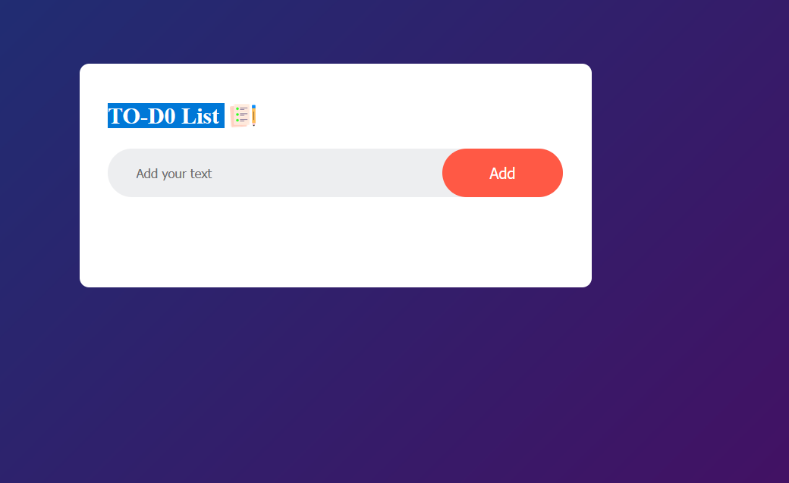

Step -1 Start project.

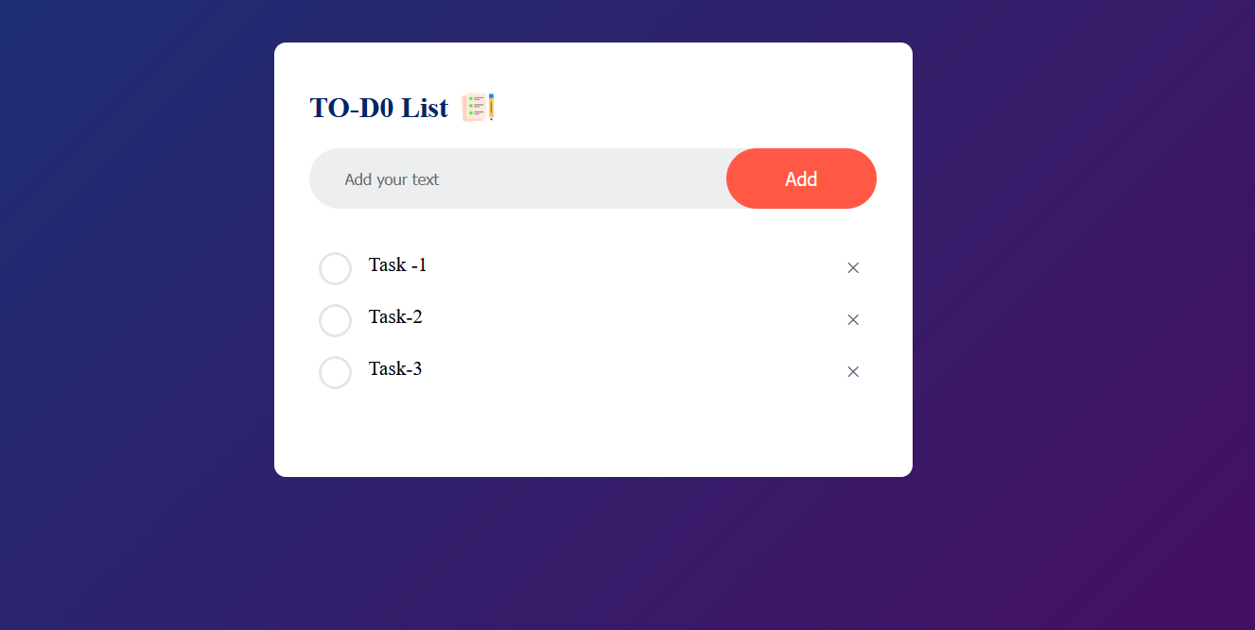

Step-2 Enter the value in input and ADD in the List.

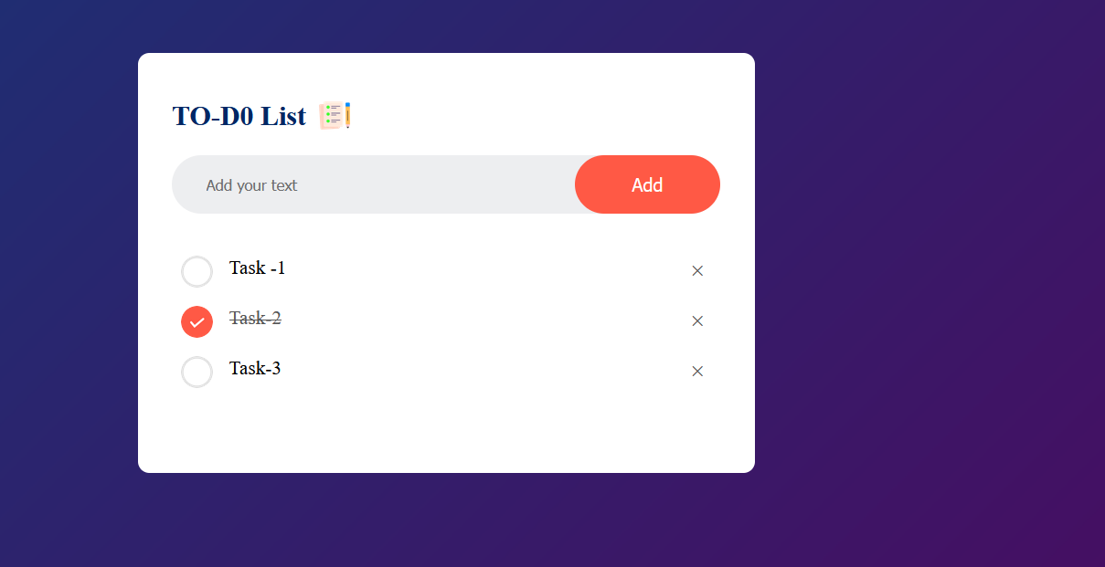

Step -3 Check any value in the given task .

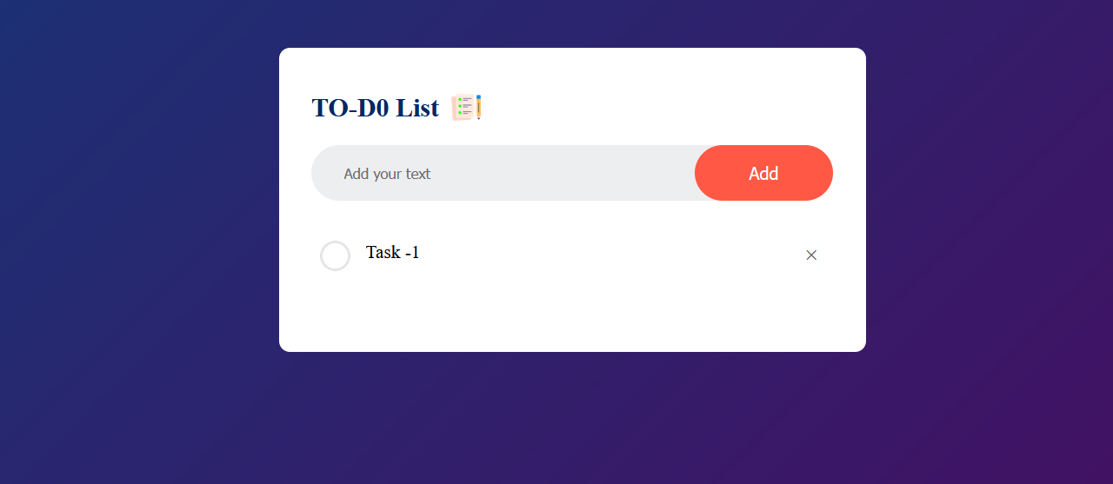

Step- 4 Delete any task

**5. Example Implementation:**

* Users can input tasks into a text field and click a button to add them to the list.
* Each task is displayed as an item in the list, and users can mark tasks as completed by clicking on them.
* Completed tasks may visually change appearance (e.g., strikethrough text or a change in background color) to indicate their status.
* The UI is styled using CSS to enhance the visual appeal and usability of the application.

**6. Demonstration:**

* Perform a live demonstration of the TODO app, walking through each feature and interaction.
* Show how tasks can be added, marked as completed, and deleted, emphasizing the app's responsiveness and ease of use.

**7. Benefits:**

* Discuss the benefits of the TODO app, such as its simplicity, accessibility, and effectiveness in task management.
* Highlight how the app addresses common user needs and improves productivity by providing a convenient way to organize tasks.

**8. Future Enhancements:**

* Mention potential enhancements or features that could be added to the TODO app in the future, such as task categorization, due dates, or reminders.

**9. Conclusion:**

* Summarize the key points covered in the presentation, reiterating the importance and usefulness of the TODO app.
* Encourage feedback and questions from the audience, inviting discussion about the project and its potential applications.

**10. Q&A Session:**

* Open the floor for questions from the audience, addressing any queries about the project's implementation, functionality, or design.