**Title : Weather APP Project using HTML CSS JAVASCRIPT**

**Weather App Presentation:**

**Introduction:**

The Weather App is a simple web application that allows users to check the weather conditions of any city. It provides real-time weather data such as temperature, humidity, and wind speed.

**User Interface:**

* **Card Layout**: The app features a card-based layout for a clean and organized display of weather information.
* **Search Bar**: Users can enter the name of the city they want to check the weather for in the search bar.
* **Search Button**: Clicking the search button triggers the weather data retrieval process.
* **Weather Display**: Upon successful retrieval, the weather information is displayed including the city name, temperature, humidity, wind speed, and an icon representing the weather condition.
* **Error Message**: If the entered city name is invalid or not found, an error message is displayed.

**Features:**

1. **Dynamic Weather Data**: The app fetches real-time weather data from the OpenWeatherMap API based on the user's input.
2. **Error Handling**: It provides feedback to the user in case of an invalid city name or if the city is not found.
3. **Responsive Design**: The app is designed to be responsive and can adapt to various screen sizes, making it accessible across devices.

**Technologies Used:**

* **HTML, CSS, JavaScript**: The core technologies used for building the front-end interface and functionality.
* **OpenWeatherMap API**: Used to retrieve weather data based on the city entered by the user.

**HTML Structure:**

* The HTML structure consists of a div with the class card, which represents the main container for the weather app.
* Inside the card, there are three main sections:
  1. **Search Section (div.search)**: Contains an input field and a search button for users to enter and search for a city.
  2. **Error Section (div.error)**: Displays an error message if the city entered is invalid.
  3. **Weather Section (div.weather)**: Displays weather information such as temperature, city name, humidity, wind speed, and weather icon.

**CSS Styling:**

* The CSS styles are used to layout and style the elements of the weather app, giving it a visually appealing appearance.
* Styles are applied to elements such as the card container, search input field, search button, weather details, and error message.

**JavaScript Functionality:**

* The JavaScript code handles fetching weather data from the OpenWeatherMap API based on the city entered by the user.
* It retrieves the user input from the search input field when the search button is clicked.
* It then sends a request to the OpenWeatherMap API using fetch, passing the city name and API key as parameters.
* If the response status is 404 (city not found), it displays an error message.
* If the response is successful, it parses the JSON data and updates the weather information displayed in the app, such as temperature, city name, humidity, wind speed, and weather icon.
* Depending on the weather condition, it dynamically updates the weather icon displayed.

**OpenWeatherMap API:**

* The application utilizes the OpenWeatherMap API to fetch current weather data for the specified city.
* It uses a provided API key (apikey) and constructs the API request URL based on the city name entered by the user.

**Summary:**

In summary, this weather application allows users to search for the weather conditions of a city. It fetches real-time weather data from the OpenWeatherMap API and displays it in a visually appealing interface, providing users with essential weather information at a glance.

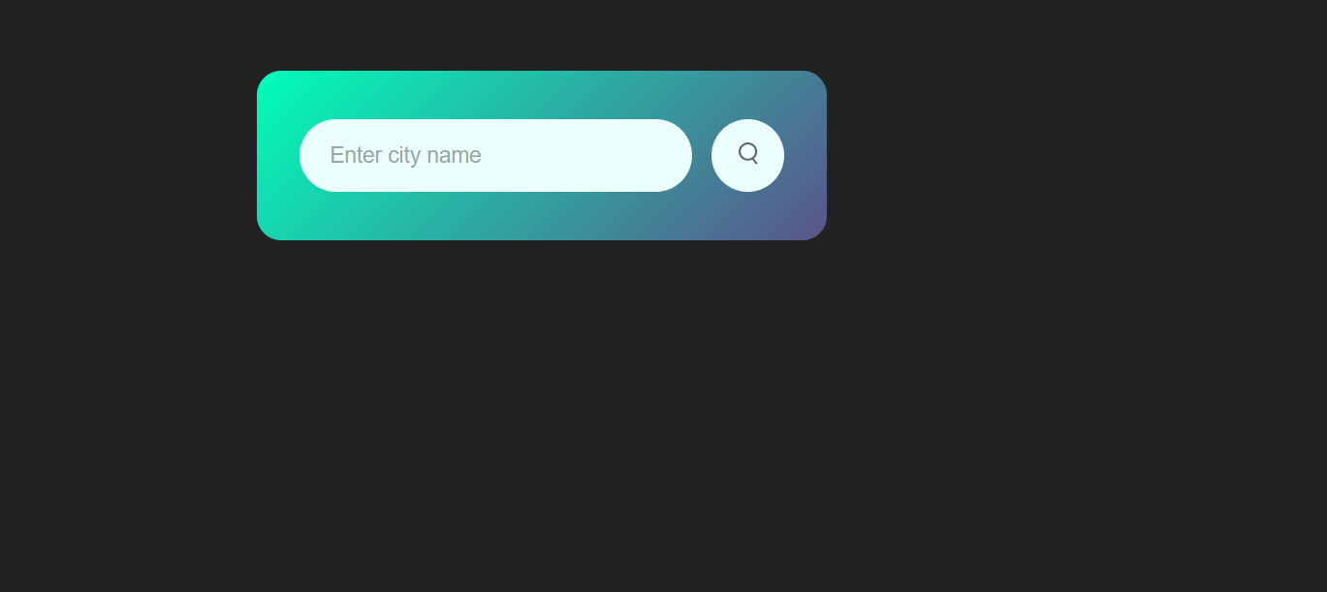

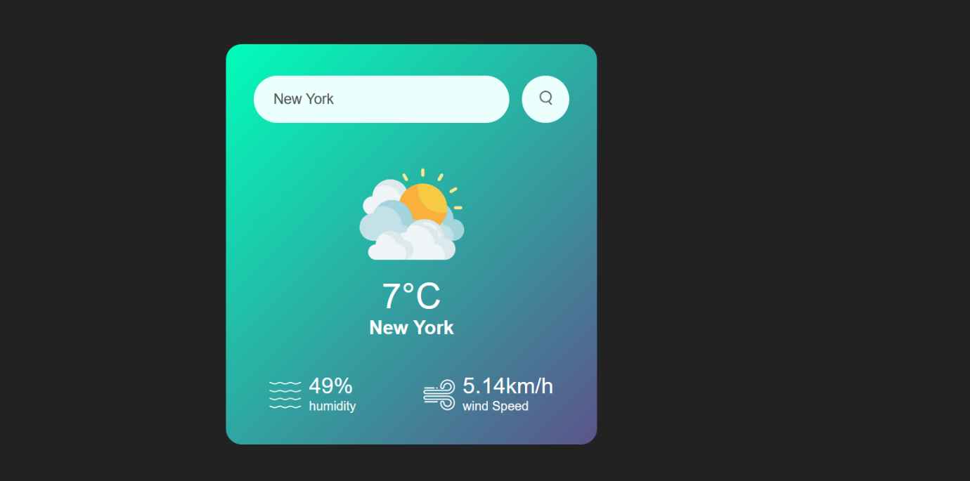

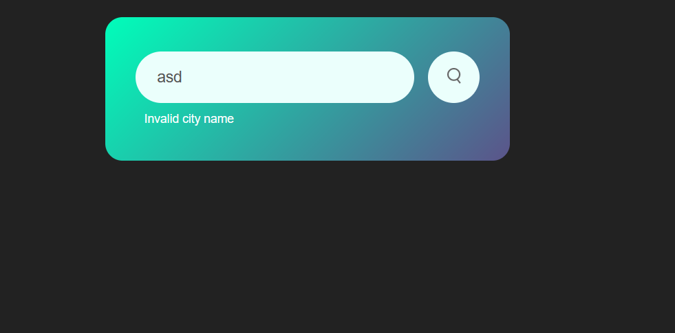

**Working Process:**

1. **User Input**: The user enters the name of the city they want to check the weather for.
2. **Data Retrieval**: When the user clicks the search button, the app sends a request to the OpenWeatherMap API to fetch weather data for the specified city.
3. **Data Display**: Upon receiving the response, the app updates the interface with the retrieved weather information.
4. **Error Handling**: If the city is not found or the request fails, an error message is displayed to the user.

**Conclusion:**

The Weather App provides a convenient way for users to access weather information for any city quickly and easily. With its intuitive interface and reliable data retrieval, it serves as a useful tool for staying informed about weather conditions worldwide.