|  |
| --- |
| **Devsync.in** |
| Gujar Nagar, Thergaon, Wakad, Pune – 411057, Maharashtra, India |
| support@devsync.in | 🌐 <https://devsync.in> |

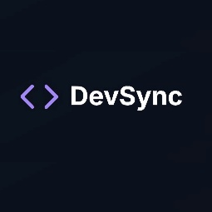

**OFFER LETTER**

**Date:** 26/05/2025

**Dear {{ first_name }},**

We are excited to offer you an internship with **Devsync** for the role of **Full Stack Developer** as part of our hands-on product development pipeline.

**Devsync** is a next-generation edtech and SaaS startup redefining how tech talent is identified and nurtured in India. We specialize in discovering skilled students from Tier-2/3 colleges, training them in Full Stack Development, DevOps, and Generative AI, and integrating them into live client projects and internal product teams. As part of this internship, you will contribute directly to building real-world SaaS applications—gaining both technical and entrepreneurial exposure.

**Position Details**

* **Job Title:** Full Stack Developer
* **Start Date:** 27/05/2025
* **Employment Type:** Internship
* **Duration:** 4 Weeks
* **Work Schedule:** Flexible
* **Job Location:** Hybrid

**During the internship, you will:**

Be engaged in live projects, coding challenges, mentorship sessions, and collaborative development environments that reflect real-world tech scenarios. Upon successful completion, you will receive an internship certificate and may be considered for extended roles or future product initiatives at **Devsync.**

**Terms and Conditions**

* This is a project-based internship and is expected to be completed in full. Early exit without valid reason or prior approval may forfeit your certificate and future opportunities with Devsync.
* This offer does not imply employment. Confirmation is subject to acknowledgment and onboarding.
* Your performance will be reviewed during a 7-day evaluation period.
* You may be required to sign a Confidentiality/Non-Compete Agreement to protect the company’s interests.

**Acceptance**

This letter outlines the terms of your internship with Devsync. Onboarding and compliance with guidelines are required to begin.

If you have any questions, feel free to contact **Tanay Burbure** atsupport@devsync.in.

Sincerely,

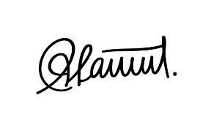   
**Devsync**

**Acknowledgment:**

I, **{{ first_name }} {{ last_name }}**, accept and agree to the proposed terms of the internship as outlined in the offer letter provided by **Devsync**

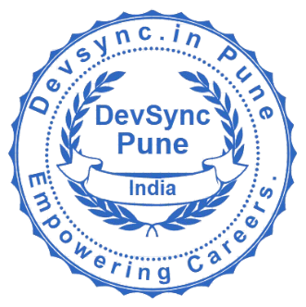**Signature**

**Intern**