**Name:** R Abhishek

**Reg No:**1832001

**Department:** MSc Data Science

Problem Statement:

Malaria is a life-threatening disease caused by parasites that are transmitted to people through the bites of infected female Anopheles mosquitoes. It is preventable and curable. In 2018, there were an estimated 228 million cases of malaria worldwide. The estimated number of malaria deaths stood at 405 000 in 2018. Children aged under 5 years are the most vulnerable group affected by malaria. In 2018, they accounted for 67% (272 000) of all malaria deaths worldwide. In 2018, the region was home to 93% of malaria cases and 94% of malaria deaths.

There are three datasets, one is reported number of cases around the world. Next one is expected number of cases around the world. And final one is incidence per 1000 people at risk area. A brief exploratory analysis is done to explore whether the no of cases, death has increased every year.

Installing Necessary Updates:

To solve the above problem statement, Python language is opted and Colab is the tool to be used. Colab usually maintain a default version of libraries. To use higher version or updated version, we have to install the necessary updates on Colab by specifying the updated version. Pandas-Profiling is an opensource Python module with which we can quickly do an exploratory data analysis with just a few lines of code. For using Pandas Profiling, we have to get it installed in Colab using pip install.

Importing Necessary Libraries:

We have to import pandas for storing data in the form of dataframe. Numpy is imported for working with numpy arrays. Pandas-profiling is imported for performing EDA process in few lines of code. For Scaling data, Standard Scalar is imported. For fitting numerous ML models, sklearn library is imported. For showing any extra graphs or charts, pyplot and seaboarn is imported.

Exploratory Data Analysis:

. Pandas Profiling is used to perform EDA for the dataset. Necessary library is imported and report is generated and stored as an HTML file.

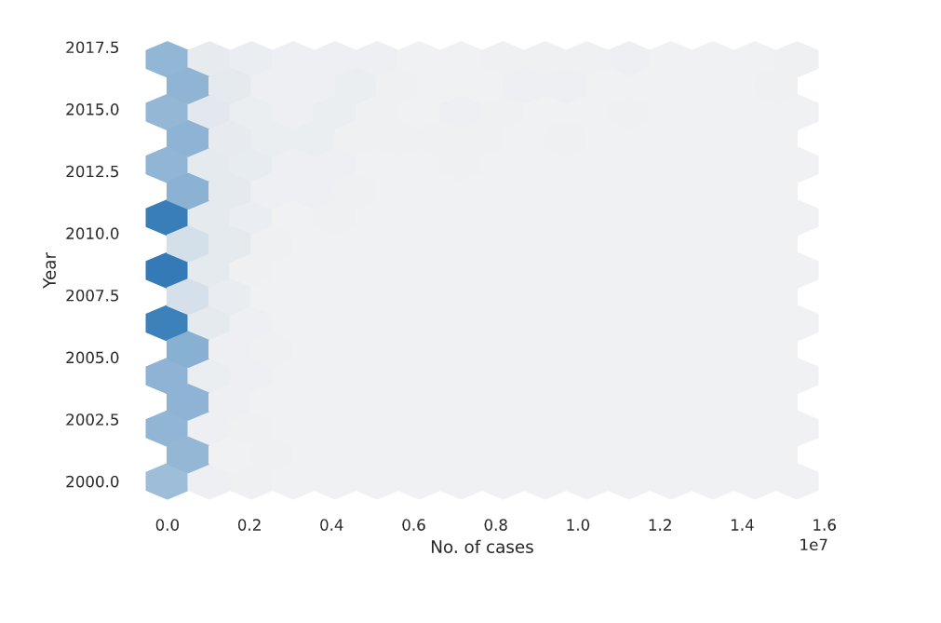

Figure 1 No of cases recorded in each year

In figure 1 we can see the greatest number of cases recorded in 2006-2010 span. It touched the peak in those years. Comparatively 2017 had recorded less number of cases.

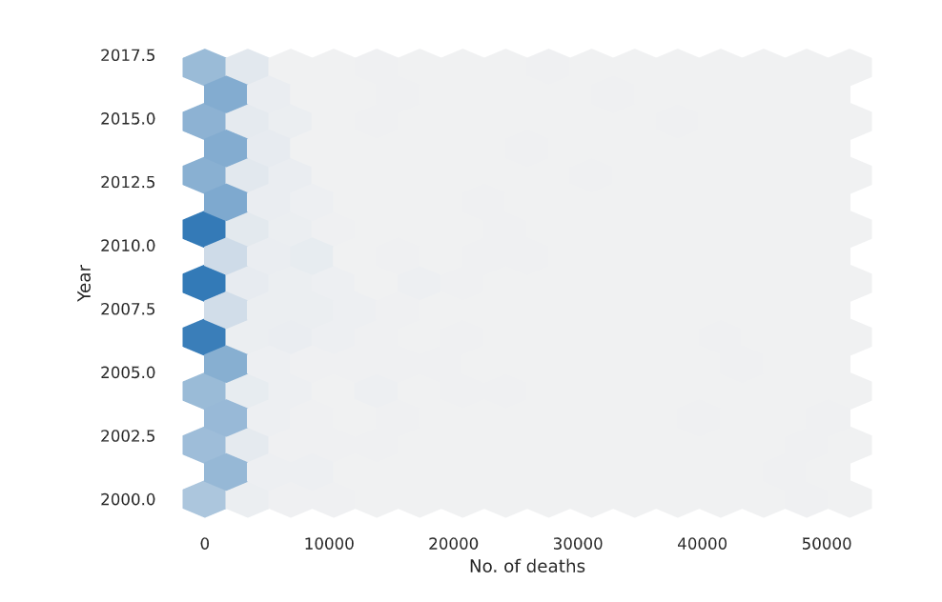

Figure 2 No of deaths recorded in each year

From figure 2 we can say that from 2006-2010 death due to malaria has increased rapidly. In 2017 we can see a slight decrease in the number of death when compared to 2010.

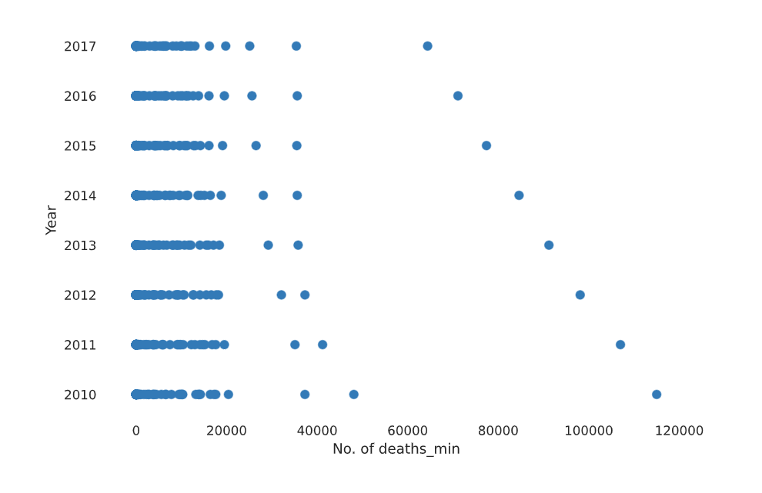

Figure 3 Min no of death estimated in each year

From figure 3, In 2010 minimum of 1,20,000 cases have be estimated to result in death. As the year passes by, the minimum number has been reduced to less than 80,000 in 2017.

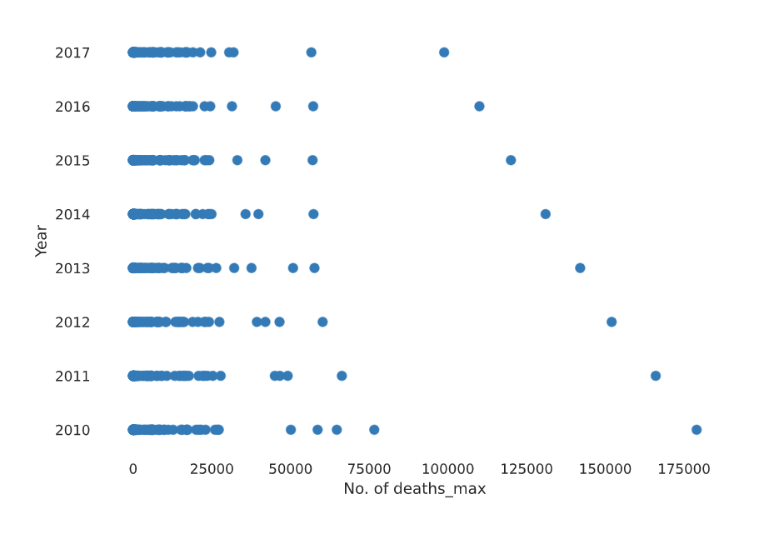

Figure 4 Max no of death estimated in each year

From figure 4, analyst expected to record more than 1,75,000 cases to death and it decreased its value to nearly 1 lac death count.

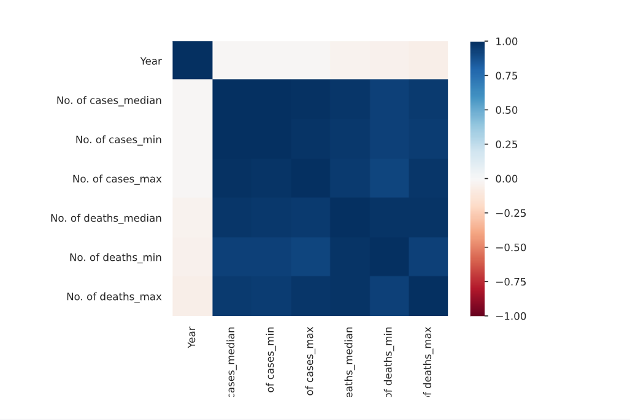

Figure 5 Correlation between each independent variable

We can see there exist some strong correlation between each variable. Year seems to have no effect on any other variable. No of cases median has strong correlation with no of cases min and max.

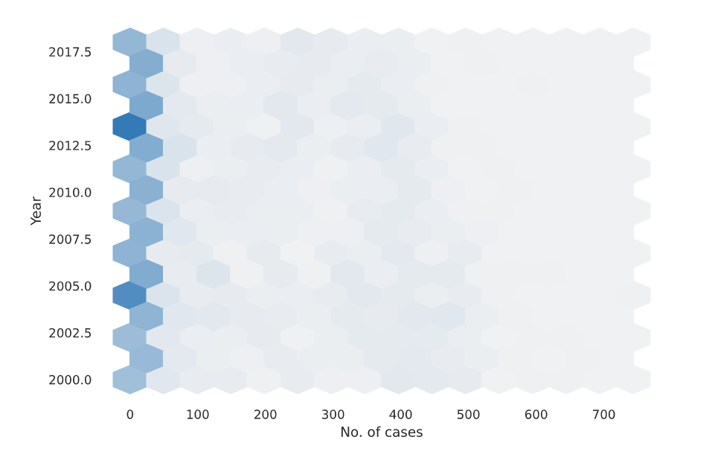

Figure 6 No of cases in each year recorded at risk areas.

As recorded in risk areas, in 2014 it was estimated to have more cases per 1000people. There was no proper precautionary taken in those areas labelled to be risk. In 2017 slightly lesser than what expected to get recorded.

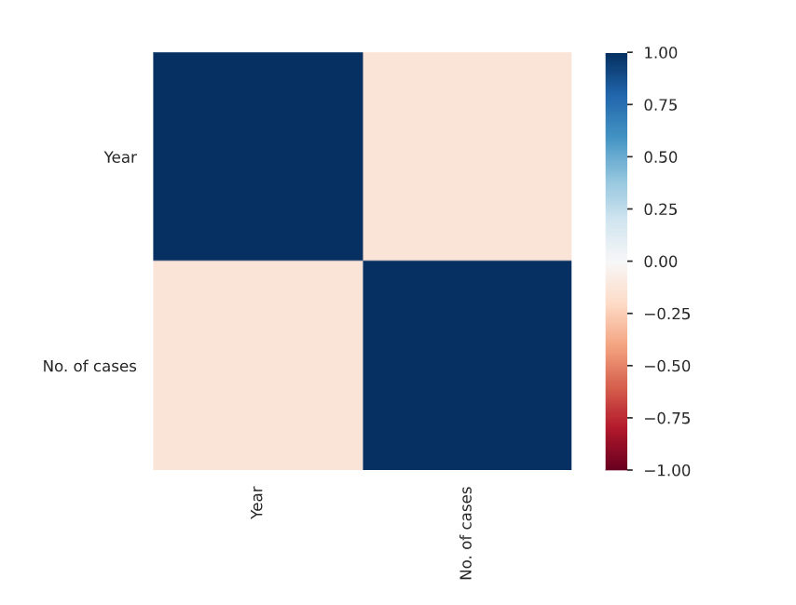

Figure 7 Correlation between Year and No of cases in risk area

In risk areas, from correlation graph we can say there is no relation between no of cases and year. That is there is no pattern to be followed to increase steadily or decrease steadily.

Conclusion:

We can see from the above visualizations, there is no increase in the no of cases and death in every year. After 2010 in fact, the no of cases started to decrease over years. Some awareness has been spread across people about how dangerous Malaria is and there are many treatments found to cure this malaria effect.