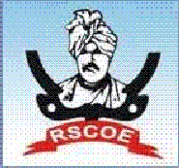

**JSPM’s**

**RAJARSHI SHAHU COLLEGE OF ENGINEERING TATHAWADE, PUNE-33**

**(An Autonomous Institute Affiliated to Savitribai Phule Pune University, Pune)**

**DEPARTMENT OF COMPUTER ENGINEERING**

**“PROJECT MANUAL”**

**Mission: Project to Product**

***“Enhancing the capabilities of students by transforming the knowledge gained into real models to serve the Society & Industry”***

**Prepared By: Prof. S. N. Lohar**

**PREFACE**

It is our great pleasure to present the manual highlighting project activities of UG students conducted in Computer Engineering Department of our college. Engineers play most vital and important role in nation building. They create new inventions using best engineered technologies to make human life more comfortable, secure and productive. We have identified the needs of latest engineering, technology and management education for modern age students.

With keeping this in mind, we encourage our students to design and develop the minor and major projects at the under graduate level in their course works and also provide the platform for participation in various project competitions. We also organize the project competition every year in the department as a part of the National Event “LOGICA” in JSPM’s Tathwawade campus.

Our department works rigorously for projects of UG students with an Objective:

1. The characteristic study of equipment, models and processing plants available in various Industries.
2. The design and development of projects by understanding the current needs of the society and the industry and transforming these projects into product in near future.

With keeping the objectives in mind, this activity gives outcome in the form of the major projects into the product as per the industry standards.

This manual is presented before you with following contents:

1. Titles of last three BE Computer Engineering projects
2. Summary of Publications since last three years
3. List of Participation in Project Competition

Prof. S. N. Lohar

**PROCESS OF PROJECT WORK**

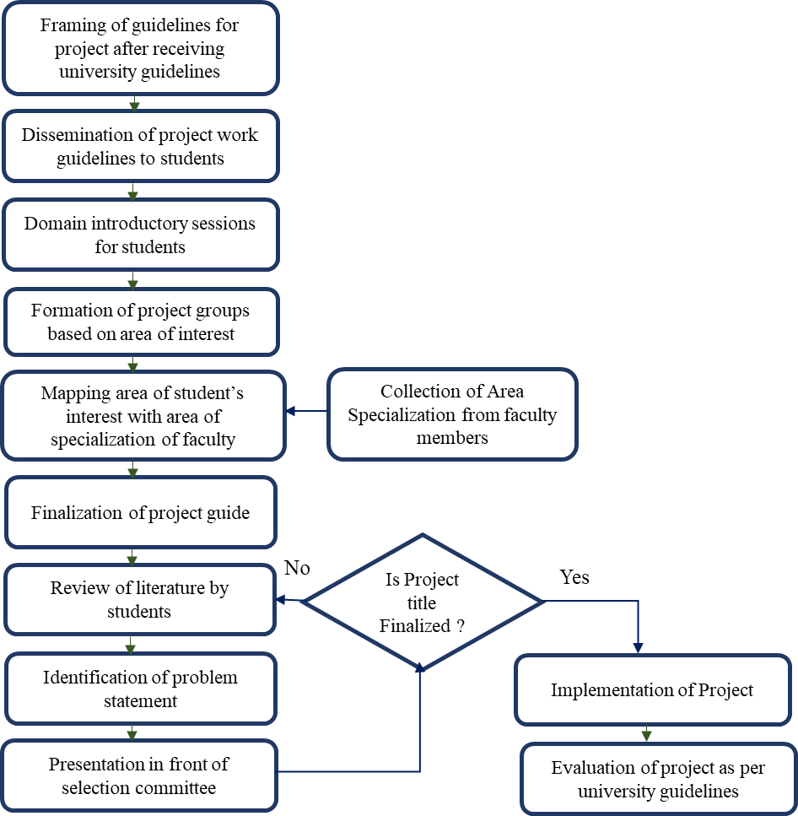

**GUIDELINES**

**Stage-I**

Project work Stage – I is an integral part of the Project work. In this, the student shall complete the partial work of the Project which will consist of problem statement, literature review, design, scheme of implementation (Mathematical Model/SRS/UML/ERD/block diagram/ PERT chart, etc.) and Layout & Design of the Set-up. The student is expected to complete the project up to the design phase. As a part of the progress report of Dissertation work Stage-I, the candidate shall deliver a presentation on the advancement in Technology pertaining to the selected project topic. The student shall submit the duly certified progress report of Project work Stage-I in standard format for satisfactory completion of the work by the concerned guide and head of the Department/Institute.

The examinee will be assessed by a panel of examiners of which one is necessarily an external examiner. The assessment will be broadly based on work undergone, content delivery, presentation skills, documentation and report.

**Stage-II**

In Project Work Stage–II, the student shall complete the remaining project work which consists of Selection of Technology and Tools, Installations, UML implementations, testing, Results, performance discussions using data tables per parameter considered for the improvement with existing/known algorithms/systems and comparative analysis and validation of results and conclusions. The student shall prepare and submit the report of Project work in standard format for satisfactory completion of the work that is the duly certified by the concerned guide and head of the Department/Institute

**PROJECT REVIEWS – (STAGE-1)**

**Review -I: Problem Statement, Motivation, Objectives and Literature Review**

**Summary of expected outcomes:**

* Identification of research gap leading to project motivation
* Preparing problem statement
* Study of existing literature
* Establish project objectives

**Review – II: Feasibility and Scope**

**Summary of expected outcomes:**

* Identifying project end-user.
* Projecting cost of project/product
* Assessing project requirements
* Defining scope clearly.
* Defining milestones in project timeline
* Risk assessment- Technical, Operational, Schedule, Business.

**Review – III: Requirement Analysis**

**Summary of expected outcomes:**

* Assessment of complete information domain analysis
* Mapping of feasibility between requirements with schedule, resources and budget
* Specifying the need of product
* Identification of stakeholders
* SRS document preparation

**Review – IV: Design**

**Summary of expected outcomes:**

* Verifying whether the design supports both the project(product) and the project goals.
* Check whether efficient modularity is achieved and all modules are independent
* Assess if all classes are clearly defined
* Assess all the UML diagrams as per project requirements, risk assessment and designed modules.

**PROJECT REVIEWS – (STAGE-II)**

**Review – I: Modeling (Model Refinement and Algorithm development)**

**Summary of expected outcomes:**

* Identify and finalize the software development process model
* Verifying the relations between objects and their classes
* Development and assessment of mathematical model related to the project
* Identifying the functional dependencies.
* Verifying the Deployment diagram as per system requirements.

**Review – II: Coding/ Implementation**

**Summary of expected outcomes:**

* Assessment of whether the code is correctly implemented as per design
* Verifying whether code complies with coding standard
* Functionality and granularity of the code is verified.
* Assessing if code optimization is achieved using the language features.

**Review – III: Validation and Testing**

**Summary of expected outcomes:**

* Verifying the alpha and beta testing
* Validating the requirements, design and code as per standard
* Testing the code in real time environment
* Checking the performance of the system after integration of the modules
* Verifying if social, safety, environmental, ethical and legal issues have been considered in developing the solution.

**Review - -IV: Report Writing**

**Summary of expected outcomes:**

* Verifying if the report is in prescribed format
* Assessment of report for proper organization, grammatical correctness
* Checking for plagiarism
* Assessment of relative graphs and analysis for results
* Verification of proper citations and references.

**Project Work Monitoring**

* The Final year projects are monitored and evaluated by the project guide and project assessment team.
* Every group maintains a project log register, which the project guide reviews once a week. The periodic review is conducted by the project guide to keep track of students’ work progress.
* The department project coordinator along with the internal project guide reviews the presentation and demonstration each semester.
* The student is expected to submit the duly certified progress report of the project in standard format for satisfactory completion of the work by the concerned guide.

**Project Work Evaluation**

* + Evaluation of the project is done by project guide based on the Project assessment rubric.
  + Each semester two internal project reviews are conducted to evaluate the progress of project work by the internal project guide, and project assessment team.
  + Every year, a department holds a state-level project competition in which industry experts are invited to evaluate the student’s projects.
  + The final review and demonstration of the project are conducted by the external examiners as per the university guidelines.

**Process to assess individual and team performance**

In the presence of the Project selection Assessment Committee, progress report presentations and activities are held twice a semester, followed by question-and-answer sessions. At the time of review, a panel evaluates the performance of each project team member based on the following parameters.

* Presentation skills
* Communication skills
* Confidence level
* Overall contribution to the project accomplishment
* Leadership skills

The performance of the project team is assessed by considering the following criteria:

* All designed objectives are full filled
* Project contribution in terms of paper presentation
* Participation in project competitions
* Time management
* Documentation and Demonstration
* Balanced distribution of work

|  |  |  |  |  |  |  |  |
| --- | --- | --- | --- | --- | --- | --- | --- |
|  | **PROJECT CATEGORIES** | | | | |  |  |
|  |  |  |  |  |  |  |  |
|  |  |  |  |  |  |  |  |
| **Sr.No** | **Academic Year** | **Total No. of Projects** | **Research Based** | **Social** | **Application based** | **Environmental** | **Product based** |
| 1 | 2019-20 | 38 | 10 | 10 | 6 | 5 | 7 |
| 2 | 2020-21 | 39 | 7 | 15 | 9 | 3 | 5 |
| 3 | 2021-22 | 21 | 3 | 9 | 3 | 3 | 3 |
| **Total** | | 98 | 20 | 34 | 18 | 11 | 15 |