

**Tachyon Communications Pvt Ltd**

Reg.Off:3 Sarvapalli, Mall Avenue Lucknow 226001 IN.

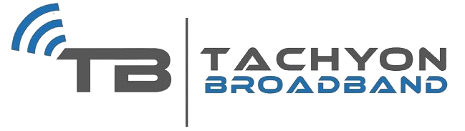**BILL TO:**

Abhishek Singh

User ID

Invoice number

INVOICE

:abhisheksingh57

:1759

5/10 Superviser Qtr CSA Kanpur, Kanpur 208001

Invoice Date :13 Jul 2023

8707848194

[abisheks10202@gmail.com](mailto:abisheks10202@gmail.com)

Billing Period Due Date Usage Plan

:13 Jul 2023 to 11 Aug 2023

:13 Jul 2023

:Unlimited400Mbps

Previous Balance (A):

# Rs. 0.00

Current Bill amt

**_ _ + =**

Payments

Rs. 1179.00

Adjustment

:

Rs. 0.00

# 1179.00

Amount due on before

# Rs. 0.00

|  |  |  |  |  |
| --- | --- | --- | --- | --- |
| **QTY** | **DESCRIPTION** | **HSN/SAC** | **UNIT PRICE** | **LINE TOTAL** |
| 1.00 | Unlimited400Mbps |  | 999.00 | Rs. 999.00 |
| CGST | | | 9.00% | Rs. 89.91 |
| SGST | | | 9.00% | Rs. 89.91 |
| Rounded Off | | |  | Rs. 0.18 |
| TOTAL  TOTAL DUE AMOUNT(A + B) | | | | Rs. 1179.00 |
| **Rs. 0.00** |

Dear customer, you can pay your bills Online, Manage your usage, raise support at our iCare Customer Portal : https://mytachyon.in

Please draw your Cheque ,online NEFT,IMPS payments in favour of BANK DETAILS

BANK NAME ICICI Bank

BRANCH

Sadar Cantt

ACCOUNT NAME ACCOUNT NUMBER

Tachyon Communications Pvt. Ltd. 126105000481

IFSC CODE MICR CODE

ICIC0001261

CIN:

GST No:

09AAFCT5499N1ZC

Unified License No:

9918634000 INDIA https://tachyonbroadband.com/

1- Kindly make renewal within expiry to avoid disconnections. 2-Checque/ECS/SI decline charges rs.250 3-For any queries, please call us at 9918634000 or Email [Support@mytachyon.in](mailto:Support@mytachyon.in) 4-Any legal activity/Dispute will be subject to Lucknow jurisdiction. 5-In case of direct payment to bank account please let us know about it and mention username/mobile no. with it.

System generated invoice and doesn’t require no Signature