Week 1

Submitted by: ABHISHEK SINGH

Reg. No.: RA1711003010827

Aim: Create a Static Home Page by using HTML Tags and forms.

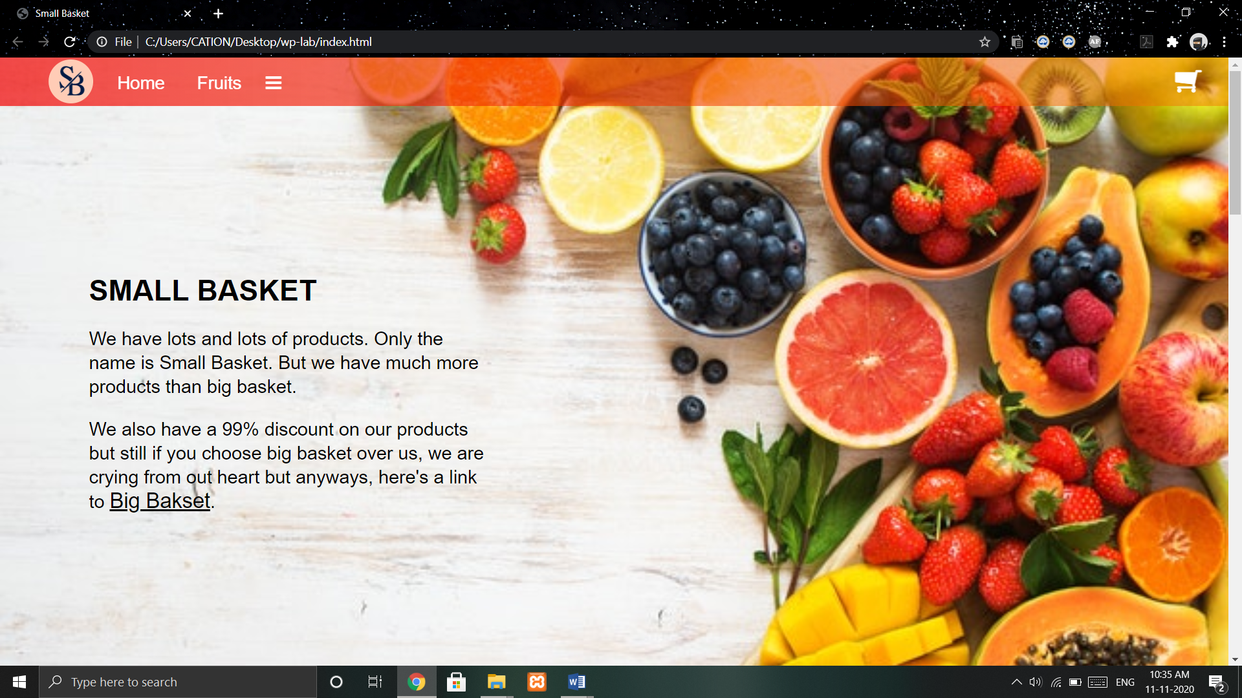

Code:

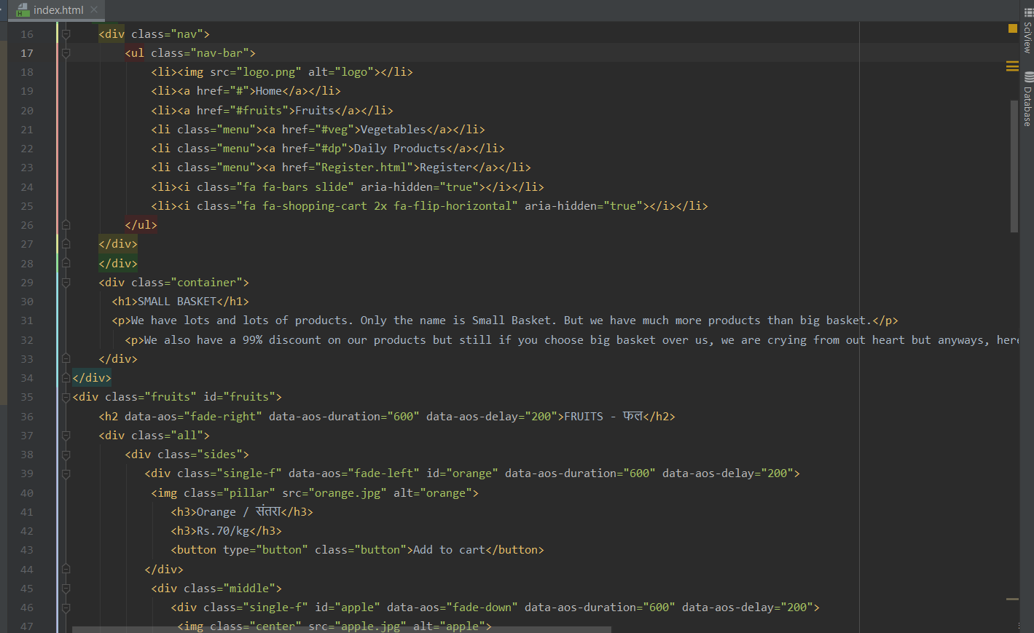

Work done:

Basic HTML structure, Links to different website and inline CSS.