Week 3

Submitted by: ABHISHEK SINGH

Reg. No.: RA1711003010827

Aim: Validate the Registration, user login, user profile pages using JavaScript.

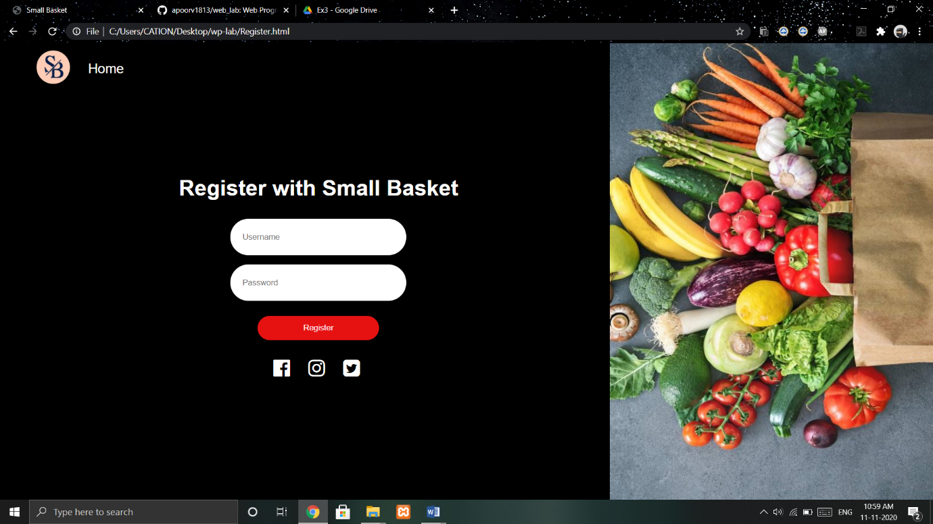

Work done:

Validated the registration using javascript. Added CSS

to forms. Added background image and other CSS to all

webpages.