Week 4

Submitted by: Apoorv Jain

Reg. No.: RA1711003010831

Aim: Write an XML file which will display the information.

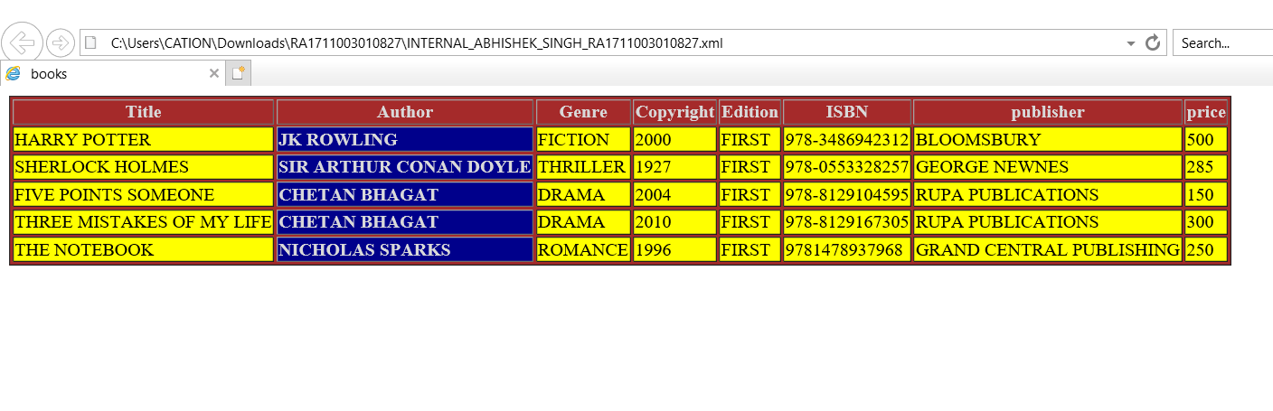

Work done:

Stored data inside an xml file and displayed it inside an html file using XMLHttpRequest.