Week 5

Submitted by: ABHISHEK SINGH

Reg. No.: RA1711003010827

Aim: Write a PHP Script for login authentication. Design an html form which takes username and password from user and validate against stored username and password in file

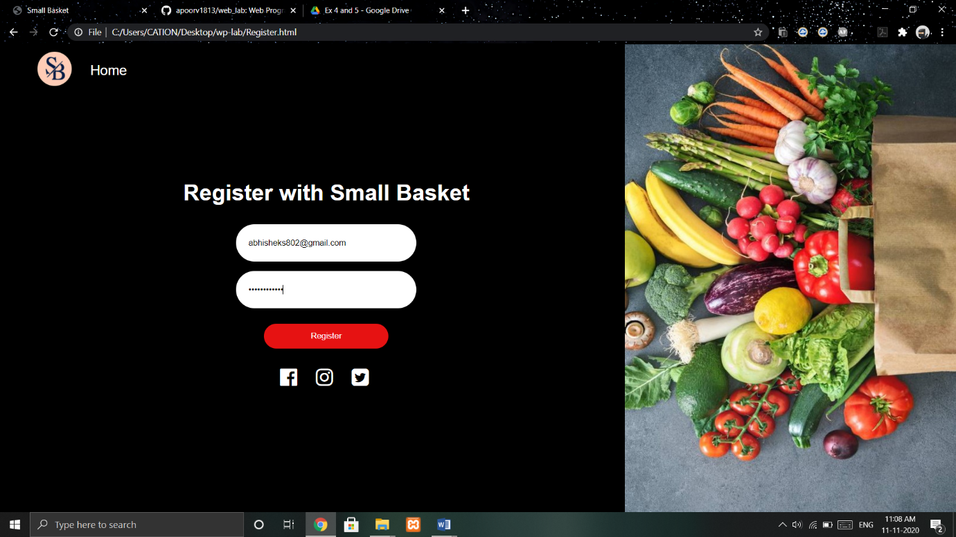

Work done:

Created a database and linked it to webpage using PHP. Created a registration page using PHP.