Week 6

Submitted by: ABHISHEK SINGH

Reg. No.: RA1711003010827

Aim: Design a dynamic web page with validation using

JavaScript

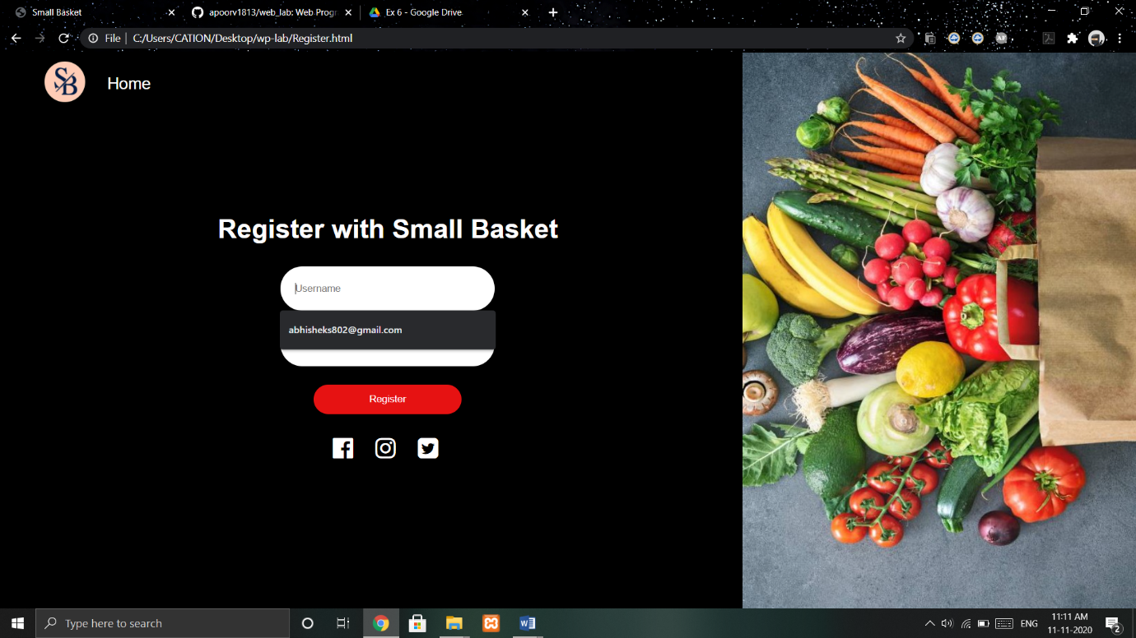

Work done:

Adding dynamic button to show and hide the registration form. Added registration validation.