Week 7

Submitted by: ABHISHEK SINGH

Reg. No.: RA1711003010827

Aim: Simple applications to demonstrate Servlets

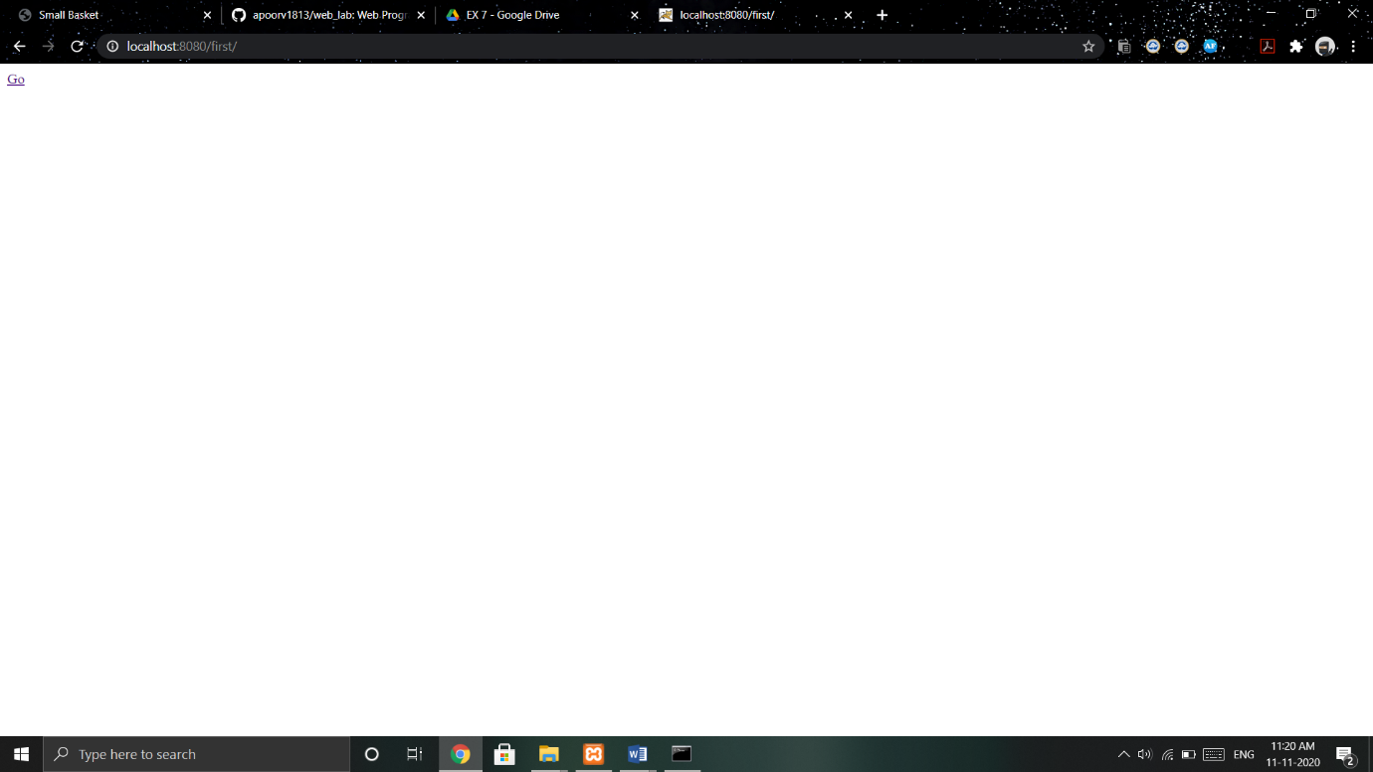

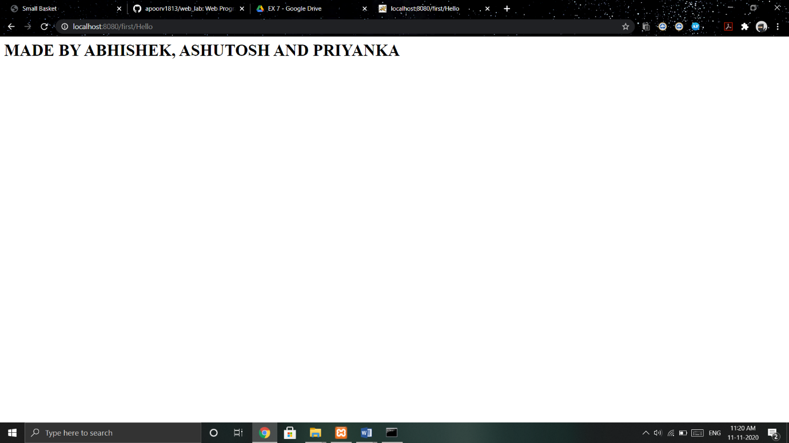

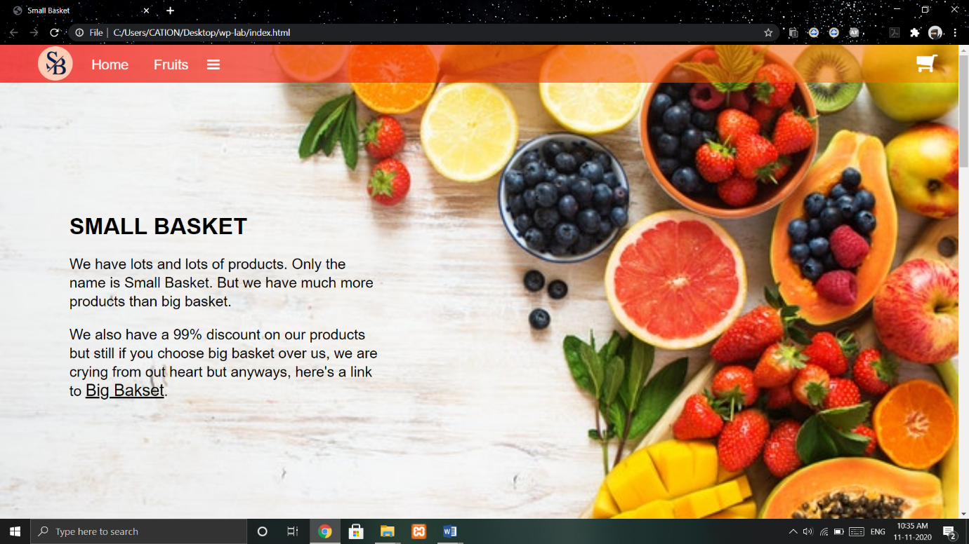

Work done:

Added a servlet application to show highlighted text and go to homepage.