Week 8

Submitted by: ABHISHEK SINGH

Reg. No.: RA1711003010827

Aim: Simple applications using JSP and AJAX

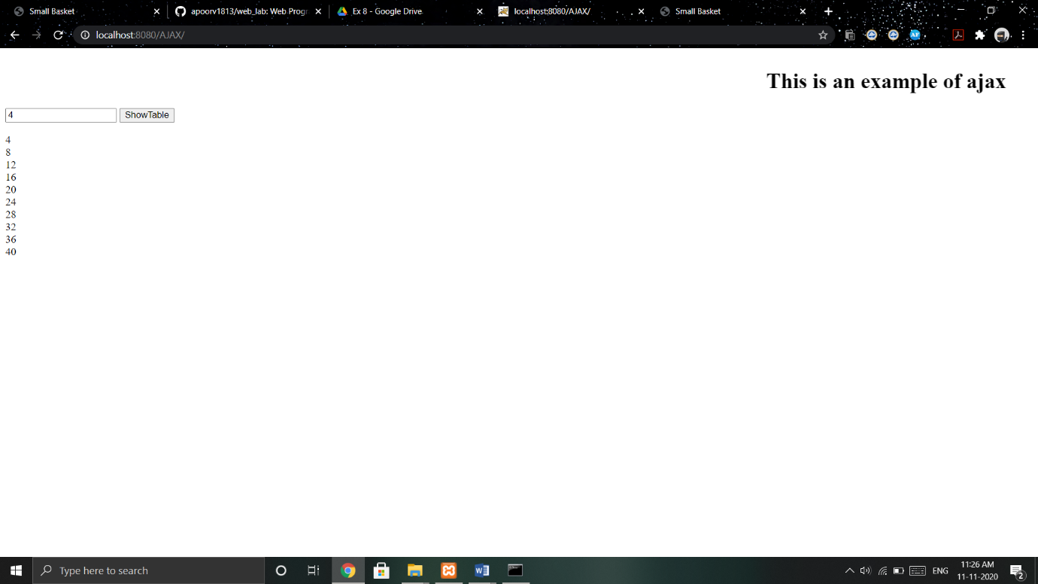

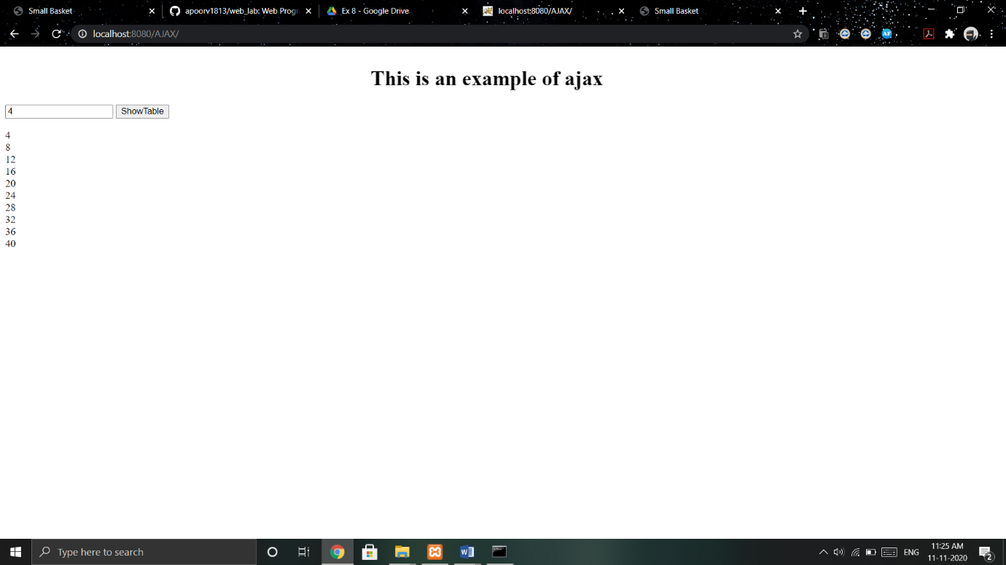

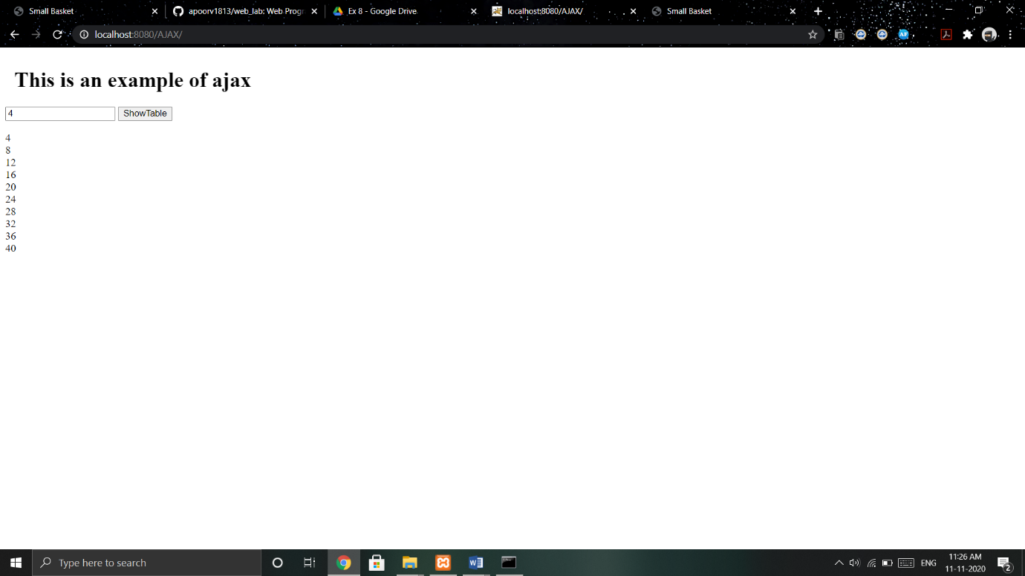

Work done:

Created a jsp application that shows the first ten multiples of inputted number. Created moving text using ajax.