Week 9

Submitted by: ABHISHEK SINGH

Reg. No.: RA1711003010827

Aim: Design a simple online test web page in PHP

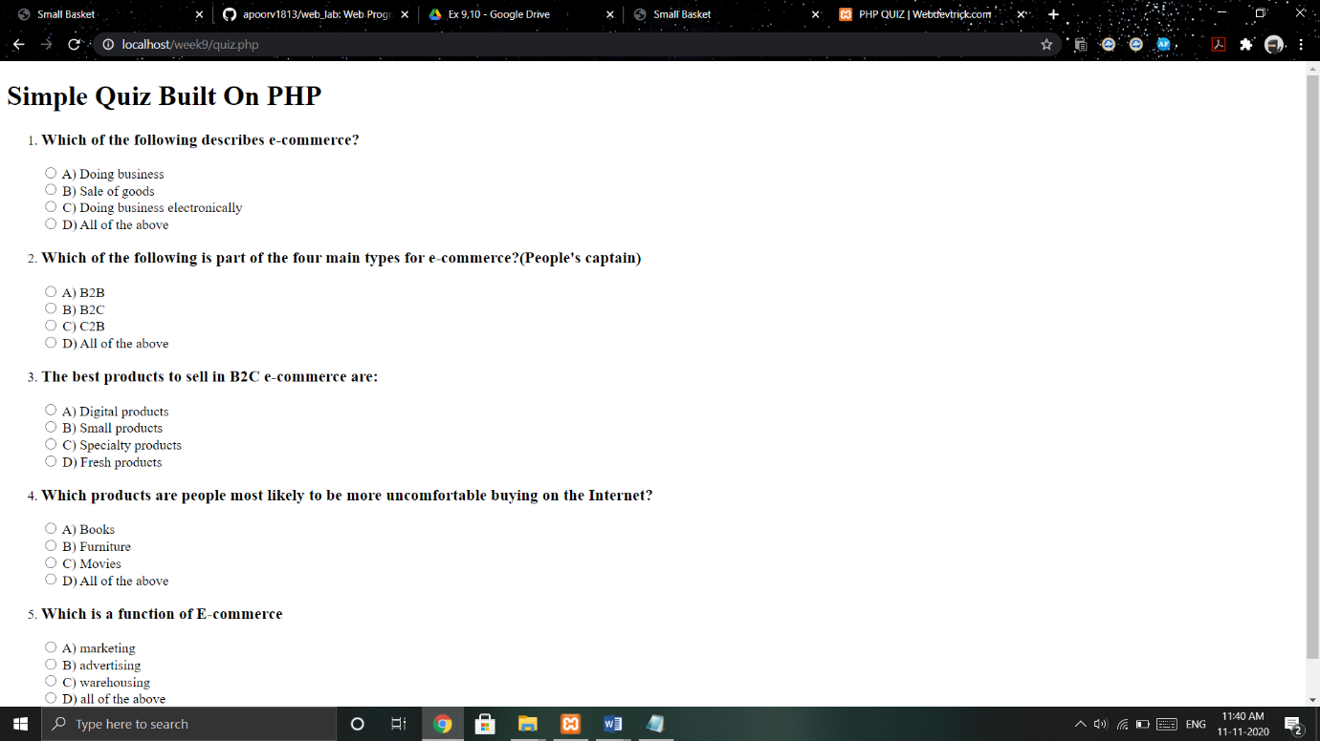

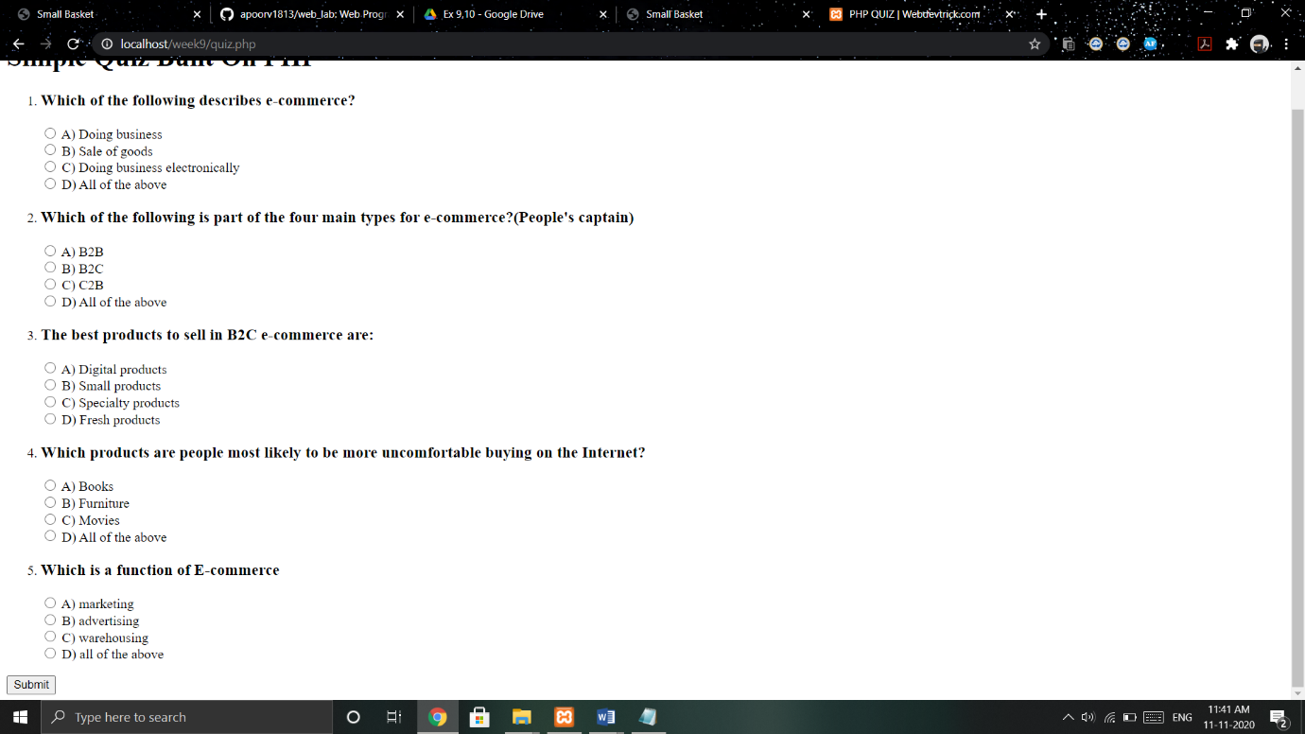

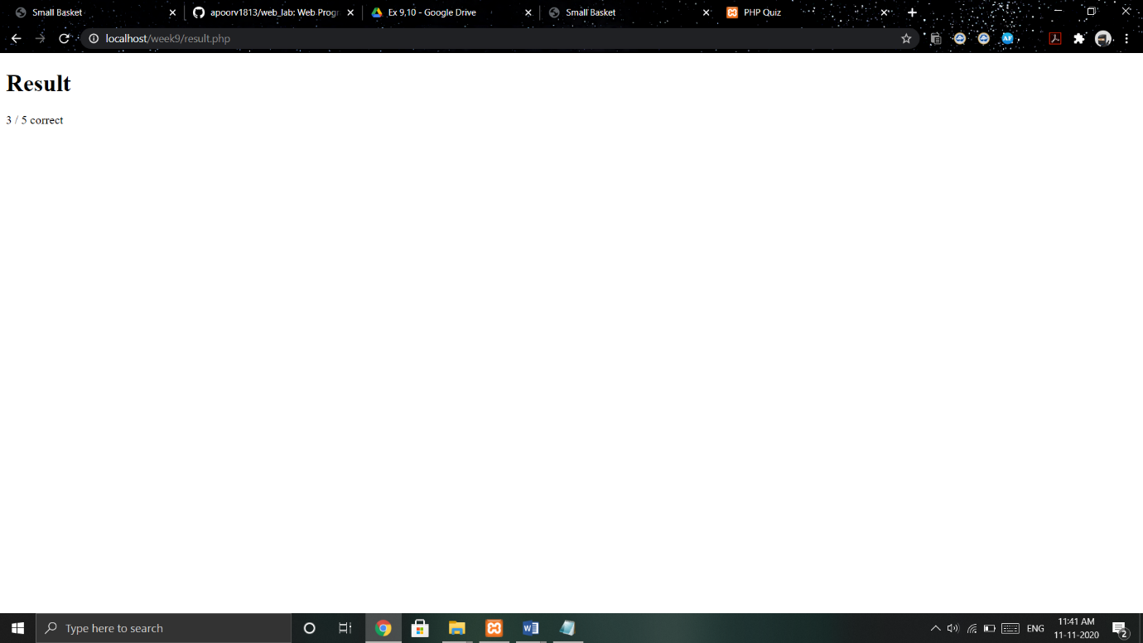

Work done:

Created a form using html and validated the answers using php.