**Lab 2**

**Program1.html**

<!DOCTYPE html>

<html>

<head>

   <title>Program1</title>

   <link rel="stylesheet" href="Program1.css">

</head>

<body>

    <div id="heading" class="heading">

        <h1>Astrological signs</h1>

    </div>

    <div class="main">

        <div class="left">

        </div>

        <div id="list" class="list">

            <dl>

                <dt>Aries</dt>

                <dd>Aries is the first fire sign in the zodiac, the other fire

                    signs being Leo and Sagittarius. Individuals born between these dates,

                    depending on which system of astrology they subscribe to,

                    may be called Arians or Ariens.</dd>

                    <hr>

                <dt>Taurus </dt>

                <dd>The sign of Taurus is associated with several myths and bull

                    worship from several ancient cultures. It was the first sign

                    of the zodiac established among the Mesopotamians, who called

                    it "The Great Bull of Heaven," as it was the constellation

                    through which the Sun rose on the vernal equinox at that time</dd>

                    <hr style="color:black">

                <dt>Gemini  </dt>

                <dd>In Babylonian astronomy, the stars Pollux and Castor were known

                            as the Great Twins. Their names were Lugal-irra and Meslamta-ea,

                            meaning "The Mighty King" and "The One who has arisen from the

                            Underworld". Both names are titles of Nergal, a major Babylonian

                            god of plague and pestilence, who was king of the underworld.</dd>

                    <hr>

                <dt>Cancer   </dt>

                <dd>Cancer is the fourth sign of the zodiac, which the sun enters at

                    the summer solstice in the Northern Hemisphere, on approximately

                    June 21.</dd>

                    <hr>

                <dt>Leo    </dt>

                <dd>Egyptians worshipped the constellation, which they referred to as

                    "Knem", because it was present during the flooding of the Nile River.

                    This event signified plentiful harvests for the upcoming year, and

                    the people interpreted it as a gift from the earth.Water is the

                    element associated with Cancer and alongside Scorpio and Pisces,

                    it forms the water trigon. </dd>

            </dl>

        </div>

        <div class="right">

        </div>

    </div>

</body>

</html>

**Program1.css**

.heading

{

    margin:auto;

    width:50%;

    text-align: center;

}

.main

{

    display:flex;

}

.left,.right

{

    min-height: 1px;

    width:33%;

}

.list

{

    display:flex;

    flex-flow: column;

    flex :1;

}

**________________________________________________________**

**Program 2.html**

<!DOCTYPE html>

<html>

<head>

   <title>Program2</title>

   <link rel="stylesheet" href="Program2.css">

</head>

<body>

    <div id="heading" class="heading">

        <h1>Unordered List</h1>

        <h2>Five input Devices</h3>

    </div>

    <div class="main">

        <div class="left">

        </div>

        <div id="list" class="list">

            <ul>

                <li>Keyboard</li>

                <li>Mouse</li>

                <li>Track pad</li>

                <li>Touch Screen</li>

                <li>Microphone</li>

            </ul>

        </div>

        <div class="right">

        </div>

    </div>

</body>

</html>

**Program2.css**

.heading

{

    margin:auto;

    width:50%;

    text-align: center;

}

.main

{

    display:flex;

}

.left,.right

{

    min-height: 1px;

    width:33%;

}

.list

{

    display:flex;

    flex-flow: column;

    flex :1;

}

**Program 2 Output:**

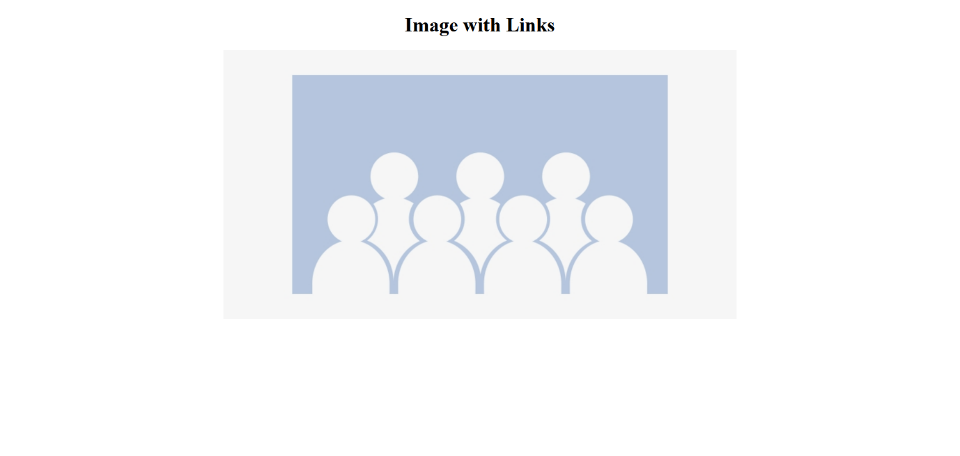

**________________________________________________________**

**Program3.html**

<!DOCTYPE html>

<html>

<head>

   <title>Program3</title>

   <link rel="stylesheet" href="Program3.css">

</head>

<body>

    <div id="heading" class="heading">

        <h1>Ordered List</h1>

        <h2>Five Output Devices</h3>

    </div>

    <div class="main">

        <div class="left">

        </div>

        <div id="list" class="list">

            <ol>

                <li>Visual Display Unit</li>

                <li>Speaker</li>

                <li>Printer</li>

                <li>HeadPhones</li>

                <li>Projector</li>

            </ol>

        </div>

        <div class="right">

        </div>

    </div>

</body>

</html>

**Program3.css**

.heading

{

    margin:auto;

    width:50%;

    text-align: center;

}

.main

{

    display:flex;

}

.left,.right

{

    min-height: 1px;

    width:33%;

}

.list

{

    display:flex;

    flex-flow: column;

    flex :1;

}

**Program 3 Output:**

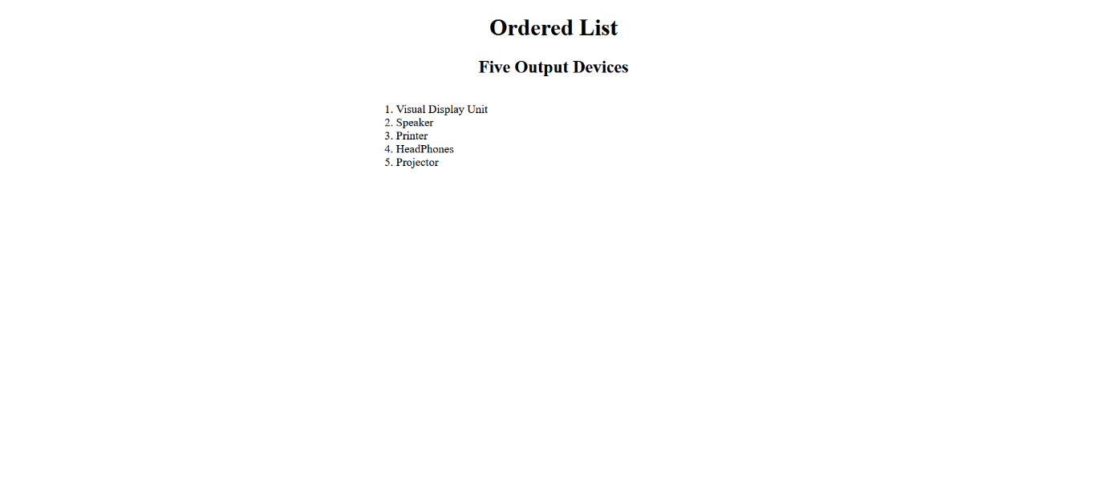

**________________________________________________________**

**Program4.html**

<!DOCTYPE html>

<html>

<head>

   <title>Program1</title>

   <link rel="stylesheet" href="Program4.css">

</head>

<body>

    <div id="heading" class="heading">

        <h1>Ordered List</h1>

        <h2>Five Softwares</h3>

    </div>

    <div class="main">

        <div class="left">

        </div>

        <div id="list" class="list">

            <ol start="3">

                <li>Visual Studio</li>

                <li>Google Chrome</li>

                <li>Firefox</li>

                <li>Visual Studio Code</li>

                <li>Code Blocks</li>

            </ol>

        </div>

        <div class="right">

        </div>

    </div>

</body>

</html>

**Program4.css**

.heading

{

    margin:auto;

    width:50%;

    text-align: center;

}

.main

{

    display:flex;

}

.left,.right

{

    min-height: 1px;

    width:33%;

}

.list

{

    display:flex;

    flex-flow: column;

    flex :1;

}

**Program4 Output:**

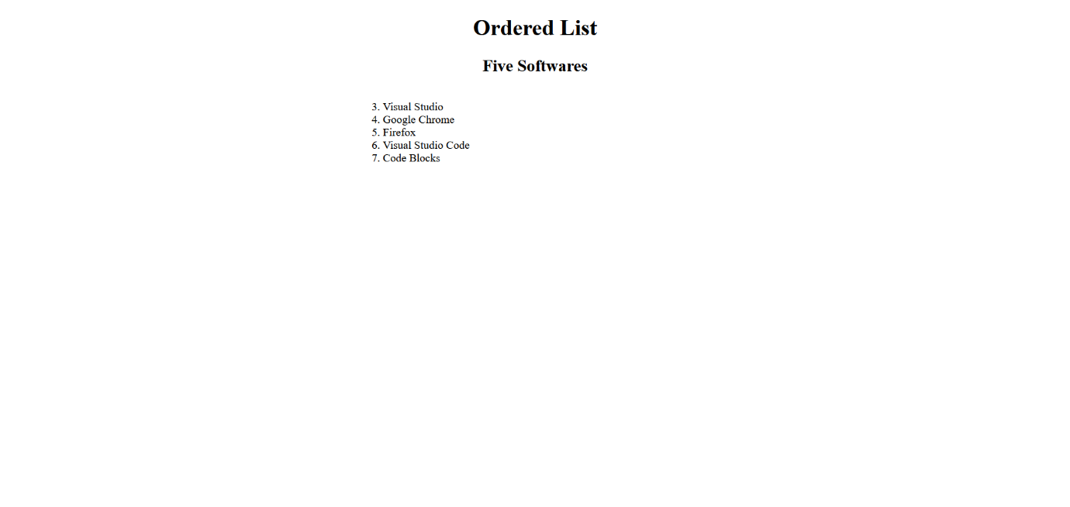

**________________________________________________________**

**Program5.html**

<!DOCTYPE html>

<html>

<head>

    <title>Program5</title>

    <link rel="stylesheet" href="Program5.css">

</head>

<body>

    <div id="heading" class="heading">

        <h1>Restaurant Menu</h1>

        <h2>Change Colour on hover</h3>

    </div>

    <div class="left">

    </div>

    <div class="main">

        <div class="list">

            <div class="item">

            <p>Item1</p>

            </div>

            <div class="item">

            <p>Item2</p>

            </div>

            <div class="item">

            <p>Item3</p>

            </div>

            <div class="item">

            <p>Item4</p>

            </div>

            <div class="item">

            <p>Item5</p>

            </div>

        </div>

    </div>

    <div class="right">

    </div>

</body>

</html>

**Program5.css**

.heading

{

    margin:auto;

    width:50%;

    text-align: center;

}

.main

{

    display:flex;

    flex-flow: row;

}

.left,.right

{

    min-height: 1px;

    width:33%;

}

.list

{

    display:flex;

    flex-flow: column;

    flex :1;

}

.item:hover

{

    background-color:red;

}

.item

{

    padding:10px;

    text-align: center;

    border-color: rgb(216, 29, 176);

}

**Program5 Output:**



