Date-25/03/2021

Abhishek Singh

1NT18IS009

lsb_release -a //finding version

No LSB modules are available.

Distributor ID: Ubuntu

Description: Ubuntu 20.04 LTS

Release: 20.04

Codename: focal

cat .bashrc :- every command first searched in this file

echo $PATH

/usr/local/sbin:/usr/local/bin:/usr/sbin:/usr/bin:/sbin:/bin:/usr/games:/usr/local/games:/snap/bin

sudo vim ~/.bashrc

export MYPATH=/home/abhiasr/Desktop/25march

export PATH=$PATH:$MYPATH

source ~/.bashrc

echo $PATH

/usr/local/sbin:/usr/local/bin:/usr/sbin:/usr/bin:/sbin:/bin:/usr/games:/usr/local/games:/snap/bin:/home/abhiasr/Desktop/25march

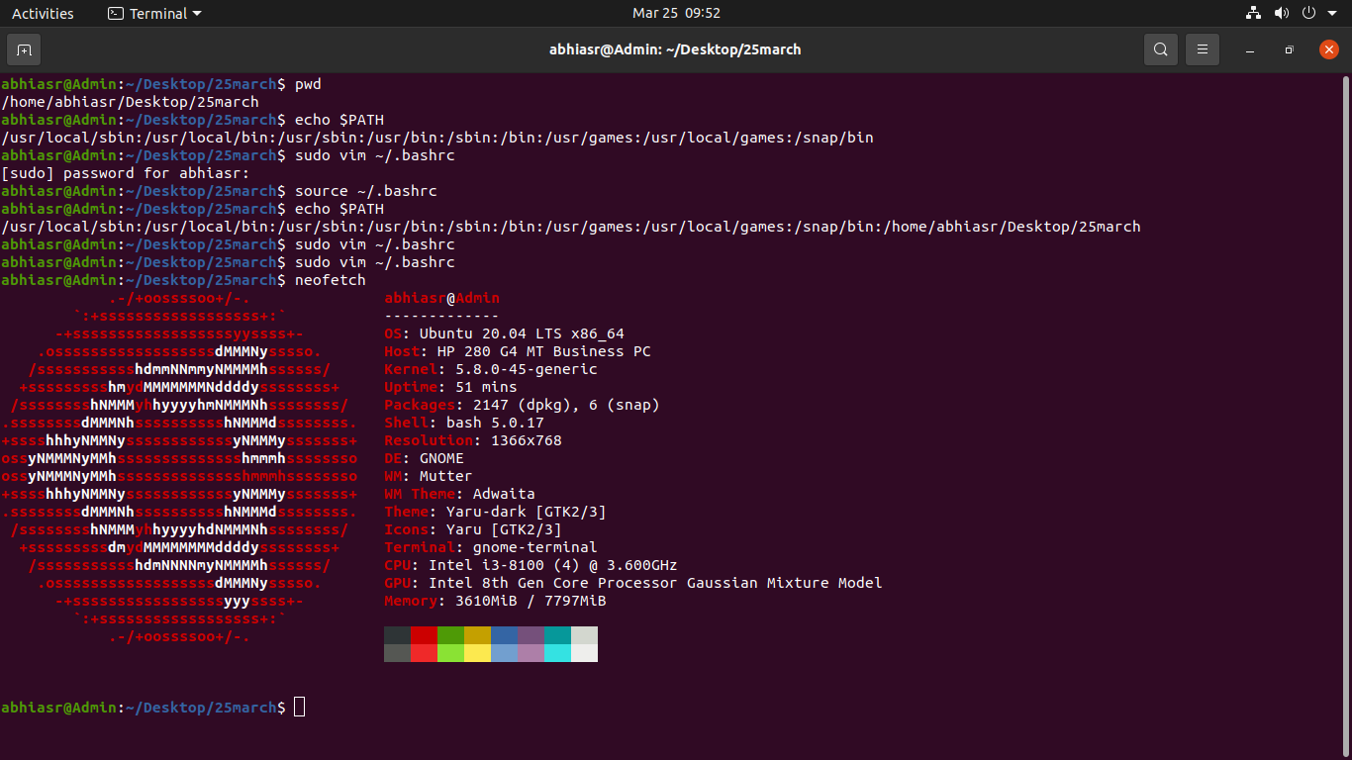

uname -a

Linux Admin 5.8.0-45-generic #51~20.04.1-Ubuntu SMP Tue Feb 23 13:46:31 UTC 2021 x86_64 x86_64 x86_64 GNU/Linux

file file1.c

file1.c: C source, ASCII text

-rw-rw-r-- 1 abhiasr abhiasr 69 Mar 25 09:34 file1.c

sudo chmod u+x file1.c

-rwxrw-r-- 1 abhiasr abhiasr 69 Mar 25 09:34 file1.c

sudo lspci //for knowing hardware specs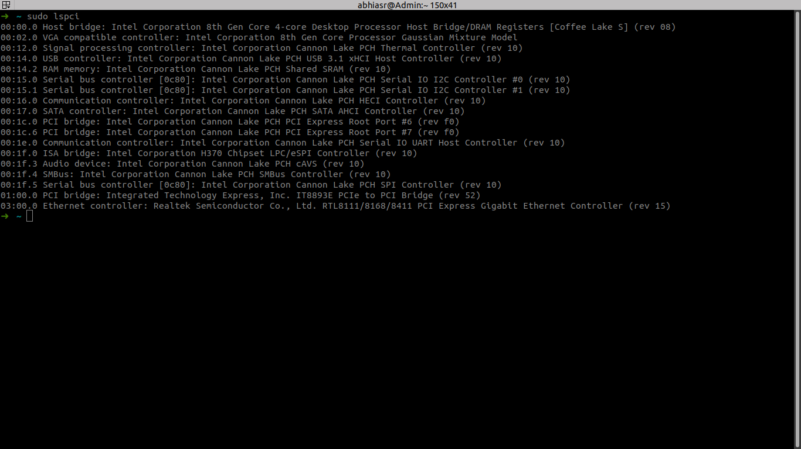

sudo fdisk -l //storage description

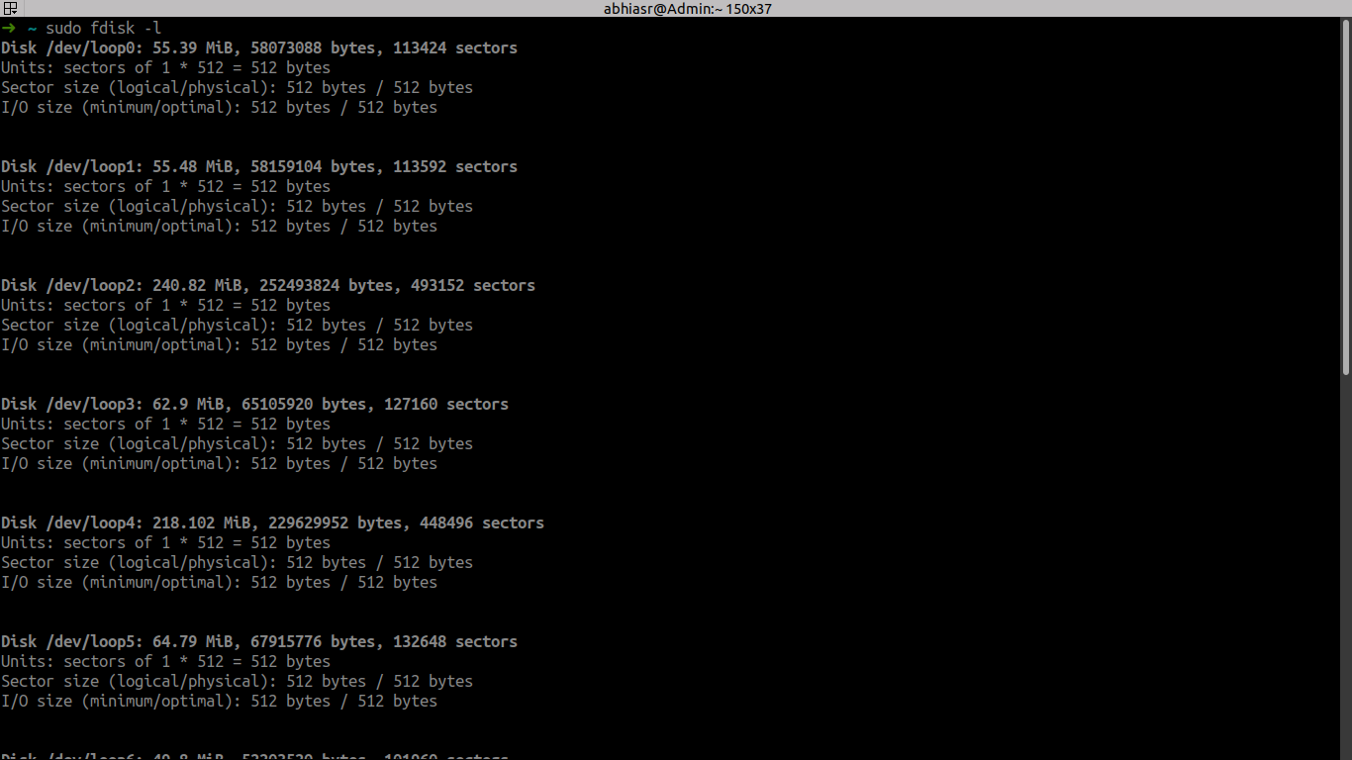

sudo top //linux process

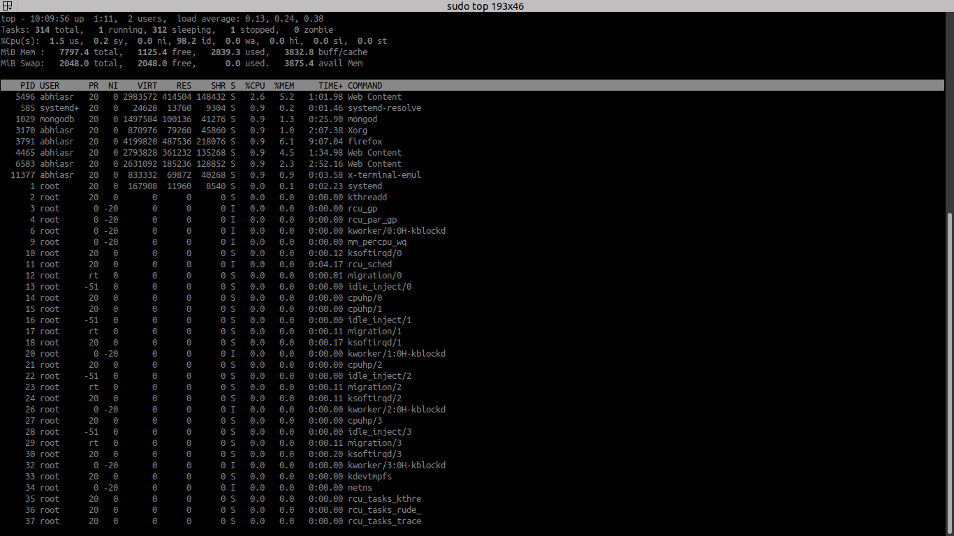

After installing mongo

Type mongo

Show dbs- for klisting database;

Use databasename-to change dbs

> show dbs

14 0.000GB

admin 0.000GB

company 0.000GB

config 0.000GB

empdetails 0.000GB

local 0.000GB

student 0.000GB

test1 0.000GB

> use mydb

switched to db mydb

> db.student.insert(

... {

... name:"asr",

... usn:9,

... age:21

... }

... )

WriteResult({ "nInserted" : 1 })

> db.student.insert( { name:"akhil", usn:14, age:21 } )

WriteResult({ "nInserted" : 1 })

> db.student.find();

{ "_id" : ObjectId("605c1d9738e84a2f4a599e16"), "name" : "asr", "usn" : 9, "age" : 21 }

{ "_id" : ObjectId("605c1da838e84a2f4a599e17"), "name" : "akhil", "usn" : 14, "age" : 21 }

> db.student.find().pretty()

{

"_id" : ObjectId("605c1d9738e84a2f4a599e16"),

"name" : "asr",

"usn" : 9,

"age" : 21

}

{

"_id" : ObjectId("605c1da838e84a2f4a599e17"),

"name" : "akhil",

"usn" : 14,

"age" : 21

}

>

debi //for installing deb file using debi command