Date-1 april 2021

lab2

Load (“path/filename.js”);

Creating collection

db.createCollection("Employee" , {capped:true , size:30000, max:12});

Creating object

db.Employee.insert({

name:{

"firstname":"abhishek",

"middlename":"sam",

"lastname":"anand"

},

age:40,

salary:100000,

designation:"professor",

role:["manager","team lead","ui designer"]

});

For salary >20000

db.Employee.find({salary:{$gt:20000}}).pretty();

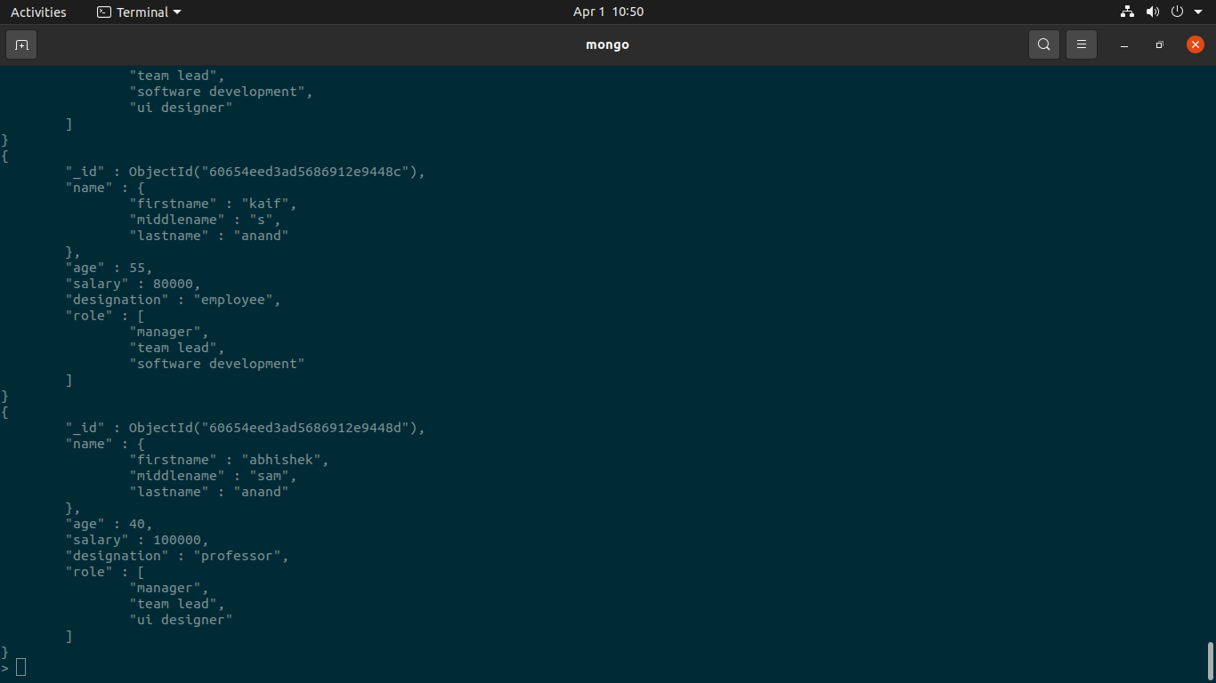

To have middle name as ‘sam’

db.Employee.find({"name.middlename":{$eq:'sam'}}).pretty();

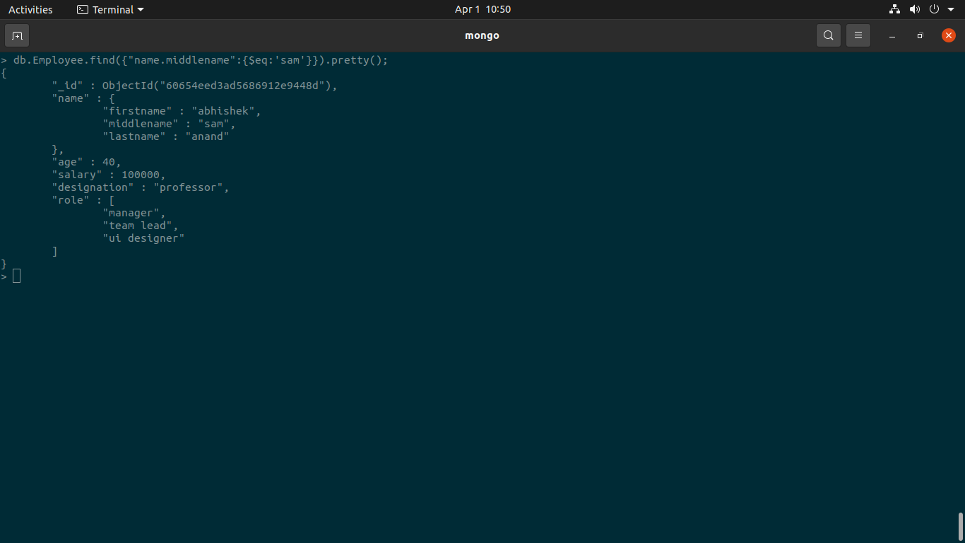

To have age <42

db.Employee.find({age:{$lt:42}}).pretty();

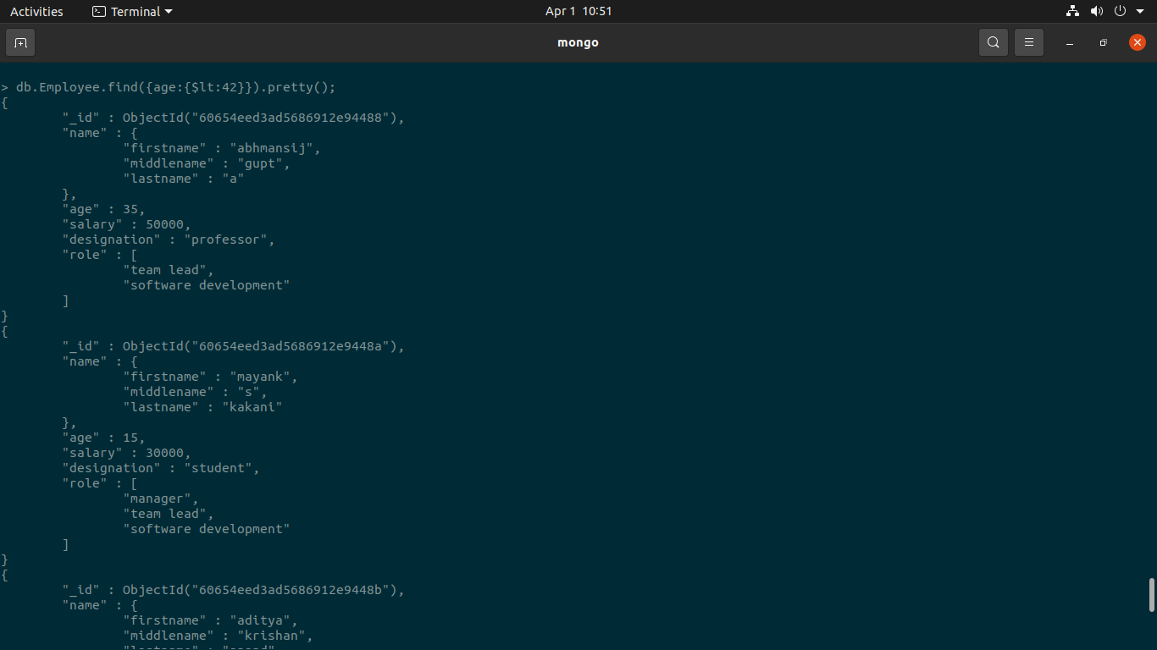

to count the employee having role as manager

db.Employee.find({"role":{$eq:"manager"}}).count();

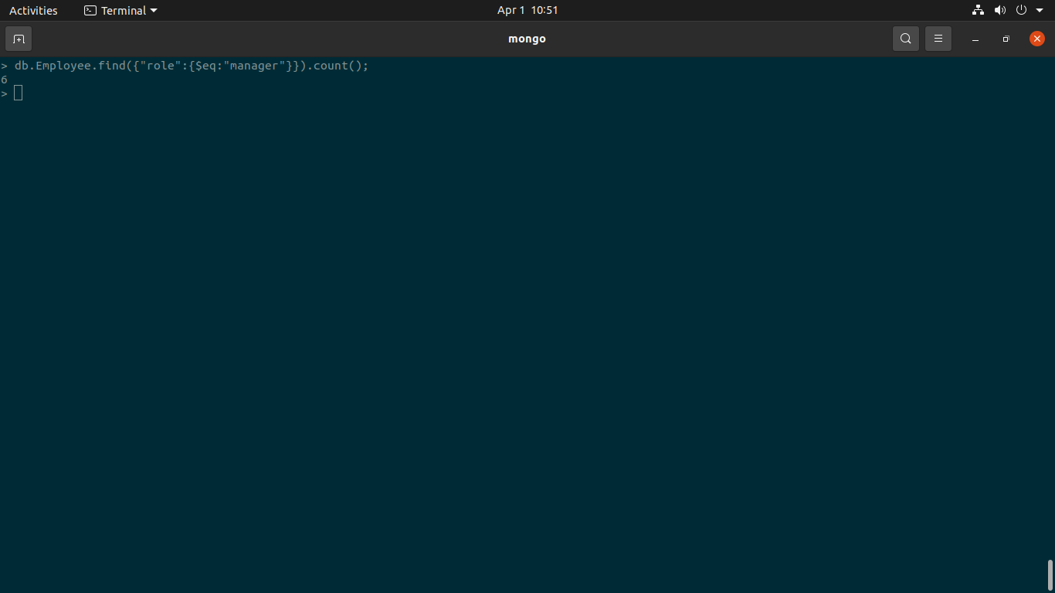

To remove anything from ubuntu

Sudo apt remove mongodb-org

Sudo apt purge mongodb-org

Q.list out all the employee int age group 18 to 34

db.Employee.find({age:{$gt:18,$lt:34}}).pretty();

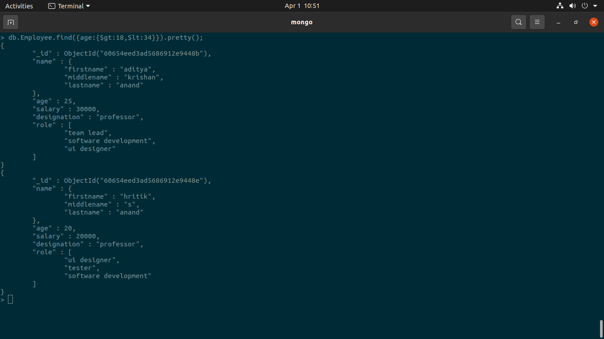

db.Employee.find({age:{$gt:18,$lt:34}}).count();

Qlist out all the employee who is having salary range from 10k to 30k

db.Employee.find({salary:{$gt:10000,$lt:30000}}).pretty();

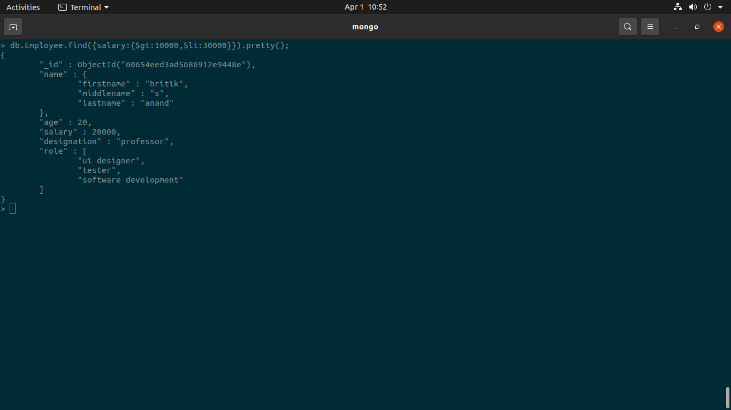

Insertion in different ways’

1. Directly from mongo db

db.collectionname.insert({});

1. From js file Then load it

3 .by making a js variable in mongo shell