**ASSIGNMENT SECTION 3**

ssesh@SSESIGHYB MINGW64 ~/Assignments (master)

$ git branch js-assignments

ssesh@SSESIGHYB MINGW64 ~/Assignments (master)

$ git checkout js-assignments

Switched to branch 'js-assignments'

ssesh@SSESIGHYB MINGW64 ~/Assignments (js-assignments)

$ touch pi.js

ssesh@SSESIGHYB MINGW64 ~/Assignments (js-assignments)

$ touch qi.js

ssesh@SSESIGHYB MINGW64 ~/Assignments (js-assignments)

$ git add README.txt

ssesh@SSESIGHYB MINGW64 ~/Assignments (js-assignments)

$ git commit -m'Readme of js commited'

[js-assignments b76c587] Readme of js commited

1 file changed, 1 insertion(+), 4 deletions(-)

ssesh@SSESIGHYB MINGW64 ~/Assignments (js-assignments)

$ git checkout master

Switched to branch 'master'

ssesh@SSESIGHYB MINGW64 ~/Assignments (master)

$ git add README.txt

ssesh@SSESIGHYB MINGW64 ~/Assignments (master)

$ git commit -m'Readme of master commited'

[master c83030e] Readme of master commited

1 file changed, 2 insertions(+), 2 deletions(-)

ssesh@SSESIGHYB MINGW64 ~/Assignments (master)

$ git checkout js-assignments

Switched to branch 'js-assignments'

ssesh@SSESIGHYB MINGW64 ~/Assignments (js-assignments)

$ git add pi.js

ssesh@SSESIGHYB MINGW64 ~/Assignments (js-assignments)

$ git add qi.js

ssesh@SSESIGHYB MINGW64 ~/Assignments (js-assignments)

$ git commit -m'Js files are committed'

[js-assignments a46eee8] Js files are committed

2 files changed, 0 insertions(+), 0 deletions(-)

create mode 100644 pi.js

create mode 100644 qi.js

ssesh@SSESIGHYB MINGW64 ~/Assignments (js-assignments)

$ git status

On branch js-assignments

Changes not staged for commit:

(use "git add <file>..." to update what will be committed)

(use "git restore <file>..." to discard changes in working directory)

modified: pi.js

modified: qi.js

no changes added to commit (use "git add" and/or "git commit -a")

ssesh@SSESIGHYB MINGW64 ~/Assignments (js-assignments)

$ git add pi.js

ssesh@SSESIGHYB MINGW64 ~/Assignments (js-assignments)

$ git add qi.js

ssesh@SSESIGHYB MINGW64 ~/Assignments (js-assignments)

$ git commit -m'Js files are committed after changes'

[js-assignments 674b282] Js files are committed after changes

2 files changed, 28 insertions(+)

ssesh@SSESIGHYB MINGW64 ~/Assignments (js-assignments)

$ git checkout master

Switched to branch 'master'

ssesh@SSESIGHYB MINGW64 ~/Assignments (master)

$ git status

On branch master

Changes not staged for commit:

(use "git add <file>..." to update what will be committed)

(use "git restore <file>..." to discard changes in working directory)

modified: README.txt

no changes added to commit (use "git add" and/or "git commit -a")

ssesh@SSESIGHYB MINGW64 ~/Assignments (master)

$ git add README.txt

ssesh@SSESIGHYB MINGW64 ~/Assignments (master)

$ git commit -m'README file is commited after 1 st line change'

[master d30c358] README file is commited after 1 st line change

1 file changed, 2 insertions(+), 1 deletion(-)

ssesh@SSESIGHYB MINGW64 ~/Assignments (master)

$ git merge js-assignments

Auto-merging README.txt

CONFLICT (content): Merge conflict in README.txt

Automatic merge failed; fix conflicts and then commit the result.

ssesh@SSESIGHYB MINGW64 ~/Assignments (master|MERGING)

$ vi README.txt

ssesh@SSESIGHYB MINGW64 ~/Assignments (master|MERGING)

$ git status

On branch master

You have unmerged paths.

(fix conflicts and run "git commit")

(use "git merge --abort" to abort the merge)

Changes to be committed:

new file: pi.js

new file: qi.js

Unmerged paths:

(use "git add <file>..." to mark resolution)

both modified: README.txt

ssesh@SSESIGHYB MINGW64 ~/Assignments (master|MERGING)

$ git add README.txt

ssesh@SSESIGHYB MINGW64 ~/Assignments (master|MERGING)

$ git commit -m'README file is commited after resolving conflict'

[master 5687517] README file is commited after resolving conflict

ssesh@SSESIGHYB MINGW64 ~/Assignments (master)

$ git branch -d js-assignments

Deleted branch js-assignments (was 674b282).

**FINAL GIT LOG**

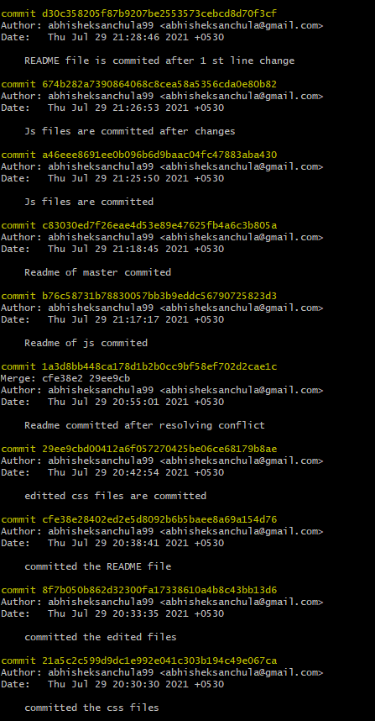

**PUSHING ASSIGNMENT FILES INTO REPOSITORY**

ssesh@SSESIGHYB MINGW64 ~/Assignments (master)

$ git config --global user.username abhisheksanchula99

ssesh@SSESIGHYB MINGW64 ~/Assignments (master)

$ git remote add origin https://github.com/abhisheksanchula99/freshersbatch-oct16.git

ssesh@SSESIGHYB MINGW64 ~/Assignments (master)

$ git push origin master

Enumerating objects: 39, done.

Counting objects: 100% (39/39), done.

Delta compression using up to 8 threads

Compressing objects: 100% (37/37), done.

Writing objects: 100% (39/39), 3.90 KiB | 570.00 KiB/s, done.

Total 39 (delta 18), reused 0 (delta 0), pack-reused 0

remote: Resolving deltas: 100% (18/18), done.

To https://github.com/abhisheksanchula99/freshersbatch-oct16.git

* [new branch] master -> master

