***TITLE:-***

*Design and development of a system for accident prevention and traffic monitoring.*

***PROBLEM:-***

Road accidents have earned India a dubious distinction. With over 130,000 deaths annually, the country has overtaken China and now has the worst road traffic accident rate worldwide. Every hour, 40 people under the age of 25 die in road accidents around the globe. According to the WHO, this is the second most important cause of death for 5 to 29 year olds. Now the major cause of this problem is driver fatigue and carelessness.

So we decided to analyse the trends and found out that the two major places where accidents occur are

1. L-Shaped/T- Shaped or 4 way crossroad track
2. Long haul drives where the driver might fall asleep.

***SOLUTION:-***

1. L-Shaped/T- Shaped or 4 way crossroad track

As we know that the modern era is an *era of smart phones* (Android/Windows). So we propose development of an application (Android mainly due to its wide usage). The app will be mainly used to *return the exact location and the speed* of all these vehicles (let say Vehicle A, Vehicle B, Vehicle C...) to the cloud based *server* that are currently in the 4 way crossroad or the other ends of an L shaped/T shaped road. Upon *analysis of the data trends (mainly the speed difference)* in the server, an *alert message* is sent to those two or more drivers who have a chance of a *possible collision at least 7-10 seconds prior* of a probable chance of a collision. The alert message sent is given out as *voice output* to the driver(s). The analysis in the server will be a continuous process. 

*Fig 1(a)**Vehicle collision on an T-shaped track*

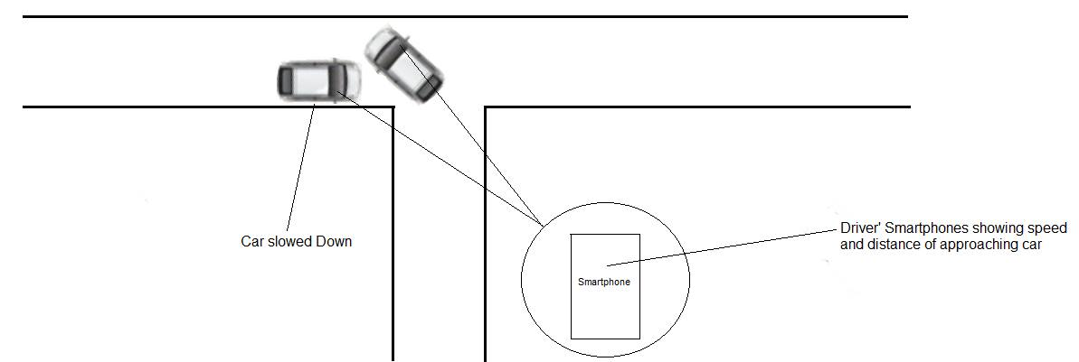

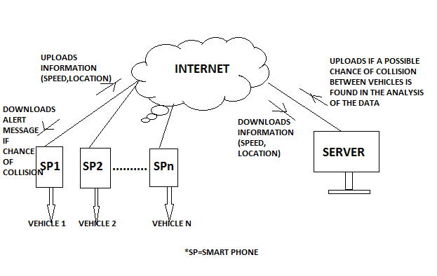*Fig 1(b) Collision of the vehicles is avoided by our proposed model.*

*Fig 1(c) Data flow model for the entire process (between Smart phones and Server)*

1. Long haul drives where the driver might fall asleep

The second concept is based on the fact that driver(s) fall asleep is long haul drives. As we know that in any form of driving, its essential that the drivers *hands are either of the steering or the gear box* and also the fact that the *orientation of the steering periodically* even in long drives. So we have a microcontroller which basically monitors if the driver’s hand is on the *steering or the gear box or both of them*. Also it will monitor if the *driver’s hand orientation* on the steering is fixed for a random *period of 15-20 seconds* while the vehicle is in motion (accelerator is pressed). If found that either of the condition or both the condition is not satisfied then we will raise an alarm warning the driver.

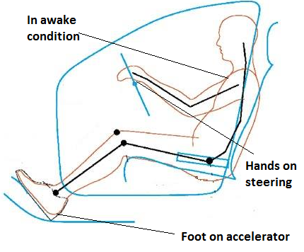 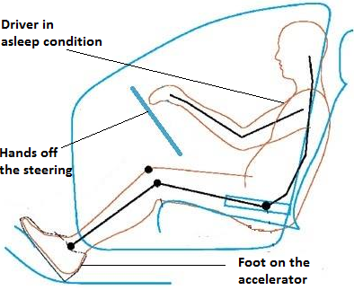

Fig 2(a)*Driver in awake condition* Fig 2(b)*Driver in asleep condition*

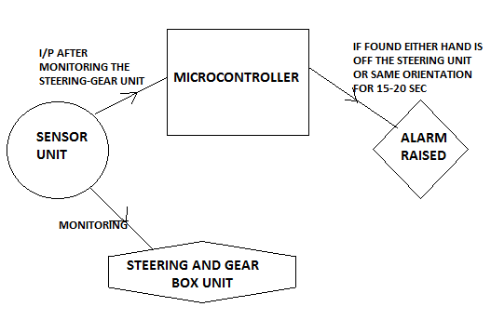

Fig 2(c)*Flow Model of the microcontroller unit*