**Introduction:**

School Record Management System is a customized solution for a school handling regular management work. By going through the flow of application one can easily maintain its student detail, subject detail and Exam with Marks detail. This software can be expanded to include the management of students, Employee, Accounts, Transportation, library, Fees, Exam, Time Table, Inventory and its respective reports with administrative module to provide better security. User-friendly menus can easily generate all the reports. School Management System opens a universe of opportunities to automate the laborious paperwork involved in proper school management. With our proposed record-keeping software the management can more effectively interact with the students as they develop skills and character for success. They will not only have more time to spend with them, but it will be quality time because they will have up-to-date student information to facilitate them.

**Objective**

The School Record Management System is designed to achieve the following objectives:

* The software must have a user-friendly interface and appealing appearance to ease the work of the end users.
* The software must be able to return the actual monetary status of the school, i.e., it must be able to say how much money has been collected in the account of fees and how much is yet to be received from the students.
* Student evaluation by their Instructors and Teacher’s evaluation by the students is kept by most of the schools to keep monitoring the students’ behaviour and teachers’ performance respectively. This facility must be incorporated in the new system.
* The electronic processing of all examination related activities is also required to be achieved by the system.
* The system should be error resistant and must operate reliably.
* Security is another feature which must be designed in the system in such a way that any unauthorised access to the system is denied and a log of such activity generated.

**Purpose and Scope**

Purpose

**Student management system** would have the following goals.

* Provide a web user interface to add, view, delete records in different areas.
* Provide a user interface to enter computer details.
* Provide a user interface to change details of all the computers and accessories.
* Provide a user interface for users to explore the store and choose items to buy.

Scope

The main scope and deliverables of the project would be to:

* Understand and prepare detailed requirement and specifications
* Prepare high level and detailed design specifications of the system
* Prepare Test Plan and Test cases
* Develop the system and coding
* Perform unit testing, integration and system testing
* Demonstrate a bug free application after suitable modification if needed.

Achievements

* By successfully implementing the project, a substantial knowledge has been acquired on the implementation of a database system using .net technologies. This knowledge will be useful in the future in creating any type of desktop application or online database systems.

**TOOLS USED**

In an application like Student Record Management System, there is a scope for a large number of platforms, languages and frameworks to choose from. Before selecting from this large array of technologies, the following aspects, which are characteristic to windows based application like this one, have been kept in mind:

* Data validation
* Performance
* Reliability
* Scalability
* Security
* Portability
* Performance
* Time constraint
* Cost constraint

The various technologies available for consideration are as follows:

**Operating System: Windows 7**

**Client Side Scripting:**

* **HTML**
* **CSS**
* **JavaScript**

**Server Side Scripting: PHP**

**Database Tool: My SQL**

**Testing Server: Apache**

**Other Software Used:**

* + - * **Adobe Dreamweaver**
      * **Adobe Photoshop**
      * **Xampp Server**

**Problem Definition**

**Problem Definition and Need for the New System**

The appearance of your student records says a lot about the quality of your school. Other educators and registrars make judgments based on student records that can permanently affect a student's life. SMS capabilities include the basics such as transcripts, report cards, attendance, and discipline as well as many other specialized capabilities, including parental access to real time student grades on the Internet. This means that not only administrators but also parents, teachers, and students have access to real-time data. With traditional reporting methods parents may not find out how their student is performing in school until the end of the quarter or semester -- usually too late to correct a problem situation. SMS allows parents to know how their student is doing on a continual basis by using the internet. SMS can even send electronic progress reports to parents via email on a weekly, monthly, or even daily basis.

You operate a quality program—NOW you can be sure your records communicate that quality. Here realizes the need for an effective school management system and that is exactly what we are striving for!

The School Management System (SMS) will replace the paper-based data collection and information exchange system among the various departments of a particular school. The School Management System provides an innovative solution for Today’s school record-keeping challenges. This school management software will give you room to handle your responsibilities whether you’re just starting or are an experienced professional.

**SYSTEM REQUIREMENTS SPECIFICATIONS**

System requirements are expressed in a software requirement document. The Software requirement specification (SRS) is the official statement of what is required of the system developers. This requirement document includes the requirements definition and the requirement specification. The software requirement document is not a design document. It should set out what the system should do without specifying how it should be done. The requirement set out in this document is complete and consistent.

The software specification document satisfies the following:-

* It specifies the external system behaviours.
* It specifies constraints on the implementation.
* It is easy to change.
* It serves as reference tool for system maintainers.
* It record forethought about the life cycle of the system.
* It characterizes acceptable response to undesired events.

**ER Diagram**

student

subject

marks

gets

has

**ER Diagram**

**Data Flow Diagram**

access

store

Get Records

Students and

marks

admin

database

**0 Level DFD**

get marks

View marks

login

Marks entry

access

store

Get subject

Sub code and name

access

store

access

store

View Records

Student details

student

admin

subject

marks

student

**Level 1 DFD**

**Database Design**

**Student Table**

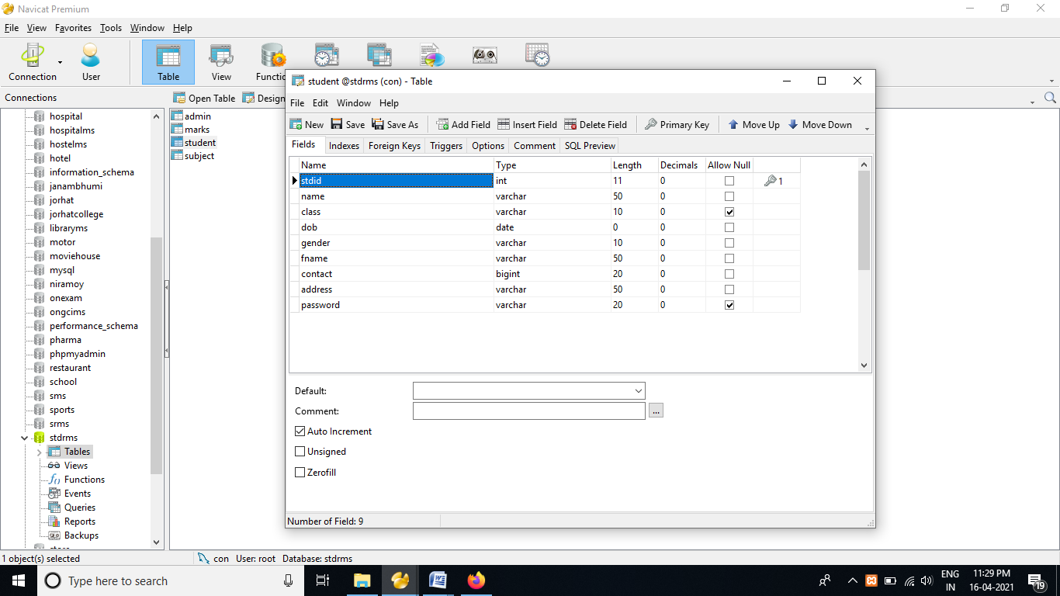

**Subject Table**

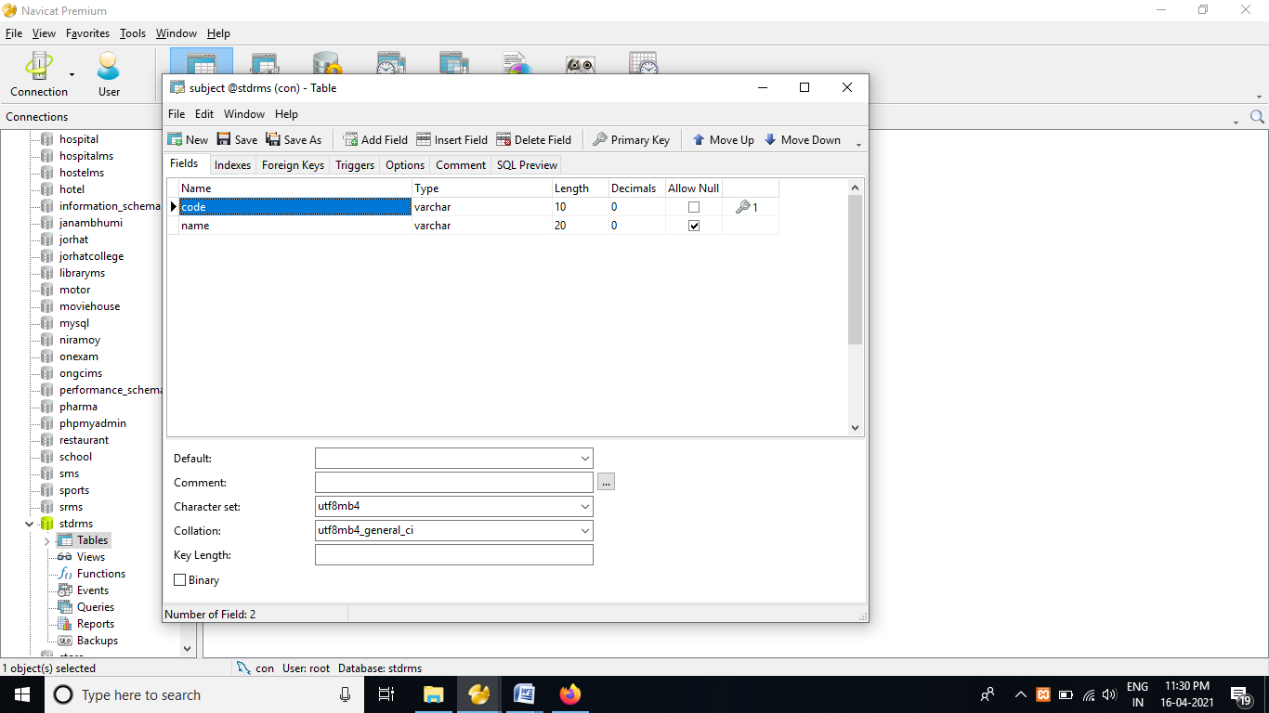

**Marks Table**

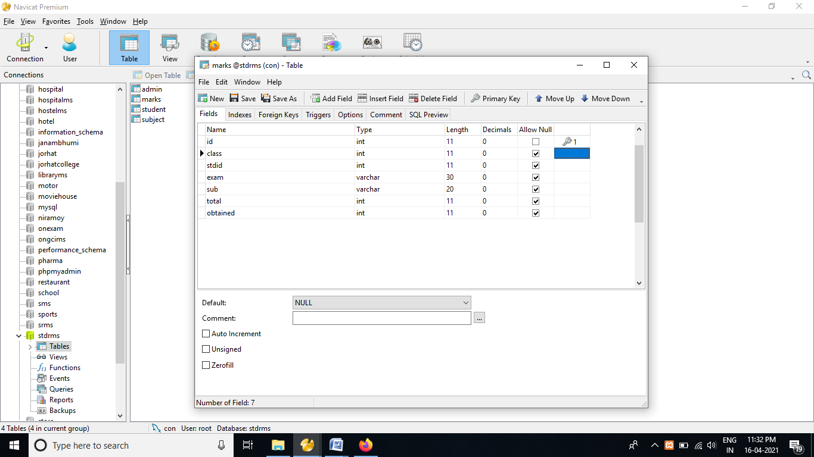

**Screenshot and Coding**

Login Page

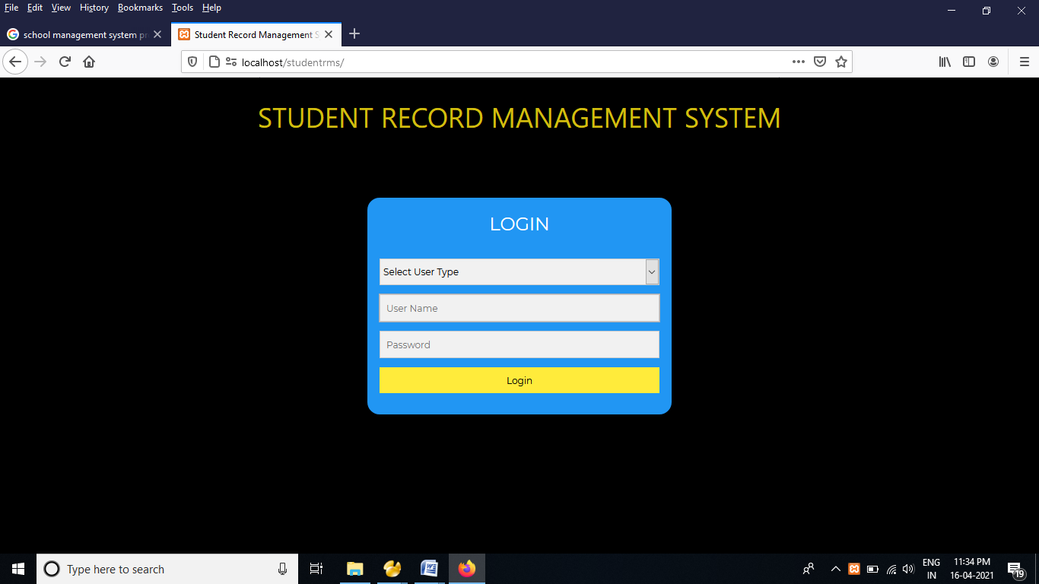

Admin Home Page

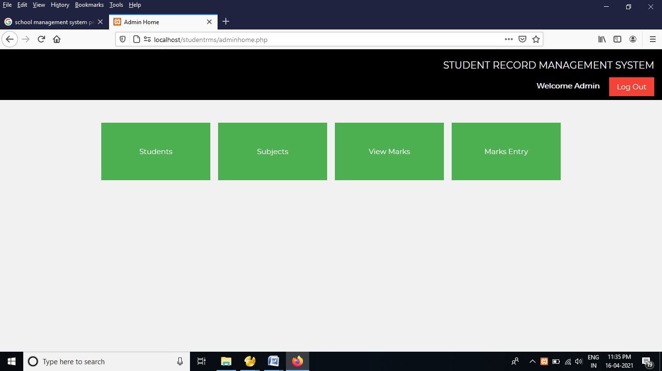

Student Details

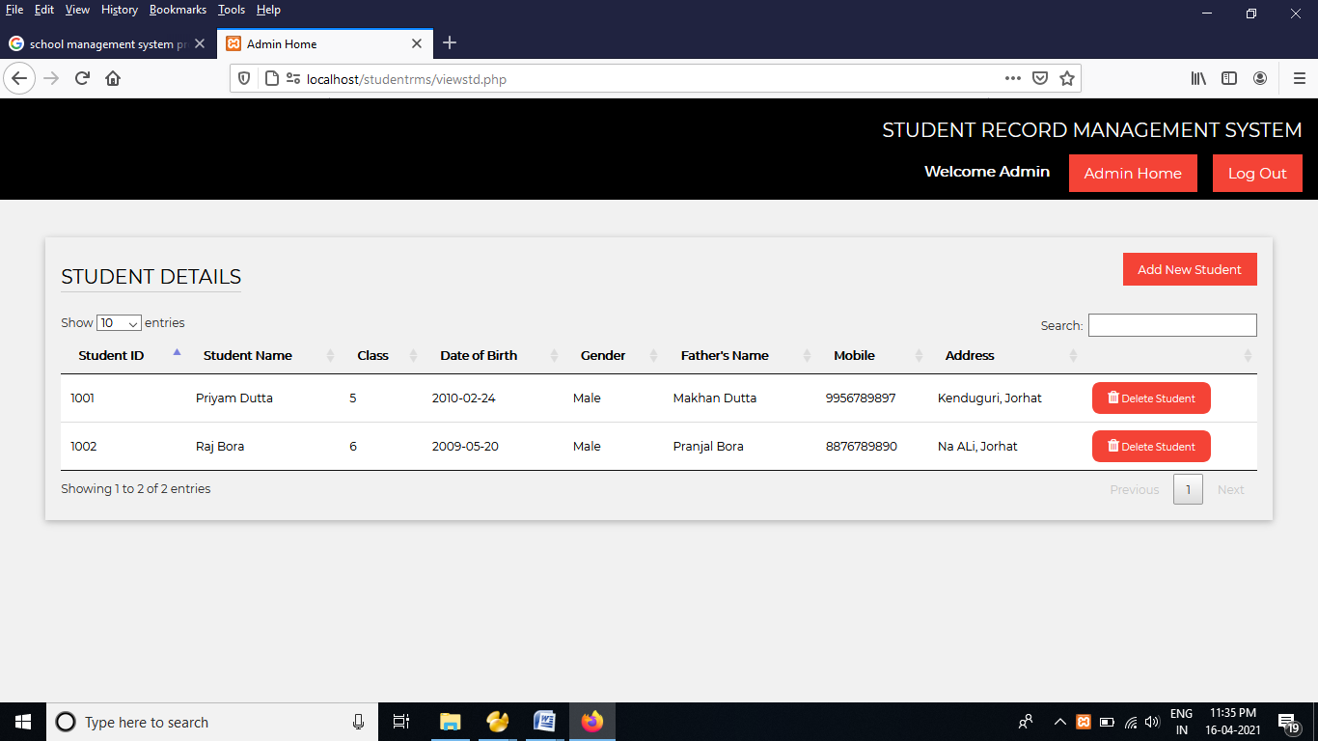

Marks Entry

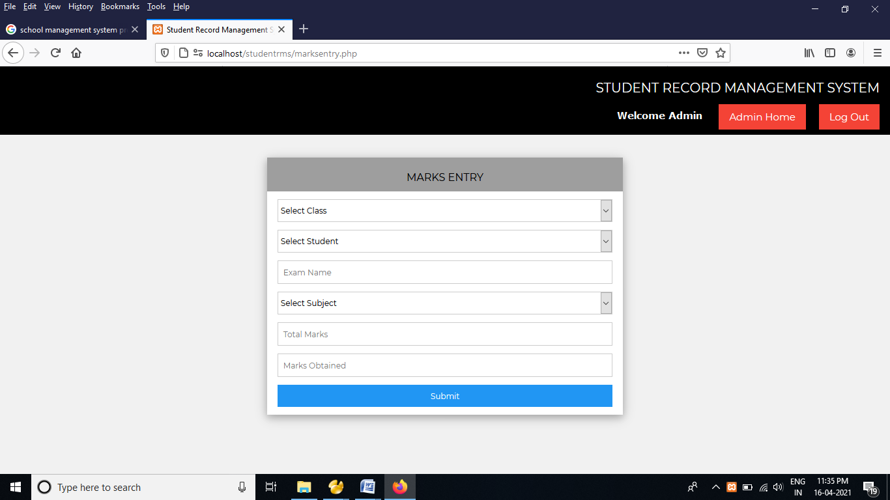 **Documentation**

* + **For Management**

Student Record Management System is primarily designed for providing information from the data after processing them. This system is designed for supplying information to the strategic level of management from the operational control. It includes almost all the functional areas needed like keeping Employee Records Student Records and Fees Records.

* + **For User**

With this electronic data processing system, the operators will able to maintain the following task:

* + - Information regarding Students.
    - Records of Students with their details.
    - Subject and Marks Details
  + **For data processing department**
* In maintenance, the data processing department needs to create backup of the database file from time to time.
* The main menu of the system provides different menus for different purposes.

**FUTURE APPLICATION**

Software development is never –ending process and continues the life of the software as per the changing needs of the user from time to time. The project is no doubt has been developed keeping in mind easy modification and enhancement that may be required from time to time.

However, there are many scopes to modify this software. As because due to shortage of time, we here become unable to include many things. We are trying to cover all their existing system for sales return records of the items but due to shortage of time we become unable to include many things. Due to lake of time I here include none of them and a future scope one can develop these returns which are so much essential. Only with a little more doing it is possible to design the formats for those returns. Moreover, an on-line system will be more helpful to the organization. . With almost the same data with only a little modification an on-line system can be designed to fulfill their demands. All these can be considered to be future scope for this project.

**CONCLUSION**

After implementing the application it will contain the advantages were incomparable to the present contemporary systems used by company. The most admirable feature founded was its simplicity in terms of application to the user but its highly beneficial outputs can’t be ignored. The users will be highly benefited after using the system.

It is hoped that this project will help the future developers to modify and implement the system. After modifying some techniques of the programs, it will give us the best performance as our requirements. The project will be very useful for the users.