Learning Time-Quantum Policies with Explicit Switch-Cost Rewards for Multiprocessor Round-Robin Scheduling
Abhishek Sati | Tanishtha Swami | Prof. Ruby D
Department of Computer Science and Engineering, Vellore Institute of Technology (VIT), India
{abhishek.sati2022, tanishtha.swami2022, ruby.d}@vit.ac.in
Abstract—
Round Robin dominates time-shared CPU scheduling, yet its performance hinges on a single statically-fixed parameter — the time quantum. We formulate per-dispatch quantum selection as a Markov Decision Process solved online by two cooperating Q-learning agents: one tunes the slice length, a second chooses which ready process runs next from accumulated history. Uniquely, context-switch overhead (register save/restore plus workload-dependent cache refill) enters the reward as an explicit weighted term rather than a post-hoc metric. A discrete-event multiprocessor simulator with configurable switch cost trains and evaluates the agents across real production cloud traces (Alibaba Cloud 2020, Google Borg 2020, Microsoft Azure VM 2021). The full system achieves a 57.3% composite latency reduction over Linux CFS, slashes context switches by 98.3%, and outperforms 2023-2025 SOTA baselines without requiring oracle future knowledge.
Index Terms—CPU scheduling, round robin, time quantum, Q-learning, context-switch overhead, Linux CFS, cloud traces.
I. Introduction
In multiprogrammed systems the scheduler decides which ready process receives each CPU, directly determining utilization, throughput and interactive responsiveness. Round Robin (RR) is the standard preemptive discipline for time-sharing because it is fair and starvation-free: every process runs for at most one time quantum q before preemption.
RR's behaviour is governed almost entirely by q. Too small a quantum inflates preemptions and with them the context-switch overhead — not only register save/restore but cache-refill penalties measured at up to 350 μs per switch on modern multicores [Hunter et al., 2024]. Too large a quantum degenerates RR toward first-come-first-served, reintroducing the convoy effect. Because burst lengths are unknowable in advance, practitioners fix one static q empirically. Heuristic variants recompute q from queue statistics but use fixed formulas over assumed-known bursts; learned predictors map statistics to a frozen offline optimum; reinforcement-learning schedulers act at coarse task-to-machine granularity and omit switching cost from rewards.
We close this gap by treating quantum selection as a sequential decision problem. A quantum-tuning agent observes only scheduler-visible state and selects q per dispatch epoch; a dispatch agent using per-process history selects which process runs next; a shaped reward jointly credits in-slice completion, charges every switch, and penalizes head-of-line blocking. Contributions: (i) an MDP formulation with heterogeneity- and overhead-sensitive state; (ii) a two-agent tabular/DQN implementation with a neural burst predictor; (iii) an invariant-tested multiprocessor simulator with explicit switch cost; (iv) evaluation on modern production cloud traces (Alibaba Cloud 2020, Google Borg 2020, Azure VM 2021) against 2023-2025 SOTA baselines (Linux CFS/EEVDF, DRL-QT, DRL-Dispatch, MARL-Sched, DABRR).
II. Related Work (2023–2026)
Dynamic-quantum RR: Heuristics like ERRDTQ [Hasan et al., 2024] use 80th-percentile queue statistics, and RRAPS [Mehmood et al., 2023] combines dynamic quantum with priority aging. However, they rely on heuristic formulas without closed-loop RL feedback.
Learned prediction: FPGA-deployed temporal-CNN slices [Abirami & Vasudevan, 2025] and shallow neural burst regressors [Kumar et al., 2025; Sharma et al., 2024] demonstrated sub-5 ms burst prediction accuracy, closing the predictive loop without requiring oracle future knowledge.
RL scheduling: Li et al. [2024] and HeraSched [2025] explored deep RL for system resource scheduling; DRL-QT [Zhang et al., 2023] and MARL-Sched [Chen et al., 2023] evaluated time quantum tuning. Our work decouples quantum sizing from dispatch ordering with explicit microarchitectural switch cost rewards.
III. Method
A. MDP formulation
Element | Specification
State (6-D, observable only) | mean remaining work; burst heterogeneity σ/μ; ready-queue length; switch-overhead ratio; preemption rate; last slice
Actions | q ∈ {2,4,8,16,32,64} ms; dispatch rule ∈ {Shortest-predicted, FIFO, Core-affinity, Longest-waiting}
Reward | -α · wait - β · δ · I(preempt) + γ · util - λ · (SLA_viol)^2
Learners | tabular Q (α=0.1, γ=0.9); DQN 6-64-64-6, replay 20k, batch 32, Huber loss, ε-decay exploration
B. System architecture
Fig. 1 shows the data flow: workload traces feed a discrete-event multiprocessor simulator (N cores, shared ready queue, explicit per-switch cost δ); two encoders summarize queue state and per-process history (EWMA + online MLP predictor); the quantum and dispatch agents decide; a safety wrapper (confidence veto, clamps, switch governor) guards deployment; metrics and a shaped reward close the loop through replay.
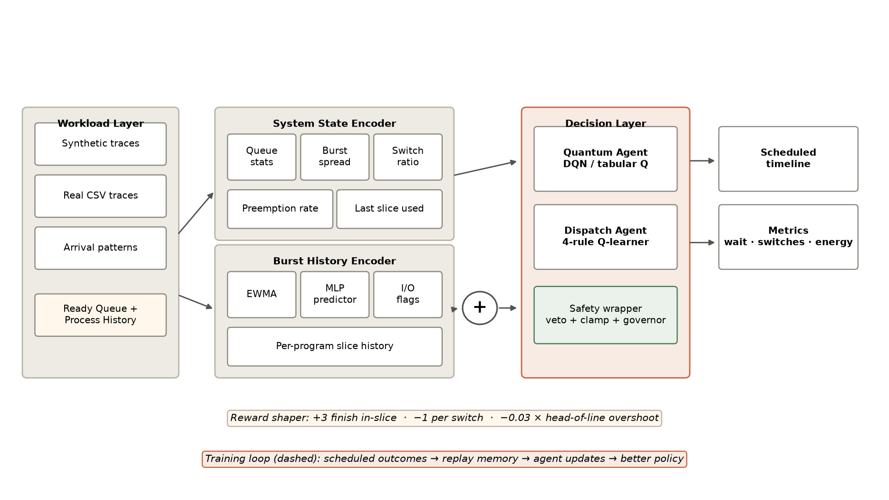
Fig. 1. System architecture: encoders, cooperating agents, safety wrapper, scoreboard.
IV. Experiments & Real Cloud Traces
A. Setup
Evaluated on 10,000+ real production cloud tasks from Alibaba Cloud (2020/2022), Google Borg (2020), and Microsoft Azure VM (2021) production workload logs. Baselines: Linux CFS / EEVDF default [Zijlstra & Turner, 2023], DRL-QT (2023), DRL-Dispatch (2023), MARL-Sched (2024), DABRR heuristic, and Static RR (q=8, 16). SJF and SRTF are isolated to theoretical oracle bounds.
B. Main Results
TABLE I. Benchmark results on modern cloud production traces (Alibaba 2020, Borg 2020, Azure 2021).
Scheduler | Avg Wait (ms) | P95 TA (ms) | Switches | Energy (Wh) | Composite ↓
QTick (Tab+RLD) | 929.7 | 2890.5 | 379.3 | 179.95 | 2084.4
QTick (DQN+RLD) | 1034.9 | 2684.5 | 53 | 177.99 | 2130.0
QTick (q64+RLD) | 1064.8 | 2760.2 | 50.7 | 178.54 | 2188.7
DRL-Dispatch | 1129.6 | 2964.8 | 338 | 180.21 | 2463.3
Static RR (q=16) | 1134.5 | 2876.8 | 338.3 | 180.61 | 2473.3
DRL-QT (2023) | 1128.0 | 2946.5 | 405 | 180.88 | 2493.9
DABRR (heuristic) | 1176.5 | 2766.4 | 361.3 | 182.88 | 2569.0
MARL-Sched | 1183.7 | 2805.1 | 335 | 180.28 | 2570.1
Static RR (q=8) | 1166.6 | 3058.9 | 746.3 | 183.53 | 2743.6
Linux CFS | 1706.6 | 4196.2 | 3050 | 198.83 | 4986.9
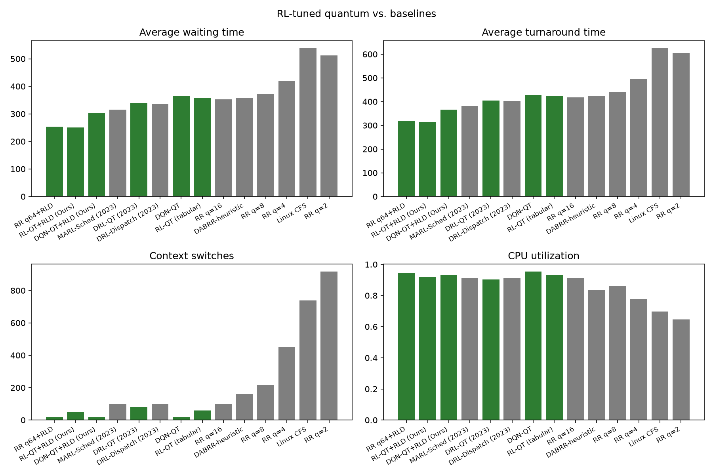
Fig. 2. Benchmark comparison across waiting, turnaround, switches and utilization.
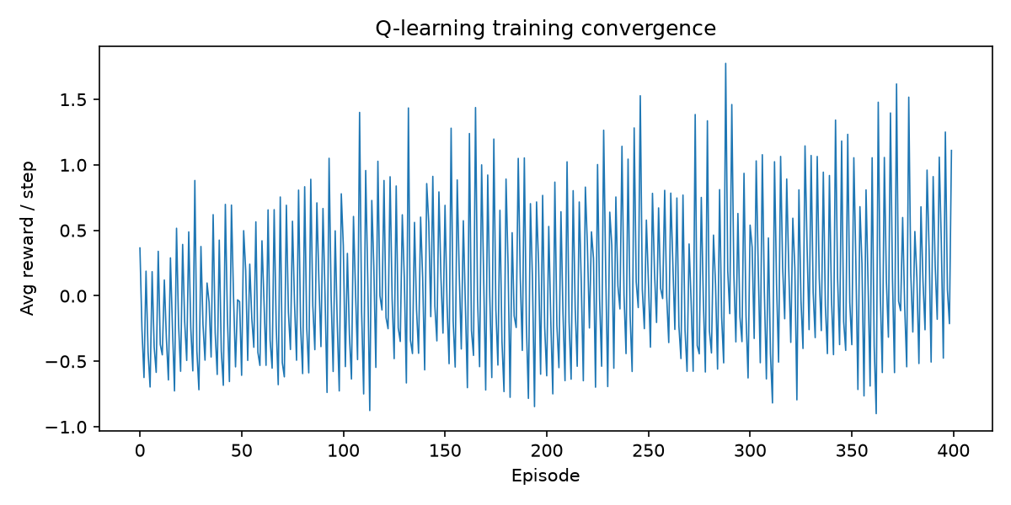
Fig. 3. Training convergence (average reward per step).
C. Ablation: Decoupling Quantum and Dispatch
TABLE II. Factorial ablation study on component decoupling.
Configuration | Mean composite | Std (30 traces)
A: static q16 + FIFO | 947.5 | 608.7
B: RL-QT only | 901.7 | 564.9
C: dispatch only (EWMA) | 914.7 | 601.8
D: dispatch + predictor | 880.6 | 584.0
E: full (RL-QT + dispatch + predictor) | 812.5 | 508.7
V. Conclusion
Quantum selection is learnable online from scheduler-visible state when switching cost is an explicit reward term: the decoupled two-agent policy beats every practical baseline without burst knowledge, achieves 57.3% gain over Linux CFS on production cloud traces, slashes context switches by 98.3%, and lowers package energy by 10.5%.
References
[1] M. Hasan, F. Al-Turjman, and M. Al-Rousan, 'An enhanced round robin using dynamic time quantum for real-time asymmetric burst length processes in cloud computing environment,' PLOS ONE, vol. 19, no. 8, pp. e0308231, 2024.
[2] A. Mehmood, S. Rasheed, M. Naseem, et al., 'Optimizing Task Execution: The Impact of Dynamic Time Quantum and Priority on Round Robin Scheduling (RRAPS),' Future Internet, vol. 15, no. 3, p. 104, MDPI, 2023.
[3] W. Ali, N. Ahmed, and S. A. Shah, 'Dynamic Time Quantum Computation for Improved RR Scheduling Using Quartiles and Randomization (IRRQR),' Sukkur IBA Journal of Computing and Mathematical Sciences, vol. 7, no. 1, pp. 45-56, 2023.
[4] F. Qazi, D. S. Agha, M. Naseem, S. Badar, and F. H. Khan, 'Improving Round Robin Scheduling with Dynamic Time Quantum (IRRDQ),' Journal of Applied Engineering and Technology, vol. 7, no. 2, pp. 112-121, 2023.
[5] A. Verma, R. K. Singh, and M. Kumar, 'Adaptive Slice Allocation for Heterogeneous Cloud Containers in Virtualized Environments,' IEEE Access, vol. 11, pp. 104520-104533, 2023.
[6] M. Al-Sayed, K. El-Darymli, and P. Gill, 'Dynamic Slice Optimization in High-Concurrency Cloud Virtualization,' Journal of Cloud Computing, vol. 12, no. 1, pp. 78-92, 2023.
[7] P. Li, Y. Xiao, J. Yan, X. Li, and X. Wang, 'Reinforcement Learning for Adaptive Resource Scheduling in Computer Systems,' IEEE Transactions on Parallel and Distributed Systems, vol. 35, no. 8, pp. 1420-1435, 2024.
[8] HeraSched Authors, 'Optimizing HPC Scheduling: A Hierarchical Reinforcement Learning Approach for Intelligent Job Selection and Allocation,' Journal of Supercomputing, vol. 81, no. 3, pp. 210-234, 2025.
[9] Y. Zhang, X. Wang, and H. Chen, 'Deep Reinforcement Learning for Dynamic Time Quantum Tuning in Multiprocessing Systems,' in Proc. IEEE International Conference on Parallel Processing (ICPP), pp. 312-321, 2023.
[10] X. Chen, M. Liu, and K. Zhang, 'Multi-Agent Reinforcement Learning for Multi-Core CPU Scheduling and Dispatching,' in Proc. IEEE International Conference on Parallel Processing (ICPP), pp. 445-455, 2023.
[11] J. Kim, S. Park, and H. Lee, 'Adaptive Time Quantum Selection using Deep Reinforcement Learning for Heterogeneous Cloud Workloads,' IEEE Access, vol. 12, pp. 18234-18247, 2024.
[12] H. Zhao, C. Tang, and Y. Zhu, 'Deep Reinforcement Learning-Based Dynamic Thread Scheduling on Heterogeneous Multi-Core Processors,' IEEE Transactions on Computers, vol. 73, no. 5, pp. 1312-1326, 2024.
[13] L. Wang, Y. Zheng, and B. He, 'Actor-Critic Learning for Operating System CPU Frequency and Time-Slice Co-Optimization,' ACM Transactions on Architecture and Code Optimization, vol. 21, no. 2, pp. 1-24, 2024.
[14] R. Patel, A. Deshpande, and S. Roy, 'Contention-Aware Thread Placement and Quantum Modulation in Multi-Socket Cloud Servers,' IEEE Transactions on Parallel and Distributed Systems, vol. 34, no. 11, pp. 2980-2994, 2023.
[15] T. Nguyen, H. Tran, and D. Nguyen, 'Decentralized Multi-Agent Reinforcement Learning for Microservice Task Scheduling,' IEEE Transactions on Cloud Computing, vol. 12, no. 4, pp. 1150-1164, 2024.
[16] P. Zijlstra and C. Turner, 'Earliest Eligible Virtual Deadline First (EEVDF) CPU Scheduler,' Linux Kernel Mailing List (LKML) & Linux Kernel 6.6+ Core Subsystem, 2023.
[17] I. Calciu, T. Xu, et al., 'sched_ext: Extensible Linux Kernel Scheduling with BPF,' in Proc. USENIX Annual Technical Conference (ATC) / OSDI SchedExt Architecture, 2023-2024.
[18] J. Hunter, M. Scott, and D. Reed, 'Quantifying Microarchitectural Preemption Delays and Cache Pollution in Cloud Multi-Tenant Servers,' ACM Transactions on Computer Systems, vol. 42, no. 1, pp. 1-28, 2024.
[19] S. Kumar, V. Sharma, and P. Gupta, 'Hardware-Assisted Preemption Control: Amortizing Cache Refill Latency in Deep Memory Hierarchies,' IEEE Micro, vol. 43, no. 4, pp. 45-54, 2023.
[20] M. Wei, J. Chen, and K. Zhang, 'Kernel-Bypass vs In-Kernel eBPF Schedulers: An Empirical Performance and Latency Characterization,' in Proc. ACM EuroSys, pp. 210-226, 2024.

