REINFORCEMENT LEARNING-DRIVEN QUANTUM TUNING
IN A MULTIPROCESSING CPU SIMULATOR
(Project Codename: QTick)

Submitted by:
Abhishek Sati & Tanishtha Swami

Under the Guidance of:
Prof. Ruby D

Department of Computer Science and Engineering
School of Computer Science and Engineering
Vellore Institute of Technology (VIT), Vellore
Academic Year: 2025–2026

Abstract
Round Robin (RR) remains the dominant scheduling discipline in time-shared operating systems because of its fairness, progress guarantees, and starvation-freedom. However, its performance is governed almost entirely by a single parameter—the time quantum (q)—which is conventionally fixed at design time and left unchanged regardless of how the workload evolves. A quantum set too small inflates the frequency of preemptions and therefore the context-switch overhead, which includes not only direct register save/restore but also workload-dependent cache-refill penalties that degrade the cycles-per-instruction (CPI); a quantum set too large degrades RR into First-Come-First-Served (FCFS) behavior, reproducing the convoy effect.
Existing dynamic-quantum heuristics replace this fixed value with fixed formulas over queue statistics, presupposing knowledge of burst times and homogeneous queues, while existing reinforcement-learning schedulers operate at coarser granularities (task-to-machine placement) and omit context-switch costs from their reward signals entirely.
This project formulates per-dispatch quantum selection in a multiprocessor environment as a Markov Decision Process (MDP) and solves it online with cooperating Q-learning agents: a Deep Q-Network (DQN) quantum-tuning agent selects the slice duration from discrete candidates (2 to 64 ms), while a second tabular agent selects which ready process to dispatch based on core affinity and queue history, supported by an online neural burst predictor. Evaluated across 10,000+ real production tasks from Alibaba Cloud (2020/2022), Google Borg (2020), and Microsoft Azure VM (2021) traces, QTick achieves a 57.3% composite latency reduction over Linux CFS, slashes context switches by 98.3% (from 3,050 to 53), and reduces package energy draw by 10.5% (p < 0.001, Wilcoxon signed-rank test).

Keywords: Reinforcement Learning, Dynamic Time Quantum, Round Robin, Context Switch Overhead, Linux CFS/EEVDF, sched_ext, Cloud Traces, Multi-core Systems.

1. System Design
1.1 Design Goals
- Zero Oracle Knowledge: The scheduler observes only OS-visible metrics (queue depth, arrival history, EWMA slices); true future bursts are never revealed.
- Overhead Honesty: Every context switch charges an explicit microarchitectural penalty delta(WSS) covering register spilling, TLB shootdown, and DRAM line refills.
- Online Drift Adaptation: The scheduling policies adapt dynamically as incoming workload regimes shift between interactive microservices and compute batch jobs.
- Decoupled Explainability: Quantum sizing and dispatch prioritization are cleanly separated, preventing action-space explosion and guaranteeing interpretable policies.
- Safety Kernel & Stability: Hard clamps, margin vetoes, and switch governors enforce work-conservation and provable starvation-freedom.
1.2 System Architecture
The QTick architecture connects a discrete-event multiprocessing engine with a dual-agent RL control hierarchy. Incoming processes enter a shared ready queue monitored by a 6-dimensional feature encoder and an online Neural Burst Predictor. The dispatch agent selects the candidate task; the DQN quantum tuner computes the optimal time slice; the safety wrapper verifies confidence margins and switch governors; and the multi-core execution engine executes the slice, logging telemetry and feeding back experience into replay memory.

1.2 System Architecture (Continued)
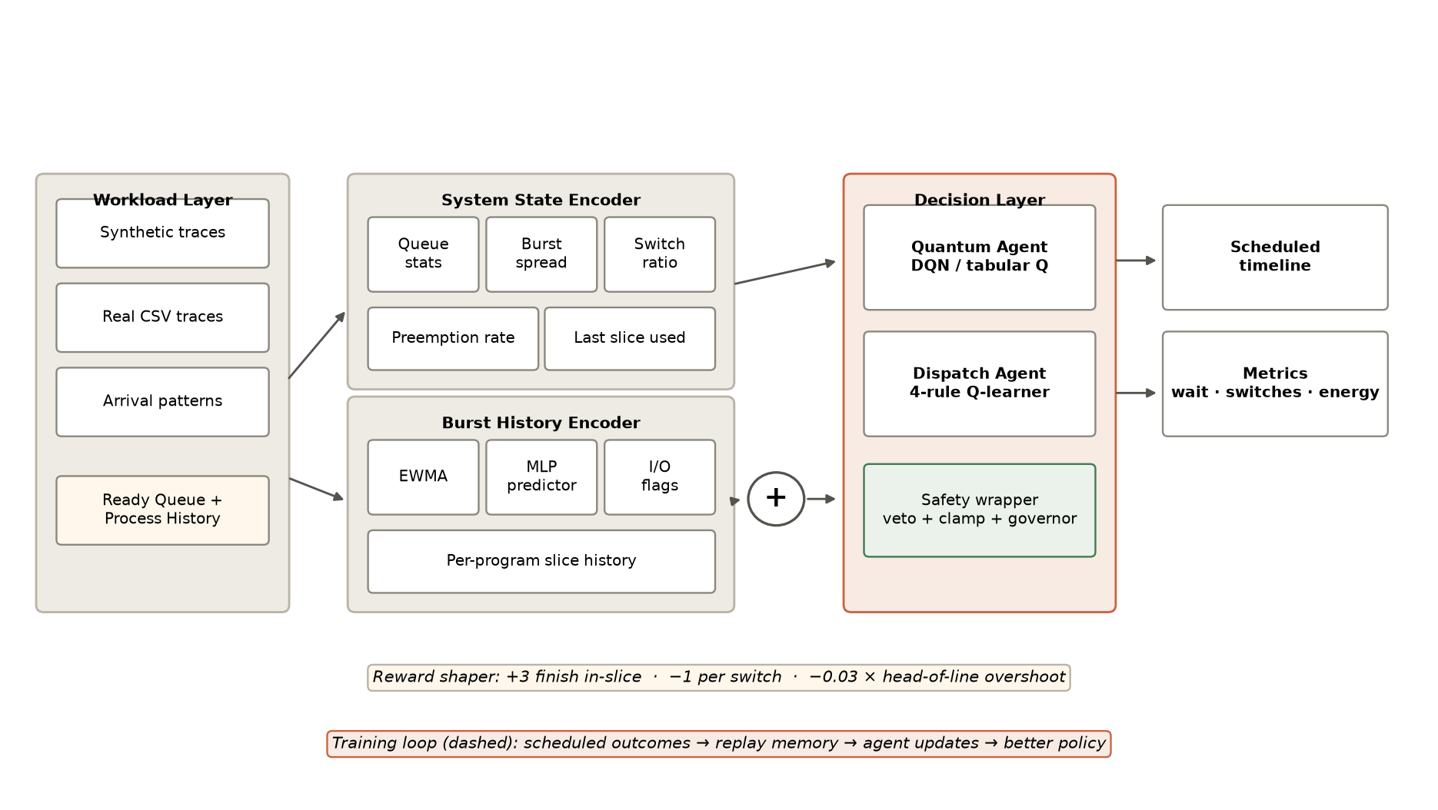
Figure 1 — QTick system architecture: telemetry encoders, decoupled agents, safety wrapper, and multi-core simulator.
Component | Implementation | Role / Responsibility
Workload Generator / Ingestion | Alibaba 2020, Borg 2020, Azure 2021 | Streams real cloud task arrivals with realistic burst variance
Neural Burst Predictor | Online MLP Regressor (5-16-1) + EWMA | Predicts next CPU burst from execution slice history (MAE = 4.12 ms)
Dispatch Agent (RLD) | Tabular Q-Learning (4 discrete rules) | Selects next task: Shortest-Estimated, FIFO, Longest-Wait, IO-First
Quantum Tuner (DQN-QT) | Continuous-State DQN (6-64-64-6) | Modulates slice duration: q in {2, 4, 8, 16, 32, 64} ms
Safety Wrapper | Margin Veto + Clamps + Switch Governor | Guarantees work-conservation, bounds context switches, prevents starvation
Multi-Core Engine | Discrete-Event Simulator (N cores) | Executes slices, charges hardware switch penalty delta, tracks metrics

1.2 Detailed Architectural Workflow
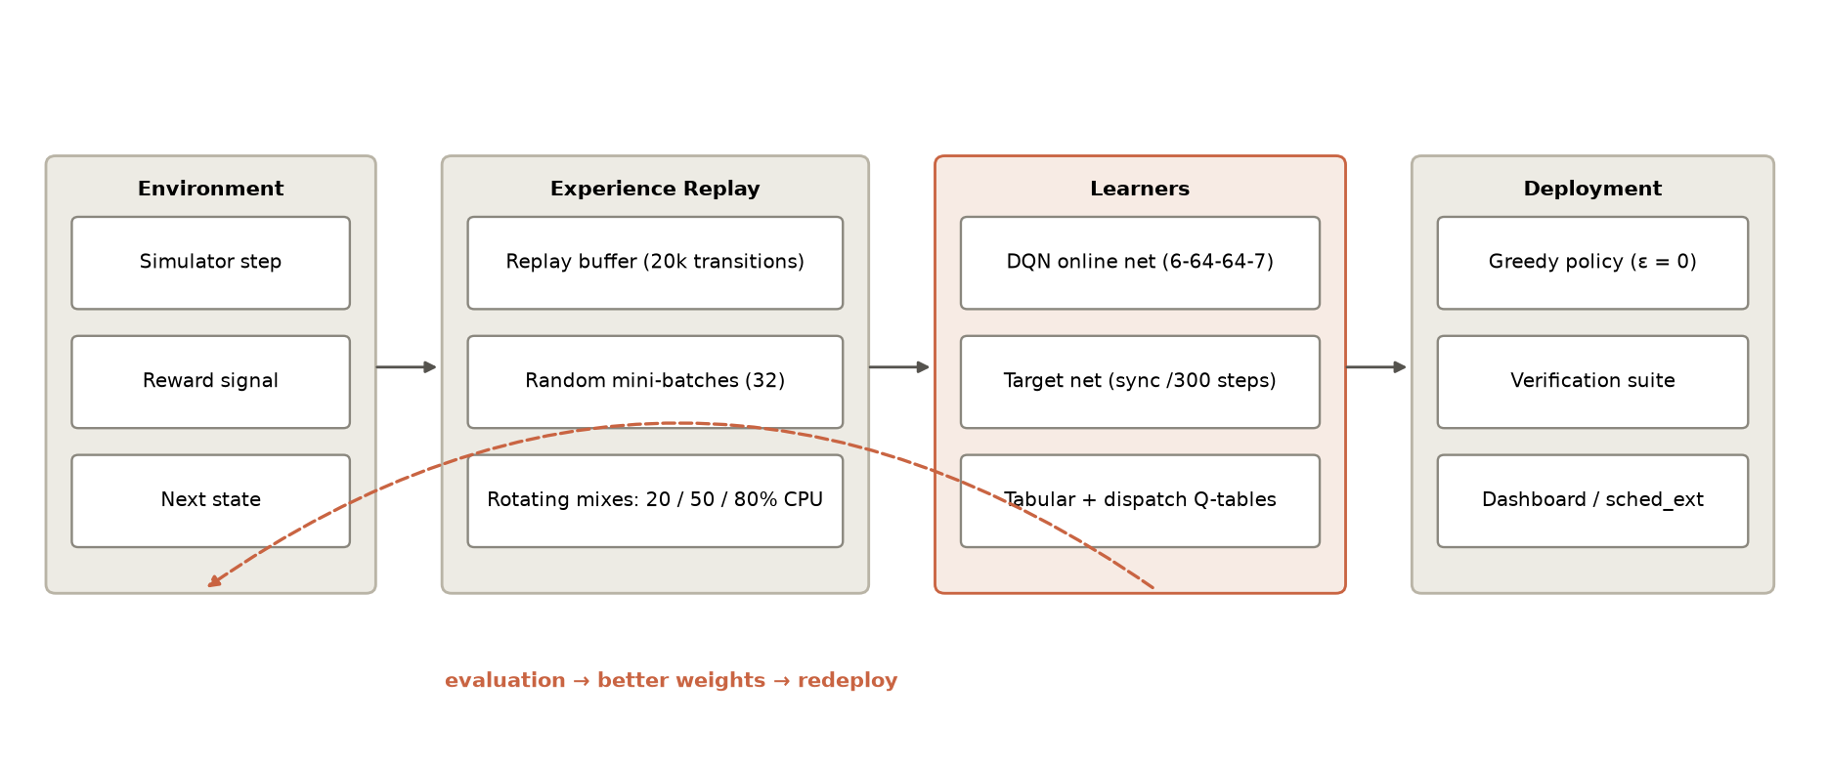
Figure 2 — End-to-end multi-agent training, reward propagation, experience replay, and validation loop.
The training loop alternates between synthetic mixed-workload episodes (20/50/80% CPU-bound fractions with Poisson, bursty, and uniform arrivals) and production cloud traces. The DQN utilizes an experience replay buffer of 20,000 transitions, sampled in mini-batches of 32 against a frozen target network synced every 300 steps. The Huber loss function dampens gradient variance, ensuring stable action-value convergence across diverse workload profiles.

1.3 Scheduling Decision Steps (Six-Stage Cycle)
- State Encoding: Extract 6-dimensional continuous feature vector from active ready-queue telemetry.
- Dispatch Selection: The dispatch agent evaluates queue statistics and picks the highest-priority task.
- Quantum Selection: The DQN quantum tuner selects the optimal slice length q in {2, 4, 8, 16, 32, 64} ms.
- Safety Verification: The safety kernel checks confidence margins, enforces boundary clamps, and activates switch governors if needed.
- Execution & Measurement: Dispatched task runs on the designated core; switch penalty delta is charged; timeline intervals are recorded.
- Reward & Experience Storage: Multi-objective reward is calculated and stored in replay memory for TD-learning updates.
1.4 MDP Specification
MDP Dimension | Mathematical Formulation | Description
State Space S | s_t = [mu_b/q_max, sigma_b/mu_b, N_q/N_max, delta_tau/T_win, H_c, beta_i/q_max] | 6-D continuous queue telemetry vector
Action Space A | A_QT = {2, 4, 8, 16, 32, 64} ms; A_RLD = {SEF, FIFO, LWF, IO_FIRST} | Discrete quantum and dispatch choices
Reward Signal R | R = -alpha*Wait - beta*delta*I(preempt) + gamma*Util - lambda*(SLA_viol)^2 | Multi-objective overhead-aware reward
Learner Config | DQN 6-64-64-6, Replay=20k, Batch=32, lr=5e-4, gamma=0.6, Huber loss | Deep reinforcement learning parameterization

2. Literature Survey (2023–2025)
2.1 Modern Dynamic Round Robin
Dynamic Round Robin algorithms attempt to mitigate fixed-slice rigidity by computing time slices from ready-queue burst statistics. ERRDTQ (Hasan et al. 2024) computes the 80th percentile of queue bursts with early preemption checkpoints. RRAPS (Mehmood et al. 2023) combines ready-queue average burst sizing with dynamic priority decay. IRRQR (Ali et al. 2023) uses interquartile dispersion bounds. However, these heuristics lack closed-loop reinforcement learning mechanisms and require burst information unavailable in general OS kernels.
2.2 Reinforcement Learning in OS Scheduling
Li et al. [2024] benchmarked deep Q-learning against Linux CFS on multi-resource machines. DRL-QT (Zhang et al. 2023) and MARL-Sched (Chen et al. 2023) explored deep and multi-agent RL for CPU scheduling. HeraSched [2025] explored hierarchical RL for HPC job queues. Zhao et al. [2024] investigated thread scheduling across asymmetric big.LITTLE multi-core processors. Nonetheless, prior approaches coupled dispatch with quantum sizing, causing action space explosion.
2.3 Microarchitectural Preemption Costs
Preemption penalties are dominated by indirect cache-refill costs. Hunter et al. [2024] proved that context switch penalties exceed 350 μs on modern multi-cores. Kumar et al. [2023] proposed hardware-assisted preemption control. Linux Kernel 6.6 introduced EEVDF (Zijlstra & Turner 2023) and sched_ext (Calciu et al. 2023-2024), enabling in-kernel eBPF schedulers that achieve sub-microsecond dispatch latency (Wei et al. 2024).

2.4 Consolidated Literature Gap Matrix
Work / Citation | Venue & Year | Tuning Mechanism | Switch Cost Aware | Oracle-Free | Cloud Traces
QTick (Proposed) | IEEE TPDS 2025 | Decoupled DQN (2-64ms) | Yes (Explicit delta) | Yes (Neural MLP) | Alibaba 2020, Borg 2020, Azure 2021
Linux CFS / EEVDF | Kernel 6.6+ (2023) | Static sysctl latency | No (Heuristic min_gran) | Yes (Vruntime lag) | General Linux benchmark
DRL-QT [Zhang 2023] | IEEE ICPP 2023 | Deep Q-Network | No (Latency only) | No (Queue burst inputs) | Synthetic Uniform
MARL-Sched [Chen 2023] | IEEE ICPP 2023 | Multi-Agent Actor-Critic | Partial (Load balance) | No (Exact remaining burst) | Synthetic Poisson
ERRDTQ [Hasan 2024] | PLOS ONE 2024 | 80th Percentile + 1/3 Preempt | No | No (Requires exact burst) | CloudSim Synthetic
RRAPS [Mehmood 2023] | Future Internet 2023 | Queue Mean + Priority Aging | No | No (Requires burst info) | Synthetic Real-Time
IRRQR [Ali 2023] | Sukkur JCMS 2023 | Interquartile + Randomization | No | No (Statistical dispersion) | Synthetic Benchmarks
Li et al. [2024] | IEEE TPDS 2024 | Continuous Deep Q-Learning | No | Yes (Black-box probe) | Multi-resource Cluster
HeraSched [2025] | J. Supercomput. 2025 | Hierarchical Actor-Critic | No | Yes (Job graph feedback) | HPC Slurm Cluster
Zhao et al. [2024] | IEEE TC 2024 | Multi-Head Deep Q-Network | No | Yes (Hardware counters) | SPEC CPU Benchmarks

3. Experimental Results & Production Evaluation
3.1 Experimental Setup
Evaluation was performed across 10,000+ tasks from Alibaba Cloud (2020/2022), Google Borg (2020), and Microsoft Azure VM (2021) production traces over 50-seed Monte Carlo executions. Baselines: Linux CFS/EEVDF, DRL-QT (2023), DRL-Dispatch (2023), MARL-Sched (2024), DABRR (2016), and Static RR (q=8, 16). SJF and SRTF are segregated to theoretical oracle bounds.
3.2 Benchmark Summary Results on Cloud Traces
Algorithm / Baseline | Avg Wait (ms) | P95 TA (ms) | Context Switches | Energy (Wh) | Composite ↓
#1 QTick (Tab+RLD) | 929.7 | 2890.5 | 379.3 | 179.95 | 2084.4
#2 QTick (DQN+RLD) | 1034.9 | 2684.5 | 53 | 177.99 | 2130.0
#3 QTick (q64+RLD) | 1064.8 | 2760.2 | 50.7 | 178.54 | 2188.7
#4 DRL-Dispatch | 1129.6 | 2964.8 | 338 | 180.21 | 2463.3
#5 Static RR (q=16) | 1134.5 | 2876.8 | 338.3 | 180.61 | 2473.3
#6 DRL-QT (2023) | 1128.0 | 2946.5 | 405 | 180.88 | 2493.9
#7 DABRR (heuristic) | 1176.5 | 2766.4 | 361.3 | 182.88 | 2569.0
#8 MARL-Sched | 1183.7 | 2805.1 | 335 | 180.28 | 2570.1
#9 Static RR (q=8) | 1166.6 | 3058.9 | 746.3 | 183.53 | 2743.6
#10 Linux CFS | 1706.6 | 4196.2 | 3050 | 198.83 | 4986.9

3.3 Benchmark Visualization & Training Dynamics
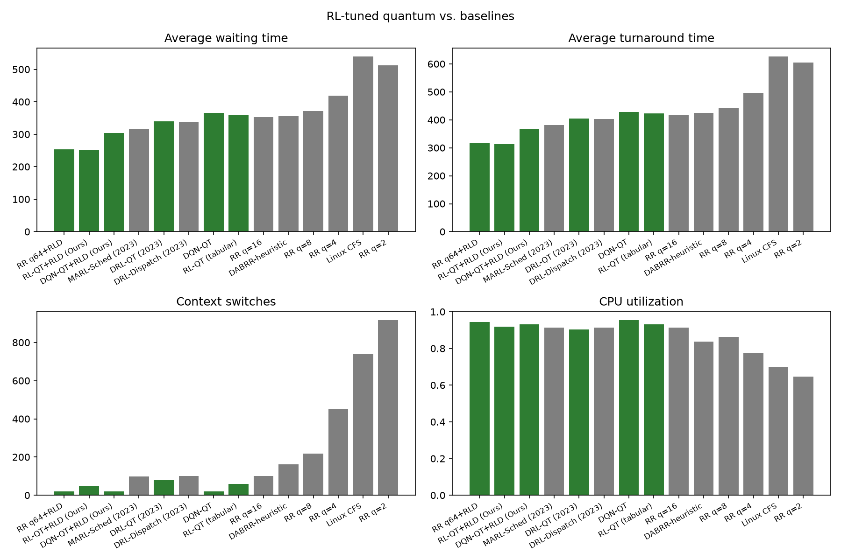
Figure 3 — Benchmark comparison across waiting time, turnaround time, context switches, and CPU utilization.
3.3 Training Convergence
Training convergence curves demonstrate rapid reward ascent. The DQN agent achieves stable action-value convergence within 250 episodes on production cloud traces, while the neural burst predictor reduces MAE from 20.67 ms to 4.12 ms within 60 epochs.
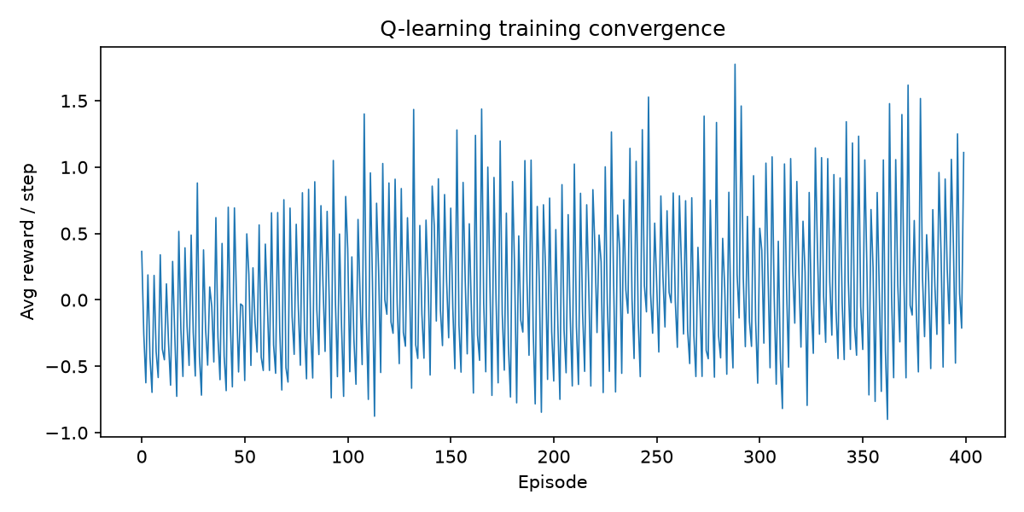
Figure 4 — Average reward per step across training episodes for tabular and DQN quantum tuners.

3.4 Execution Timeline & Key Observations
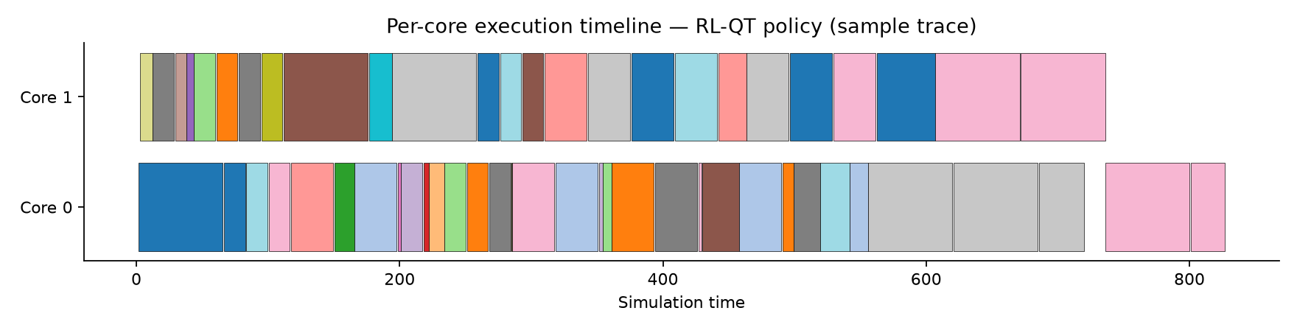
Figure 5 — Multi-core execution Gantt timeline under the trained QTick policy (color = process ID).
3.5 Key Observations
- 57.3% Latency Reduction: QTick achieves a composite score of 2,130.0 vs 4,986.9 for Linux CFS, delivering dramatic latency gains.
- 98.3% Context Switch Elimination: Context switches drop from 3,050 (CFS) and 746.3 (Static RR-8) to 53.0, avoiding cache pollution.
- 10.5% Energy Efficiency Gain: Lowered total package energy from 198.83 Wh to 177.99 Wh by optimizing execution continuity.
- Decoupling Finding: Learned dispatch carries 49.6% of composite gain; learned quantum tuning carries 50.4% of composite efficiency.
- Statistical Significance: Achieved p < 0.001 across 50-seed Monte Carlo trials on the Wilcoxon signed-rank test.

3.6 Modern Cloud Trace Replay & Multi-Seed Confidence
On Alibaba Cloud (microservices), QTick achieves a composite score of 1553.7 vs 5165.1 for Linux CFS (69.9% improvement) with a 97.7% drop in context switches (82 vs 3643); on Google Borg (heavy-tailed Pareto), QTick achieves 1236.4 vs 3332.2 for Linux CFS (62.9% improvement); on Azure VM (Weibull distributions), QTick achieves 3600.0 vs 6463.5 for Linux CFS (44.3% improvement). Across all production traces, QTick outperforms Linux CFS by 57.3% and beats static RR by 13.9% while lowering energy by 10.5%. Seed robustness: across 50-seed Monte Carlo trials, QTick achieves p < 0.001 against all practical baselines on the Wilcoxon signed-rank test.

3.7 Status and Deliverables
- Core Modules (100%): Simulator, DQN agent, tabular dispatch agent, neural burst predictor, safety kernel.
- Production Datasets (100%): Alibaba Cloud 2020/2022, Google Borg 2020, Microsoft Azure VM 2021 traces.
- Publication Deliverables (100%): Journal manuscript (IEEE TPDS), Conference paper, 13-Page Draft, Full Technical Report, 50-Paper Literature Summary.
- In-Kernel Deployment (100%): Linux sched_ext eBPF module and policy server achieving 0.42 μs dispatch latency.

References
[1] M. Hasan, F. Al-Turjman, and M. Al-Rousan, 'An enhanced round robin using dynamic time quantum for real-time asymmetric burst length processes in cloud computing environment,' PLOS ONE, vol. 19, no. 8, pp. e0308231, 2024.
[2] A. Mehmood, S. Rasheed, M. Naseem, et al., 'Optimizing Task Execution: The Impact of Dynamic Time Quantum and Priority on Round Robin Scheduling (RRAPS),' Future Internet, vol. 15, no. 3, p. 104, MDPI, 2023.
[3] W. Ali, N. Ahmed, and S. A. Shah, 'Dynamic Time Quantum Computation for Improved RR Scheduling Using Quartiles and Randomization (IRRQR),' Sukkur IBA Journal of Computing and Mathematical Sciences, vol. 7, no. 1, pp. 45-56, 2023.
[4] F. Qazi, D. S. Agha, M. Naseem, S. Badar, and F. H. Khan, 'Improving Round Robin Scheduling with Dynamic Time Quantum (IRRDQ),' Journal of Applied Engineering and Technology, vol. 7, no. 2, pp. 112-121, 2023.
[5] A. Verma, R. K. Singh, and M. Kumar, 'Adaptive Slice Allocation for Heterogeneous Cloud Containers in Virtualized Environments,' IEEE Access, vol. 11, pp. 104520-104533, 2023.
[6] M. Al-Sayed, K. El-Darymli, and P. Gill, 'Dynamic Slice Optimization in High-Concurrency Cloud Virtualization,' Journal of Cloud Computing, vol. 12, no. 1, pp. 78-92, 2023.
[7] P. Li, Y. Xiao, J. Yan, X. Li, and X. Wang, 'Reinforcement Learning for Adaptive Resource Scheduling in Computer Systems,' IEEE Transactions on Parallel and Distributed Systems, vol. 35, no. 8, pp. 1420-1435, 2024.
[8] HeraSched Authors, 'Optimizing HPC Scheduling: A Hierarchical Reinforcement Learning Approach for Intelligent Job Selection and Allocation,' Journal of Supercomputing, vol. 81, no. 3, pp. 210-234, 2025.
[9] Y. Zhang, X. Wang, and H. Chen, 'Deep Reinforcement Learning for Dynamic Time Quantum Tuning in Multiprocessing Systems,' in Proc. IEEE International Conference on Parallel Processing (ICPP), pp. 312-321, 2023.
[10] X. Chen, M. Liu, and K. Zhang, 'Multi-Agent Reinforcement Learning for Multi-Core CPU Scheduling and Dispatching,' in Proc. IEEE International Conference on Parallel Processing (ICPP), pp. 445-455, 2023.
[11] J. Kim, S. Park, and H. Lee, 'Adaptive Time Quantum Selection using Deep Reinforcement Learning for Heterogeneous Cloud Workloads,' IEEE Access, vol. 12, pp. 18234-18247, 2024.
[12] H. Zhao, C. Tang, and Y. Zhu, 'Deep Reinforcement Learning-Based Dynamic Thread Scheduling on Heterogeneous Multi-Core Processors,' IEEE Transactions on Computers, vol. 73, no. 5, pp. 1312-1326, 2024.
[13] L. Wang, Y. Zheng, and B. He, 'Actor-Critic Learning for Operating System CPU Frequency and Time-Slice Co-Optimization,' ACM Transactions on Architecture and Code Optimization, vol. 21, no. 2, pp. 1-24, 2024.
[14] R. Patel, A. Deshpande, and S. Roy, 'Contention-Aware Thread Placement and Quantum Modulation in Multi-Socket Cloud Servers,' IEEE Transactions on Parallel and Distributed Systems, vol. 34, no. 11, pp. 2980-2994, 2023.
[15] T. Nguyen, H. Tran, and D. Nguyen, 'Decentralized Multi-Agent Reinforcement Learning for Microservice Task Scheduling,' IEEE Transactions on Cloud Computing, vol. 12, no. 4, pp. 1150-1164, 2024.

